United States
Securities And Exchange Commission
Washington, DC 20549

FORM 8-K

Current Report Pursuant to
Section 13 or 15(d) of the
Securities Exchange Act of 1934

Date of report (Date of earliest event reported): July 28, 2026

Midland States Bancorp, Inc.
(Exact Name of Registrant as Specified in Charter)

Illinois | 001-35272 | 37-1233196
(State or Other Jurisdiction of  Incorporation) | (Commission File Number) | (IRS Employer Identification No.)

1201 Network Centre Drive
Effingham, Illinois 62401
(Address of Principal Executive Offices) (Zip Code)

Registrant’s telephone number, including area code: (217) 342-7321

N/A
(Former Name or Former Address, if Changed Since Last Report)

Securities registered pursuant to Section 12(b) of the Act:

Check the appropriate box below if the Form 8-K filing is intended to simultaneously satisfy the filing obligation of the registrant under any of the following provisions (see General Instruction A.2. below):

☐ | Written communications pursuant to Rule 425 under the Securities Act (17 CFR 230.425)
☐ | Soliciting material pursuant to Rule 14a-12 under the Exchange Act (17 CFR 240.14a-12)
☐ | Pre-commencement communications pursuant to Rule 14d-2(b) under the Exchange Act (17 CFR 240.14d-2(b))
☐ | Pre-commencement communications pursuant to Rule 13e-4(c) under the Exchange Act (17 CFR 240.13e-4(c))

Title of each class | Trading  Symbol(s) | Name of each exchange  on which registered
Common stock, $0.01 par value | MSBI | The Nasdaq Stock Market LLC
Depositary Shares (each representing a 1/40th interest in a share of 7.750% Fixed-Rate Reset Non-Cumulative Perpetual Preferred Stock, Series A, $2.00 par value) | MSBIP | The Nasdaq Stock Market LLC

Indicate by check mark whether the registrant is an emerging growth company as defined in Rule 405 of the Securities Act of 1933 (§ 230.405 of this chapter) or Rule 12b–2 of the Securities Exchange Act of 1934 (§ 240.12b-2 of this chapter).

Emerging growth company ☐

If an emerging growth company, indicate by check mark if the registrant has elected not to use the extended transition period for complying with any new or revised financial accounting standards provided pursuant to Section 13(a) of the Exchange Act. ☐

Item 7.01 | Regulation FD Disclosure.

Midland States Bancorp, Inc. (the “Company”) is filing an investor presentation (the “Presentation”) that will be used by the Company in meetings with investors and analysts. A copy of the Presentation is attached hereto as Exhibit 99.1 and is incorporated herein by reference.

The information in this Item 7.01 and the attached exhibits shall not be deemed “filed” for purposes of Section 18 of the Securities Exchange Act of 1934, as amended, nor shall they be deemed incorporated by reference in any filing under the Securities Act of 1933, as amended, except as shall be expressly set forth by specific reference in any such filing.

Item 9.01. | Financial Statements and Exhibits.

(d) Exhibits

Exhibit No. | Description
99.1 | Midland States Bancorp, Inc. Investor Presentation
104 | Cover Page Interactive Data File (embedded within the Inline XBRL document)

SignatureS

Pursuant to the requirements of the Securities Exchange Act of 1934, the registrant has duly caused this report to be signed on its behalf by the undersigned hereunto duly authorized.

Date: July 28, 2026 | MIDLAND STATES BANCORP, INC.
 | By: | /s/ Nathan Sturycz
 |  | Nathan Sturycz
 |  | General Counsel

Exhibit 99.1

 |  | Midland States Bancorp, Inc. NASDAQ: MSBI Investor Presentation July 2026
 | 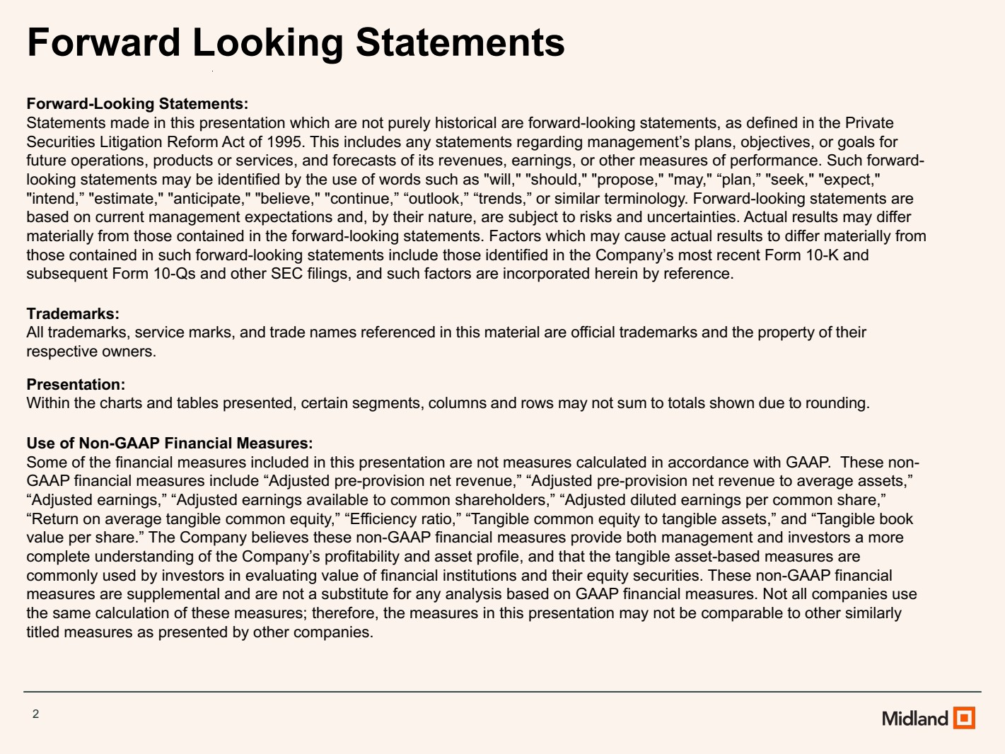 | 2 Forward Looking Statements Forward-Looking Statements: Statements made in this presentation which are not purely historical are forward-looking statements, as defined in the Private Securities Litigation Reform Act of 1995. This includes any statements regarding management’s plans, objectives, or goals for future operations, products or services, and forecasts of its revenues, earnings, or other measures of performance. Such forward-looking statements may be identified by the use of words such as "will," "should," "propose," "may," “plan,” "seek," "expect," "intend,” "estimate," "anticipate," "believe," "continue,” “outlook,” “trends,” or similar terminology. Forward-looking statements are based on current management expectations and, by their nature, are subject to risks and uncertainties. Actual results may differ materially from those contained in the forward-looking statements. Factors which may cause actual results to differ materially from those contained in such forward-looking statements include those identified in the Company’s most recent Form 10-K and subsequent Form 10-Qs and other SEC filings, and such factors are incorporated herein by reference. Trademarks: All trademarks, service marks, and trade names referenced in this material are official trademarks and the property of their respective owners. Presentation: Within the charts and tables presented, certain segments, columns and rows may not sum to totals shown due to rounding. Use of Non-GAAP Financial Measures: Some of the financial measures included in this presentation are not measures calculated in accordance with GAAP. These non-GAAP financial measures include “Adjusted pre-provision net revenue,” “Adjusted pre-provision net revenue to average assets,” “Adjusted earnings,” “Adjusted earnings available to common shareholders,” “Adjusted diluted earnings per common share,” “Return on average tangible common equity,” “Efficiency ratio,” “Tangible common equity to tangible assets,” and “Tangible book value per share.” The Company believes these non-GAAP financial measures provide both management and investors a more complete understanding of the Company’s profitability and asset profile, and that the tangible asset-based measures are commonly used by investors in evaluating value of financial institutions and their equity securities. These non-GAAP financial measures are supplemental and are not a substitute for any analysis based on GAAP financial measures. Not all companies use the same calculation of these measures; therefore, the measures in this presentation may not be comparable to other similarly titled measures as presented by other companies.
 | 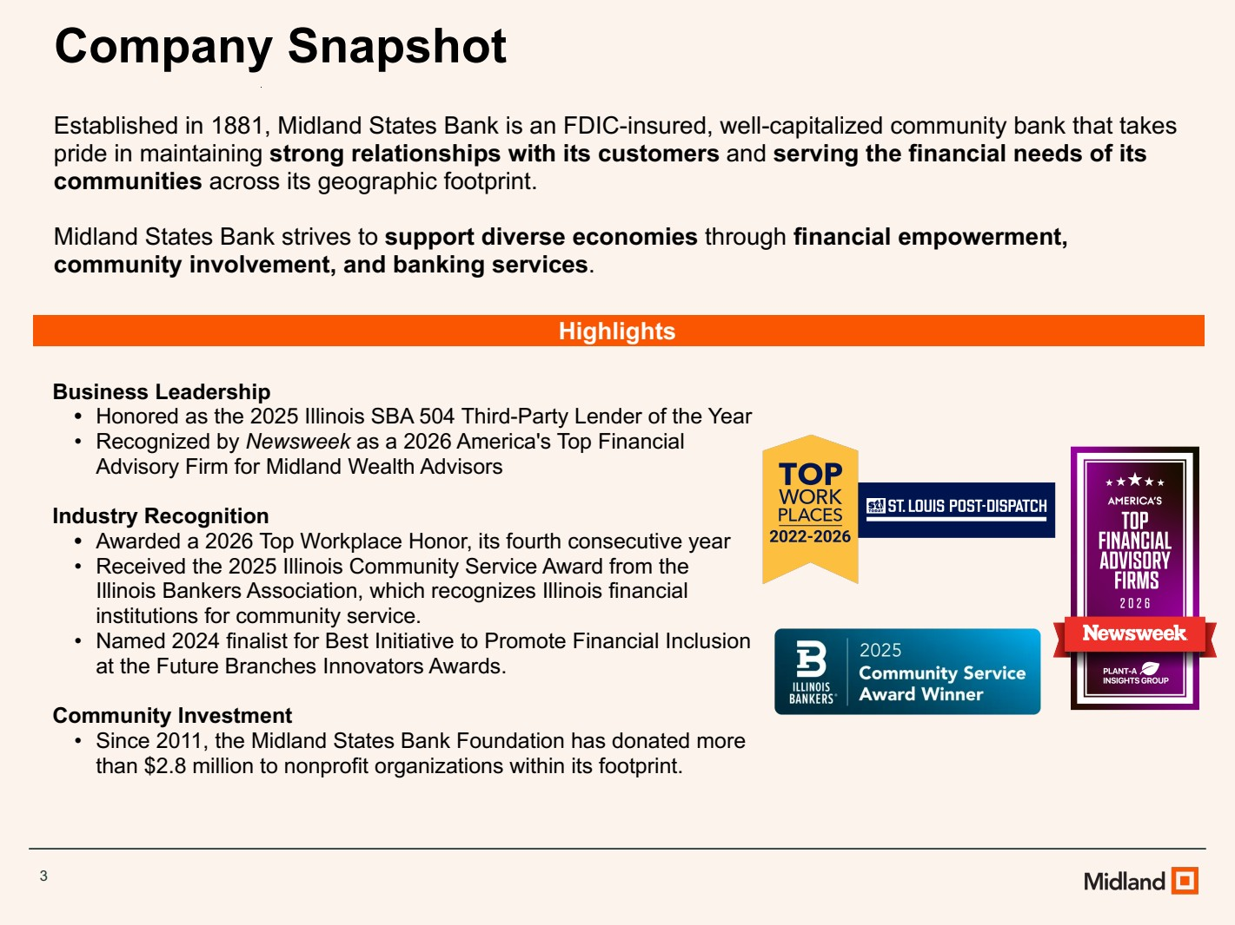 | Business Leadership • Honored as the 2025 Illinois SBA 504 Third-Party Lender of the Year • Recognized by Newsweek as a 2026 America's Top Financial Advisory Firm for Midland Wealth Advisors Industry Recognition • Awarded a 2026 Top Workplace Honor, its fourth consecutive year • Received the 2025 Illinois Community Service Award from the Illinois Bankers Association, which recognizes Illinois financial institutions for community service. • Named 2024 finalist for Best Initiative to Promote Financial Inclusion at the Future Branches Innovators Awards. Community Investment • Since 2011, the Midland States Bank Foundation has donated more than $2.8 million to nonprofit organizations within its footprint. Company Snapshot Highlights Established in 1881, Midland States Bank is an FDIC-insured, well-capitalized community bank that takes pride in maintaining strong relationships with its customers and serving the financial needs of its communities across its geographic footprint. Midland States Bank strives to support diverse economies through financial empowerment, community involvement, and banking services. 3
 | 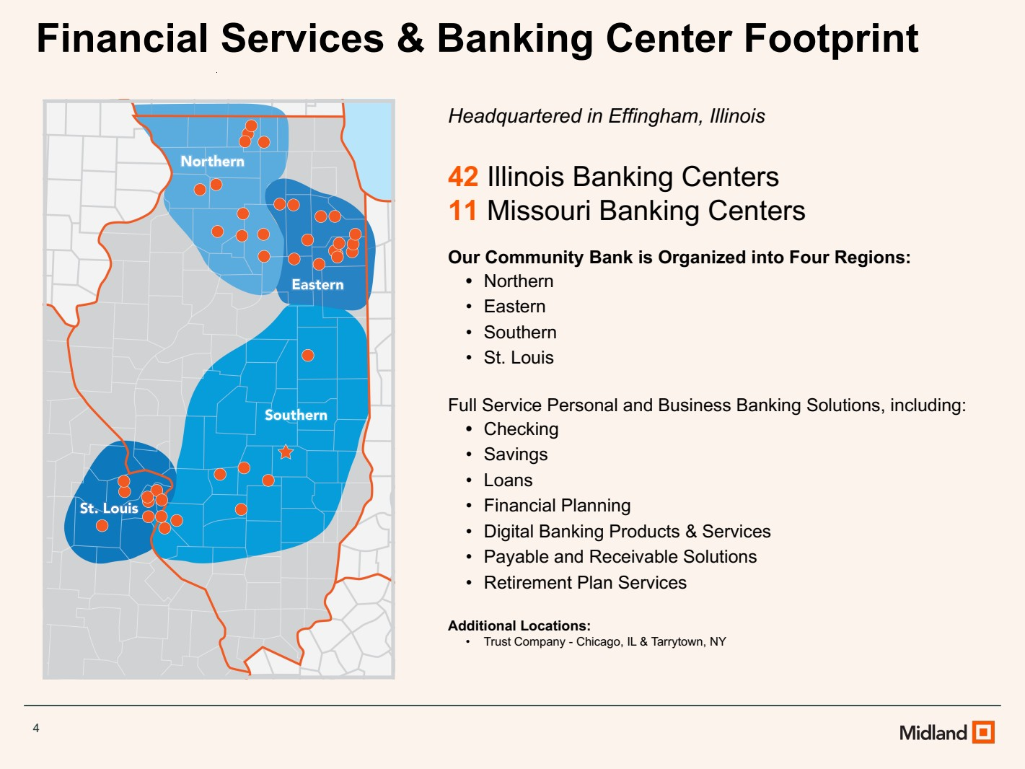 | Headquartered in Effingham, Illinois 42 Illinois Banking Centers 11 Missouri Banking Centers Our Community Bank is Organized into Four Regions: • Northern • Eastern • Southern • St. Louis Full Service Personal and Business Banking Solutions, including: • Checking • Savings • Loans • Financial Planning • Digital Banking Products & Services • Payable and Receivable Solutions • Retirement Plan Services Additional Locations: • Trust Company - Chicago, IL & Tarrytown, NY Financial Services & Banking Center Footprint 4
 | 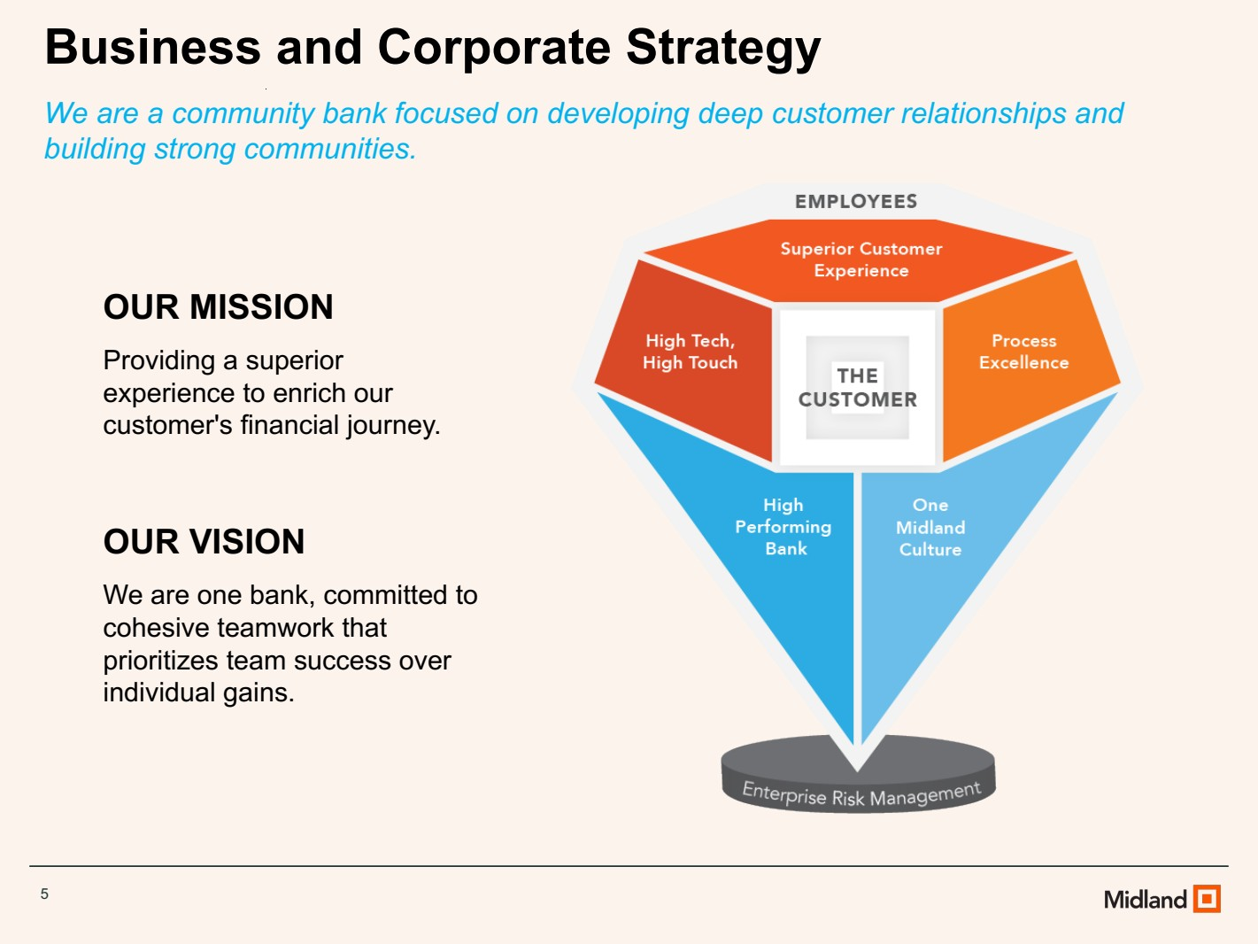 | Business and Corporate Strategy We are a community bank focused on developing deep customer relationships and building strong communities. OUR MISSION Providing a superior experience to enrich our customer's financial journey. OUR VISION We are one bank, committed to cohesive teamwork that prioritizes team success over individual gains. 5
 | 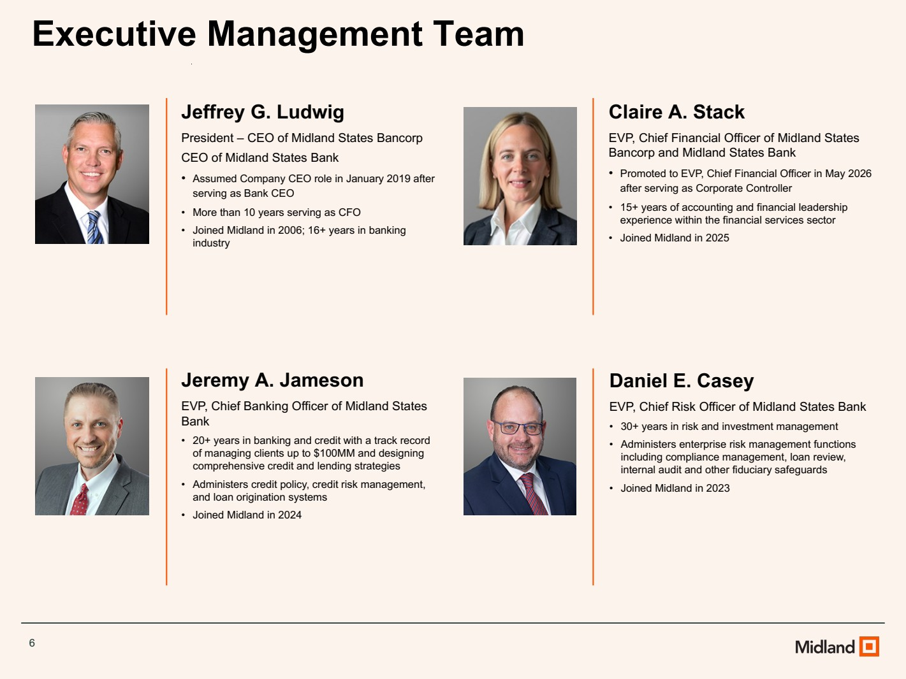 | Executive Management Team Jeffrey G. Ludwig President – CEO of Midland States Bancorp CEO of Midland States Bank • Assumed Company CEO role in January 2019 after serving as Bank CEO • More than 10 years serving as CFO • Joined Midland in 2006; 16+ years in banking industry Claire A. Stack EVP, Chief Financial Officer of Midland States Bancorp and Midland States Bank • Promoted to EVP, Chief Financial Officer in May 2026 after serving as Corporate Controller • 15+ years of accounting and financial leadership experience within the financial services sector • Joined Midland in 2025 Daniel E. Casey EVP, Chief Risk Officer of Midland States Bank • 30+ years in risk and investment management • Administers enterprise risk management functions including compliance management, loan review, internal audit and other fiduciary safeguards • Joined Midland in 2023 Jeremy A. Jameson EVP, Chief Banking Officer of Midland States Bank • 20+ years in banking and credit with a track record of managing clients up to $100MM and designing comprehensive credit and lending strategies • Administers credit policy, credit risk management, and loan origination systems • Joined Midland in 2024 6
 | 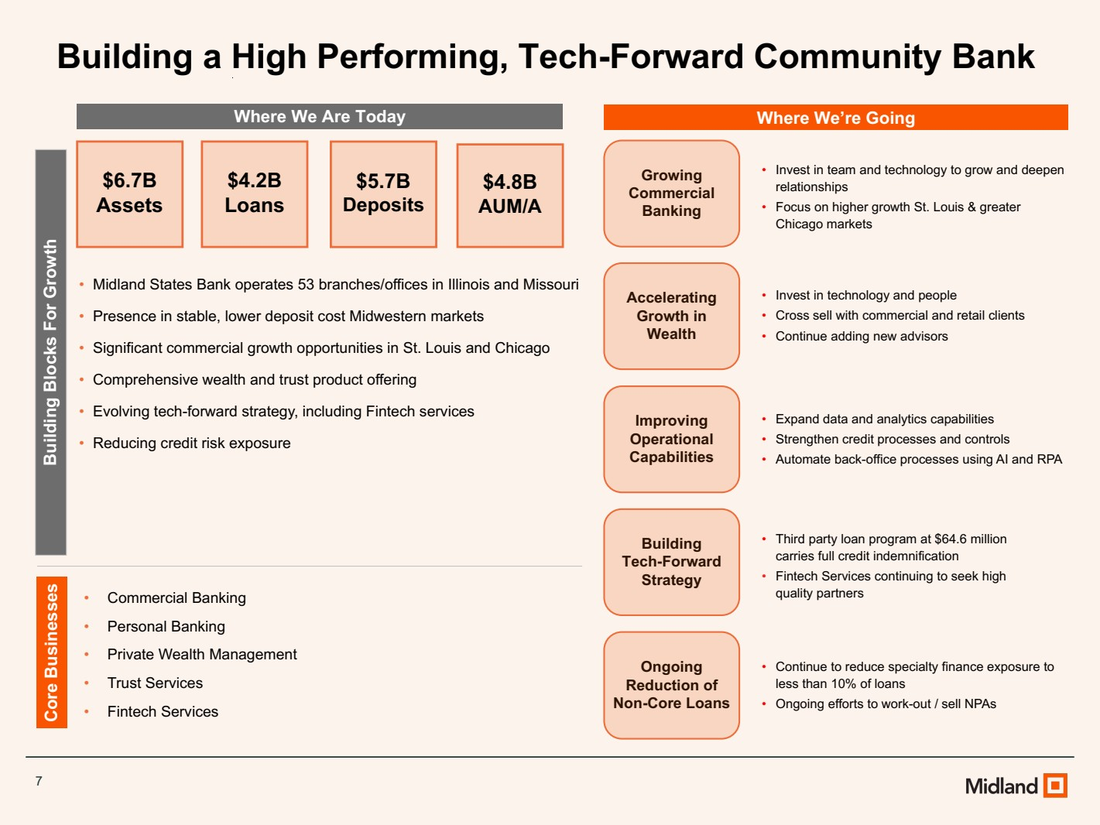 | 7 Where We Are Today Where We’re Going Building Blocks For Growth Core Businesses • Midland States Bank operates 53 branches/offices in Illinois and Missouri • Presence in stable, lower deposit cost Midwestern markets • Significant commercial growth opportunities in St. Louis and Chicago • Comprehensive wealth and trust product offering • Evolving tech-forward strategy, including Fintech services • Reducing credit risk exposure • Commercial Banking • Personal Banking • Private Wealth Management • Trust Services • Fintech Services Ongoing Reduction of Non-Core Loans Growing Commercial Banking Accelerating Growth in Wealth Improving Operational Capabilities • Continue to reduce specialty finance exposure to less than 10% of loans • Ongoing efforts to work-out / sell NPAs • Invest in team and technology to grow and deepen relationships • Focus on higher growth St. Louis & greater Chicago markets • Invest in technology and people • Cross sell with commercial and retail clients • Continue adding new advisors • Expand data and analytics capabilities • Strengthen credit processes and controls • Automate back-office processes using AI and RPA Building Tech-Forward Strategy • Third party loan program at $64.6 million carries full credit indemnification • Fintech Services continuing to seek high quality partners $6.7B Assets $4.2B Loans $5.7B Deposits $4.8B AUM/A Building a High Performing, Tech-Forward Community Bank
 | 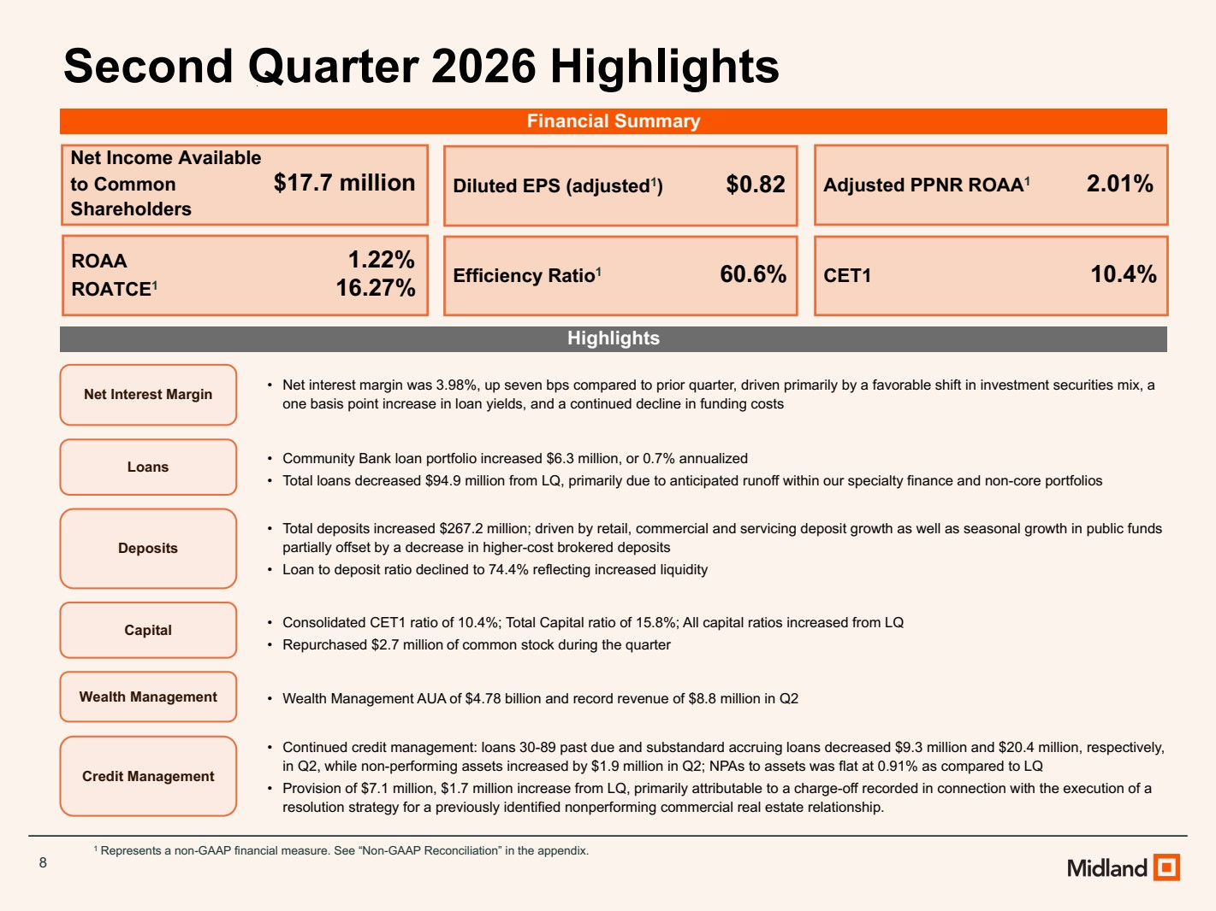 | 8 Second Quarter 2026 Highlights Highlights 1 Represents a non-GAAP financial measure. See “Non-GAAP Reconciliation” in the appendix. Net Income Available to Common $17.7 million Shareholders Diluted EPS (adjusted1 ) $0.82 ROAA 1.22% ROATCE1 16.27% Adjusted PPNR ROAA1 2.01% Efficiency Ratio1 60.6% CET1 10.4% Net Interest Margin • Net interest margin was 3.98%, up seven bps compared to prior quarter, driven primarily by a favorable shift in investment securities mix, a one basis point increase in loan yields, and a continued decline in funding costs Loans • Community Bank loan portfolio increased $6.3 million, or 0.7% annualized • Total loans decreased $94.9 million from LQ, primarily due to anticipated runoff within our specialty finance and non-core portfolios Wealth Management • Wealth Management AUA of $4.78 billion and record revenue of $8.8 million in Q2 Credit Management • Continued credit management: loans 30-89 past due and substandard accruing loans decreased $9.3 million and $20.4 million, respectively, in Q2, while non-performing assets increased by $1.9 million in Q2; NPAs to assets was flat at 0.91% as compared to LQ • Provision of $7.1 million, $1.7 million increase from LQ, primarily attributable to a charge-off recorded in connection with the execution of a resolution strategy for a previously identified nonperforming commercial real estate relationship. Deposits • Total deposits increased $267.2 million; driven by retail, commercial and servicing deposit growth as well as seasonal growth in public funds partially offset by a decrease in higher-cost brokered deposits • Loan to deposit ratio declined to 74.4% reflecting increased liquidity Capital • Consolidated CET1 ratio of 10.4%; Total Capital ratio of 15.8%; All capital ratios increased from LQ • Repurchased $2.7 million of common stock during the quarter Financial Summary
 | 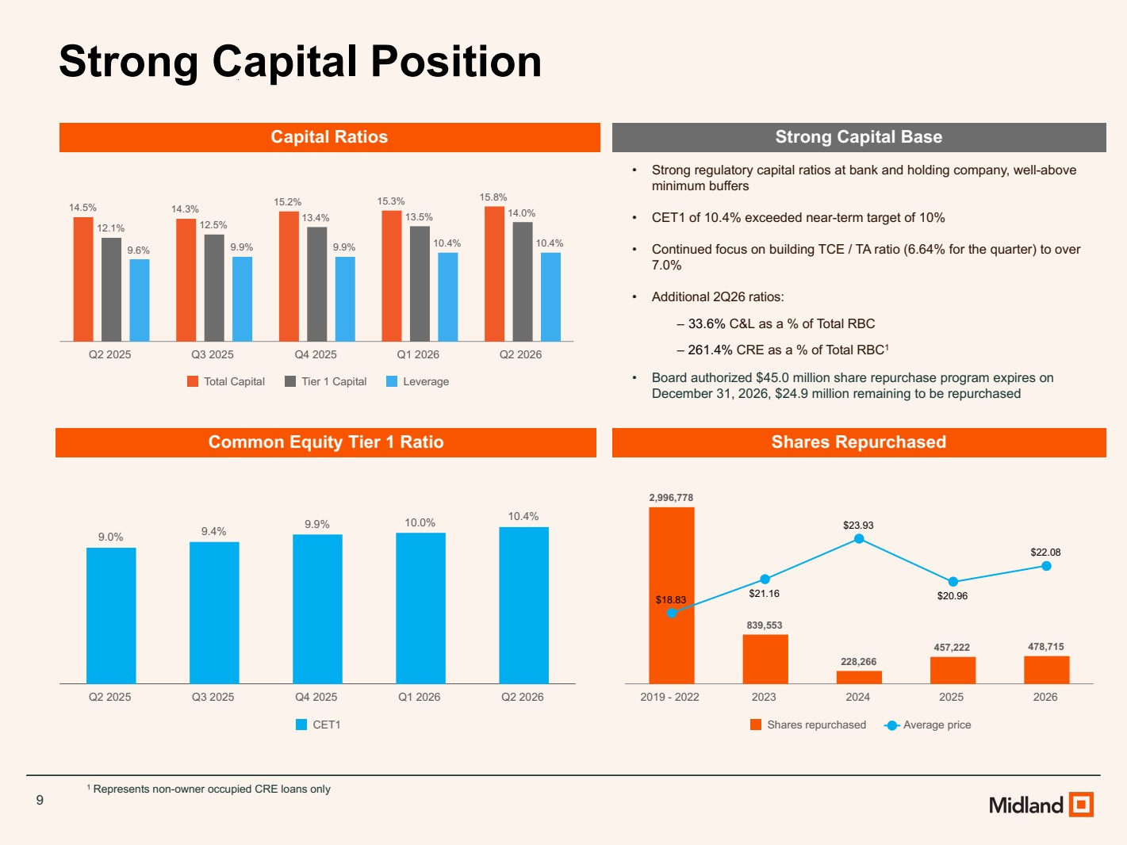 | 9 Strong Capital Position 14.5% 14.3% 15.2% 15.3% 15.8% 12.1% 12.5% 13.4% 13.5% 14.0% 9.6% 9.9% 9.9% 10.4% 10.4% Total Capital Tier 1 Capital Leverage Q2 2025 Q3 2025 Q4 2025 Q1 2026 Q2 2026 9.0% 9.4% 9.9% 10.0% 10.4% CET1 Q2 2025 Q3 2025 Q4 2025 Q1 2026 Q2 2026 • Strong regulatory capital ratios at bank and holding company, well-above minimum buffers • CET1 of 10.4% exceeded near-term target of 10% • Continued focus on building TCE / TA ratio (6.64% for the quarter) to over 7.0% • Additional 2Q26 ratios: ‒ 33.6% C&L as a % of Total RBC ‒ 261.4% CRE as a % of Total RBC1 • Board authorized $45.0 million share repurchase program expires on December 31, 2026, $24.9 million remaining to be repurchased Capital Ratios Common Equity Tier 1 Ratio Strong Capital Base 1 Represents non-owner occupied CRE loans only Shares Repurchased 2,996,778 839,553 228,266 457,222 478,715 $18.83 $21.16 $23.93 $20.96 $22.08 Shares repurchased Average price 2019 - 2022 2023 2024 2025 2026
 | 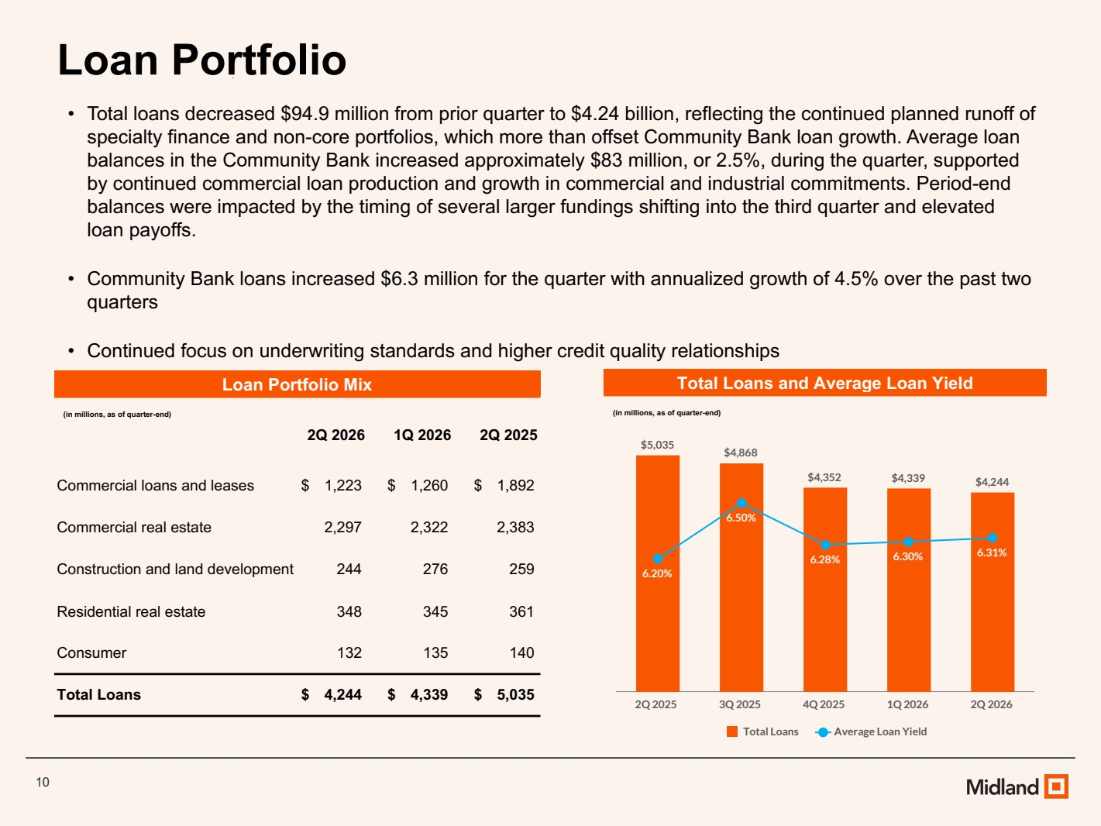 | 10 Total Loans and Average Loan Yield (in millions, as of quarter-end) Loan Portfolio • Total loans decreased $94.9 million from prior quarter to $4.24 billion, reflecting the continued planned runoff of specialty finance and non-core portfolios, which more than offset Community Bank loan growth. Average loan balances in the Community Bank increased approximately $83 million, or 2.5%, during the quarter, supported by continued commercial loan production and growth in commercial and industrial commitments. Period-end balances were impacted by the timing of several larger fundings shifting into the third quarter and elevated loan payoffs. • Community Bank loans increased $6.3 million for the quarter with annualized growth of 4.5% over the past two quarters • Continued focus on underwriting standards and higher credit quality relationships Loan Portfolio Mix (in millions, as of quarter-end) 2Q 2026 1Q 2026 2Q 2025 Commercial loans and leases $ 1,223 $ 1,260 $ 1,892 Commercial real estate 2,297 2,322 2,383 Construction and land development 244 276 259 Residential real estate 348 345 361 Consumer 132 135 140 Total Loans $ 4,244 $ 4,339 $ 5,035 $5,035 $4,868 $4,352 $4,339 $4,244 6.20% 6.50% 6.28% 6.30% 6.31% Total Loans Average Loan Yield 2Q 2025 3Q 2025 4Q 2025 1Q 2026 2Q 2026
 | 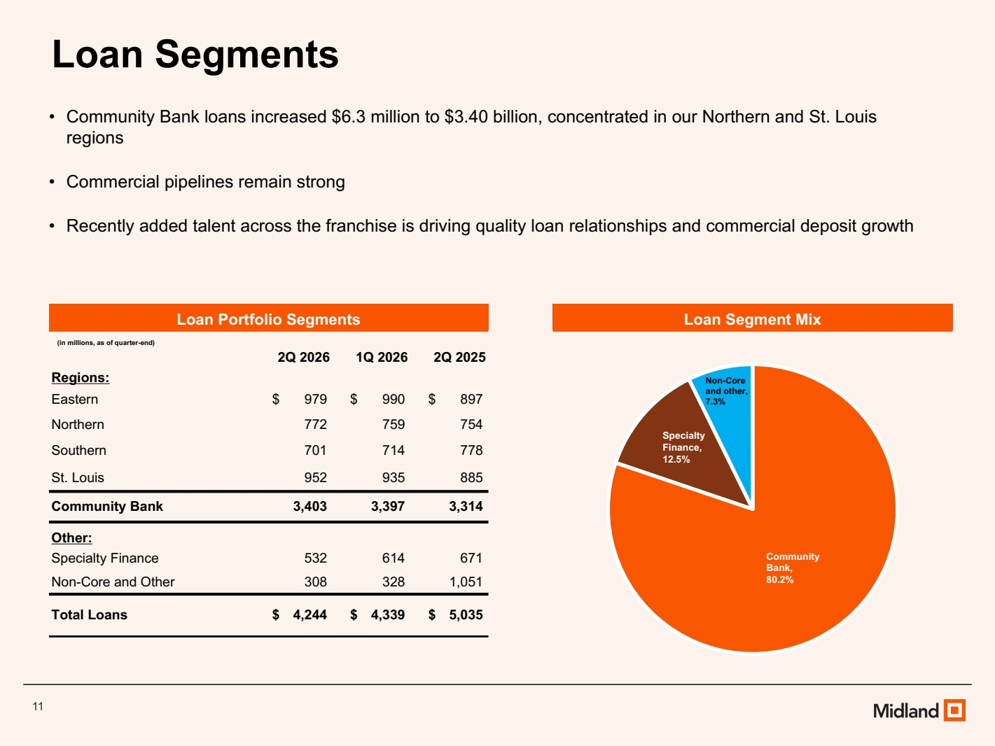 | 11 Loan Segments Loan Segment Mix • Community Bank loans increased $6.3 million to $3.40 billion, concentrated in our Northern and St. Louis regions • Commercial pipelines remain strong • Recently added talent across the franchise is driving quality loan relationships and commercial deposit growth Loan Portfolio Segments (in millions, as of quarter-end) 2Q 2026 1Q 2026 2Q 2025 Regions: Eastern $ 979 $ 990 $ 897 Northern 772 759 754 Southern 701 714 778 St. Louis 952 935 885 Community Bank 3,403 3,397 3,314 Other: Specialty Finance 532 614 671 Non-Core and Other 308 328 1,051 Total Loans $ 4,244 $ 4,339 $ 5,035 Community Bank, 80.2% Specialty Finance, 12.5% Non-Core and other, 7.3%
 | 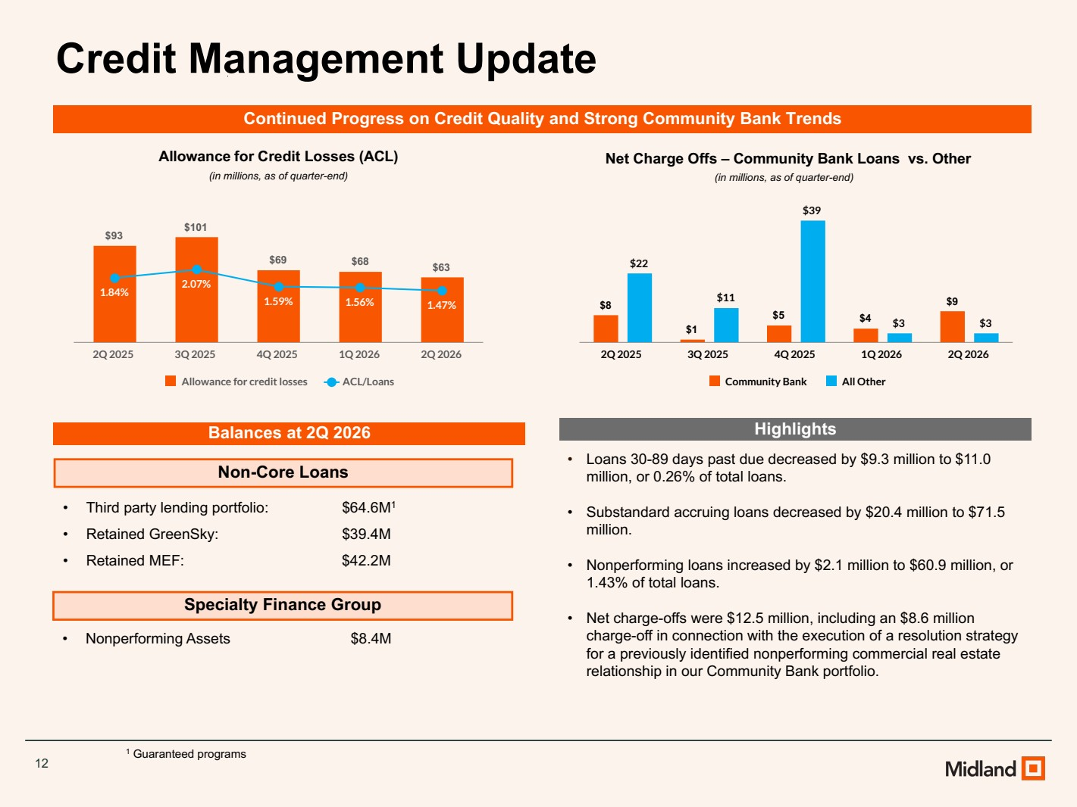 | 12 Credit Management Update Non-Core Loans Specialty Finance Group • Third party lending portfolio: $64.6M1 • Retained GreenSky: $39.4M • Retained MEF: $42.2M • Nonperforming Assets $8.4M 1 Guaranteed programs Balances at 2Q 2026 Allowance for Credit Losses (ACL) Net Charge Offs – Community Bank Loans vs. Other (in millions, as of quarter-end) (in millions, as of quarter-end) $93 $101 $69 $68 $63 1.84% 2.07% 1.59% 1.56% 1.47% Allowance for credit losses ACL/Loans 2Q 2025 3Q 2025 4Q 2025 1Q 2026 2Q 2026 $8 $1 $5 $4 $9 $22 $11 $39 $3 $3 Community Bank All Other 2Q 2025 3Q 2025 4Q 2025 1Q 2026 2Q 2026 Continued Progress on Credit Quality and Strong Community Bank Trends Highlights • Loans 30-89 days past due decreased by $9.3 million to $11.0 million, or 0.26% of total loans. • Substandard accruing loans decreased by $20.4 million to $71.5 million. • Nonperforming loans increased by $2.1 million to $60.9 million, or 1.43% of total loans. • Net charge-offs were $12.5 million, including an $8.6 million charge-off in connection with the execution of a resolution strategy for a previously identified nonperforming commercial real estate relationship in our Community Bank portfolio.
 | 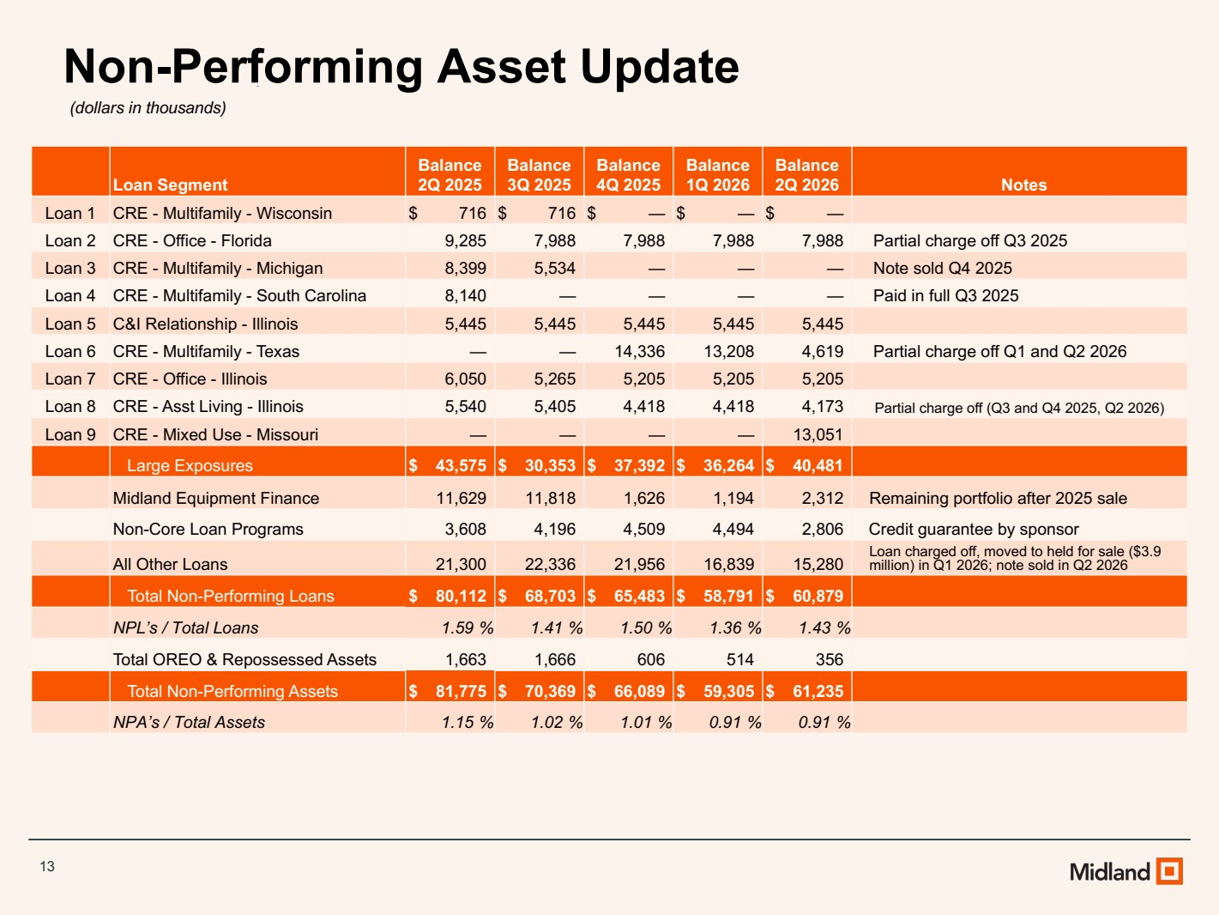 | 13 Non-Performing Asset Update (dollars in thousands) Loan Segment Balance 2Q 2025 Balance 3Q 2025 Balance 4Q 2025 Balance 1Q 2026 Balance 2Q 2026 Notes Loan 1 CRE - Multifamily - Wisconsin $ 716 $ 716 $ — $ — $ — Loan 2 CRE - Office - Florida 9,285 7,988 7,988 7,988 7,988 Partial charge off Q3 2025 Loan 3 CRE - Multifamily - Michigan 8,399 5,534 — — — Note sold Q4 2025 Loan 4 CRE - Multifamily - South Carolina 8,140 — — — — Paid in full Q3 2025 Loan 5 C&I Relationship - Illinois 5,445 5,445 5,445 5,445 5,445 Loan 6 CRE - Multifamily - Texas — — 14,336 13,208 4,619 Partial charge off Q1 and Q2 2026 Loan 7 CRE - Office - Illinois 6,050 5,265 5,205 5,205 5,205 Loan 8 CRE - Asst Living - Illinois 5,540 5,405 4,418 4,418 4,173 Partial charge off (Q3 and Q4 2025, Q2 2026) Loan 9 CRE - Mixed Use - Missouri — — — — 13,051 Large Exposures $ 43,575 $ 30,353 $ 37,392 $ 36,264 $ 40,481 Midland Equipment Finance 11,629 11,818 1,626 1,194 2,312 Remaining portfolio after 2025 sale Non-Core Loan Programs 3,608 4,196 4,509 4,494 2,806 Credit guarantee by sponsor All Other Loans 21,300 22,336 21,956 16,839 15,280 Loan charged off, moved to held for sale ($3.9 million) in Q1 2026; note sold in Q2 2026 Total Non-Performing Loans $ 80,112 $ 68,703 $ 65,483 $ 58,791 $ 60,879 NPL’s / Total Loans 1.59 % 1.41 % 1.50 % 1.36 % 1.43 % Total OREO & Repossessed Assets 1,663 1,666 606 514 356 Total Non-Performing Assets $ 81,775 $ 70,369 $ 66,089 $ 59,305 $ 61,235 NPA’s / Total Assets 1.15 % 1.02 % 1.01 % 0.91 % 0.91 %
 | 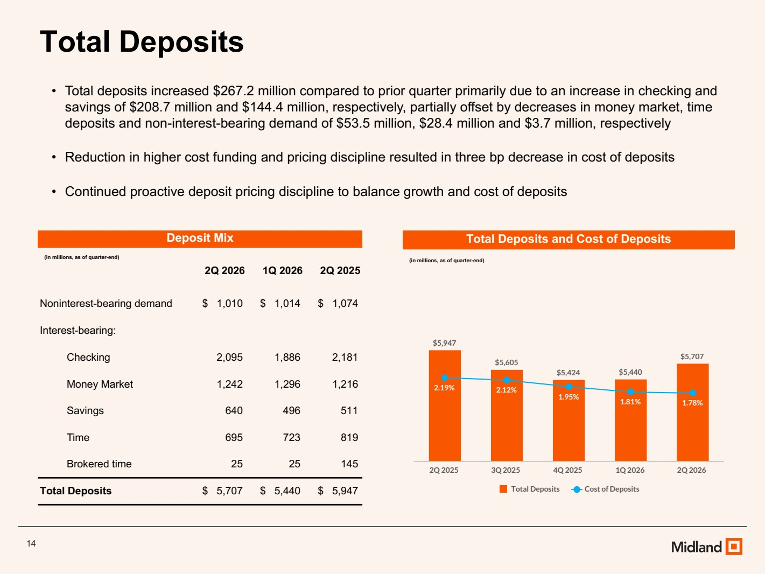 | 14 Total Deposits • Total deposits increased $267.2 million compared to prior quarter primarily due to an increase in checking and savings of $208.7 million and $144.4 million, respectively, partially offset by decreases in money market, time deposits and non-interest-bearing demand of $53.5 million, $28.4 million and $3.7 million, respectively • Reduction in higher cost funding and pricing discipline resulted in three bp decrease in cost of deposits • Continued proactive deposit pricing discipline to balance growth and cost of deposits Deposit Mix (in millions, as of quarter-end) 2Q 2026 1Q 2026 2Q 2025 Noninterest-bearing demand $ 1,010 $ 1,014 $ 1,074 Interest-bearing: Checking 2,095 1,886 2,181 Money Market 1,242 1,296 1,216 Savings 640 496 511 Time 695 723 819 Brokered time 25 25 145 Total Deposits $ 5,707 $ 5,440 $ 5,947 Total Deposits and Cost of Deposits (in millions, as of quarter-end) $5,947 $5,605 $5,424 $5,440 $5,707 2.19% 2.12% 1.95% 1.81% 1.78% Total Deposits Cost of Deposits 2Q 2025 3Q 2025 4Q 2025 1Q 2026 2Q 2026
 | 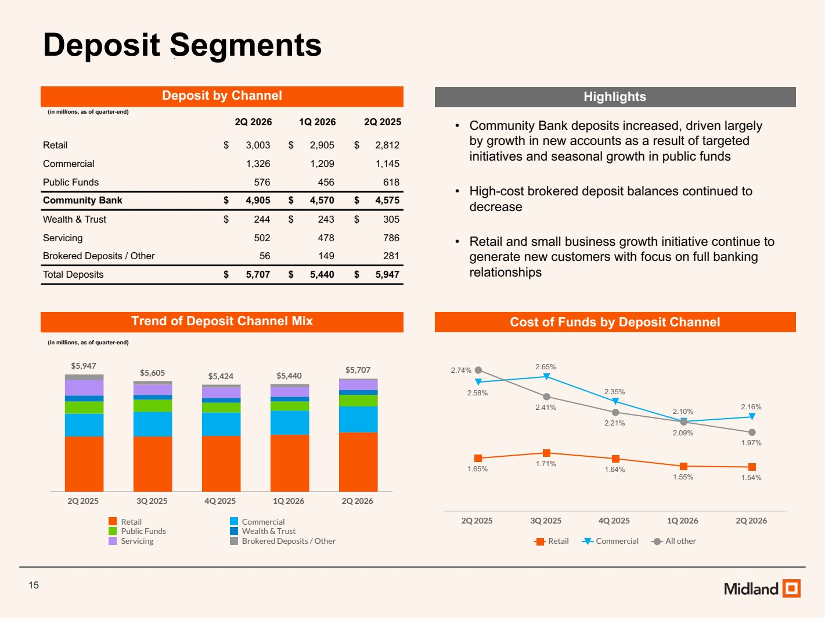 | 15 Deposit Segments • Community Bank deposits increased, driven largely by growth in new accounts as a result of targeted initiatives and seasonal growth in public funds • High-cost brokered deposit balances continued to decrease • Retail and small business growth initiative continue to generate new customers with focus on full banking relationships Deposit by Channel (in millions, as of quarter-end) 2Q 2026 1Q 2026 2Q 2025 Retail $ 3,003 $ 2,905 $ 2,812 Commercial 1,326 1,209 1,145 Public Funds 576 456 618 Community Bank $ 4,905 $ 4,570 $ 4,575 Wealth & Trust $ 244 $ 243 $ 305 Servicing 502 478 786 Brokered Deposits / Other 56 149 281 Total Deposits $ 5,707 $ 5,440 $ 5,947 Trend of Deposit Channel Mix (in millions, as of quarter-end) $5,947 $5,605 $5,424 $5,440 $5,707 Retail Commercial Public Funds Wealth & Trust Servicing Brokered Deposits / Other 2Q 2025 3Q 2025 4Q 2025 1Q 2026 2Q 2026 Highlights Cost of Funds by Deposit Channel 1.65% 1.71% 1.64% 1.55% 1.54% 2.58% 2.65% 2.35% 2.10% 2.16% 2.74% 2.41% 2.21% 2.09% 1.97% Retail Commercial All other 2Q 2025 3Q 2025 4Q 2025 1Q 2026 2Q 2026
 | 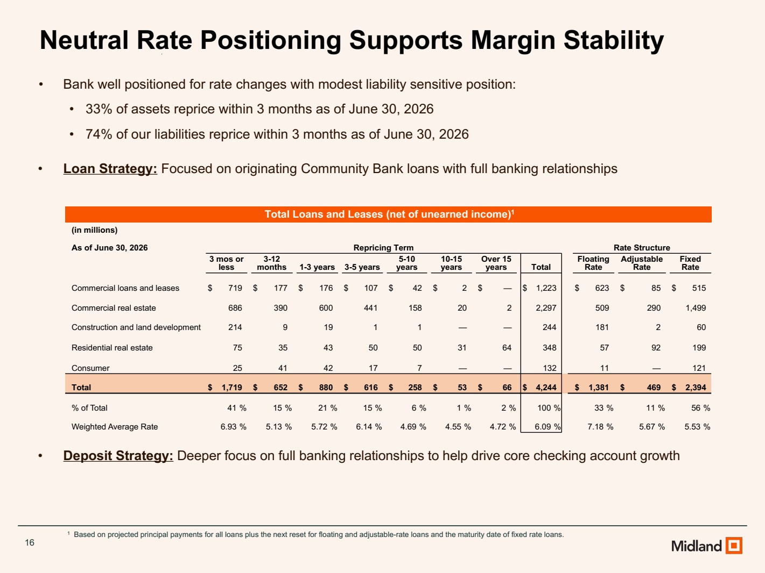 | 16 Neutral Rate Positioning Supports Margin Stability • Bank well positioned for rate changes with modest liability sensitive position: • 33% of assets reprice within 3 months as of June 30, 2026 • 74% of our liabilities reprice within 3 months as of June 30, 2026 • Loan Strategy: Focused on originating Community Bank loans with full banking relationships • Deposit Strategy: Deeper focus on full banking relationships to help drive core checking account growth 1 Based on projected principal payments for all loans plus the next reset for floating and adjustable-rate loans and the maturity date of fixed rate loans. Total Loans and Leases (net of unearned income)1 (in millions) As of June 30, 2026 Repricing Term Rate Structure 3 mos or less 3-12 months 1-3 years 3-5 years 5-10 years 10-15 years Over 15 years Total Floating Rate Adjustable Rate Fixed Rate Commercial loans and leases $ 719 $ 177 $ 176 $ 107 $ 42 $ 2 $ — $ 1,223 $ 623 $ 85 $ 515 Commercial real estate 686 390 600 441 158 20 2 2,297 509 290 1,499 Construction and land development 214 9 19 1 1 — — 244 181 2 60 Residential real estate 75 35 43 50 50 31 64 348 57 92 199 Consumer 25 41 42 17 7 — — 132 11 — 121 Total $ 1,719 $ 652 $ 880 $ 616 $ 258 $ 53 $ 66 $ 4,244 $ 1,381 $ 469 $ 2,394 % of Total 41 % 15 % 21 % 15 % 6 % 1 % 2 % 100 % 33 % 11 % 56 % Weighted Average Rate 6.93 % 5.13 % 5.72 % 6.14 % 4.69 % 4.55 % 4.72 % 6.09 % 7.18 % 5.67 % 5.53 %
 | 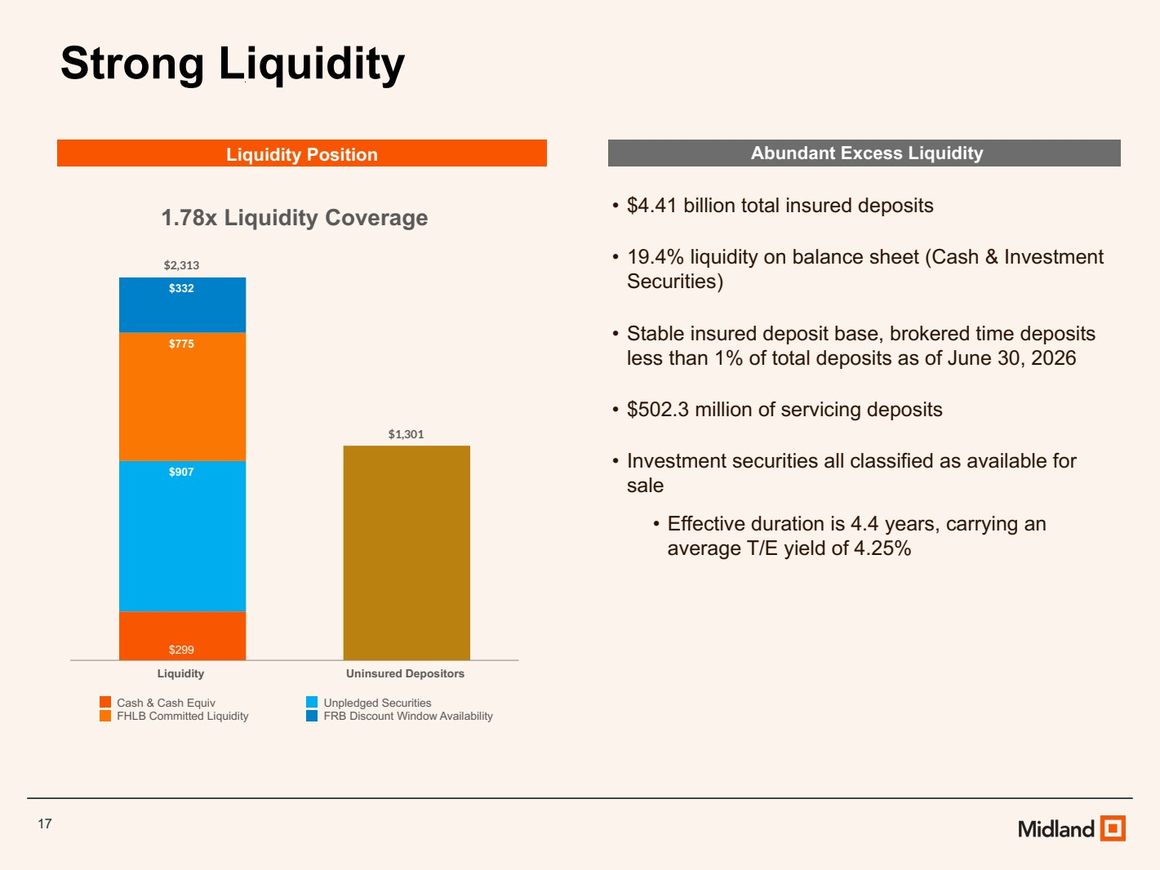 | 17 Strong Liquidity Abundant Excess Liquidity • $4.41 billion total insured deposits • 19.4% liquidity on balance sheet (Cash & Investment Securities) • Stable insured deposit base, brokered time deposits less than 1% of total deposits as of June 30, 2026 • $502.3 million of servicing deposits • Investment securities all classified as available for sale • Effective duration is 4.4 years, carrying an average T/E yield of 4.25% 1.78x Liquidity Coverage $2,313 $1,301 $299 $907 $775 $332 Cash & Cash Equiv Unpledged Securities FHLB Committed Liquidity FRB Discount Window Availability Liquidity Uninsured Depositors Liquidity Position
 | 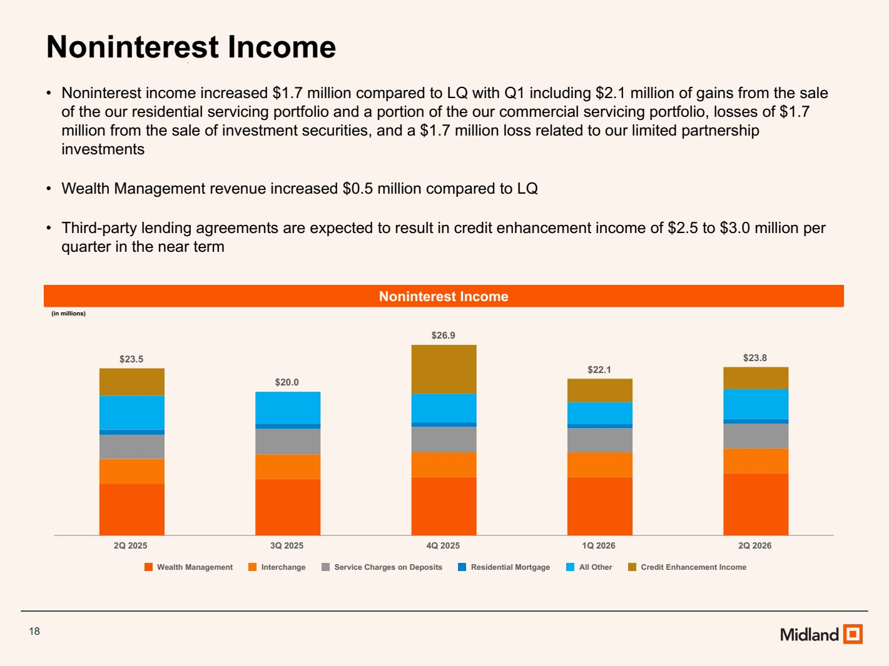 | 18 Noninterest Income • Noninterest income increased $1.7 million compared to LQ with Q1 including $2.1 million of gains from the sale of the our residential servicing portfolio and a portion of the our commercial servicing portfolio, losses of $1.7 million from the sale of investment securities, and a $1.7 million loss related to our limited partnership investments • Wealth Management revenue increased $0.5 million compared to LQ • Third-party lending agreements are expected to result in credit enhancement income of $2.5 to $3.0 million per quarter in the near term Noninterest Income (in millions) $23.5 $20.0 $26.9 $22.1 $23.8 Wealth Management Interchange Service Charges on Deposits Residential Mortgage All Other Credit Enhancement Income 2Q 2025 3Q 2025 4Q 2025 1Q 2026 2Q 2026
 | 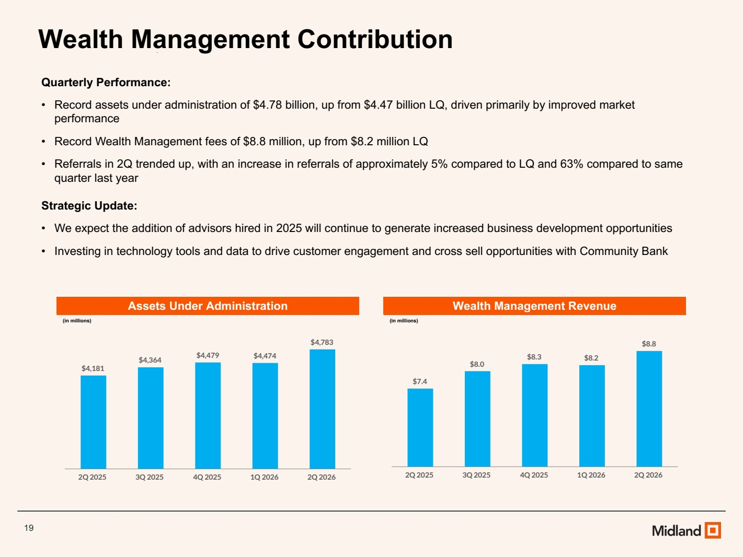 | 19 Wealth Management Contribution Quarterly Performance: • Record assets under administration of $4.78 billion, up from $4.47 billion LQ, driven primarily by improved market performance • Record Wealth Management fees of $8.8 million, up from $8.2 million LQ • Referrals in 2Q trended up, with an increase in referrals of approximately 5% compared to LQ and 63% compared to same quarter last year Strategic Update: • We expect the addition of advisors hired in 2025 will continue to generate increased business development opportunities • Investing in technology tools and data to drive customer engagement and cross sell opportunities with Community Bank Assets Under Administration (in millions) Wealth Management Revenue (in millions) $4,181 $4,364 $4,479 $4,474 $4,783 2Q 2025 3Q 2025 4Q 2025 1Q 2026 2Q 2026 $7.4 $8.0 $8.3 $8.2 $8.8 2Q 2025 3Q 2025 4Q 2025 1Q 2026 2Q 2026
 | 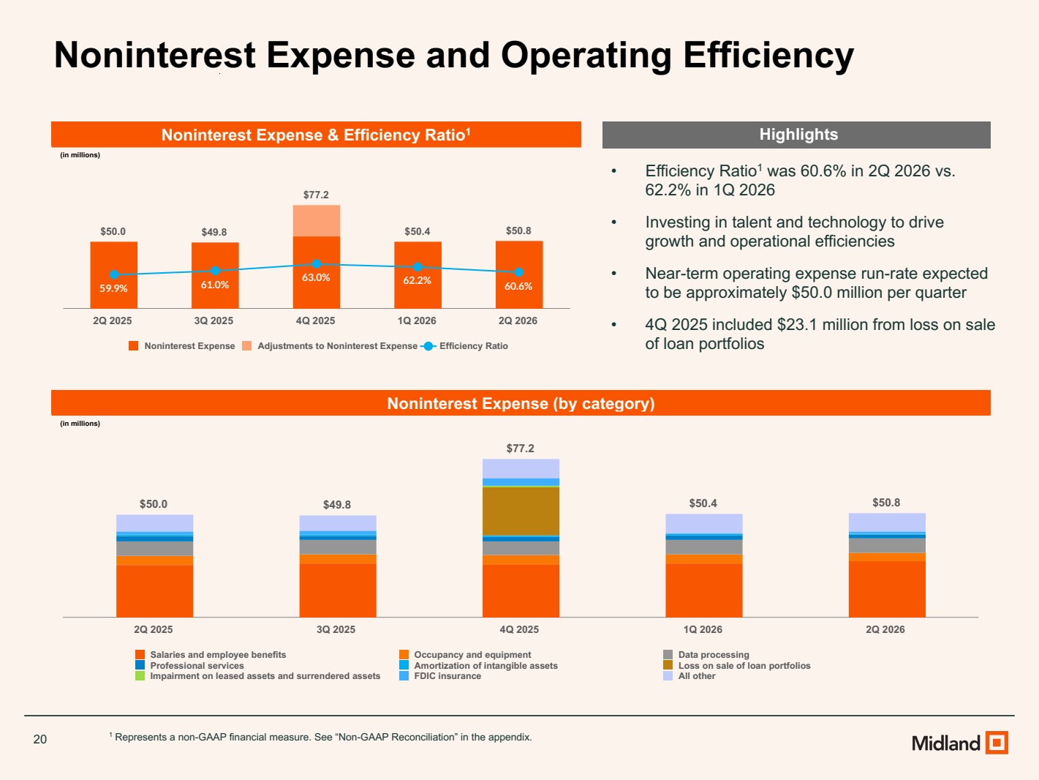 | 20 Noninterest Expense and Operating Efficiency Noninterest Expense & Efficiency Ratio1 (in millions) • Efficiency Ratio1 was 60.6% in 2Q 2026 vs. 62.2% in 1Q 2026 • Investing in talent and technology to drive growth and operational efficiencies • Near-term operating expense run-rate expected to be approximately $50.0 million per quarter • 4Q 2025 included $23.1 million from loss on sale of loan portfolios 1 Represents a non-GAAP financial measure. See “Non-GAAP Reconciliation” in the appendix. $50.0 $49.8 $77.2 $50.4 $50.8 59.9% 61.0% 63.0% 62.2% 60.6% Noninterest Expense Adjustments to Noninterest Expense Efficiency Ratio 2Q 2025 3Q 2025 4Q 2025 1Q 2026 2Q 2026 Noninterest Expense (by category) (in millions) Highlights $50.0 $49.8 $77.2 $50.4 $50.8 Salaries and employee benefits Occupancy and equipment Data processing Professional services Amortization of intangible assets Loss on sale of loan portfolios Impairment on leased assets and surrendered assets FDIC insurance All other 2Q 2025 3Q 2025 4Q 2025 1Q 2026 2Q 2026
 | 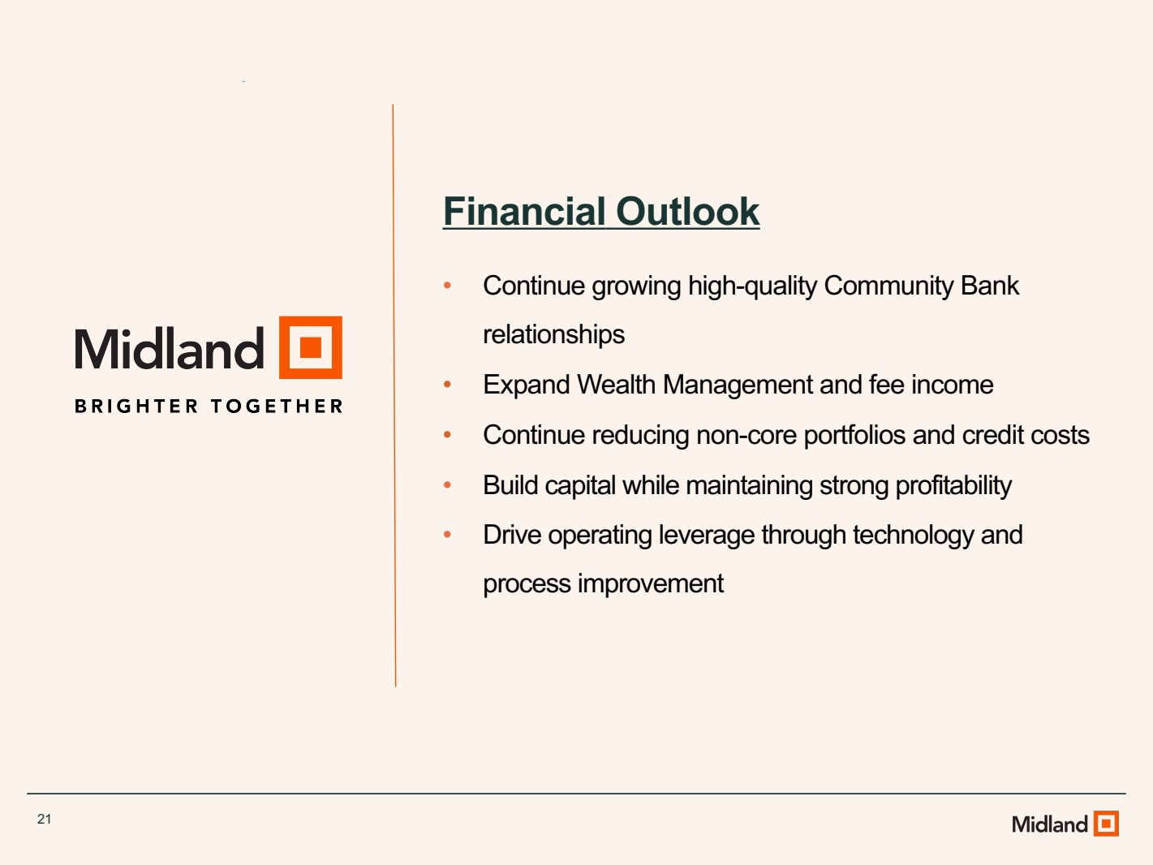 | 21 Financial Outlook • Continue growing high-quality Community Bank relationships • Expand Wealth Management and fee income • Continue reducing non-core portfolios and credit costs • Build capital while maintaining strong profitability • Drive operating leverage through technology and process improvement
 | 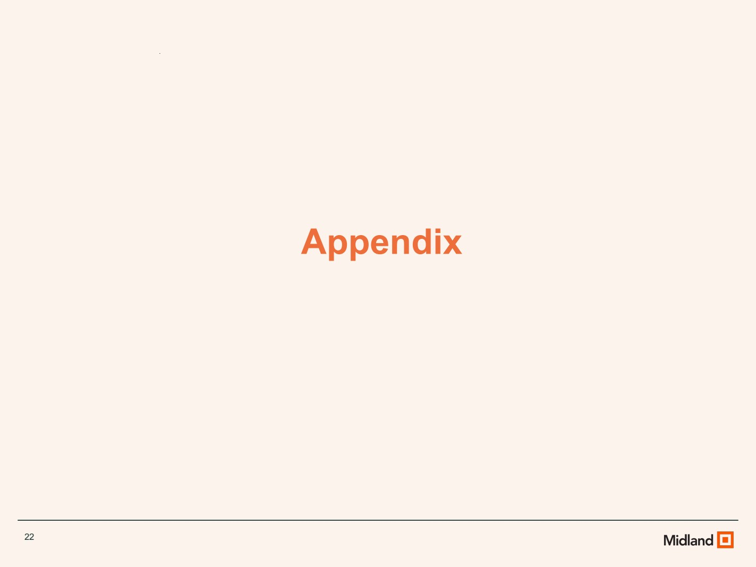 | 22 Appendix
 | 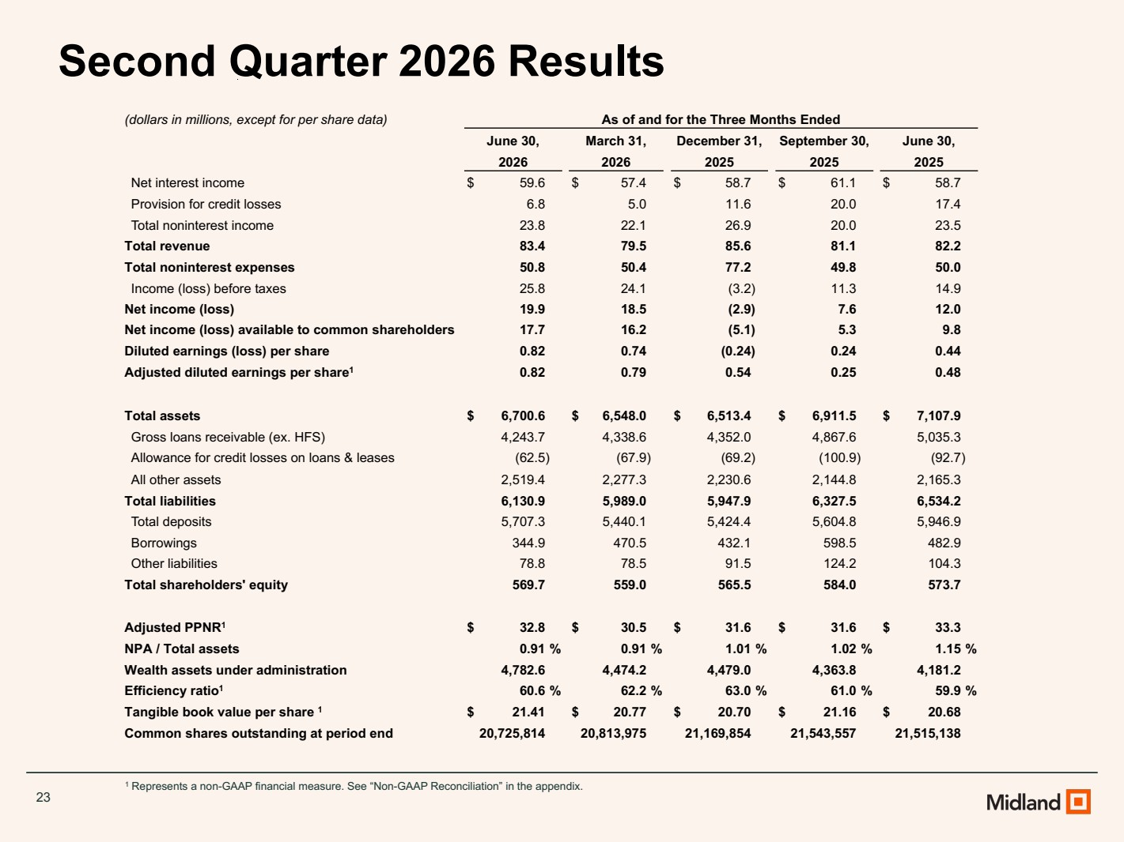 | 23 1 Represents a non-GAAP financial measure. See “Non-GAAP Reconciliation” in the appendix. Second Quarter 2026 Results (dollars in millions, except for per share data) As of and for the Three Months Ended June 30, March 31, December 31, September 30, June 30, 2026 2026 2025 2025 2025 Net interest income $ 59.6 $ 57.4 $ 58.7 $ 61.1 $ 58.7 Provision for credit losses 6.8 5.0 11.6 20.0 17.4 Total noninterest income 23.8 22.1 26.9 20.0 23.5 Total revenue 83.4 79.5 85.6 81.1 82.2 Total noninterest expenses 50.8 50.4 77.2 49.8 50.0 Income (loss) before taxes 25.8 24.1 (3.2) 11.3 14.9 Net income (loss) 19.9 18.5 (2.9) 7.6 12.0 Net income (loss) available to common shareholders 17.7 16.2 (5.1) 5.3 9.8 Diluted earnings (loss) per share 0.82 0.74 (0.24) 0.24 0.44 Adjusted diluted earnings per share1 0.82 0.79 0.54 0.25 0.48 Total assets $ 6,700.6 $ 6,548.0 $ 6,513.4 $ 6,911.5 $ 7,107.9 Gross loans receivable (ex. HFS) 4,243.7 4,338.6 4,352.0 4,867.6 5,035.3 Allowance for credit losses on loans & leases (62.5) (67.9) (69.2) (100.9) (92.7) All other assets 2,519.4 2,277.3 2,230.6 2,144.8 2,165.3 Total liabilities 6,130.9 5,989.0 5,947.9 6,327.5 6,534.2 Total deposits 5,707.3 5,440.1 5,424.4 5,604.8 5,946.9 Borrowings 344.9 470.5 432.1 598.5 482.9 Other liabilities 78.8 78.5 91.5 124.2 104.3 Total shareholders' equity 569.7 559.0 565.5 584.0 573.7 Adjusted PPNR1 $ 32.8 $ 30.5 $ 31.6 $ 31.6 $ 33.3 NPA / Total assets 0.91 % 0.91 % 1.01 % 1.02 % 1.15 % Wealth assets under administration 4,782.6 4,474.2 4,479.0 4,363.8 4,181.2 Efficiency ratio1 60.6 % 62.2 % 63.0 % 61.0 % 59.9 % Tangible book value per share 1 $ 21.41 $ 20.77 $ 20.70 $ 21.16 $ 20.68 Common shares outstanding at period end 20,725,814 20,813,975 21,169,854 21,543,557 21,515,138
 | 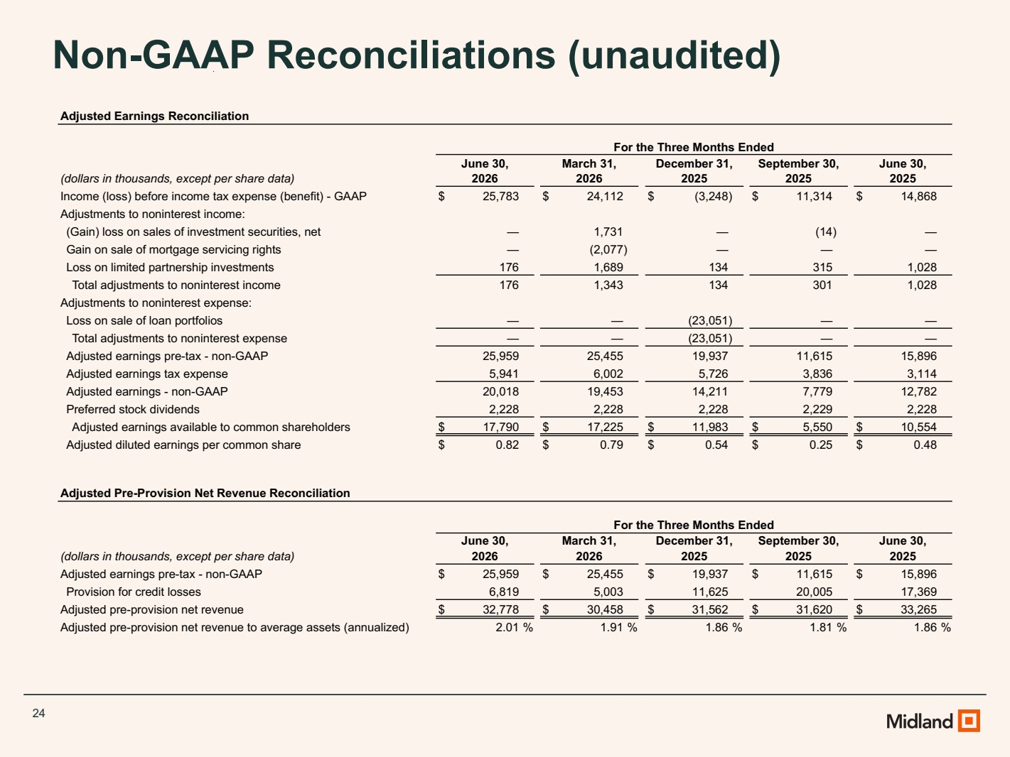 | 24 Non-GAAP Reconciliations (unaudited) Adjusted Earnings Reconciliation For the Three Months Ended June 30, March 31, December 31, September 30, June 30, (dollars in thousands, except per share data) 2026 2026 2025 2025 2025 Income (loss) before income tax expense (benefit) - GAAP $ 25,783 $ 24,112 $ (3,248) $ 11,314 $ 14,868 Adjustments to noninterest income: (Gain) loss on sales of investment securities, net — 1,731 — (14) — Gain on sale of mortgage servicing rights — (2,077) — — — Loss on limited partnership investments 176 1,689 134 315 1,028 Total adjustments to noninterest income 176 1,343 134 301 1,028 Adjustments to noninterest expense: Loss on sale of loan portfolios — — (23,051) — — Total adjustments to noninterest expense — — (23,051) — — Adjusted earnings pre-tax - non-GAAP 25,959 25,455 19,937 11,615 15,896 Adjusted earnings tax expense 5,941 6,002 5,726 3,836 3,114 Adjusted earnings - non-GAAP 20,018 19,453 14,211 7,779 12,782 Preferred stock dividends 2,228 2,228 2,228 2,229 2,228 Adjusted earnings available to common shareholders $ 17,790 $ 17,225 $ 11,983 $ 5,550 $ 10,554 Adjusted diluted earnings per common share $ 0.82 $ 0.79 $ 0.54 $ 0.25 $ 0.48 Adjusted Pre-Provision Net Revenue Reconciliation For the Three Months Ended June 30, March 31, December 31, September 30, June 30, (dollars in thousands, except per share data) 2026 2026 2025 2025 2025 Adjusted earnings pre-tax - non-GAAP $ 25,959 $ 25,455 $ 19,937 $ 11,615 $ 15,896 Provision for credit losses 6,819 5,003 11,625 20,005 17,369 Adjusted pre-provision net revenue $ 32,778 $ 30,458 $ 31,562 $ 31,620 $ 33,265 Adjusted pre-provision net revenue to average assets (annualized) 2.01 % 1.91 % 1.86 % 1.81 % 1.86 %
 | 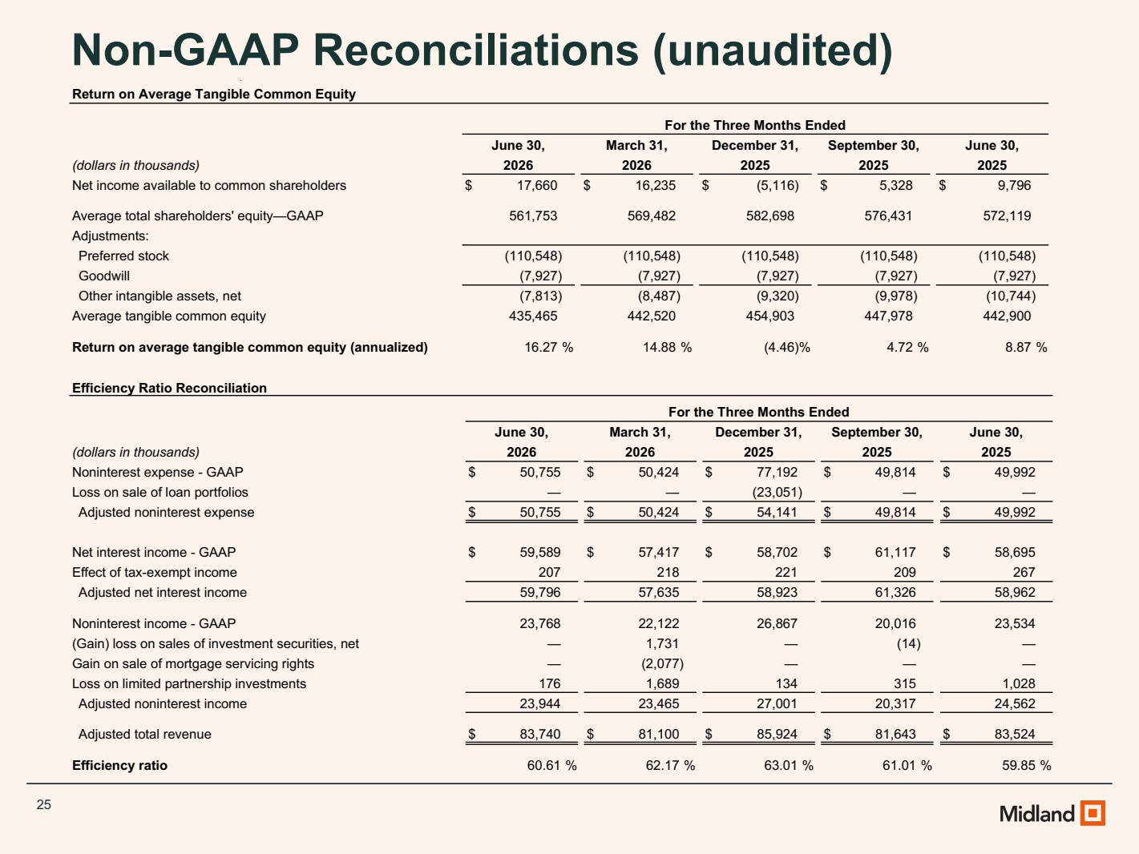 | 25 Non-GAAP Reconciliations (unaudited) Efficiency Ratio Reconciliation For the Three Months Ended June 30, March 31, December 31, September 30, June 30, (dollars in thousands) 2026 2026 2025 2025 2025 Noninterest expense - GAAP $ 50,755 $ 50,424 $ 77,192 $ 49,814 $ 49,992 Loss on sale of loan portfolios — — (23,051) — — Adjusted noninterest expense $ 50,755 $ 50,424 $ 54,141 $ 49,814 $ 49,992 Net interest income - GAAP $ 59,589 $ 57,417 $ 58,702 $ 61,117 $ 58,695 Effect of tax-exempt income 207 218 221 209 267 Adjusted net interest income 59,796 57,635 58,923 61,326 58,962 Noninterest income - GAAP 23,768 22,122 26,867 20,016 23,534 (Gain) loss on sales of investment securities, net — 1,731 — (14) — Gain on sale of mortgage servicing rights — (2,077) — — — Loss on limited partnership investments 176 1,689 134 315 1,028 Adjusted noninterest income 23,944 23,465 27,001 20,317 24,562 Adjusted total revenue $ 83,740 $ 81,100 $ 85,924 $ 81,643 $ 83,524 Efficiency ratio 60.61 % 62.17 % 63.01 % 61.01 % 59.85 % Return on Average Tangible Common Equity For the Three Months Ended June 30, March 31, December 31, September 30, June 30, (dollars in thousands) 2026 2026 2025 2025 2025 Net income available to common shareholders $ 17,660 $ 16,235 $ (5,116) $ 5,328 $ 9,796 Average total shareholders' equity—GAAP 561,753 569,482 582,698 576,431 572,119 Adjustments: Preferred stock (110,548) (110,548) (110,548) (110,548) (110,548) Goodwill (7,927) (7,927) (7,927) (7,927) (7,927) Other intangible assets, net (7,813) (8,487) (9,320) (9,978) (10,744) Average tangible common equity 435,465 442,520 454,903 447,978 442,900 Return on average tangible common equity (annualized) 16.27 % 14.88 % (4.46) % 4.72 % 8.87 %
 | 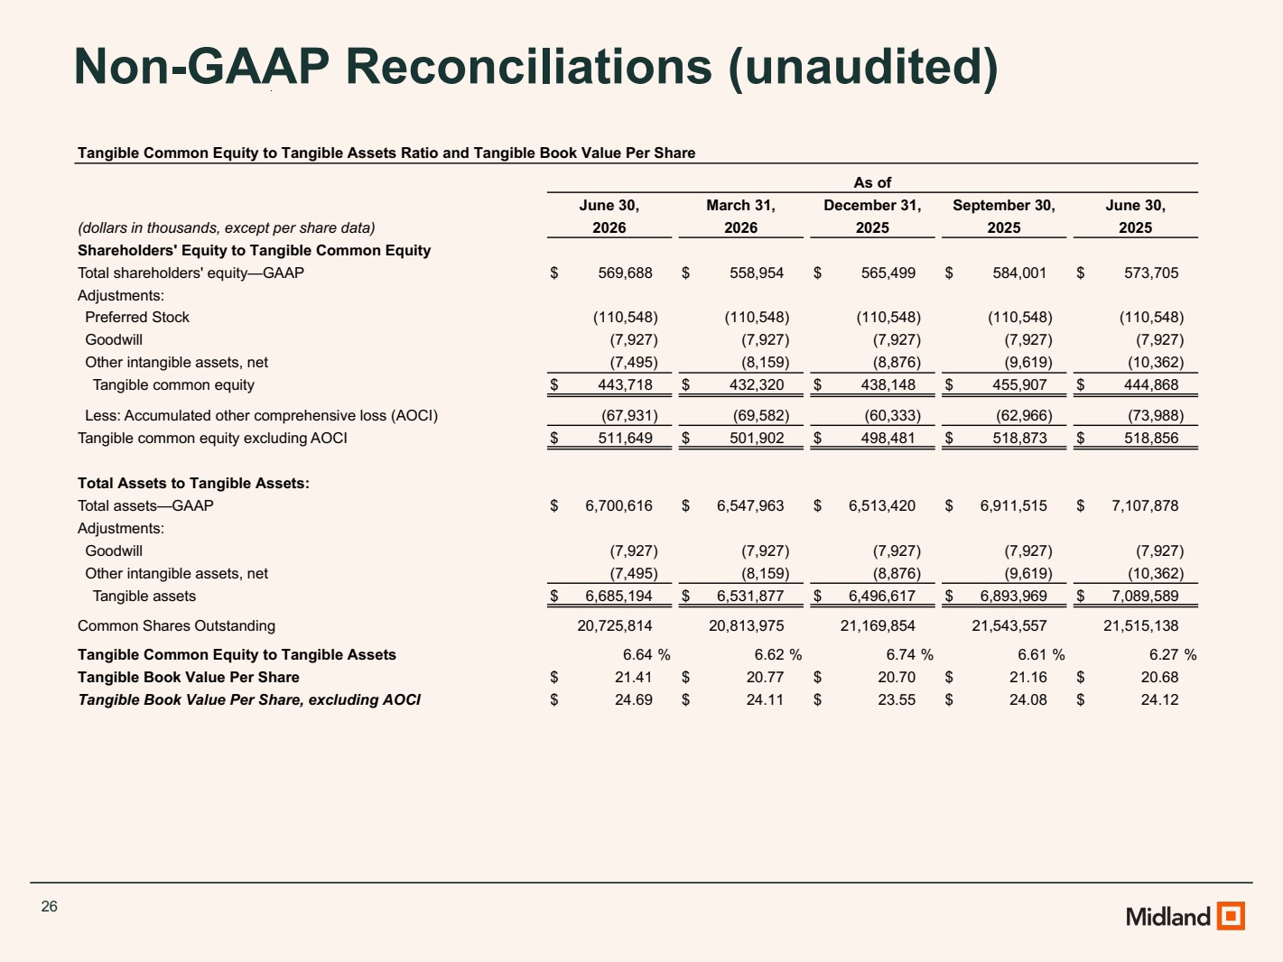 | 26 Non-GAAP Reconciliations (unaudited) Tangible Common Equity to Tangible Assets Ratio and Tangible Book Value Per Share As of June 30, March 31, December 31, September 30, June 30, (dollars in thousands, except per share data) 2026 2026 2025 2025 2025 Shareholders' Equity to Tangible Common Equity Total shareholders' equity—GAAP $ 569,688 $ 558,954 $ 565,499 $ 584,001 $ 573,705 Adjustments: Preferred Stock (110,548) (110,548) (110,548) (110,548) (110,548) Goodwill (7,927) (7,927) (7,927) (7,927) (7,927) Other intangible assets, net (7,495) (8,159) (8,876) (9,619) (10,362) Tangible common equity $ 443,718 $ 432,320 $ 438,148 $ 455,907 $ 444,868 Less: Accumulated other comprehensive loss (AOCI) (67,931) (69,582) (60,333) (62,966) (73,988) Tangible common equity excluding AOCI $ 511,649 $ 501,902 $ 498,481 $ 518,873 $ 518,856 Total Assets to Tangible Assets: Total assets—GAAP $ 6,700,616 $ 6,547,963 $ 6,513,420 $ 6,911,515 $ 7,107,878 Adjustments: Goodwill (7,927) (7,927) (7,927) (7,927) (7,927) Other intangible assets, net (7,495) (8,159) (8,876) (9,619) (10,362) Tangible assets $ 6,685,194 $ 6,531,877 $ 6,496,617 $ 6,893,969 $ 7,089,589 Common Shares Outstanding 20,725,814 20,813,975 21,169,854 21,543,557 21,515,138 Tangible Common Equity to Tangible Assets 6.64 % 6.62 % 6.74 % 6.61 % 6.27 % Tangible Book Value Per Share $ 21.41 $ 20.77 $ 20.70 $ 21.16 $ 20.68 Tangible Book Value Per Share, excluding AOCI $ 24.69 $ 24.11 $ 23.55 $ 24.08 $ 24.12

