UNITED STATES
SECURITIES AND EXCHANGE COMMISSION
WASHINGTON, DC 20549
FORM 8-K
CURRENT REPORT
Pursuant to Section 13 OR 15(d) of the Securities Exchange Act of 1934
Date of Report (Date of earliest event reported): July 23, 2026
Midland States Bancorp, Inc.
(Exact Name of Registrant as Specified in Its Charter)
Illinois |  |  |  |  |  | 001-35272 |  |  |  |  |  | 37-1233196
(State or Other Jurisdiction of Incorporation) |  |  |  |  |  | (Commission File Number) |  |  |  |  |  | (IRS Employer Identification No.)

1201 Network Centre Drive
Effingham, Illinois 62401
(Address of Principal Executive Offices) (Zip Code)

(217) 342-7321
(Registrant’s Telephone Number, Including Area Code)
N/A
(Former Name or Former Address, if Changed Since Last Report)
Check the appropriate box below if the Form 8-K filing is intended to simultaneously satisfy the filing obligation of the registrant under any of the following provisions (see General Instruction A.2. below):
☐ |  |  | Written communications pursuant to Rule 425 under the Securities Act (17 CFR 230.425)
☐ |  |  | Soliciting material pursuant to Rule 14a-12 under the Exchange Act (17 CFR 240.14a-12)
☐ |  |  | Pre-commencement communications pursuant to Rule 14d-2(b) under the Exchange Act (17 CFR 240.14d-2(b))
☐ |  |  | Pre-commencement communications pursuant to Rule 13e-4(c) under the Exchange Act (17 CFR 240.13e-4(c))
Securities registered pursuant to Section 12(b) of the Act:
Title of each class |  |  | Trading symbol(s) |  |  | Name of each exchange on which registered
Common Stock, $0.01 par value |  |  | MSBI |  |  | The Nasdaq Market LLC
Depositary Shares, each representing a 1/40th interest in a share of 7.75% fixed rate reset non-cumulative perpetual preferred stock, Series A, $2.00 par value |  |  | MSBIP |  |  | The Nasdaq Market LLC
Indicate by check mark whether the registrant is an emerging growth company as defined in Rule 405 of the Securities Act of 1933 (§230.405 of this chapter) or Rule 12b-2 of the Securities Exchange Act of 1934 (§240.12b-2 of this chapter).
Emerging growth company ☐
If an emerging growth company, indicate by check mark if the registrant has elected not to use the extended transition period for complying with any new or revised financial accounting standards provided pursuant to Section 13(a) of the Exchange Act. ☐

Item 2.02. Results of Operations and Financial Condition.
On July 23, 2026, Midland States Bancorp, Inc. (the “Company”) issued a press release announcing its financial results for the second quarter of 2026. The press release is attached as Exhibit 99.1.

Item 7.01. Regulation FD Disclosure.
On July 23, 2026, the Company made available on its website a slide presentation regarding the Company’s second quarter 2026 financial results. The slide presentation is attached as Exhibit 99.2.

The information set forth under Items 2.02 and 7.01 in this Form 8-K and the attached exhibits shall not be deemed “filed” for purposes of Section 18 of the Securities Exchange Act of 1934, and shall not be deemed incorporated by reference in any filing under the Securities Act of 1933, except as shall be expressly set forth by specific reference in any such filing.

Item 9.01. Financial Statements and Exhibits.
(d) Exhibits.
Exhibit No. |  |  |  |  |  | Description
99.1 |  |  |  |  |  | Press Release of Midland States Bancorp, Inc., dated July 23, 2026
99.2 |  |  |  |  |  | Slide Presentation of Midland States Bancorp, Inc. regarding second quarter 2026 financial results
104 |  |  |  |  |  | Cover Page Interactive Data File (embedded within the Inline XBRL document)
SIGNATURE
Pursuant to the requirements of the Securities Exchange Act of 1934, the Registrant has duly caused this report to be signed on its behalf by the undersigned thereunto duly authorized.
Date: July 23, 2026 |  |  | By: |  |  | /s/ Claire A. Stack
 |  |  |  |  |  | Claire A. Stack
 |  |  |  |  |  | Chief Financial Officer

EXHIBIT 99.1

Midland States Bancorp, Inc. Announces 2026 Second Quarter Results
Effingham, IL, July 23, 2026 (GLOBE NEWSWIRE) -- Midland States Bancorp, Inc. (Nasdaq: MSBI) (the “Company”) today reported net income available to common shareholders of $17.7 million, or $0.82 per diluted share, for the second quarter of 2026, compared to net income available to common shareholders of $16.2 million, or $0.74 per diluted share, for the first quarter of 2026. This also compares to net income available to common shareholders of $9.8 million, or $0.44 per diluted share, for the second quarter of 2025.

2026 Second Quarter Results

•Net income available to common shareholders of $17.7 million, or $0.82 per diluted share
•Return on average assets of 1.22% and return on average tangible common equity of 16.27%
•Adjusted pre-provision net revenue of $32.8 million, or 2.01% of average assets, compared to $30.5 million, or 1.91% of average assets, for the first quarter of 2026
•Net interest margin of 3.98% compared to 3.91% in the prior quarter
•Community Bank loan portfolio increased $6.3 million, or 0.7% annualized, compared to prior quarter. Total loans decreased $94.9 million, primarily due to anticipated runoff within specialty finance and non-core portfolios.
•Total capital to risk-weighted assets of 15.77% and common equity tier 1 capital of 10.39%
•Ratio of nonperforming assets to total assets of 0.91%, flat compared to prior quarter
Discussion of Outlook; President & Chief Executive Officer, Jeffrey G. Ludwig:
“Our second quarter results demonstrate the continued progress we’ve made transforming Midland into a higher-performing community bank. Core profitability remained strong, our net interest margin expanded, capital increased above our near-term target, and our Community Bank continued to generate growth in deposits and customer relationships while we further simplified our balance sheet through the planned runoff of specialty finance and non-core loan portfolios.

"Net interest margin expansion was driven by favorable loan repricing and continued optimization of our earning assets. Total deposits increased $267 million, while we further reduced our reliance on higher-cost brokered deposits. We also strengthened our capital position, increasing our common equity Tier 1 ratio to 10.4%, while continuing to return capital to shareholders through share repurchases.

"While we recognized a higher charge-off associated with the resolution of a previously identified nonperforming commercial real estate credit, broader credit trends continued to improve, including reductions in past due and substandard loans. Looking ahead, we remain focused on disciplined growth across our Community Bank, expanding our wealth management business following a record quarter, and leveraging our stronger financial position to deliver consistent earnings growth and long-term shareholder value.”
1
Financial Highlights and Key Performance Indicators
 |  |  |  |  |  | As of and for the Three Months Ended
 |  |  |  |  |  | June 30, |  |  |  |  |  | March 31, |  |  |  |  |  | December 31, |  |  |  |  |  | September 30, |  |  |  |  |  | June 30,
(dollars in thousands, except per share data) |  |  |  |  |  | 2026 |  |  |  |  |  | 2026 |  |  |  |  |  | 2025 |  |  |  |  |  | 2025 |  |  |  |  |  | 2025
Diluted earnings (loss) per common share |  |  |  |  |  | $ | 0.82 |  |  |  |  | $ | 0.74 |  |  |  |  | $ | (0.24) |  |  |  |  | $ | 0.24 |  |  |  |  | $ | 0.44
Return on average assets (annualized) |  |  |  |  |  | 1.22 |  | % |  |  |  | 1.16 |  | % |  |  |  | (0.17) |  | % |  |  |  | 0.43 |  | % |  |  |  | 0.67 |  | %
Return on average tangible common equity (annualized) (1) |  |  |  |  |  | 16.27 |  | % |  |  |  | 14.88 |  | % |  |  |  | (4.46) |  | % |  |  |  | 4.72 |  | % |  |  |  | 8.87 |  | %
Adjusted pre-provision net revenue to average assets (annualized) (1) |  |  |  |  |  | 2.01 |  | % |  |  |  | 1.91 |  | % |  |  |  | 1.86 |  | % |  |  |  | 1.81 |  | % |  |  |  | 1.86 |  | %
Net interest margin (annualized) |  |  |  |  |  | 3.98 |  | % |  |  |  | 3.91 |  | % |  |  |  | 3.74 |  | % |  |  |  | 3.79 |  | % |  |  |  | 3.56 |  | %
Efficiency ratio (1) |  |  |  |  |  | 60.61 |  | % |  |  |  | 62.17 |  | % |  |  |  | 63.01 |  | % |  |  |  | 61.01 |  | % |  |  |  | 59.85 |  | %
Noninterest expense to average assets |  |  |  |  |  | 3.12 |  | % |  |  |  | 3.16 |  | % |  |  |  | 4.54 |  | % |  |  |  | 2.86 |  | % |  |  |  | 2.80 |  | %
Net charge-offs to average loans (annualized) |  |  |  |  |  | 1.17 |  | % |  |  |  | 0.64 |  | % |  |  |  | 3.69 |  | % |  |  |  | 0.99 |  | % |  |  |  | 2.34 |  | %
Tangible book value per share at period end (1) |  |  |  |  |  | $ | 21.41 |  |  |  |  | $ | 20.77 |  |  |  |  | $ | 20.70 |  |  |  |  | $ | 21.16 |  |  |  |  | $ | 20.68
Common shares outstanding at period end |  |  |  |  |  | 20,725,814 |  |  |  |  |  | 20,813,975 |  |  |  |  |  | 21,169,854 |  |  |  |  |  | 21,543,557 |  |  |  |  |  | 21,515,138
Trust assets under administration |  |  |  |  |  | $ | 4,782,625 |  |  |  |  | $ | 4,474,234 |  |  |  |  | $ | 4,478,999 |  |  |  |  | $ | 4,363,756 |  |  |  |  | $ | 4,181,180
(1) Non-GAAP financial measures. Refer to pages 10-11 for a reconciliation to the comparable GAAP financial measures.
Key Points for Second Quarter and Outlook
Growth Trends in Community Bank & Wealth Management

•Total loans at June 30, 2026 were $4.24 billion, a decrease of $94.9 million from March 31, 2026, reflecting the continued planned runoff of specialty finance and non-core portfolios, which more than offset Community Bank loan growth. Average loan balances in the Community Bank increased approximately $83 million, or 2.5%, during the quarter, supported by continued commercial loan production and growth in commercial and industrial commitments. Period-end balances were impacted by the timing of several larger fundings shifting into the third quarter and elevated loan payoffs. Key changes in the loan portfolio were as follows:

◦Community Bank balances increased $6.3 million, or 0.7% annualized.

◦Specialty finance loans decreased $81.4 million to $532.1 million from March 31, 2026.

◦Non-core loans, which include our third-party lending and servicing programs and remaining equipment finance portfolio, decreased $19.7 million to $308.4 million from March 31, 2026.

•Total deposits were $5.71 billion at June 30, 2026, an increase of $267.2 million from March 31, 2026. Key changes in deposits were as follows:

◦Retail and commercial deposits increased $98.4 million and $116.4 million, respectively, driven primarily by growth in new accounts as a result of targeted initiatives.

◦Public funds and servicing deposits increased $120.2 million and $23.8 million, respectively.

◦Higher-cost brokered deposits decreased $100.9 million.

2
•Wealth Management revenue totaled $8.8 million in the second quarter of 2026. Assets under administration were $4.78 billion at June 30, 2026, compared to $4.47 billion at March 31, 2026, driven primarily by improved market performance.

Net Interest Margin

•Net interest margin was 3.98%, up seven basis points compared to the first quarter of 2026, driven primarily by a favorable shift in investment securities mix, a one basis point increase in loan yields, and a continued decline in funding costs. The cost of deposits decreased three basis points to 1.78% in the second quarter of 2026, as a result of continued pricing discipline.

The following table presents the Company’s net interest margin for the second quarter of 2026 compared to the first quarter of 2026 and the second quarter of 2025.

 |  |  |  |  |  | For the Three Months Ended
(dollars in thousands) |  |  |  |  |  | June 30, 2026 |  |  |  |  |  |  |  |  |  |  |  |  |  |  |  |  |  | March 31, 2026 |  |  |  |  |  |  |  |  |  |  |  |  |  |  |  |  |  | June 30, 2025
Interest-earning assets |  |  |  |  |  | Average Balance |  |  |  |  |  | Interest & Fees |  |  |  |  |  | Yield/Rate |  |  |  |  |  | Average Balance |  |  |  |  |  | Interest & Fees |  |  |  |  |  | Yield/Rate |  |  |  |  |  | Average Balance |  |  |  |  |  | Interest & Fees |  |  |  |  |  | Yield/Rate
Cash and cash equivalents |  |  |  |  |  | $ | 108,157 |  |  |  |  | $ | 987 |  |  |  |  | 3.66 |  | % |  |  |  | $ | 89,412 |  |  |  |  | $ | 809 |  |  |  |  | 3.67 |  | % |  |  |  | $ | 67,326 |  |  |  |  | $ | 716 |  |  |  |  | 4.27 |  | %
Investment securities (1) |  |  |  |  |  | 1,617,474 |  |  |  |  |  | 19,540 |  |  |  |  |  | 4.85 |  |  |  |  |  | 1,592,433 |  |  |  |  |  | 18,702 |  |  |  |  |  | 4.76 |  |  |  |  |  | 1,367,180 |  |  |  |  |  | 17,164 |  |  |  |  |  | 5.04
Loans (1)(2) |  |  |  |  |  | 4,268,168 |  |  |  |  |  | 67,195 |  |  |  |  |  | 6.31 |  |  |  |  |  | 4,254,321 |  |  |  |  |  | 66,044 |  |  |  |  |  | 6.30 |  |  |  |  |  | 5,123,558 |  |  |  |  |  | 79,240 |  |  |  |  |  | 6.20
Loans held for sale |  |  |  |  |  | 8,431 |  |  |  |  |  | 128 |  |  |  |  |  | 6.10 |  |  |  |  |  | 6,892 |  |  |  |  |  | 102 |  |  |  |  |  | 6.01 |  |  |  |  |  | 44,642 |  |  |  |  |  | 377 |  |  |  |  |  | 3.39
Nonmarketable equity securities |  |  |  |  |  | 30,285 |  |  |  |  |  | 534 |  |  |  |  |  | 7.07 |  |  |  |  |  | 31,547 |  |  |  |  |  | 583 |  |  |  |  |  | 7.50 |  |  |  |  |  | 38,803 |  |  |  |  |  | 694 |  |  |  |  |  | 7.17
Total interest-earning assets |  |  |  |  |  | 6,032,515 |  |  |  |  |  | 88,384 |  |  |  |  |  | 5.88 |  |  |  |  |  | 5,974,605 |  |  |  |  |  | 86,240 |  |  |  |  |  | 5.85 |  |  |  |  |  | 6,641,509 |  |  |  |  |  | 98,191 |  |  |  |  |  | 5.93
Noninterest-earning assets |  |  |  |  |  | 495,663 |  |  |  |  |  |  |  |  |  |  |  |  |  |  |  |  |  | 496,233 |  |  |  |  |  |  |  |  |  |  |  |  |  |  |  |  |  | 513,801
Total assets |  |  |  |  |  | $ | 6,528,178 |  |  |  |  |  |  |  |  |  |  |  |  |  |  |  |  | $ | 6,470,838 |  |  |  |  |  |  |  |  |  |  |  |  |  |  |  |  | $ | 7,155,310
Interest-Bearing Liabilities
Interest-bearing deposits |  |  |  |  |  | $ | 4,512,697 |  |  |  |  | $ | 24,526 |  |  |  |  | 2.18 |  | % |  |  |  | $ | 4,430,873 |  |  |  |  | $ | 24,203 |  |  |  |  | 2.22 |  | % |  |  |  | $ | 4,845,609 |  |  |  |  | $ | 32,290 |  |  |  |  | 2.67 |  | %
Short-term borrowings |  |  |  |  |  | 28,521 |  |  |  |  |  | 202 |  |  |  |  |  | 2.84 |  |  |  |  |  | 33,236 |  |  |  |  |  | 231 |  |  |  |  |  | 2.82 |  |  |  |  |  | 60,117 |  |  |  |  |  | 573 |  |  |  |  |  | 3.82
FHLB advances & other borrowings |  |  |  |  |  | 249,044 |  |  |  |  |  | 2,349 |  |  |  |  |  | 3.78 |  |  |  |  |  | 273,444 |  |  |  |  |  | 2,670 |  |  |  |  |  | 3.96 |  |  |  |  |  | 363,505 |  |  |  |  |  | 3,766 |  |  |  |  |  | 4.16
Subordinated debt |  |  |  |  |  | 27,027 |  |  |  |  |  | 380 |  |  |  |  |  | 5.64 |  |  |  |  |  | 27,022 |  |  |  |  |  | 380 |  |  |  |  |  | 5.70 |  |  |  |  |  | 77,757 |  |  |  |  |  | 1,394 |  |  |  |  |  | 7.19
Trust preferred debentures |  |  |  |  |  | 52,128 |  |  |  |  |  | 1,131 |  |  |  |  |  | 8.70 |  |  |  |  |  | 51,948 |  |  |  |  |  | 1,121 |  |  |  |  |  | 8.75 |  |  |  |  |  | 51,439 |  |  |  |  |  | 1,206 |  |  |  |  |  | 9.40
Total interest-bearing liabilities |  |  |  |  |  | 4,869,417 |  |  |  |  |  | 28,588 |  |  |  |  |  | 2.35 |  |  |  |  |  | 4,816,523 |  |  |  |  |  | 28,605 |  |  |  |  |  | 2.41 |  |  |  |  |  | 5,398,427 |  |  |  |  |  | 39,229 |  |  |  |  |  | 2.91
Noninterest-bearing deposits |  |  |  |  |  | 1,012,592 |  |  |  |  |  |  |  |  |  |  |  |  |  |  |  |  |  | 996,926 |  |  |  |  |  |  |  |  |  |  |  |  |  |  |  |  |  | 1,075,945
Other noninterest-bearing liabilities |  |  |  |  |  | 84,416 |  |  |  |  |  |  |  |  |  |  |  |  |  |  |  |  |  | 87,907 |  |  |  |  |  |  |  |  |  |  |  |  |  |  |  |  |  | 108,819
Shareholders’ equity |  |  |  |  |  | 561,753 |  |  |  |  |  |  |  |  |  |  |  |  |  |  |  |  |  | 569,482 |  |  |  |  |  |  |  |  |  |  |  |  |  |  |  |  |  | 572,119
Total liabilities and shareholders’ equity |  |  |  |  |  | $ | 6,528,178 |  |  |  |  |  |  |  |  |  |  |  |  |  |  |  |  | $ | 6,470,838 |  |  |  |  |  |  |  |  |  |  |  |  |  |  |  |  | $ | 7,155,310
Net Interest Margin |  |  |  |  |  |  |  |  |  |  |  | $ | 59,796 |  |  |  |  | 3.98 |  | % |  |  |  |  |  |  |  |  |  | $ | 57,635 |  |  |  |  | 3.91 |  | % |  |  |  |  |  |  |  |  |  | $ | 58,962 |  |  |  |  | 3.56 |  | %
Cost of Deposits |  |  |  |  |  |  |  |  |  |  |  |  |  |  |  |  |  | 1.78 |  | % |  |  |  |  |  |  |  |  |  |  |  |  |  |  |  | 1.81 |  | % |  |  |  |  |  |  |  |  |  |  |  |  |  |  |  | 2.19 |  | %
(1)Interest income and average rates for tax-exempt loans and investment securities are presented on a tax-equivalent basis, assuming a federal income tax rate of 21%. Tax-equivalent adjustments totaled $0.2 million, $0.2 million, and $0.3 million for the three months ended June 30, 2026, March 31, 2026, and June 30, 2025, respectively.
(2)Average loan balances include nonaccrual loans. Interest income on loans includes amortization of deferred loan fees, net of deferred loan costs.
3
Trends in Noninterest Income and Expense
•Noninterest income was $23.8 million for the second quarter of 2026 compared to $22.1 million for the first quarter of 2026. Noninterest income for the first quarter of 2026 included $2.1 million of gains from the sale of the Company’s residential servicing portfolio and a portion of the Company’s commercial servicing portfolio, losses of $1.7 million from the sale of investment securities, and a $1.7 million loss related to our limited partnership investments. Excluding these transactions, noninterest income for the first quarter of 2026 was $23.5 million.

•Noninterest expense remained relatively flat for the second quarter of 2026 at $50.8 million compared to $50.4 million for the first quarter of 2026.

•Income tax expense was $5.9 million, resulting in an effective tax rate of 22.9% for the second quarter of 2026 compared to 23.4% and 19.1% for the first quarter of 2026 and second quarter of 2025, respectively. We currently expect our effective tax rate to be approximately 23% for the full year, subject to changes in earnings mix, state tax legislation, and other factors.

Continued Progress on Credit Quality
•Loans 30-89 days past due decreased to $11.0 million, or 0.26% of total loans, at June 30, 2026, compared to $20.3 million, or 0.47% of total loans, at March 31, 2026. Substandard accruing loans decreased by $20.4 million to $71.5 million at June 30, 2026.

•Nonperforming loans increased to $60.9 million, or 1.43% of total loans, at June 30, 2026, compared to $58.8 million, or 1.36% of total loans, at March 31, 2026.

•Net charge-offs were $12.5 million for the second quarter of 2026, including an $8.6 million charge-off on a previously identified nonperforming commercial real estate relationship in our Community Bank portfolio. The charge-off reflects the execution of a resolution strategy for the relationship following the borrower’s acceptance of a purchase agreement for the underlying collateral.

•Provision for credit losses on loans was $7.1 million for the second quarter of 2026, driven primarily by the replenishment of reserve balances resulting from the net charge-off activity during the quarter, partially offset by improved credit quality metrics, including favorable past due and delinquency trends, and anticipated continued runoff of our specialty finance and non-core loan portfolios.

•Allowance for credit losses on loans was $62.5 million, or 1.47% of total loans, at June 30, 2026, compared to an allowance of $67.9 million, or 1.56% of total loans, at March 31, 2026.

4
The table below summarizes certain information regarding the Company’s loan portfolio asset quality for the periods presented.
 |  |  |  |  |  | As of and for the Three Months Ended
(dollars in thousands) |  |  |  |  |  | June 30, |  |  |  |  |  | March 31, |  |  |  |  |  | December 31, |  |  |  |  |  | September 30, |  |  |  |  |  | June 30,
 |  |  |  |  |  | 2026 |  |  |  |  |  | 2026 |  |  |  |  |  | 2025 |  |  |  |  |  | 2025 |  |  |  |  |  | 2025
Asset Quality
Loans 30-89 days past due |  |  |  |  |  | $ | 10,984 |  |  |  |  | $ | 20,266 |  |  |  |  | $ | 17,079 |  |  |  |  | $ | 26,019 |  |  |  |  | $ | 40,959
Nonperforming loans |  |  |  |  |  | 60,879 |  |  |  |  |  | 58,791 |  |  |  |  |  | 65,483 |  |  |  |  |  | 68,703 |  |  |  |  |  | 80,112
Nonperforming assets |  |  |  |  |  | 61,235 |  |  |  |  |  | 59,305 |  |  |  |  |  | 66,089 |  |  |  |  |  | 70,369 |  |  |  |  |  | 81,775
Substandard accruing loans |  |  |  |  |  | 71,526 |  |  |  |  |  | 91,963 |  |  |  |  |  | 76,000 |  |  |  |  |  | 78,901 |  |  |  |  |  | 58,478
Net charge-offs |  |  |  |  |  | 12,465 |  |  |  |  |  | 6,747 |  |  |  |  |  | 43,492 |  |  |  |  |  | 12,309 |  |  |  |  |  | 29,855
Loans 30-89 days past due to total loans |  |  |  |  |  | 0.26 |  | % |  |  |  | 0.47 |  | % |  |  |  | 0.39 |  | % |  |  |  | 0.53 |  | % |  |  |  | 0.81 |  | %
Nonperforming loans to total loans |  |  |  |  |  | 1.43 |  | % |  |  |  | 1.36 |  | % |  |  |  | 1.50 |  | % |  |  |  | 1.41 |  | % |  |  |  | 1.59 |  | %
Nonperforming assets to total assets |  |  |  |  |  | 0.91 |  | % |  |  |  | 0.91 |  | % |  |  |  | 1.01 |  | % |  |  |  | 1.02 |  | % |  |  |  | 1.15 |  | %
Allowance for credit losses to total loans |  |  |  |  |  | 1.47 |  | % |  |  |  | 1.56 |  | % |  |  |  | 1.59 |  | % |  |  |  | 2.07 |  | % |  |  |  | 1.84 |  | %
Allowance for credit losses to nonperforming loans |  |  |  |  |  | 102.69 |  | % |  |  |  | 115.45 |  | % |  |  |  | 105.71 |  | % |  |  |  | 146.84 |  | % |  |  |  | 115.70 |  | %
Net charge-offs to average loans (annualized) |  |  |  |  |  | 1.17 |  | % |  |  |  | 0.64 |  | % |  |  |  | 3.69 |  | % |  |  |  | 0.99 |  | % |  |  |  | 2.34 |  | %
Capital
As previously announced, the Company’s board of directors authorized a share repurchase program, pursuant to which the Company was authorized to repurchase up to $45.0 million of its common stock through December 31, 2026. During the second quarter of 2026, the Company repurchased $2.7 million of its common stock (113,208 shares of its common stock at a weighted average price of $24.05), resulting in approximately $24.9 million in remaining repurchase authority under the program.

The Company and Midland States Bank exceeded all regulatory capital requirements under Basel III, and Midland States Bank met the qualifications to be a ‘‘well-capitalized’’ financial institution, as summarized in the following table:
 |  |  | As of June 30, 2026
 |  |  | Midland States Bank |  |  |  |  |  | Midland States Bancorp, Inc. |  |  |  |  |  | Minimum Regulatory Requirements (2)
Total capital to risk-weighted assets |  |  | 14.84% |  |  |  |  |  | 15.77% |  |  |  |  |  | 10.50%
Tier 1 capital to risk-weighted assets |  |  | 13.59% |  |  |  |  |  | 13.97% |  |  |  |  |  | 8.50%
Common equity Tier 1 capital to risk-weighted assets |  |  | 13.59% |  |  |  |  |  | 10.39% |  |  |  |  |  | 7.00%
Tier 1 leverage ratio |  |  | 10.08% |  |  |  |  |  | 10.37% |  |  |  |  |  | 4.00%
Tangible common equity to tangible assets (1) |  |  | N/A |  |  |  |  |  | 6.64% |  |  |  |  |  | N/A
 |  |  | As of March 31, 2026
 |  |  | Midland States Bank |  |  |  |  |  | Midland States Bancorp, Inc. |  |  |  |  |  | Minimum Regulatory Requirements (2)
Total capital to risk-weighted assets |  |  | 14.42% |  |  |  |  |  | 15.27% |  |  |  |  |  | 10.50%
Tier 1 capital to risk-weighted assets |  |  | 13.17% |  |  |  |  |  | 13.48% |  |  |  |  |  | 8.50%
Common equity Tier 1 capital to risk-weighted assets |  |  | 13.17% |  |  |  |  |  | 9.98% |  |  |  |  |  | 7.00%
Tier 1 leverage ratio |  |  | 10.10% |  |  |  |  |  | 10.35% |  |  |  |  |  | 4.00%
Tangible common equity to tangible assets (1) |  |  | N/A |  |  |  |  |  | 6.62% |  |  |  |  |  | N/A

(1) Non-GAAP financial measure. Refer to pages 10-11 for a reconciliation to the comparable GAAP financial measure.
(2) Includes the capital conservation buffer of 2.5%, as applicable.
5
About Midland States Bancorp, Inc.
Midland States Bancorp, Inc. is a community-based financial holding company headquartered in Effingham, Illinois, and is the sole shareholder of Midland States Bank. As of June 30, 2026, the Company had total assets of approximately $6.70 billion, and its Wealth Management Group had assets under administration of approximately $4.78 billion. The Company provides a full range of commercial and consumer banking products and services, merchant credit card services, trust and investment management, insurance and financial planning services. For additional information, visit https://www.midlandsb.com/ or https://www.linkedin.com/company/midland-states-bank.
Non-GAAP Financial Measures
Some of the financial measures included in this press release are not measures calculated in accordance with GAAP.
These non-GAAP financial measures include “Adjusted pre-provision net revenue,” “Adjusted pre-provision net revenue to average assets,” “Adjusted earnings,” “Adjusted earnings available to common shareholders,” “Adjusted diluted earnings per common share,” “Return on average tangible common equity,” “Efficiency ratio,” “Tangible common equity to tangible assets,” and “Tangible book value per share.” The Company believes these non-GAAP financial measures provide both management and investors a more complete understanding of the Company’s profitability and asset profile, and that the tangible asset-based measures are commonly used by investors in evaluating value of financial institutions and their equity securities. These non-GAAP financial measures are supplemental and are not a substitute for any analysis based on GAAP financial measures. Not all companies use the same calculation of these measures; therefore, the measures in this press release may not be comparable to other similarly titled measures as presented by other companies.
Forward-Looking Statements
Readers should note that in addition to the historical information contained herein, this press release includes "forward-looking statements" within the meanings of the Private Securities Litigation Reform Act of 1995, Section 27A of the Securities Act of 1933, as amended, and Section 21E of the Securities Exchange Act of 1934, as amended, including but not limited to statements about the Company’s plans, objectives, future performance, goals and future earnings levels, including currently anticipated levels of noninterest income and operating expenses. These statements are subject to many risks and uncertainties, including changes in interest rates and other general economic, business and political conditions; the impact of federal trade policy, inflation, deposit volatility and potential regulatory developments; the performance of our loan portfolio and our ability to manage credit risk; changes in the financial markets; the effects of armed conflict, including the scope and duration of disruptions in global energy markets relating to war in the Middle East; changes in the business environment resulting from the adoption of artificial intelligence, including fraud and cybersecurity risk; operational risks, including with respect to fraud and information technology; changes in business plans as circumstances warrant; changes to U.S. and state tax laws, regulations and guidance; and other risks detailed from time to time in filings made by the Company with the Securities and Exchange Commission, including the risk factors set forth in our Annual Report on Form 10-K for the year ended December 31, 2025, which are incorporated herein by reference. Readers should note that the forward-looking statements included in this press release are not a guarantee of future events, and that actual events may differ materially from those made in or suggested by the forward-looking statements. Forward-looking statements generally can be identified by the use of forward-looking terminology such as "will," “should,” "propose," "may," "plan," "seek," "expect," "intend," "estimate," "anticipate," "believe," "continue," “outlook,” “trends,” or similar terminology. Any forward-looking statements presented herein are made only as of the date of this press release, and the
6
Company does not undertake any obligation to update or revise any forward-looking statements to reflect changes in assumptions, the occurrence of unanticipated events, or otherwise.
CONTACTS:
Jeffrey G. Ludwig, President and CEO, at jludwig@midlandsb.com or (217) 342-7321
Claire A. Stack, Chief Financial Officer, at cstack@midlandsb.com or (217) 342-7321

MIDLAND STATES BANCORP, INC.
CONSOLIDATED FINANCIAL SUMMARY (unaudited)
 |  |  |  |  |  | As of
 |  |  |  |  |  | June 30, |  |  |  |  |  | March 31, |  |  |  |  |  | December 31, |  |  |  |  |  | September 30, |  |  |  |  |  | June 30,
(dollars in thousands) |  |  |  |  |  | 2026 |  |  |  |  |  | 2026 |  |  |  |  |  | 2025 |  |  |  |  |  | 2025 |  |  |  |  |  | 2025
Assets
Cash and cash equivalents |  |  |  |  |  | $ | 298,747 |  |  |  |  | $ | 113,658 |  |  |  |  | $ | 127,811 |  |  |  |  | $ | 166,147 |  |  |  |  | $ | 176,587
Investment securities |  |  |  |  |  | 1,657,313 |  |  |  |  |  | 1,596,220 |  |  |  |  |  | 1,527,236 |  |  |  |  |  | 1,383,121 |  |  |  |  |  | 1,354,652
Loans |  |  |  |  |  | 4,243,704 |  |  |  |  |  | 4,338,573 |  |  |  |  |  | 4,352,004 |  |  |  |  |  | 4,867,587 |  |  |  |  |  | 5,035,295
Allowance for credit losses on loans |  |  |  |  |  | (62,519) |  |  |  |  |  | (67,875) |  |  |  |  |  | (69,219) |  |  |  |  |  | (100,886) |  |  |  |  |  | (92,690)
Total loans, net |  |  |  |  |  | 4,181,185 |  |  |  |  |  | 4,270,698 |  |  |  |  |  | 4,282,785 |  |  |  |  |  | 4,766,701 |  |  |  |  |  | 4,942,605
Loans held for sale |  |  |  |  |  | 8,944 |  |  |  |  |  | 6,709 |  |  |  |  |  | 7,781 |  |  |  |  |  | 7,535 |  |  |  |  |  | 37,299
Premises and equipment, net |  |  |  |  |  | 82,898 |  |  |  |  |  | 84,169 |  |  |  |  |  | 85,134 |  |  |  |  |  | 86,005 |  |  |  |  |  | 86,240
Other real estate owned |  |  |  |  |  | 356 |  |  |  |  |  | 514 |  |  |  |  |  | 606 |  |  |  |  |  | 393 |  |  |  |  |  | 393
Loan servicing rights, at lower of cost or fair value |  |  |  |  |  | 11,316 |  |  |  |  |  | 11,688 |  |  |  |  |  | 11,932 |  |  |  |  |  | 16,165 |  |  |  |  |  | 16,720
Goodwill |  |  |  |  |  | 7,927 |  |  |  |  |  | 7,927 |  |  |  |  |  | 7,927 |  |  |  |  |  | 7,927 |  |  |  |  |  | 7,927
Other intangible assets, net |  |  |  |  |  | 7,495 |  |  |  |  |  | 8,159 |  |  |  |  |  | 8,876 |  |  |  |  |  | 9,619 |  |  |  |  |  | 10,362
Company-owned life insurance |  |  |  |  |  | 222,757 |  |  |  |  |  | 220,630 |  |  |  |  |  | 218,554 |  |  |  |  |  | 216,494 |  |  |  |  |  | 214,392
Credit enhancement asset |  |  |  |  |  | 13,642 |  |  |  |  |  | 13,476 |  |  |  |  |  | 12,557 |  |  |  |  |  | 5,765 |  |  |  |  |  | 5,800
Other assets |  |  |  |  |  | 208,036 |  |  |  |  |  | 214,115 |  |  |  |  |  | 222,221 |  |  |  |  |  | 245,643 |  |  |  |  |  | 254,901
Total assets |  |  |  |  |  | $ | 6,700,616 |  |  |  |  | $ | 6,547,963 |  |  |  |  | $ | 6,513,420 |  |  |  |  | $ | 6,911,515 |  |  |  |  | $ | 7,107,878
Liabilities and Shareholders' Equity
Noninterest-bearing demand deposits |  |  |  |  |  | $ | 1,010,128 |  |  |  |  | $ | 1,013,808 |  |  |  |  | $ | 1,040,411 |  |  |  |  | $ | 1,015,930 |  |  |  |  | $ | 1,074,212
Interest-bearing deposits |  |  |  |  |  | 4,697,150 |  |  |  |  |  | 4,426,259 |  |  |  |  |  | 4,383,968 |  |  |  |  |  | 4,588,895 |  |  |  |  |  | 4,872,707
Total deposits |  |  |  |  |  | 5,707,278 |  |  |  |  |  | 5,440,067 |  |  |  |  |  | 5,424,379 |  |  |  |  |  | 5,604,825 |  |  |  |  |  | 5,946,919
Short-term borrowings |  |  |  |  |  | 7,645 |  |  |  |  |  | 153,425 |  |  |  |  |  | 60,181 |  |  |  |  |  | 146,766 |  |  |  |  |  | 8,654
FHLB advances |  |  |  |  |  | 258,000 |  |  |  |  |  | 238,000 |  |  |  |  |  | 293,000 |  |  |  |  |  | 373,000 |  |  |  |  |  | 345,000
Subordinated debt |  |  |  |  |  | 27,030 |  |  |  |  |  | 27,024 |  |  |  |  |  | 27,019 |  |  |  |  |  | 27,014 |  |  |  |  |  | 77,759
Trust preferred debentures |  |  |  |  |  | 52,219 |  |  |  |  |  | 52,035 |  |  |  |  |  | 51,857 |  |  |  |  |  | 51,684 |  |  |  |  |  | 51,518
Other liabilities |  |  |  |  |  | 78,756 |  |  |  |  |  | 78,458 |  |  |  |  |  | 91,485 |  |  |  |  |  | 124,225 |  |  |  |  |  | 104,323
Total liabilities |  |  |  |  |  | 6,130,928 |  |  |  |  |  | 5,989,009 |  |  |  |  |  | 5,947,921 |  |  |  |  |  | 6,327,514 |  |  |  |  |  | 6,534,173
Total shareholders’ equity |  |  |  |  |  | 569,688 |  |  |  |  |  | 558,954 |  |  |  |  |  | 565,499 |  |  |  |  |  | 584,001 |  |  |  |  |  | 573,705
Total liabilities and shareholders’ equity |  |  |  |  |  | $ | 6,700,616 |  |  |  |  | $ | 6,547,963 |  |  |  |  | $ | 6,513,420 |  |  |  |  | $ | 6,911,515 |  |  |  |  | $ | 7,107,878
7
MIDLAND STATES BANCORP, INC.
CONSOLIDATED FINANCIAL SUMMARY (unaudited) (continued)
 |  |  |  |  |  | For the Three Months Ended
 |  |  |  |  |  | June 30, |  |  |  |  |  | March 31, |  |  |  |  |  | December 31, |  |  |  |  |  | September 30, |  |  |  |  |  | June 30,
(dollars in thousands, except per share data) |  |  |  |  |  | 2026 |  |  |  |  |  | 2026 |  |  |  |  |  | 2025 |  |  |  |  |  | 2025 |  |  |  |  |  | 2025
Net interest income:
Interest income |  |  |  |  |  | $ | 88,177 |  |  |  |  | $ | 86,022 |  |  |  |  | $ | 92,095 |  |  |  |  | $ | 98,493 |  |  |  |  | $ | 97,924
Interest expense |  |  |  |  |  | 28,588 |  |  |  |  |  | 28,605 |  |  |  |  |  | 33,393 |  |  |  |  |  | 37,376 |  |  |  |  |  | 39,229
Net interest income |  |  |  |  |  | 59,589 |  |  |  |  |  | 57,417 |  |  |  |  |  | 58,702 |  |  |  |  |  | 61,117 |  |  |  |  |  | 58,695
Provision for credit losses:
Provision for credit losses on loans |  |  |  |  |  | 7,109 |  |  |  |  |  | 5,403 |  |  |  |  |  | 11,825 |  |  |  |  |  | 20,505 |  |  |  |  |  | 17,369
Recapture of credit losses on unfunded commitments |  |  |  |  |  | (290) |  |  |  |  |  | (400) |  |  |  |  |  | (200) |  |  |  |  |  | (500) |  |  |  |  |  | —
Total provision for credit losses |  |  |  |  |  | 6,819 |  |  |  |  |  | 5,003 |  |  |  |  |  | 11,625 |  |  |  |  |  | 20,005 |  |  |  |  |  | 17,369
Net interest income after provision for credit losses |  |  |  |  |  | 52,770 |  |  |  |  |  | 52,414 |  |  |  |  |  | 47,077 |  |  |  |  |  | 41,112 |  |  |  |  |  | 41,326
Noninterest income:
Wealth management revenue |  |  |  |  |  | 8,768 |  |  |  |  |  | 8,248 |  |  |  |  |  | 8,272 |  |  |  |  |  | 8,018 |  |  |  |  |  | 7,379
Service charges on deposit accounts |  |  |  |  |  | 3,449 |  |  |  |  |  | 3,355 |  |  |  |  |  | 3,573 |  |  |  |  |  | 3,598 |  |  |  |  |  | 3,351
Interchange revenue |  |  |  |  |  | 3,553 |  |  |  |  |  | 3,528 |  |  |  |  |  | 3,437 |  |  |  |  |  | 3,445 |  |  |  |  |  | 3,463
Residential mortgage banking revenue |  |  |  |  |  | 686 |  |  |  |  |  | 626 |  |  |  |  |  | 690 |  |  |  |  |  | 735 |  |  |  |  |  | 756
Income on company-owned life insurance |  |  |  |  |  | 2,127 |  |  |  |  |  | 2,076 |  |  |  |  |  | 2,060 |  |  |  |  |  | 2,102 |  |  |  |  |  | 2,068
Gain (loss) on sales of investment securities, net |  |  |  |  |  | — |  |  |  |  |  | (1,731) |  |  |  |  |  | — |  |  |  |  |  | 14 |  |  |  |  |  | —
Credit enhancement income (loss) |  |  |  |  |  | 3,081 |  |  |  |  |  | 3,360 |  |  |  |  |  | 6,876 |  |  |  |  |  | (242) |  |  |  |  |  | 3,848
Other income |  |  |  |  |  | 2,104 |  |  |  |  |  | 2,660 |  |  |  |  |  | 1,959 |  |  |  |  |  | 2,346 |  |  |  |  |  | 2,669
Total noninterest income |  |  |  |  |  | 23,768 |  |  |  |  |  | 22,122 |  |  |  |  |  | 26,867 |  |  |  |  |  | 20,016 |  |  |  |  |  | 23,534
Noninterest expense:
Salaries and employee benefits |  |  |  |  |  | 27,354 |  |  |  |  |  | 26,157 |  |  |  |  |  | 25,906 |  |  |  |  |  | 26,393 |  |  |  |  |  | 25,685
Occupancy and equipment |  |  |  |  |  | 4,229 |  |  |  |  |  | 4,535 |  |  |  |  |  | 4,353 |  |  |  |  |  | 4,206 |  |  |  |  |  | 4,166
Data processing |  |  |  |  |  | 6,994 |  |  |  |  |  | 7,065 |  |  |  |  |  | 6,834 |  |  |  |  |  | 7,186 |  |  |  |  |  | 7,035
Professional services |  |  |  |  |  | 1,665 |  |  |  |  |  | 2,242 |  |  |  |  |  | 2,321 |  |  |  |  |  | 2,017 |  |  |  |  |  | 2,792
Amortization of intangible assets |  |  |  |  |  | 664 |  |  |  |  |  | 717 |  |  |  |  |  | 743 |  |  |  |  |  | 743 |  |  |  |  |  | 827
Loss on sale of loan portfolios |  |  |  |  |  | — |  |  |  |  |  | — |  |  |  |  |  | 23,051 |  |  |  |  |  | — |  |  |  |  |  | —
Impairment on leased assets and surrendered assets |  |  |  |  |  | — |  |  |  |  |  | — |  |  |  |  |  | 684 |  |  |  |  |  | — |  |  |  |  |  | —
FDIC insurance |  |  |  |  |  | 781 |  |  |  |  |  | 529 |  |  |  |  |  | 3,739 |  |  |  |  |  | 1,512 |  |  |  |  |  | 1,422
Other expense |  |  |  |  |  | 9,068 |  |  |  |  |  | 9,179 |  |  |  |  |  | 9,561 |  |  |  |  |  | 7,757 |  |  |  |  |  | 8,065
Total noninterest expense |  |  |  |  |  | 50,755 |  |  |  |  |  | 50,424 |  |  |  |  |  | 77,192 |  |  |  |  |  | 49,814 |  |  |  |  |  | 49,992
Income (loss) before income taxes |  |  |  |  |  | 25,783 |  |  |  |  |  | 24,112 |  |  |  |  |  | (3,248) |  |  |  |  |  | 11,314 |  |  |  |  |  | 14,868
Income tax expense (benefit) |  |  |  |  |  | 5,895 |  |  |  |  |  | 5,649 |  |  |  |  |  | (360) |  |  |  |  |  | 3,757 |  |  |  |  |  | 2,844
Net income (loss) |  |  |  |  |  | 19,888 |  |  |  |  |  | 18,463 |  |  |  |  |  | (2,888) |  |  |  |  |  | 7,557 |  |  |  |  |  | 12,024
Preferred stock dividends |  |  |  |  |  | 2,228 |  |  |  |  |  | 2,228 |  |  |  |  |  | 2,228 |  |  |  |  |  | 2,229 |  |  |  |  |  | 2,228
Net income (loss) available to common shareholders |  |  |  |  |  | $ | 17,660 |  |  |  |  | $ | 16,235 |  |  |  |  | $ | (5,116) |  |  |  |  | $ | 5,328 |  |  |  |  | $ | 9,796
Basic earnings (loss) per common share |  |  |  |  |  | $ | 0.82 |  |  |  |  | $ | 0.74 |  |  |  |  | $ | (0.24) |  |  |  |  | $ | 0.24 |  |  |  |  | $ | 0.44
Diluted earnings (loss) per common share |  |  |  |  |  | $ | 0.82 |  |  |  |  | $ | 0.74 |  |  |  |  | $ | (0.24) |  |  |  |  | $ | 0.24 |  |  |  |  | $ | 0.44
Weighted average common shares outstanding |  |  |  |  |  | 21,074,683 |  |  |  |  |  | 21,301,246 |  |  |  |  |  | 21,854,033 |  |  |  |  |  | 21,863,911 |  |  |  |  |  | 21,820,190
Weighted average diluted common shares outstanding |  |  |  |  |  | 21,074,683 |  |  |  |  |  | 21,301,246 |  |  |  |  |  | 21,854,033 |  |  |  |  |  | 21,863,911 |  |  |  |  |  | 21,820,190

8
MIDLAND STATES BANCORP, INC.
CONSOLIDATED FINANCIAL SUMMARY (unaudited)(continued)
 |  |  |  |  |  | As of
 |  |  |  |  |  | June 30, |  |  |  |  |  | March 31, |  |  |  |  |  | December 31, |  |  |  |  |  | September 30, |  |  |  |  |  | June 30,
(dollars in thousands) |  |  |  |  |  | 2026 |  |  |  |  |  | 2026 |  |  |  |  |  | 2025 |  |  |  |  |  | 2025 |  |  |  |  |  | 2025
Loan Portfolio Mix
Commercial loans |  |  |  |  |  | $ | 1,185,730 |  |  |  |  | $ | 1,216,511 |  |  |  |  | $ | 1,178,521 |  |  |  |  | $ | 1,476,533 |  |  |  |  | $ | 1,544,386
Equipment finance leases |  |  |  |  |  | 37,086 |  |  |  |  |  | 43,803 |  |  |  |  |  | 50,981 |  |  |  |  |  | 310,983 |  |  |  |  |  | 347,155
Total commercial loans and leases |  |  |  |  |  | 1,222,816 |  |  |  |  |  | 1,260,314 |  |  |  |  |  | 1,229,502 |  |  |  |  |  | 1,787,516 |  |  |  |  |  | 1,891,541
Commercial real estate |  |  |  |  |  | 2,296,978 |  |  |  |  |  | 2,322,198 |  |  |  |  |  | 2,342,664 |  |  |  |  |  | 2,336,661 |  |  |  |  |  | 2,383,361
Construction and land development |  |  |  |  |  | 243,840 |  |  |  |  |  | 276,469 |  |  |  |  |  | 286,140 |  |  |  |  |  | 260,073 |  |  |  |  |  | 258,729
Residential real estate |  |  |  |  |  | 347,664 |  |  |  |  |  | 344,511 |  |  |  |  |  | 349,623 |  |  |  |  |  | 353,475 |  |  |  |  |  | 361,261
Consumer |  |  |  |  |  | 132,406 |  |  |  |  |  | 135,081 |  |  |  |  |  | 144,075 |  |  |  |  |  | 129,862 |  |  |  |  |  | 140,403
Total loans |  |  |  |  |  | $ | 4,243,704 |  |  |  |  | $ | 4,338,573 |  |  |  |  | $ | 4,352,004 |  |  |  |  | $ | 4,867,587 |  |  |  |  | $ | 5,035,295
Loan Portfolio Segment
Regions
Eastern |  |  |  |  |  | $ | 978,944 |  |  |  |  | $ | 989,596 |  |  |  |  | $ | 972,031 |  |  |  |  | $ | 927,977 |  |  |  |  | $ | 897,348
Northern |  |  |  |  |  | 771,844 |  |  |  |  |  | 758,815 |  |  |  |  |  | 711,702 |  |  |  |  |  | 724,695 |  |  |  |  |  | 753,590
Southern |  |  |  |  |  | 700,937 |  |  |  |  |  | 713,592 |  |  |  |  |  | 729,368 |  |  |  |  |  | 725,892 |  |  |  |  |  | 778,124
St. Louis |  |  |  |  |  | 951,505 |  |  |  |  |  | 934,974 |  |  |  |  |  | 915,126 |  |  |  |  |  | 896,005 |  |  |  |  |  | 884,685
Total Community Bank |  |  |  |  |  | 3,403,230 |  |  |  |  |  | 3,396,977 |  |  |  |  |  | 3,328,227 |  |  |  |  |  | 3,274,569 |  |  |  |  |  | 3,313,747
Specialty finance |  |  |  |  |  | 532,070 |  |  |  |  |  | 613,514 |  |  |  |  |  | 668,183 |  |  |  |  |  | 642,167 |  |  |  |  |  | 670,566
Non-core loan program and other (1) |  |  |  |  |  | 308,404 |  |  |  |  |  | 328,082 |  |  |  |  |  | 355,594 |  |  |  |  |  | 950,851 |  |  |  |  |  | 1,050,982
Total loans |  |  |  |  |  | $ | 4,243,704 |  |  |  |  | $ | 4,338,573 |  |  |  |  | $ | 4,352,004 |  |  |  |  | $ | 4,867,587 |  |  |  |  | $ | 5,035,295
Deposit Portfolio Mix
Noninterest-bearing demand |  |  |  |  |  | $ | 1,010,128 |  |  |  |  | $ | 1,013,808 |  |  |  |  | $ | 1,040,411 |  |  |  |  | $ | 1,015,930 |  |  |  |  | $ | 1,074,212
Interest-bearing:
Checking |  |  |  |  |  | 2,094,880 |  |  |  |  |  | 1,886,212 |  |  |  |  |  | 1,855,215 |  |  |  |  |  | 1,996,501 |  |  |  |  |  | 2,180,717
Money market |  |  |  |  |  | 1,242,303 |  |  |  |  |  | 1,295,781 |  |  |  |  |  | 1,248,942 |  |  |  |  |  | 1,240,885 |  |  |  |  |  | 1,216,357
Savings |  |  |  |  |  | 640,292 |  |  |  |  |  | 495,899 |  |  |  |  |  | 487,742 |  |  |  |  |  | 486,953 |  |  |  |  |  | 511,470
Time |  |  |  |  |  | 694,642 |  |  |  |  |  | 723,055 |  |  |  |  |  | 748,942 |  |  |  |  |  | 804,740 |  |  |  |  |  | 818,813
Brokered time |  |  |  |  |  | 25,033 |  |  |  |  |  | 25,312 |  |  |  |  |  | 43,127 |  |  |  |  |  | 59,816 |  |  |  |  |  | 145,350
Total deposits |  |  |  |  |  | $ | 5,707,278 |  |  |  |  | $ | 5,440,067 |  |  |  |  | $ | 5,424,379 |  |  |  |  | $ | 5,604,825 |  |  |  |  | $ | 5,946,919
Deposit Portfolio by Channel
Retail |  |  |  |  |  | $ | 3,003,073 |  |  |  |  | $ | 2,904,695 |  |  |  |  | $ | 2,823,064 |  |  |  |  | $ | 2,791,085 |  |  |  |  | $ | 2,811,838
Commercial |  |  |  |  |  | 1,325,592 |  |  |  |  |  | 1,209,210 |  |  |  |  |  | 1,193,637 |  |  |  |  |  | 1,248,445 |  |  |  |  |  | 1,145,369
Public Funds |  |  |  |  |  | 576,188 |  |  |  |  |  | 455,982 |  |  |  |  |  | 473,381 |  |  |  |  |  | 605,474 |  |  |  |  |  | 618,172
Wealth & Trust |  |  |  |  |  | 243,549 |  |  |  |  |  | 242,977 |  |  |  |  |  | 265,747 |  |  |  |  |  | 263,765 |  |  |  |  |  | 304,626
Servicing |  |  |  |  |  | 502,335 |  |  |  |  |  | 478,496 |  |  |  |  |  | 498,496 |  |  |  |  |  | 498,892 |  |  |  |  |  | 785,659
Brokered Deposits |  |  |  |  |  | 25,033 |  |  |  |  |  | 125,949 |  |  |  |  |  | 143,192 |  |  |  |  |  | 167,228 |  |  |  |  |  | 248,707
Other |  |  |  |  |  | 31,508 |  |  |  |  |  | 22,758 |  |  |  |  |  | 26,862 |  |  |  |  |  | 29,936 |  |  |  |  |  | 32,548
Total deposits |  |  |  |  |  | $ | 5,707,278 |  |  |  |  | $ | 5,440,067 |  |  |  |  | $ | 5,424,379 |  |  |  |  | $ | 5,604,825 |  |  |  |  | $ | 5,946,919
(1) Non-core loan programs refer to loan portfolios originated through third parties or capital markets, including loans to finance the sale of the GreenSky portfolio, and equipment financing loans and leases.

9
MIDLAND STATES BANCORP, INC.
RECONCILIATIONS OF NON-GAAP FINANCIAL MEASURES (unaudited)
Adjusted Earnings Reconciliation
 |  |  |  |  |  | For the Three Months Ended
 |  |  |  |  |  | June 30, |  |  |  |  |  | March 31, |  |  |  |  |  | December 31, |  |  |  |  |  | September 30, |  |  |  |  |  | June 30,
(dollars in thousands, except per share data) |  |  |  |  |  | 2026 |  |  |  |  |  | 2026 |  |  |  |  |  | 2025 |  |  |  |  |  | 2025 |  |  |  |  |  | 2025
Income (loss) before income tax expense (benefit) - GAAP |  |  |  |  |  | $ | 25,783 |  |  |  |  | $ | 24,112 |  |  |  |  | $ | (3,248) |  |  |  |  | $ | 11,314 |  |  |  |  | $ | 14,868
Adjustments to noninterest income:
(Gain) loss on sales of investment securities, net |  |  |  |  |  | — |  |  |  |  |  | 1,731 |  |  |  |  |  | — |  |  |  |  |  | (14) |  |  |  |  |  | —
Gain on sale of mortgage servicing rights |  |  |  |  |  | — |  |  |  |  |  | (2,077) |  |  |  |  |  | — |  |  |  |  |  | — |  |  |  |  |  | —
Loss on limited partnership investments |  |  |  |  |  | 176 |  |  |  |  |  | 1,689 |  |  |  |  |  | 134 |  |  |  |  |  | 315 |  |  |  |  |  | 1,028
Total adjustments to noninterest income |  |  |  |  |  | 176 |  |  |  |  |  | 1,343 |  |  |  |  |  | 134 |  |  |  |  |  | 301 |  |  |  |  |  | 1,028
Adjustments to noninterest expense:
Loss on sale of loan portfolios |  |  |  |  |  | — |  |  |  |  |  | — |  |  |  |  |  | (23,051) |  |  |  |  |  | — |  |  |  |  |  | —
Total adjustments to noninterest expense |  |  |  |  |  | — |  |  |  |  |  | — |  |  |  |  |  | (23,051) |  |  |  |  |  | — |  |  |  |  |  | —
Adjusted earnings pre-tax - non-GAAP |  |  |  |  |  | 25,959 |  |  |  |  |  | 25,455 |  |  |  |  |  | 19,937 |  |  |  |  |  | 11,615 |  |  |  |  |  | 15,896
Adjusted earnings tax expense |  |  |  |  |  | 5,941 |  |  |  |  |  | 6,002 |  |  |  |  |  | 5,726 |  |  |  |  |  | 3,836 |  |  |  |  |  | 3,114
Adjusted earnings - non-GAAP |  |  |  |  |  | 20,018 |  |  |  |  |  | 19,453 |  |  |  |  |  | 14,211 |  |  |  |  |  | 7,779 |  |  |  |  |  | 12,782
Preferred stock dividends |  |  |  |  |  | 2,228 |  |  |  |  |  | 2,228 |  |  |  |  |  | 2,228 |  |  |  |  |  | 2,229 |  |  |  |  |  | 2,228
Adjusted earnings available to common shareholders |  |  |  |  |  | $ | 17,790 |  |  |  |  | $ | 17,225 |  |  |  |  | $ | 11,983 |  |  |  |  | $ | 5,550 |  |  |  |  | $ | 10,554
Adjusted diluted earnings per common share |  |  |  |  |  | $ | 0.82 |  |  |  |  | $ | 0.79 |  |  |  |  | $ | 0.54 |  |  |  |  | $ | 0.25 |  |  |  |  | $ | 0.48
Adjusted Pre-Provision Net Revenue Reconciliation
 |  |  |  |  |  | For the Three Months Ended
 |  |  |  |  |  | June 30, |  |  |  |  |  | March 31, |  |  |  |  |  | December 31, |  |  |  |  |  | September 30, |  |  |  |  |  | June 30,
(dollars in thousands, except per share data) |  |  |  |  |  | 2026 |  |  |  |  |  | 2026 |  |  |  |  |  | 2025 |  |  |  |  |  | 2025 |  |  |  |  |  | 2025
Adjusted earnings pre-tax - non-GAAP |  |  |  |  |  | $ | 25,959 |  |  |  |  | $ | 25,455 |  |  |  |  | $ | 19,937 |  |  |  |  | $ | 11,615 |  |  |  |  | $ | 15,896
Provision for credit losses |  |  |  |  |  | 6,819 |  |  |  |  |  | 5,003 |  |  |  |  |  | 11,625 |  |  |  |  |  | 20,005 |  |  |  |  |  | 17,369
Adjusted pre-provision net revenue |  |  |  |  |  | $ | 32,778 |  |  |  |  | $ | 30,458 |  |  |  |  | $ | 31,562 |  |  |  |  | $ | 31,620 |  |  |  |  | $ | 33,265
Adjusted pre-provision net revenue to average assets (annualized) |  |  |  |  |  | 2.01 |  | % |  |  |  | 1.91 |  | % |  |  |  | 1.86 |  | % |  |  |  | 1.81 |  | % |  |  |  | 1.86 |  | %
Return on Average Tangible Common Equity
 |  |  |  |  |  | For the Three Months Ended
 |  |  |  |  |  | June 30, |  |  |  |  |  | March 31, |  |  |  |  |  | December 31, |  |  |  |  |  | September 30, |  |  |  |  |  | June 30,
(dollars in thousands) |  |  |  |  |  | 2026 |  |  |  |  |  | 2026 |  |  |  |  |  | 2025 |  |  |  |  |  | 2025 |  |  |  |  |  | 2025
Net income available to common shareholders |  |  |  |  |  | $ | 17,660 |  |  |  |  | $ | 16,235 |  |  |  |  | $ | (5,116) |  |  |  |  | $ | 5,328 |  |  |  |  | $ | 9,796
Average total shareholders' equity—GAAP |  |  |  |  |  | $ | 561,753 |  |  |  |  | $ | 569,482 |  |  |  |  | $ | 582,698 |  |  |  |  | $ | 576,431 |  |  |  |  | $ | 572,119
Adjustments:
Preferred stock |  |  |  |  |  | (110,548) |  |  |  |  |  | (110,548) |  |  |  |  |  | (110,548) |  |  |  |  |  | (110,548) |  |  |  |  |  | (110,548)
Goodwill |  |  |  |  |  | (7,927) |  |  |  |  |  | (7,927) |  |  |  |  |  | (7,927) |  |  |  |  |  | (7,927) |  |  |  |  |  | (7,927)
Other intangible assets, net |  |  |  |  |  | (7,813) |  |  |  |  |  | (8,487) |  |  |  |  |  | (9,320) |  |  |  |  |  | (9,978) |  |  |  |  |  | (10,744)
Average tangible common equity |  |  |  |  |  | $ | 435,465 |  |  |  |  | $ | 442,520 |  |  |  |  | $ | 454,903 |  |  |  |  | $ | 447,978 |  |  |  |  | $ | 442,900
Return on average tangible common equity (annualized) |  |  |  |  |  | 16.27 |  | % |  |  |  | 14.88 |  | % |  |  |  | (4.46) |  | % |  |  |  | 4.72 |  | % |  |  |  | 8.87 |  | %

10
MIDLAND STATES BANCORP, INC.
RECONCILIATIONS OF NON-GAAP FINANCIAL MEASURES (unaudited)(continued)
Efficiency Ratio Reconciliation
 |  |  |  |  |  | For the Three Months Ended
 |  |  |  |  |  | June 30, |  |  |  |  |  | March 31, |  |  |  |  |  | December 31, |  |  |  |  |  | September 30, |  |  |  |  |  | June 30,
(dollars in thousands) |  |  |  |  |  | 2026 |  |  |  |  |  | 2026 |  |  |  |  |  | 2025 |  |  |  |  |  | 2025 |  |  |  |  |  | 2025
Noninterest expense - GAAP |  |  |  |  |  | $ | 50,755 |  |  |  |  | $ | 50,424 |  |  |  |  | $ | 77,192 |  |  |  |  | $ | 49,814 |  |  |  |  | $ | 49,992
Loss on sale of loan portfolios |  |  |  |  |  | — |  |  |  |  |  | — |  |  |  |  |  | (23,051) |  |  |  |  |  | — |  |  |  |  |  | —
Adjusted noninterest expense |  |  |  |  |  | $ | 50,755 |  |  |  |  | $ | 50,424 |  |  |  |  | $ | 54,141 |  |  |  |  | $ | 49,814 |  |  |  |  | $ | 49,992
Net interest income - GAAP |  |  |  |  |  | $ | 59,589 |  |  |  |  | $ | 57,417 |  |  |  |  | $ | 58,702 |  |  |  |  | $ | 61,117 |  |  |  |  | $ | 58,695
Effect of tax-exempt income |  |  |  |  |  | 207 |  |  |  |  |  | 218 |  |  |  |  |  | 221 |  |  |  |  |  | 209 |  |  |  |  |  | 267
Adjusted net interest income |  |  |  |  |  | 59,796 |  |  |  |  |  | 57,635 |  |  |  |  |  | 58,923 |  |  |  |  |  | 61,326 |  |  |  |  |  | 58,962
Noninterest income - GAAP |  |  |  |  |  | 23,768 |  |  |  |  |  | 22,122 |  |  |  |  |  | 26,867 |  |  |  |  |  | 20,016 |  |  |  |  |  | 23,534
(Gain) loss on sales of investment securities, net |  |  |  |  |  | — |  |  |  |  |  | 1,731 |  |  |  |  |  | — |  |  |  |  |  | (14) |  |  |  |  |  | —
Gain on sale of mortgage servicing rights |  |  |  |  |  | — |  |  |  |  |  | (2,077) |  |  |  |  |  | — |  |  |  |  |  | — |  |  |  |  |  | —
Loss on limited partnership investments |  |  |  |  |  | 176 |  |  |  |  |  | 1,689 |  |  |  |  |  | 134 |  |  |  |  |  | 315 |  |  |  |  |  | 1,028
Adjusted noninterest income |  |  |  |  |  | 23,944 |  |  |  |  |  | 23,465 |  |  |  |  |  | 27,001 |  |  |  |  |  | 20,317 |  |  |  |  |  | 24,562
Adjusted total revenue |  |  |  |  |  | $ | 83,740 |  |  |  |  | $ | 81,100 |  |  |  |  | $ | 85,924 |  |  |  |  | $ | 81,643 |  |  |  |  | $ | 83,524
Efficiency ratio |  |  |  |  |  | 60.61 |  | % |  |  |  | 62.17 |  | % |  |  |  | 63.01 |  | % |  |  |  | 61.01 |  | % |  |  |  | 59.85 |  | %

Tangible Common Equity to Tangible Assets Ratio and Tangible Book Value Per Share
 |  |  |  |  |  | As of
 |  |  |  |  |  | June 30, |  |  |  |  |  | March 31, |  |  |  |  |  | December 31, |  |  |  |  |  | September 30, |  |  |  |  |  | June 30,
(dollars in thousands, except per share data) |  |  |  |  |  | 2026 |  |  |  |  |  | 2026 |  |  |  |  |  | 2025 |  |  |  |  |  | 2025 |  |  |  |  |  | 2025
Shareholders' Equity to Tangible Common Equity
Total shareholders' equity—GAAP |  |  |  |  |  | $ | 569,688 |  |  |  |  | $ | 558,954 |  |  |  |  | $ | 565,499 |  |  |  |  | $ | 584,001 |  |  |  |  | $ | 573,705
Adjustments:
Preferred Stock |  |  |  |  |  | (110,548) |  |  |  |  |  | (110,548) |  |  |  |  |  | (110,548) |  |  |  |  |  | (110,548) |  |  |  |  |  | (110,548)
Goodwill |  |  |  |  |  | (7,927) |  |  |  |  |  | (7,927) |  |  |  |  |  | (7,927) |  |  |  |  |  | (7,927) |  |  |  |  |  | (7,927)
Other intangible assets, net |  |  |  |  |  | (7,495) |  |  |  |  |  | (8,159) |  |  |  |  |  | (8,876) |  |  |  |  |  | (9,619) |  |  |  |  |  | (10,362)
Tangible common equity |  |  |  |  |  | $ | 443,718 |  |  |  |  | $ | 432,320 |  |  |  |  | $ | 438,148 |  |  |  |  | $ | 455,907 |  |  |  |  | $ | 444,868
Total Assets to Tangible Assets:
Total assets—GAAP |  |  |  |  |  | $ | 6,700,616 |  |  |  |  | $ | 6,547,963 |  |  |  |  | $ | 6,513,420 |  |  |  |  | $ | 6,911,515 |  |  |  |  | $ | 7,107,878
Adjustments:
Goodwill |  |  |  |  |  | (7,927) |  |  |  |  |  | (7,927) |  |  |  |  |  | (7,927) |  |  |  |  |  | (7,927) |  |  |  |  |  | (7,927)
Other intangible assets, net |  |  |  |  |  | (7,495) |  |  |  |  |  | (8,159) |  |  |  |  |  | (8,876) |  |  |  |  |  | (9,619) |  |  |  |  |  | (10,362)
Tangible assets |  |  |  |  |  | $ | 6,685,194 |  |  |  |  | $ | 6,531,877 |  |  |  |  | $ | 6,496,617 |  |  |  |  | $ | 6,893,969 |  |  |  |  | $ | 7,089,589
Common Shares Outstanding |  |  |  |  |  | 20,725,814 |  |  |  |  |  | 20,813,975 |  |  |  |  |  | 21,169,854 |  |  |  |  |  | 21,543,557 |  |  |  |  |  | 21,515,138
Tangible Common Equity to Tangible Assets |  |  |  |  |  | 6.64 |  | % |  |  |  | 6.62 |  | % |  |  |  | 6.74 |  | % |  |  |  | 6.61 |  | % |  |  |  | 6.27 |  | %
Tangible Book Value Per Share |  |  |  |  |  | $ | 21.41 |  |  |  |  | $ | 20.77 |  |  |  |  | $ | 20.70 |  |  |  |  | $ | 21.16 |  |  |  |  | $ | 20.68


11
Midland States Bancorp, Inc. Second Quarter 2026 Earnings Presentation July 23, 2026

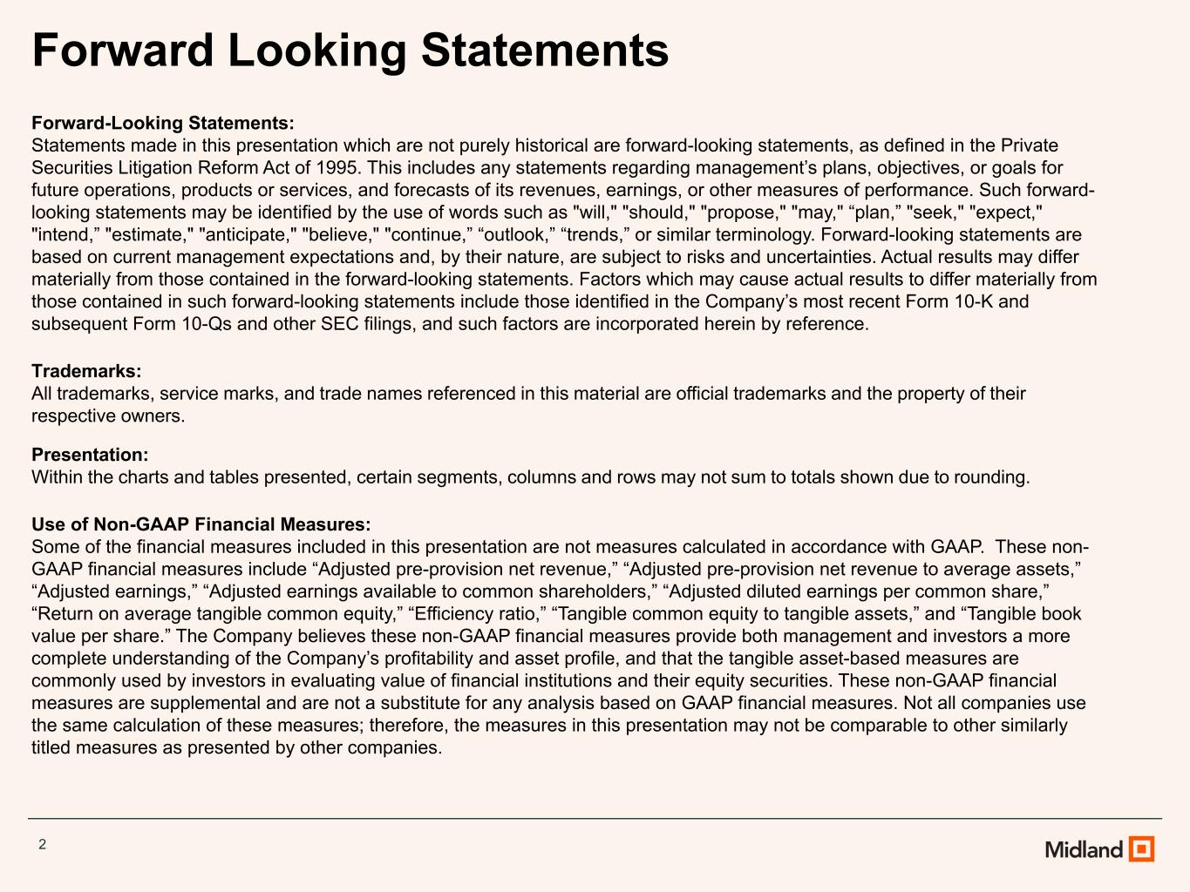
2 Forward Looking Statements Forward-Looking Statements: Statements made in this presentation which are not purely historical are forward-looking statements, as defined in the Private Securities Litigation Reform Act of 1995. This includes any statements regarding management’s plans, objectives, or goals for future operations, products or services, and forecasts of its revenues, earnings, or other measures of performance. Such forward- looking statements may be identified by the use of words such as "will," "should," "propose," "may," “plan,” "seek," "expect," "intend,” "estimate," "anticipate," "believe," "continue,” “outlook,” “trends,” or similar terminology. Forward-looking statements are based on current management expectations and, by their nature, are subject to risks and uncertainties. Actual results may differ materially from those contained in the forward-looking statements. Factors which may cause actual results to differ materially from those contained in such forward-looking statements include those identified in the Company’s most recent Form 10-K and subsequent Form 10-Qs and other SEC filings, and such factors are incorporated herein by reference. Trademarks: All trademarks, service marks, and trade names referenced in this material are official trademarks and the property of their respective owners. Presentation: Within the charts and tables presented, certain segments, columns and rows may not sum to totals shown due to rounding. Use of Non-GAAP Financial Measures: Some of the financial measures included in this presentation are not measures calculated in accordance with GAAP. These non- GAAP financial measures include “Adjusted pre-provision net revenue,” “Adjusted pre-provision net revenue to average assets,” “Adjusted earnings,” “Adjusted earnings available to common shareholders,” “Adjusted diluted earnings per common share,” “Return on average tangible common equity,” “Efficiency ratio,” “Tangible common equity to tangible assets,” and “Tangible book value per share.” The Company believes these non-GAAP financial measures provide both management and investors a more complete understanding of the Company’s profitability and asset profile, and that the tangible asset-based measures are commonly used by investors in evaluating value of financial institutions and their equity securities. These non-GAAP financial measures are supplemental and are not a substitute for any analysis based on GAAP financial measures. Not all companies use the same calculation of these measures; therefore, the measures in this presentation may not be comparable to other similarly titled measures as presented by other companies.

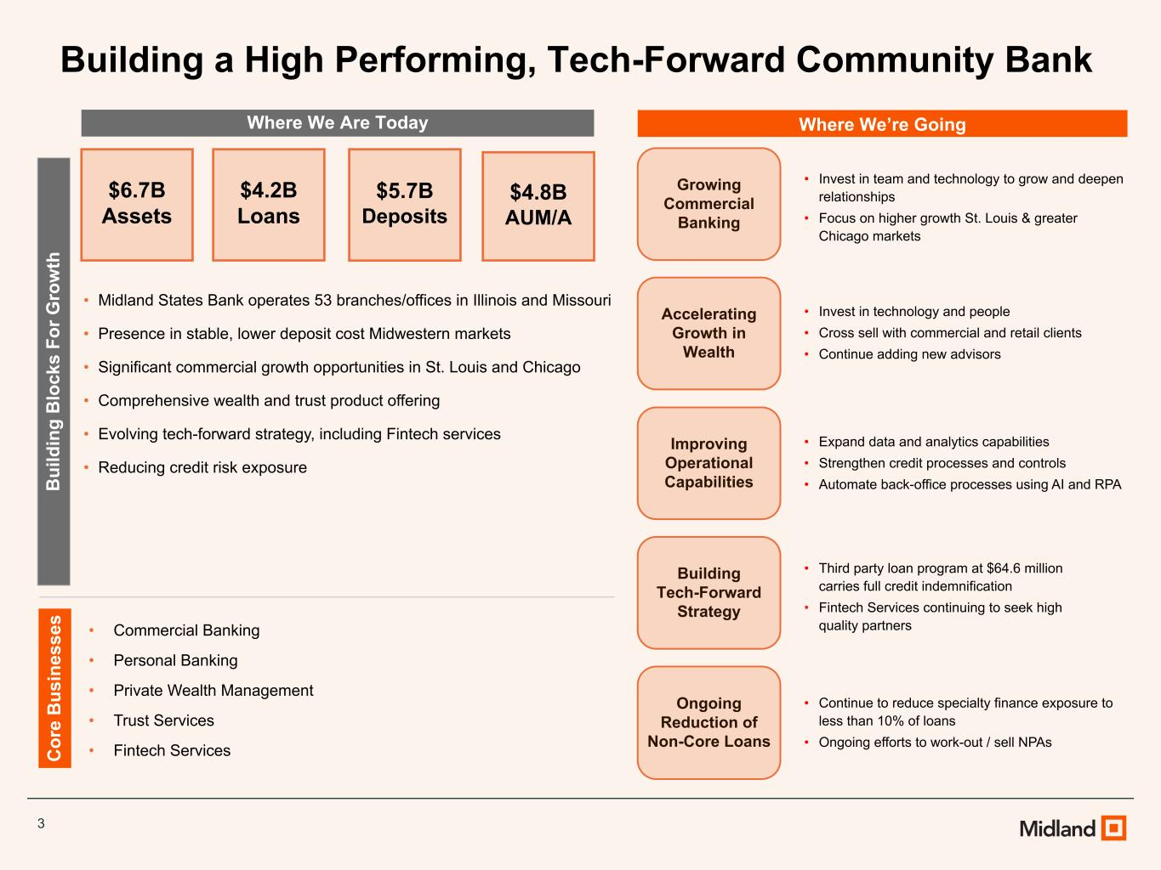
3 Where We Are Today Where We’re Going B ui ld in g B lo ck s Fo r G ro w th C or e B us in es se s • Midland States Bank operates 53 branches/offices in Illinois and Missouri • Presence in stable, lower deposit cost Midwestern markets • Significant commercial growth opportunities in St. Louis and Chicago • Comprehensive wealth and trust product offering • Evolving tech-forward strategy, including Fintech services • Reducing credit risk exposure • Commercial Banking • Personal Banking • Private Wealth Management • Trust Services • Fintech Services Ongoing Reduction of Non-Core Loans Growing Commercial Banking Accelerating Growth in Wealth Improving Operational Capabilities • Continue to reduce specialty finance exposure to less than 10% of loans • Ongoing efforts to work-out / sell NPAs • Invest in team and technology to grow and deepen relationships • Focus on higher growth St. Louis & greater Chicago markets • Invest in technology and people • Cross sell with commercial and retail clients • Continue adding new advisors • Expand data and analytics capabilities • Strengthen credit processes and controls • Automate back-office processes using AI and RPA Building Tech-Forward Strategy • Third party loan program at $64.6 million carries full credit indemnification • Fintech Services continuing to seek high quality partners $6.7B Assets $4.2B Loans $5.7B Deposits $4.8B AUM/A Building a High Performing, Tech-Forward Community Bank

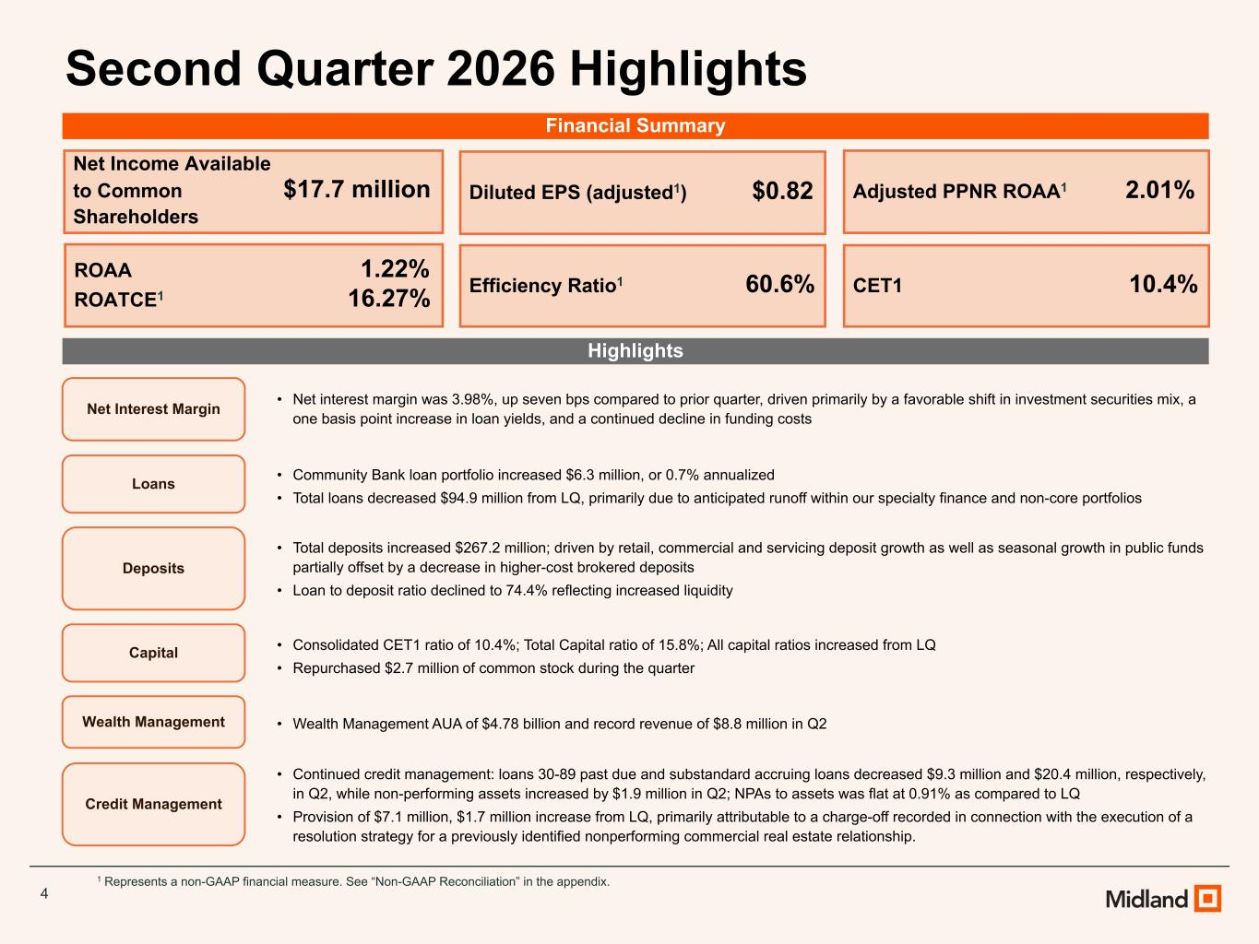
4 Second Quarter 2026 Highlights Highlights 1 Represents a non-GAAP financial measure. See “Non-GAAP Reconciliation” in the appendix. Net Income Available to Common $17.7 million Shareholders Diluted EPS (adjusted1) $0.82 ROAA 1.22% ROATCE1 16.27% Adjusted PPNR ROAA1 2.01% Efficiency Ratio1 60.6% CET1 10.4% Net Interest Margin • Net interest margin was 3.98%, up seven bps compared to prior quarter, driven primarily by a favorable shift in investment securities mix, a one basis point increase in loan yields, and a continued decline in funding costs Loans • Community Bank loan portfolio increased $6.3 million, or 0.7% annualized • Total loans decreased $94.9 million from LQ, primarily due to anticipated runoff within our specialty finance and non-core portfolios Wealth Management • Wealth Management AUA of $4.78 billion and record revenue of $8.8 million in Q2 Credit Management • Continued credit management: loans 30-89 past due and substandard accruing loans decreased $9.3 million and $20.4 million, respectively, in Q2, while non-performing assets increased by $1.9 million in Q2; NPAs to assets was flat at 0.91% as compared to LQ • Provision of $7.1 million, $1.7 million increase from LQ, primarily attributable to a charge-off recorded in connection with the execution of a resolution strategy for a previously identified nonperforming commercial real estate relationship. Deposits • Total deposits increased $267.2 million; driven by retail, commercial and servicing deposit growth as well as seasonal growth in public funds partially offset by a decrease in higher-cost brokered deposits • Loan to deposit ratio declined to 74.4% reflecting increased liquidity Capital • Consolidated CET1 ratio of 10.4%; Total Capital ratio of 15.8%; All capital ratios increased from LQ • Repurchased $2.7 million of common stock during the quarter Financial Summary

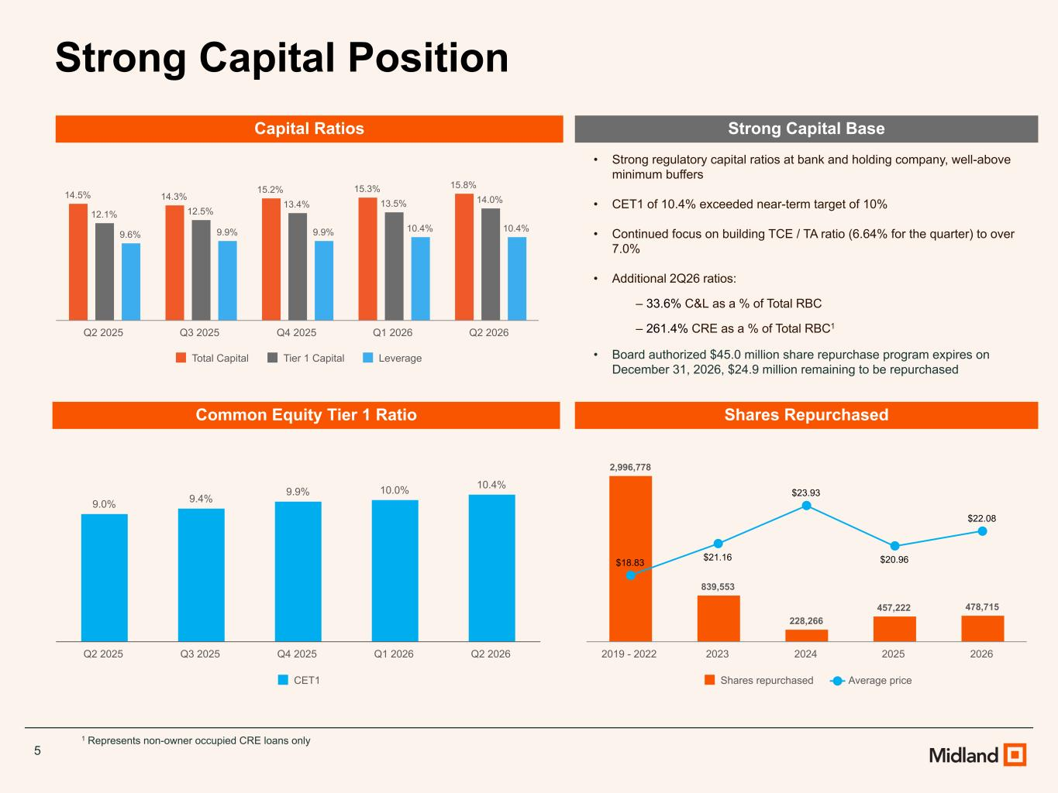
5 Strong Capital Position 14.5% 14.3% 15.2% 15.3% 15.8% 12.1% 12.5% 13.4% 13.5% 14.0% 9.6% 9.9% 9.9% 10.4% 10.4% Total Capital Tier 1 Capital Leverage Q2 2025 Q3 2025 Q4 2025 Q1 2026 Q2 2026 9.0% 9.4% 9.9% 10.0% 10.4% CET1 Q2 2025 Q3 2025 Q4 2025 Q1 2026 Q2 2026 • Strong regulatory capital ratios at bank and holding company, well-above minimum buffers • CET1 of 10.4% exceeded near-term target of 10% • Continued focus on building TCE / TA ratio (6.64% for the quarter) to over 7.0% • Additional 2Q26 ratios: ‒ 33.6% C&L as a % of Total RBC ‒ 261.4% CRE as a % of Total RBC1 • Board authorized $45.0 million share repurchase program expires on December 31, 2026, $24.9 million remaining to be repurchased Capital Ratios Common Equity Tier 1 Ratio Strong Capital Base 1 Represents non-owner occupied CRE loans only Shares Repurchased 2,996,778 839,553 228,266 457,222 478,715 $18.83 $21.16 $23.93 $20.96 $22.08 Shares repurchased Average price 2019 - 2022 2023 2024 2025 2026

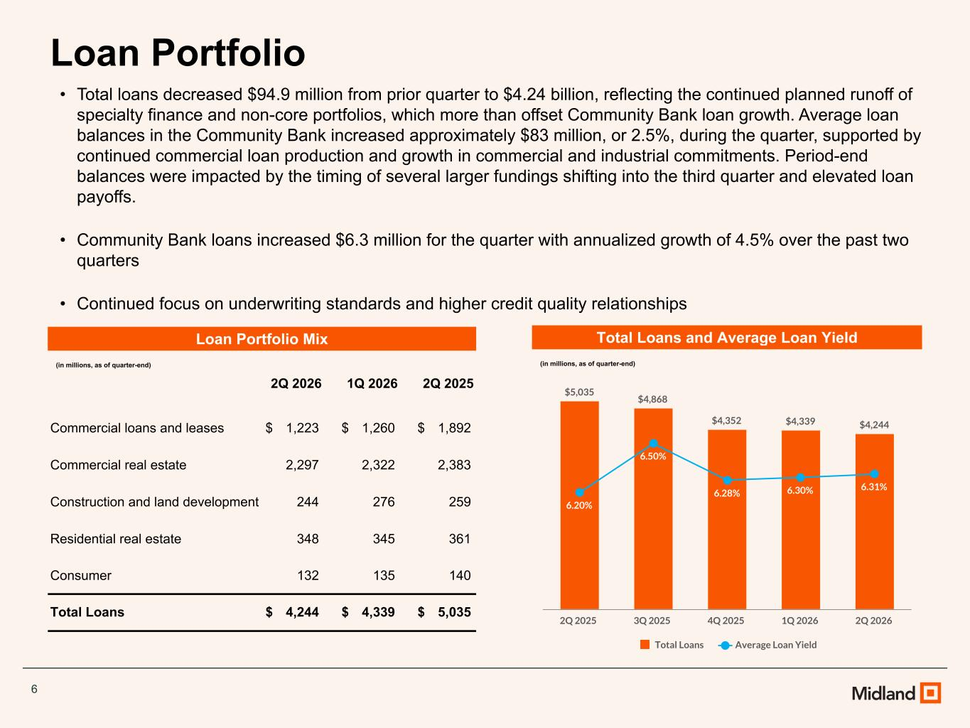
6 Loan Portfolio Total Loans and Average Loan Yield (in millions, as of quarter-end) • Total loans decreased $94.9 million from prior quarter to $4.24 billion, reflecting the continued planned runoff of specialty finance and non-core portfolios, which more than offset Community Bank loan growth. Average loan balances in the Community Bank increased approximately $83 million, or 2.5%, during the quarter, supported by continued commercial loan production and growth in commercial and industrial commitments. Period-end balances were impacted by the timing of several larger fundings shifting into the third quarter and elevated loan payoffs. • Community Bank loans increased $6.3 million for the quarter with annualized growth of 4.5% over the past two quarters • Continued focus on underwriting standards and higher credit quality relationships Loan Portfolio Mix (in millions, as of quarter-end) 2Q 2026 1Q 2026 2Q 2025 Commercial loans and leases $ 1,223 $ 1,260 $ 1,892 Commercial real estate 2,297 2,322 2,383 Construction and land development 244 276 259 Residential real estate 348 345 361 Consumer 132 135 140 Total Loans $ 4,244 $ 4,339 $ 5,035 $5,035 $4,868 $4,352 $4,339 $4,244 6.20% 6.50% 6.28% 6.30% 6.31% Total Loans Average Loan Yield 2Q 2025 3Q 2025 4Q 2025 1Q 2026 2Q 2026

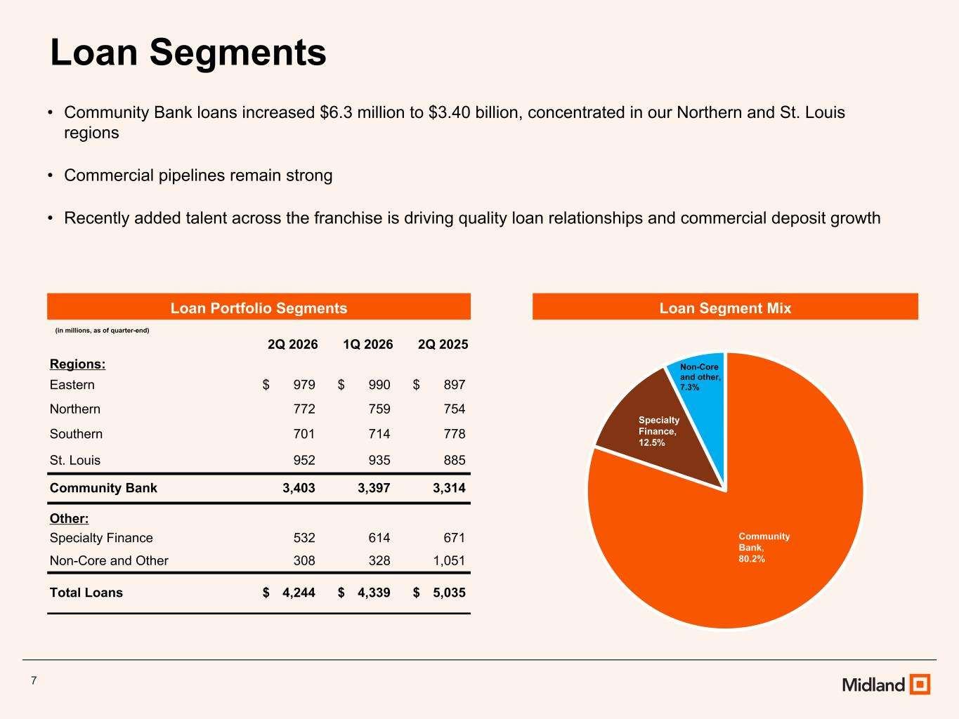
7 Loan Segments Loan Segment Mix • Community Bank loans increased $6.3 million to $3.40 billion, concentrated in our Northern and St. Louis regions • Commercial pipelines remain strong • Recently added talent across the franchise is driving quality loan relationships and commercial deposit growth Loan Portfolio Segments (in millions, as of quarter-end) 2Q 2026 1Q 2026 2Q 2025 Regions: Eastern $ 979 $ 990 $ 897 Northern 772 759 754 Southern 701 714 778 St. Louis 952 935 885 Community Bank 3,403 3,397 3,314 Other: Specialty Finance 532 614 671 Non-Core and Other 308 328 1,051 Total Loans $ 4,244 $ 4,339 $ 5,035 Community Bank, 80.2% Specialty Finance, 12.5% Non-Core and other, 7.3%

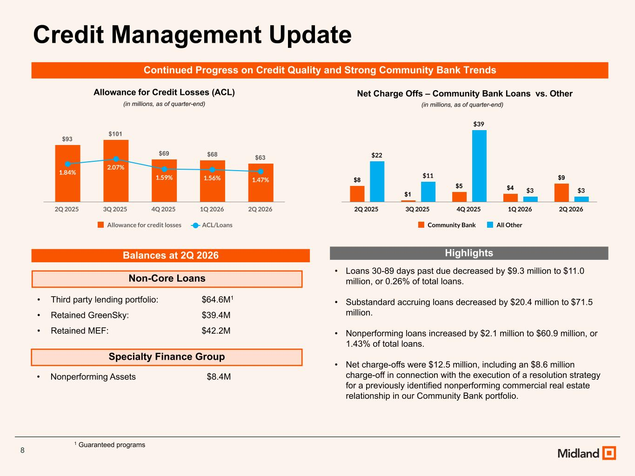
8 Credit Management Update Non-Core Loans Specialty Finance Group • Third party lending portfolio: $64.6M1 • Retained GreenSky: $39.4M • Retained MEF: $42.2M • Nonperforming Assets $8.4M 1 Guaranteed programs Balances at 2Q 2026 Allowance for Credit Losses (ACL) Net Charge Offs – Community Bank Loans vs. Other (in millions, as of quarter-end)(in millions, as of quarter-end) $93 $101 $69 $68 $63 1.84% 2.07% 1.59% 1.56% 1.47% Allowance for credit losses ACL/Loans 2Q 2025 3Q 2025 4Q 2025 1Q 2026 2Q 2026 $8 $1 $5 $4 $9 $22 $11 $39 $3 $3 Community Bank All Other 2Q 2025 3Q 2025 4Q 2025 1Q 2026 2Q 2026 Continued Progress on Credit Quality and Strong Community Bank Trends Highlights • Loans 30-89 days past due decreased by $9.3 million to $11.0 million, or 0.26% of total loans. • Substandard accruing loans decreased by $20.4 million to $71.5 million. • Nonperforming loans increased by $2.1 million to $60.9 million, or 1.43% of total loans. • Net charge-offs were $12.5 million, including an $8.6 million charge-off in connection with the execution of a resolution strategy for a previously identified nonperforming commercial real estate relationship in our Community Bank portfolio.

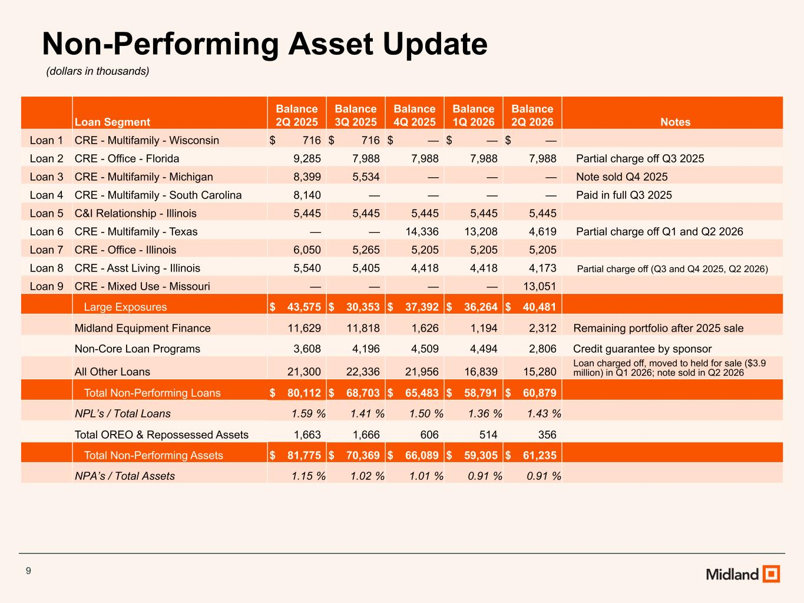
9 Non-Performing Asset Update (dollars in thousands) Loan Segment Balance 2Q 2025 Balance 3Q 2025 Balance 4Q 2025 Balance 1Q 2026 Balance 2Q 2026 Notes Loan 1 CRE - Multifamily - Wisconsin $ 716 $ 716 $ — $ — $ — Loan 2 CRE - Office - Florida 9,285 7,988 7,988 7,988 7,988 Partial charge off Q3 2025 Loan 3 CRE - Multifamily - Michigan 8,399 5,534 — — — Note sold Q4 2025 Loan 4 CRE - Multifamily - South Carolina 8,140 — — — — Paid in full Q3 2025 Loan 5 C&I Relationship - Illinois 5,445 5,445 5,445 5,445 5,445 Loan 6 CRE - Multifamily - Texas — — 14,336 13,208 4,619 Partial charge off Q1 and Q2 2026 Loan 7 CRE - Office - Illinois 6,050 5,265 5,205 5,205 5,205 Loan 8 CRE - Asst Living - Illinois 5,540 5,405 4,418 4,418 4,173 Partial charge off (Q3 and Q4 2025, Q2 2026) Loan 9 CRE - Mixed Use - Missouri — — — — 13,051 Large Exposures $ 43,575 $ 30,353 $ 37,392 $ 36,264 $ 40,481 Midland Equipment Finance 11,629 11,818 1,626 1,194 2,312 Remaining portfolio after 2025 sale Non-Core Loan Programs 3,608 4,196 4,509 4,494 2,806 Credit guarantee by sponsor All Other Loans 21,300 22,336 21,956 16,839 15,280 Loan charged off, moved to held for sale ($3.9 million) in Q1 2026; note sold in Q2 2026 Total Non-Performing Loans $ 80,112 $ 68,703 $ 65,483 $ 58,791 $ 60,879 NPL’s / Total Loans 1.59 % 1.41 % 1.50 % 1.36 % 1.43 % Total OREO & Repossessed Assets 1,663 1,666 606 514 356 Total Non-Performing Assets $ 81,775 $ 70,369 $ 66,089 $ 59,305 $ 61,235 NPA’s / Total Assets 1.15 % 1.02 % 1.01 % 0.91 % 0.91 %

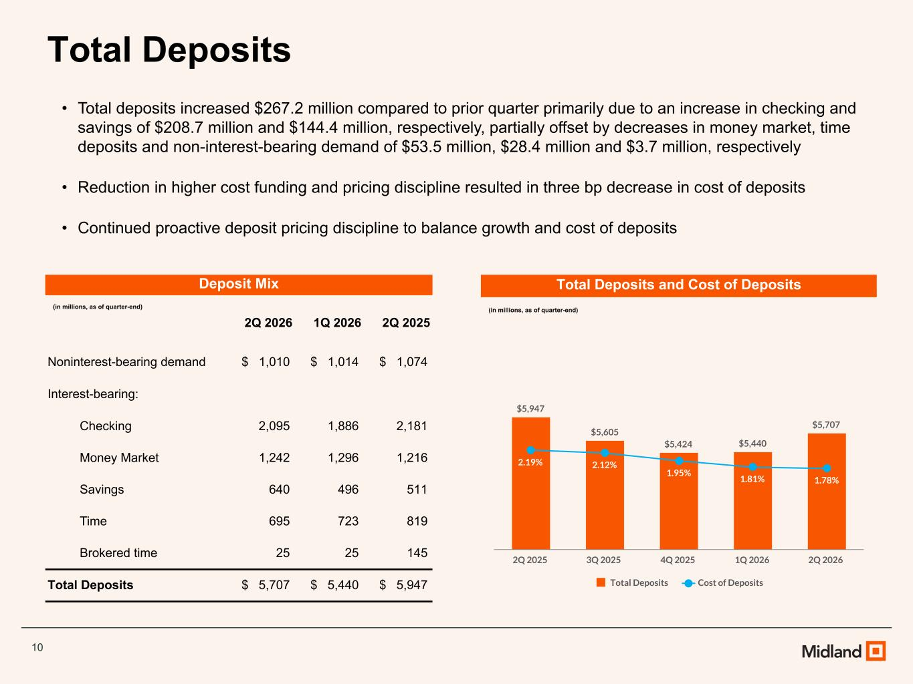
10 Total Deposits • Total deposits increased $267.2 million compared to prior quarter primarily due to an increase in checking and savings of $208.7 million and $144.4 million, respectively, partially offset by decreases in money market, time deposits and non-interest-bearing demand of $53.5 million, $28.4 million and $3.7 million, respectively • Reduction in higher cost funding and pricing discipline resulted in three bp decrease in cost of deposits • Continued proactive deposit pricing discipline to balance growth and cost of deposits Deposit Mix (in millions, as of quarter-end) 2Q 2026 1Q 2026 2Q 2025 Noninterest-bearing demand $ 1,010 $ 1,014 $ 1,074 Interest-bearing: Checking 2,095 1,886 2,181 Money Market 1,242 1,296 1,216 Savings 640 496 511 Time 695 723 819 Brokered time 25 25 145 Total Deposits $ 5,707 $ 5,440 $ 5,947 Total Deposits and Cost of Deposits (in millions, as of quarter-end) $5,947 $5,605 $5,424 $5,440 $5,707 2.19% 2.12% 1.95% 1.81% 1.78% Total Deposits Cost of Deposits 2Q 2025 3Q 2025 4Q 2025 1Q 2026 2Q 2026

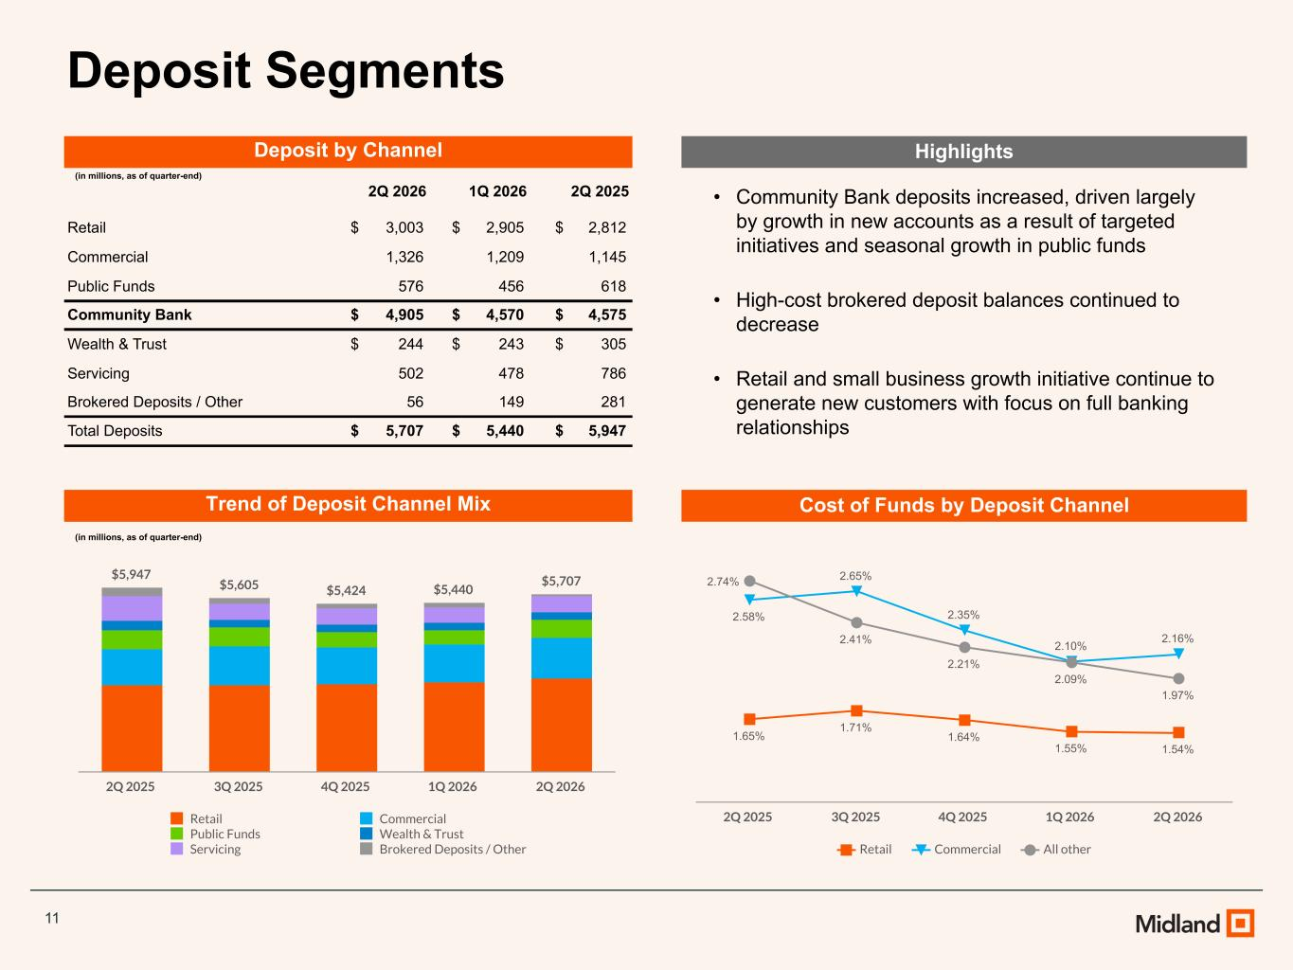
11 Deposit Segments • Community Bank deposits increased, driven largely by growth in new accounts as a result of targeted initiatives and seasonal growth in public funds • High-cost brokered deposit balances continued to decrease • Retail and small business growth initiative continue to generate new customers with focus on full banking relationships Deposit by Channel (in millions, as of quarter-end) 2Q 2026 1Q 2026 2Q 2025 Retail $ 3,003 $ 2,905 $ 2,812 Commercial 1,326 1,209 1,145 Public Funds 576 456 618 Community Bank $ 4,905 $ 4,570 $ 4,575 Wealth & Trust $ 244 $ 243 $ 305 Servicing 502 478 786 Brokered Deposits / Other 56 149 281 Total Deposits $ 5,707 $ 5,440 $ 5,947 Trend of Deposit Channel Mix (in millions, as of quarter-end) $5,947 $5,605 $5,424 $5,440 $5,707 Retail Commercial Public Funds Wealth & Trust Servicing Brokered Deposits / Other 2Q 2025 3Q 2025 4Q 2025 1Q 2026 2Q 2026 Highlights Cost of Funds by Deposit Channel 1.65% 1.71% 1.64% 1.55% 1.54% 2.58% 2.65% 2.35% 2.10% 2.16% 2.74% 2.41% 2.21% 2.09% 1.97% Retail Commercial All other 2Q 2025 3Q 2025 4Q 2025 1Q 2026 2Q 2026

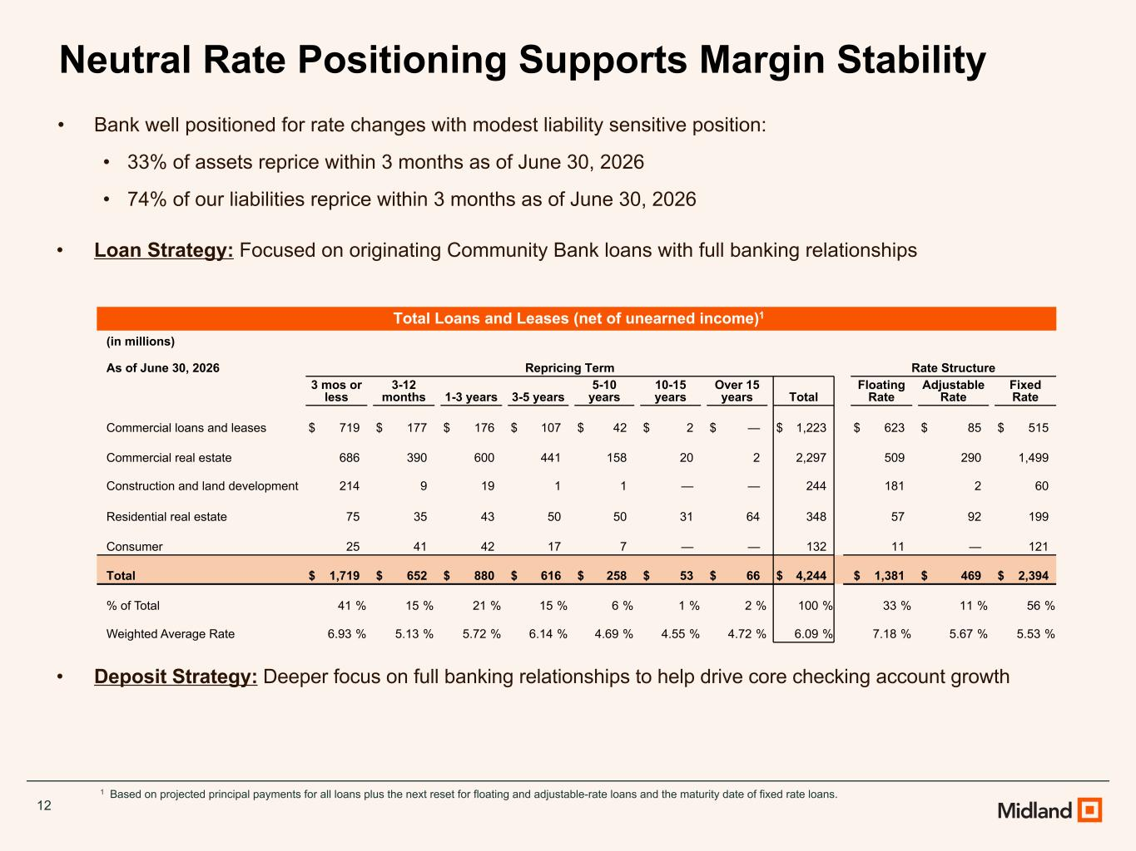
12 Neutral Rate Positioning Supports Margin Stability • Bank well positioned for rate changes with modest liability sensitive position: • 33% of assets reprice within 3 months as of June 30, 2026 • 74% of our liabilities reprice within 3 months as of June 30, 2026 • Loan Strategy: Focused on originating Community Bank loans with full banking relationships • Deposit Strategy: Deeper focus on full banking relationships to help drive core checking account growth 1 Based on projected principal payments for all loans plus the next reset for floating and adjustable-rate loans and the maturity date of fixed rate loans. Total Loans and Leases (net of unearned income)1 (in millions) As of June 30, 2026 Repricing Term Rate Structure 3 mos or less 3-12 months 1-3 years 3-5 years 5-10 years 10-15 years Over 15 years Total Floating Rate Adjustable Rate Fixed Rate Commercial loans and leases $ 719 $ 177 $ 176 $ 107 $ 42 $ 2 $ — $ 1,223 $ 623 $ 85 $ 515 Commercial real estate 686 390 600 441 158 20 2 2,297 509 290 1,499 Construction and land development 214 9 19 1 1 — — 244 181 2 60 Residential real estate 75 35 43 50 50 31 64 348 57 92 199 Consumer 25 41 42 17 7 — — 132 11 — 121 Total $ 1,719 $ 652 $ 880 $ 616 $ 258 $ 53 $ 66 $ 4,244 $ 1,381 $ 469 $ 2,394 % of Total 41 % 15 % 21 % 15 % 6 % 1 % 2 % 100 % 33 % 11 % 56 % Weighted Average Rate 6.93 % 5.13 % 5.72 % 6.14 % 4.69 % 4.55 % 4.72 % 6.09 % 7.18 % 5.67 % 5.53 %

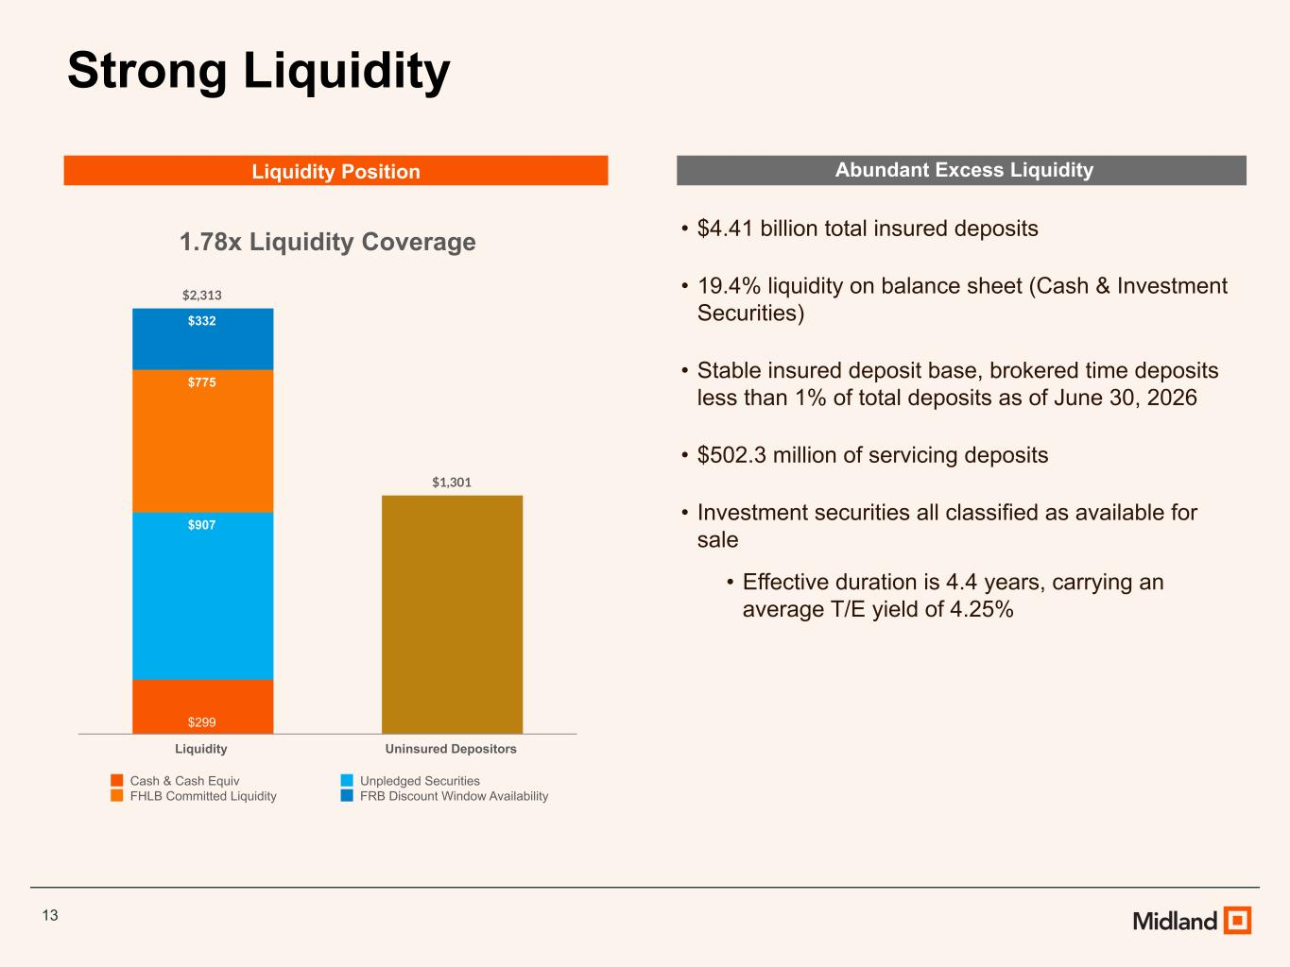
13 Strong Liquidity Abundant Excess Liquidity • $4.41 billion total insured deposits • 19.4% liquidity on balance sheet (Cash & Investment Securities) • Stable insured deposit base, brokered time deposits less than 1% of total deposits as of June 30, 2026 • $502.3 million of servicing deposits • Investment securities all classified as available for sale • Effective duration is 4.4 years, carrying an average T/E yield of 4.25% 1.78x Liquidity Coverage $2,313 $1,301 $299 $907 $775 $332 Cash & Cash Equiv Unpledged Securities FHLB Committed Liquidity FRB Discount Window Availability Liquidity Uninsured Depositors Liquidity Position

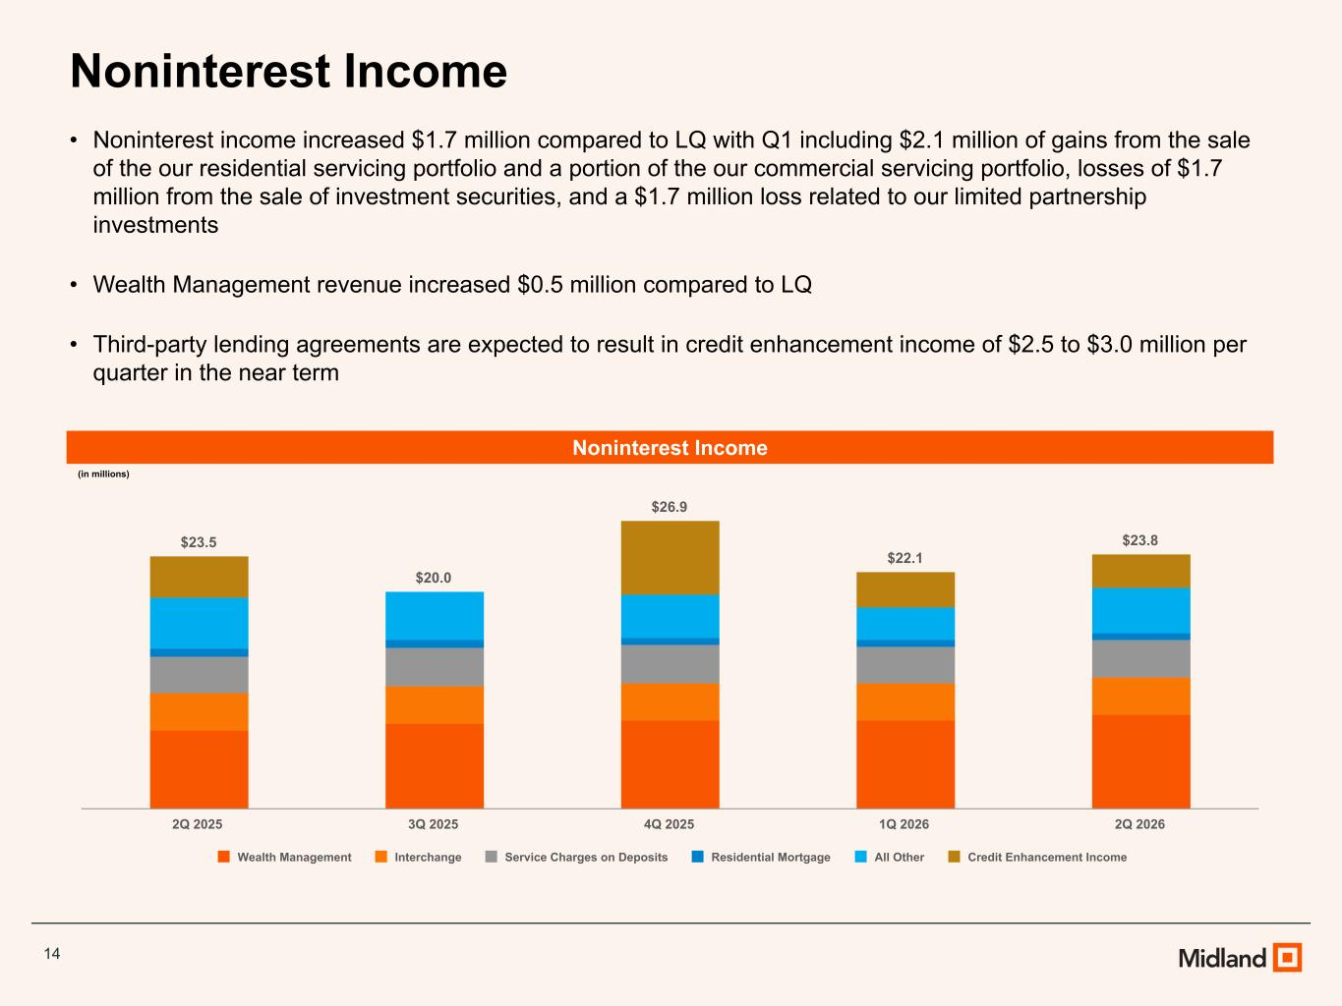
14 Noninterest Income • Noninterest income increased $1.7 million compared to LQ with Q1 including $2.1 million of gains from the sale of the our residential servicing portfolio and a portion of the our commercial servicing portfolio, losses of $1.7 million from the sale of investment securities, and a $1.7 million loss related to our limited partnership investments • Wealth Management revenue increased $0.5 million compared to LQ • Third-party lending agreements are expected to result in credit enhancement income of $2.5 to $3.0 million per quarter in the near term Noninterest Income (in millions) $23.5 $20.0 $26.9 $22.1 $23.8 Wealth Management Interchange Service Charges on Deposits Residential Mortgage All Other Credit Enhancement Income 2Q 2025 3Q 2025 4Q 2025 1Q 2026 2Q 2026

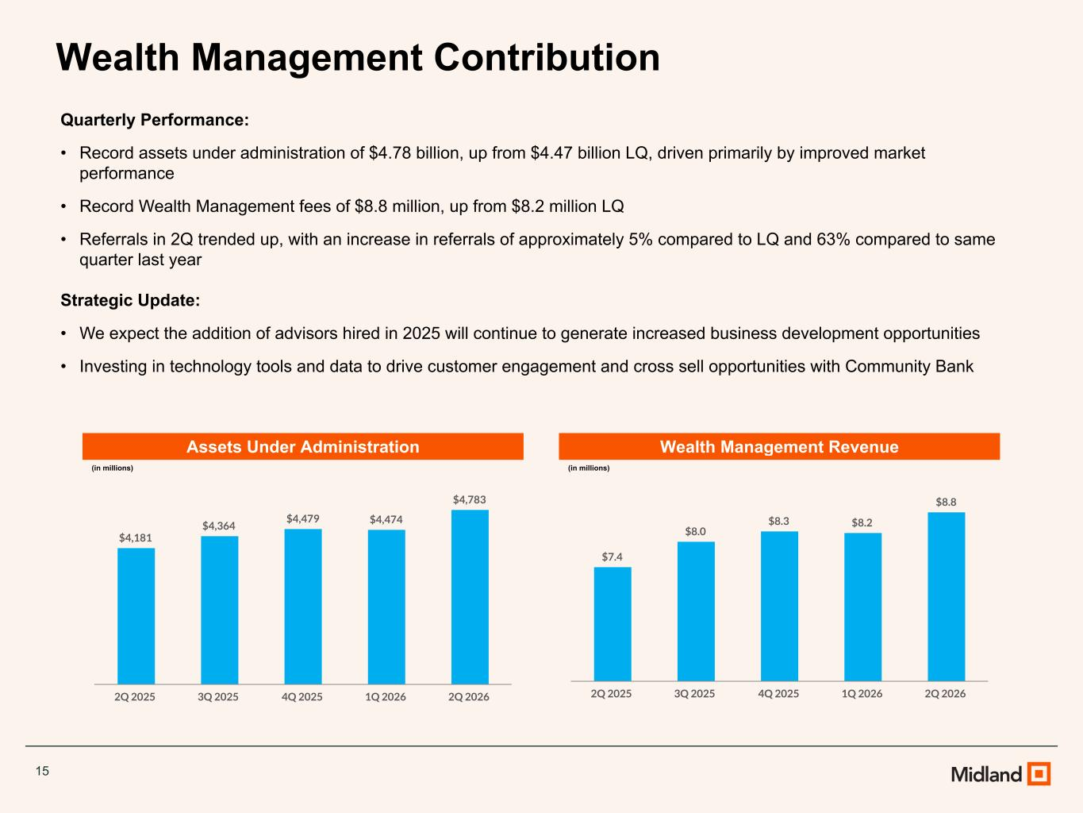
15 Wealth Management Contribution Quarterly Performance: • Record assets under administration of $4.78 billion, up from $4.47 billion LQ, driven primarily by improved market performance • Record Wealth Management fees of $8.8 million, up from $8.2 million LQ • Referrals in 2Q trended up, with an increase in referrals of approximately 5% compared to LQ and 63% compared to same quarter last year Strategic Update: • We expect the addition of advisors hired in 2025 will continue to generate increased business development opportunities • Investing in technology tools and data to drive customer engagement and cross sell opportunities with Community Bank Assets Under Administration (in millions) Wealth Management Revenue (in millions) $4,181 $4,364 $4,479 $4,474 $4,783 2Q 2025 3Q 2025 4Q 2025 1Q 2026 2Q 2026 $7.4 $8.0 $8.3 $8.2 $8.8 2Q 2025 3Q 2025 4Q 2025 1Q 2026 2Q 2026

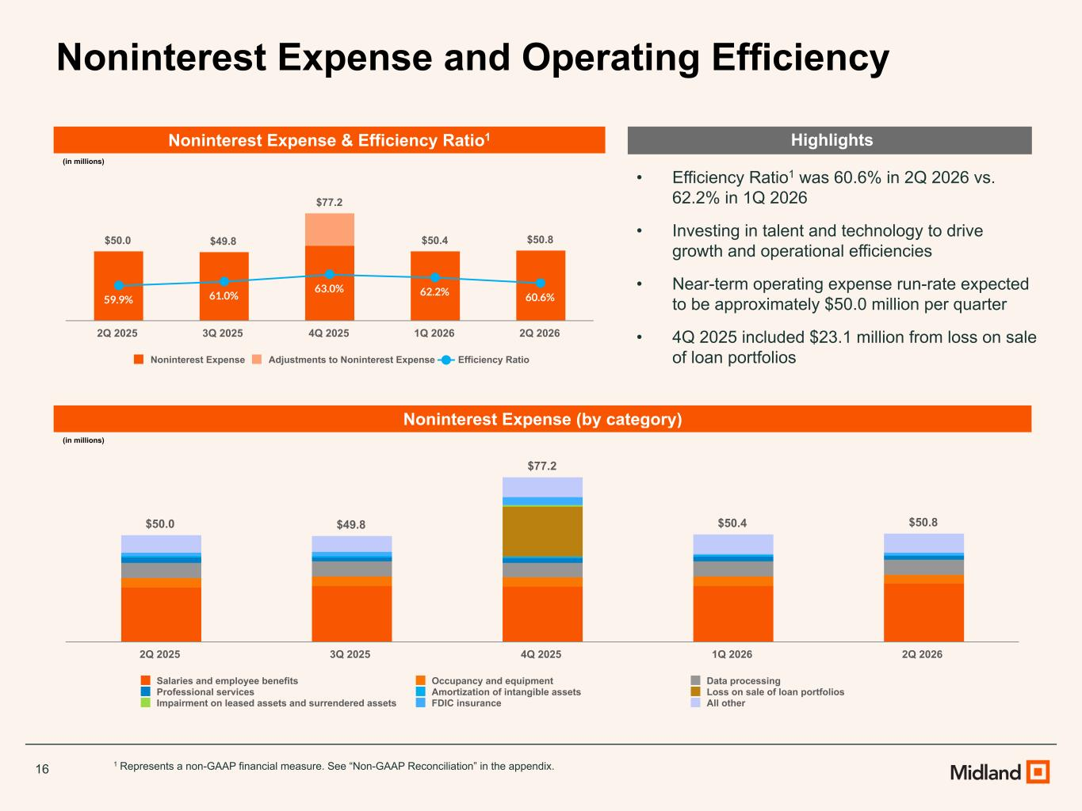
16 Noninterest Expense and Operating Efficiency Noninterest Expense & Efficiency Ratio1 (in millions) • Efficiency Ratio1 was 60.6% in 2Q 2026 vs. 62.2% in 1Q 2026 • Investing in talent and technology to drive growth and operational efficiencies • Near-term operating expense run-rate expected to be approximately $50.0 million per quarter • 4Q 2025 included $23.1 million from loss on sale of loan portfolios 1 Represents a non-GAAP financial measure. See “Non-GAAP Reconciliation” in the appendix. $50.0 $49.8 $77.2 $50.4 $50.8 59.9% 61.0% 63.0% 62.2% 60.6% Noninterest Expense Adjustments to Noninterest Expense Efficiency Ratio 2Q 2025 3Q 2025 4Q 2025 1Q 2026 2Q 2026 Noninterest Expense (by category) (in millions) Highlights $50.0 $49.8 $77.2 $50.4 $50.8 Salaries and employee benefits Occupancy and equipment Data processing Professional services Amortization of intangible assets Loss on sale of loan portfolios Impairment on leased assets and surrendered assets FDIC insurance All other 2Q 2025 3Q 2025 4Q 2025 1Q 2026 2Q 2026

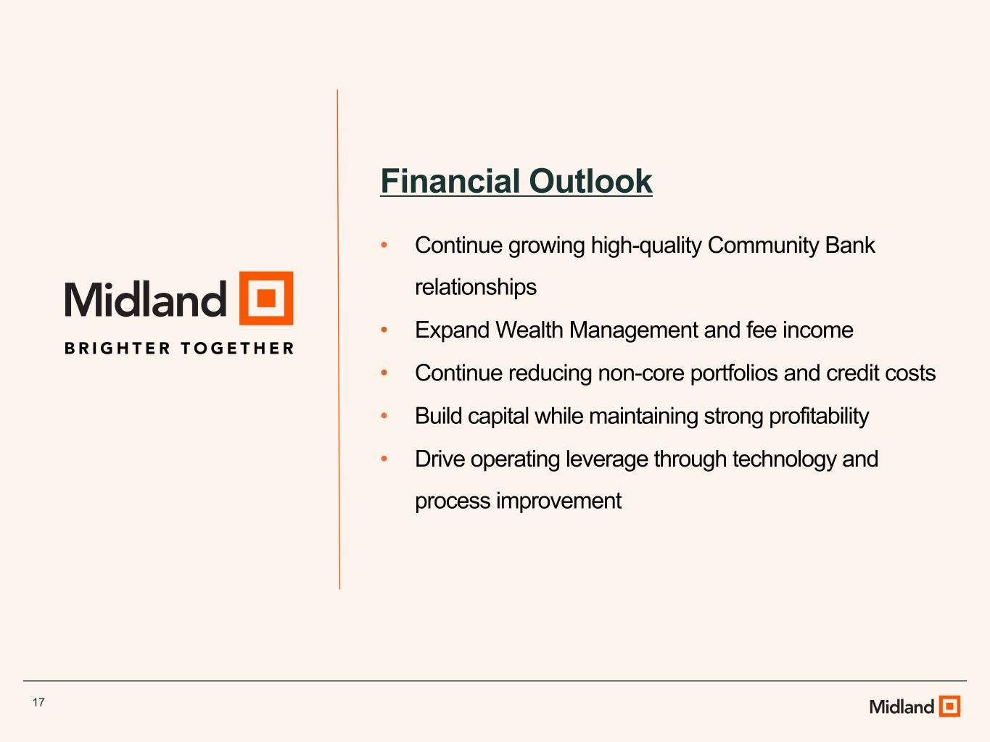
17 Financial Outlook • Continue growing high-quality Community Bank relationships • Expand Wealth Management and fee income • Continue reducing non-core portfolios and credit costs • Build capital while maintaining strong profitability • Drive operating leverage through technology and process improvement

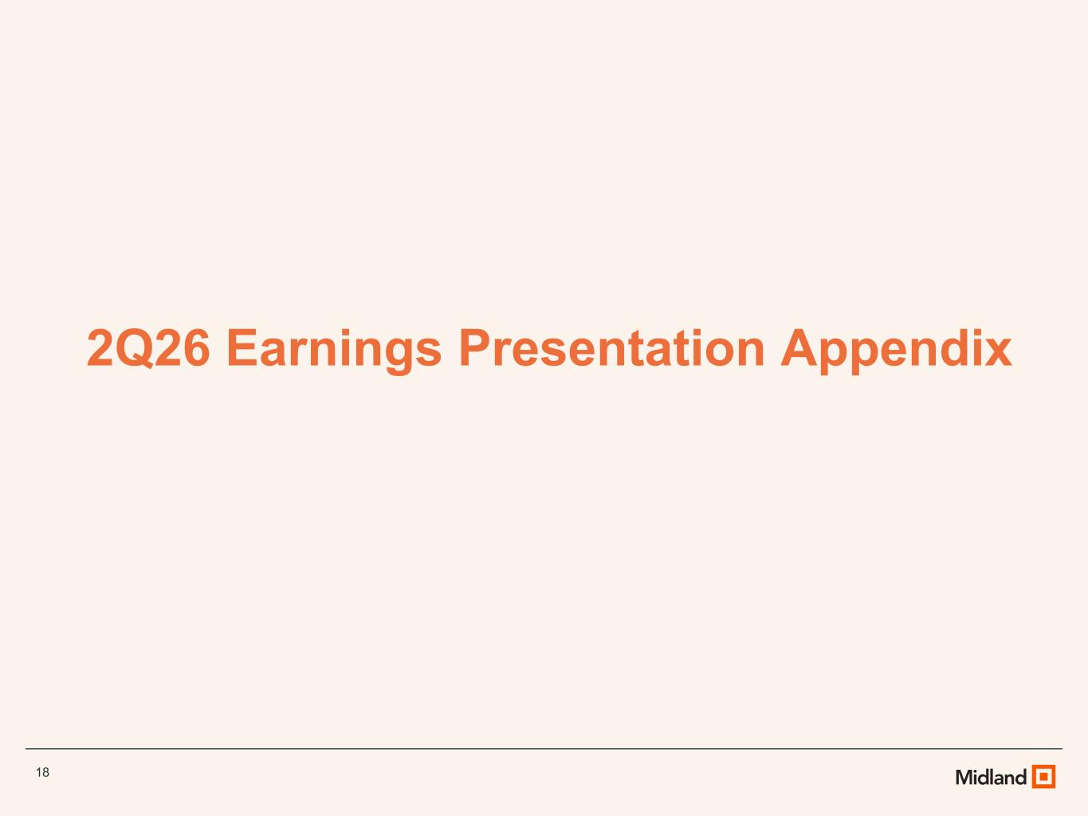
18 2Q26 Earnings Presentation Appendix

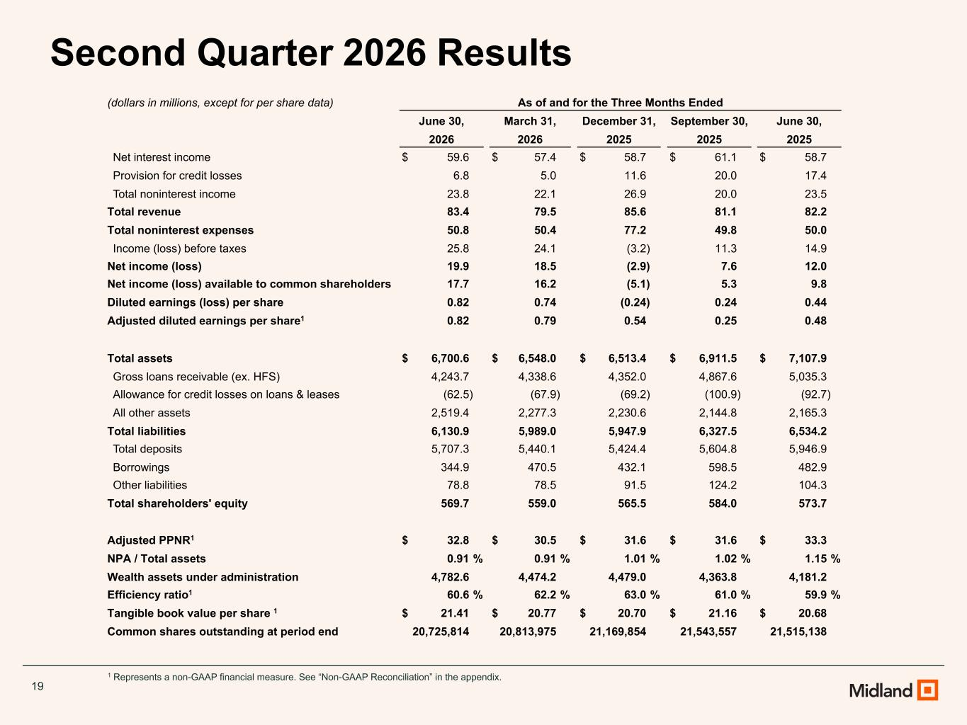
19 1 Represents a non-GAAP financial measure. See “Non-GAAP Reconciliation” in the appendix. Second Quarter 2026 Results (dollars in millions, except for per share data) As of and for the Three Months Ended June 30, March 31, December 31, September 30, June 30, 2026 2026 2025 2025 2025 Net interest income $ 59.6 $ 57.4 $ 58.7 $ 61.1 $ 58.7 Provision for credit losses 6.8 5.0 11.6 20.0 17.4 Total noninterest income 23.8 22.1 26.9 20.0 23.5 Total revenue 83.4 79.5 85.6 81.1 82.2 Total noninterest expenses 50.8 50.4 77.2 49.8 50.0 Income (loss) before taxes 25.8 24.1 (3.2) 11.3 14.9 Net income (loss) 19.9 18.5 (2.9) 7.6 12.0 Net income (loss) available to common shareholders 17.7 16.2 (5.1) 5.3 9.8 Diluted earnings (loss) per share 0.82 0.74 (0.24) 0.24 0.44 Adjusted diluted earnings per share1 0.82 0.79 0.54 0.25 0.48 Total assets $ 6,700.6 $ 6,548.0 $ 6,513.4 $ 6,911.5 $ 7,107.9 Gross loans receivable (ex. HFS) 4,243.7 4,338.6 4,352.0 4,867.6 5,035.3 Allowance for credit losses on loans & leases (62.5) (67.9) (69.2) (100.9) (92.7) All other assets 2,519.4 2,277.3 2,230.6 2,144.8 2,165.3 Total liabilities 6,130.9 5,989.0 5,947.9 6,327.5 6,534.2 Total deposits 5,707.3 5,440.1 5,424.4 5,604.8 5,946.9 Borrowings 344.9 470.5 432.1 598.5 482.9 Other liabilities 78.8 78.5 91.5 124.2 104.3 Total shareholders' equity 569.7 559.0 565.5 584.0 573.7 Adjusted PPNR1 $ 32.8 $ 30.5 $ 31.6 $ 31.6 $ 33.3 NPA / Total assets 0.91 % 0.91 % 1.01 % 1.02 % 1.15 % Wealth assets under administration 4,782.6 4,474.2 4,479.0 4,363.8 4,181.2 Efficiency ratio1 60.6 % 62.2 % 63.0 % 61.0 % 59.9 % Tangible book value per share 1 $ 21.41 $ 20.77 $ 20.70 $ 21.16 $ 20.68 Common shares outstanding at period end 20,725,814 20,813,975 21,169,854 21,543,557 21,515,138

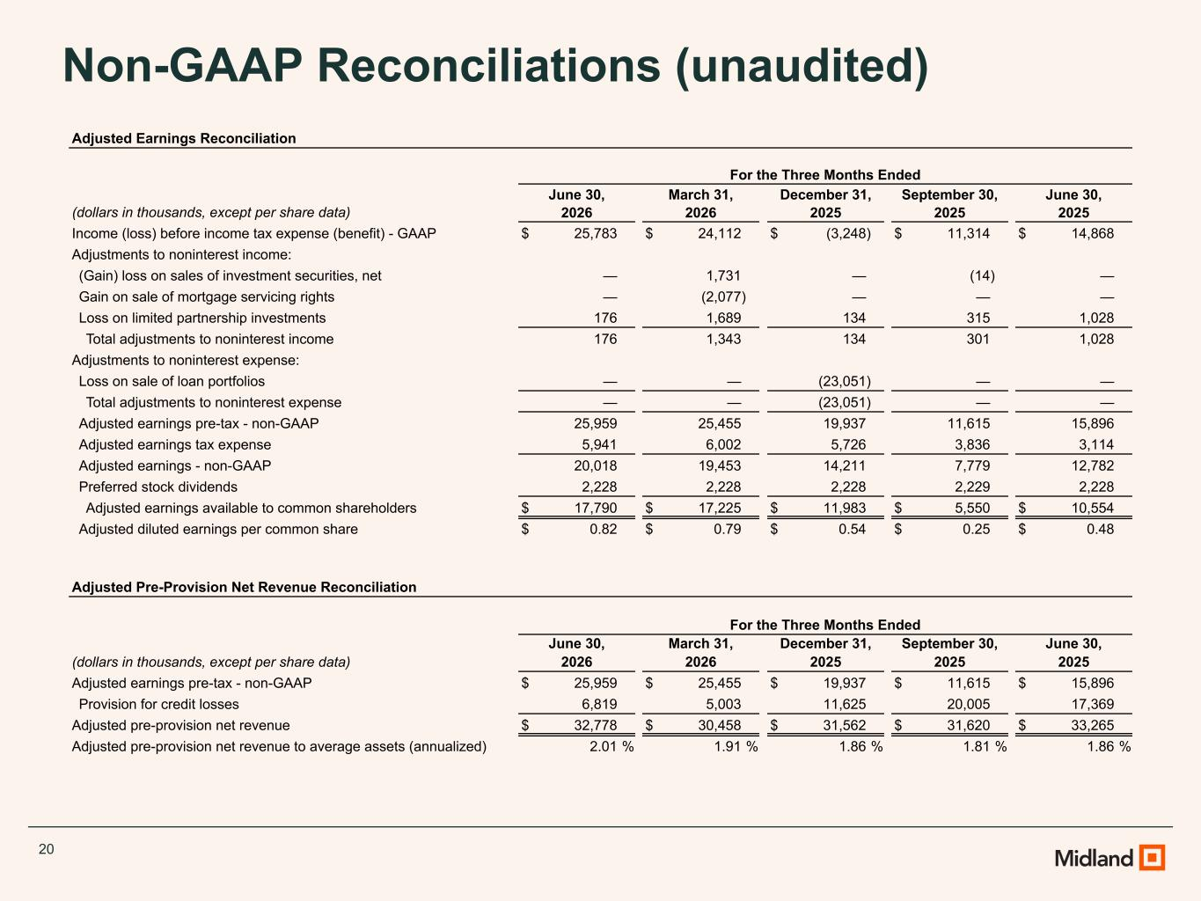
20 Non-GAAP Reconciliations (unaudited) Adjusted Earnings Reconciliation For the Three Months Ended June 30, March 31, December 31, September 30, June 30, (dollars in thousands, except per share data) 2026 2026 2025 2025 2025 Income (loss) before income tax expense (benefit) - GAAP $ 25,783 $ 24,112 $ (3,248) $ 11,314 $ 14,868 Adjustments to noninterest income: (Gain) loss on sales of investment securities, net — 1,731 — (14) — Gain on sale of mortgage servicing rights — (2,077) — — — Loss on limited partnership investments 176 1,689 134 315 1,028 Total adjustments to noninterest income 176 1,343 134 301 1,028 Adjustments to noninterest expense: Loss on sale of loan portfolios — — (23,051) — — Total adjustments to noninterest expense — — (23,051) — — Adjusted earnings pre-tax - non-GAAP 25,959 25,455 19,937 11,615 15,896 Adjusted earnings tax expense 5,941 6,002 5,726 3,836 3,114 Adjusted earnings - non-GAAP 20,018 19,453 14,211 7,779 12,782 Preferred stock dividends 2,228 2,228 2,228 2,229 2,228 Adjusted earnings available to common shareholders $ 17,790 $ 17,225 $ 11,983 $ 5,550 $ 10,554 Adjusted diluted earnings per common share $ 0.82 $ 0.79 $ 0.54 $ 0.25 $ 0.48 Adjusted Pre-Provision Net Revenue Reconciliation For the Three Months Ended June 30, March 31, December 31, September 30, June 30, (dollars in thousands, except per share data) 2026 2026 2025 2025 2025 Adjusted earnings pre-tax - non-GAAP $ 25,959 $ 25,455 $ 19,937 $ 11,615 $ 15,896 Provision for credit losses 6,819 5,003 11,625 20,005 17,369 Adjusted pre-provision net revenue $ 32,778 $ 30,458 $ 31,562 $ 31,620 $ 33,265 Adjusted pre-provision net revenue to average assets (annualized) 2.01 % 1.91 % 1.86 % 1.81 % 1.86 %

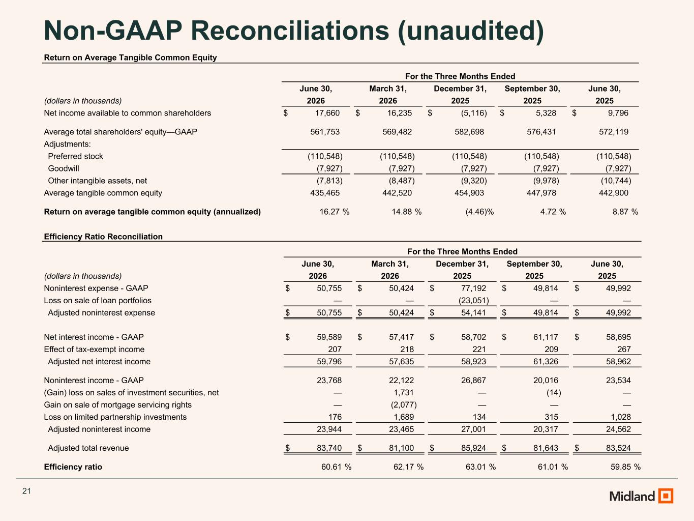
21 Non-GAAP Reconciliations (unaudited) Efficiency Ratio Reconciliation For the Three Months Ended June 30, March 31, December 31, September 30, June 30, (dollars in thousands) 2026 2026 2025 2025 2025 Noninterest expense - GAAP $ 50,755 $ 50,424 $ 77,192 $ 49,814 $ 49,992 Loss on sale of loan portfolios — — (23,051) — — Adjusted noninterest expense $ 50,755 $ 50,424 $ 54,141 $ 49,814 $ 49,992 Net interest income - GAAP $ 59,589 $ 57,417 $ 58,702 $ 61,117 $ 58,695 Effect of tax-exempt income 207 218 221 209 267 Adjusted net interest income 59,796 57,635 58,923 61,326 58,962 Noninterest income - GAAP 23,768 22,122 26,867 20,016 23,534 (Gain) loss on sales of investment securities, net — 1,731 — (14) — Gain on sale of mortgage servicing rights — (2,077) — — — Loss on limited partnership investments 176 1,689 134 315 1,028 Adjusted noninterest income 23,944 23,465 27,001 20,317 24,562 Adjusted total revenue $ 83,740 $ 81,100 $ 85,924 $ 81,643 $ 83,524 Efficiency ratio 60.61 % 62.17 % 63.01 % 61.01 % 59.85 % Return on Average Tangible Common Equity For the Three Months Ended June 30, March 31, December 31, September 30, June 30, (dollars in thousands) 2026 2026 2025 2025 2025 Net income available to common shareholders $ 17,660 $ 16,235 $ (5,116) $ 5,328 $ 9,796 Average total shareholders' equity—GAAP 561,753 569,482 582,698 576,431 572,119 Adjustments: Preferred stock (110,548) (110,548) (110,548) (110,548) (110,548) Goodwill (7,927) (7,927) (7,927) (7,927) (7,927) Other intangible assets, net (7,813) (8,487) (9,320) (9,978) (10,744) Average tangible common equity 435,465 442,520 454,903 447,978 442,900 Return on average tangible common equity (annualized) 16.27 % 14.88 % (4.46) % 4.72 % 8.87 %

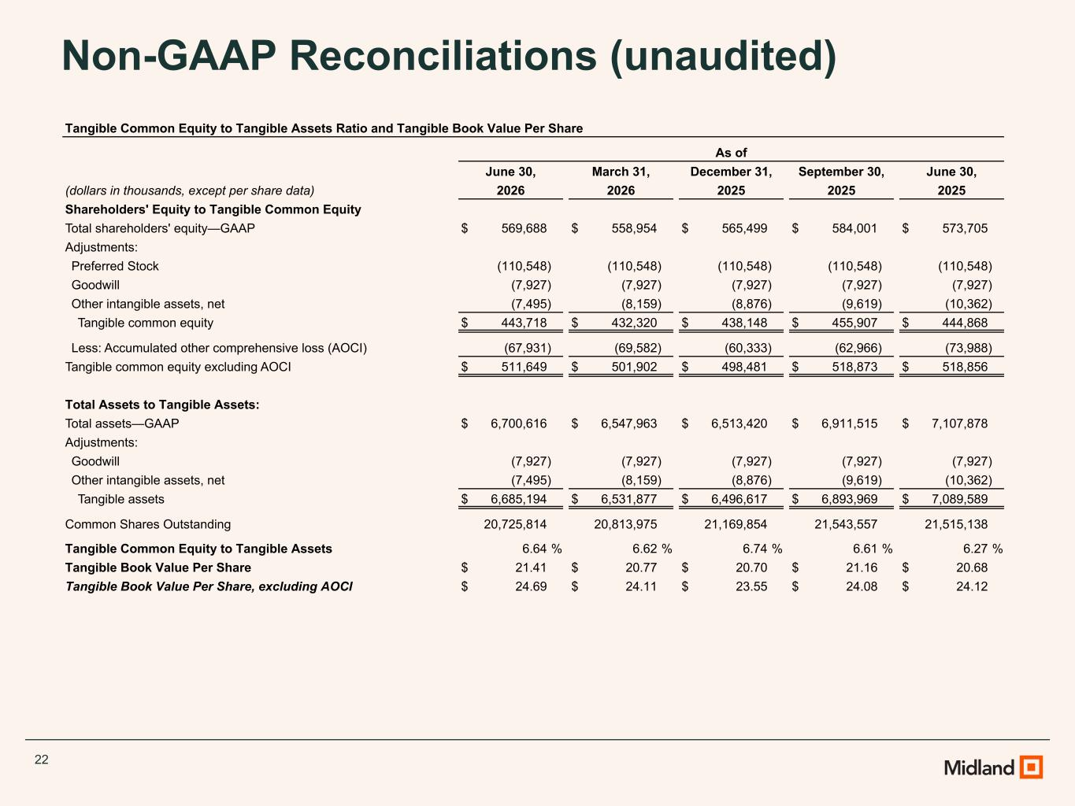
22 Non-GAAP Reconciliations (unaudited) Tangible Common Equity to Tangible Assets Ratio and Tangible Book Value Per Share As of June 30, March 31, December 31, September 30, June 30, (dollars in thousands, except per share data) 2026 2026 2025 2025 2025 Shareholders' Equity to Tangible Common Equity Total shareholders' equity—GAAP $ 569,688 $ 558,954 $ 565,499 $ 584,001 $ 573,705 Adjustments: Preferred Stock (110,548) (110,548) (110,548) (110,548) (110,548) Goodwill (7,927) (7,927) (7,927) (7,927) (7,927) Other intangible assets, net (7,495) (8,159) (8,876) (9,619) (10,362) Tangible common equity $ 443,718 $ 432,320 $ 438,148 $ 455,907 $ 444,868 Less: Accumulated other comprehensive loss (AOCI) (67,931) (69,582) (60,333) (62,966) (73,988) Tangible common equity excluding AOCI $ 511,649 $ 501,902 $ 498,481 $ 518,873 $ 518,856 Total Assets to Tangible Assets: Total assets—GAAP $ 6,700,616 $ 6,547,963 $ 6,513,420 $ 6,911,515 $ 7,107,878 Adjustments: Goodwill (7,927) (7,927) (7,927) (7,927) (7,927) Other intangible assets, net (7,495) (8,159) (8,876) (9,619) (10,362) Tangible assets $ 6,685,194 $ 6,531,877 $ 6,496,617 $ 6,893,969 $ 7,089,589 Common Shares Outstanding 20,725,814 20,813,975 21,169,854 21,543,557 21,515,138 Tangible Common Equity to Tangible Assets 6.64 % 6.62 % 6.74 % 6.61 % 6.27 % Tangible Book Value Per Share $ 21.41 $ 20.77 $ 20.70 $ 21.16 $ 20.68 Tangible Book Value Per Share, excluding AOCI $ 24.69 $ 24.11 $ 23.55 $ 24.08 $ 24.12

