UNITED STATES

SECURITIES AND EXCHANGE COMMISSION

Washington, D.C. 20549

FORM 10-Q

☒QUARTERLY REPORT PURSUANT TO SECTION 13 OR 15(d) OF THE SECURITIES EXCHANGE ACT OF 1934

For the quarterly period ended September 30, 2026

☐TRANSITION REPORT PURSUANT TO SECTION 13 OR 15(d) OF THE SECURITIES EXCHANGE ACT OF 1934

For the transition period from ______________ to _______________

Commission File Number 001-35272

MIDLAND STATES BANCORP, INC.

(Exact name of registrant as specified in its charter)

 | Illinois |  |  |  |  |  |  | 37-1233196
(State or other jurisdiction of incorporation or organization) |  |  |  |  |  |  |  | (I.R.S. Employer Identification No.)
 | 1201 Network Centre Drive |  |  |  |  |  |  | 62401
 | Effingham, IL |  |  |  |  |  |  |  | (Zip Code)
(Address of principal executive offices)
 |  |  |  | (217) 342-7321
 |  |  | (Registrant’s telephone number, including area code)
 |  |  | Securities registered pursuant to Section 12(b) of the Act:
 | Title of each class |  |  |  | Trading symbol(s) |  |  | Name of each exchange on which registered
Common stock, $0.01 par value |  |  |  |  | MSBI |  |  |  | The Nasdaq Stock Market LLC
Depositary Shares, each representing a 1/40th interest in a share of 7.75% fixed rate |  |  |  |  | MSBIP
reset non-cumulative perpetual preferred stock, Series A |  |  |  |  |  |  |  |  | The Nasdaq Stock Market LLC

Indicate by check mark whether the registrant (1) has filed all reports required to be filed by Section 13 or 15(d) of the Securities Exchange Act of 1934 during the preceding 12 months (or for such shorter period that the registrant was required to file such reports), and (2) has been subject to such filing requirements for the past 90 days. ☒ Yes ☐ No

Indicate by check mark whether the registrant has submitted electronically every Interactive Data File required to be submitted pursuant to Rule 405 of Regulation S-T (§232.405 of this chapter) during the preceding 12 months (or for such shorter period that the registrant was required to submit such files). ☒ Yes ☐ No

Indicate by check mark whether the registrant is a large accelerated filer, an accelerated filer, a non-accelerated filer, a smaller reporting company, or an emerging growth company. See the definitions of “large accelerated filer,” “accelerated filer,” “smaller reporting company,” and “emerging growth company” in Rule 12b-2 of the Exchange Act.

Large accelerated filer Emerging growth company

☐

☐

Accelerated filer

☒

Non-accelerated filer

☐

Smaller reporting company

☐

If an emerging growth company, indicate by check mark if the registrant has elected not to use the extended transition period for complying with any new or revised financial accounting standards provided pursuant to Section 13(a) of the Exchange Act. ☐

Indicate by check mark whether the registrant is a shell company (as defined in Rule 12b-2 of the Act). ☐ Yes ☒ No

As of October 20, 2026, the Registrant had 20,802,347 shares of outstanding common stock, $0.01 par value.

Table of Contents

MIDLAND STATES BANCORP, INC.

TABLE OF CONTENTS

 |  | Page
PART I. FINANCIAL INFORMATION
Item 1. | Financial Statements:
 | Consolidated Balance Sheets at September 30, 2026 (Unaudited) and December 31, 2025 | 3
 | Consolidated Statements of Income (Unaudited) for the three and nine months ended September 30, 2026 and 2025 | 4
 | Consolidated Statements of Comprehensive Income (Unaudited) for the three and nine months ended September 30, 2026 and 2025 | 5
 | Consolidated Statements of Shareholders’ Equity (Unaudited) for the three and nine months ended September 30, 2026 and 2025 | 6
 | Consolidated Statements of Cash Flows (Unaudited) for the nine months ended September 30, 2026 and 2025 | 7
 | Notes to Consolidated Financial Statements (Unaudited) | 8
Item 2. | Management’s Discussion and Analysis of Financial Condition and Results of Operations | 47
Item 3. | Quantitative and Qualitative Disclosures about Market Risk | 69
Item 4. | Controls and Procedures | 69
PART II. OTHER INFORMATION
Item 1. | Legal Proceedings | 69
Item 1A. | Risk Factors | 69
Item 2. | Unregistered Sales of Equity Securities and Use of Proceeds | 70
Item 5. | Other Information | 70
Item 6. | Exhibits | 71
SIGNATURES |  | 72

1

Table of Contents

GLOSSARY OF ABBREVIATIONS AND ACRONYMS

As used in this report, references to the "Company," "we," "our," "us," and similar terms refer to the consolidated entity consisting of Midland States Bancorp, Inc. and its wholly owned subsidiaries.

Midland States Bancorp, Inc. refers solely to the parent holding company and Midland States Bank (the "Bank") refers to our wholly owned banking subsidiary.

The acronyms and abbreviations identified below are used throughout this report, including the Notes to the Consolidated Financial Statements. You may find it helpful to refer to this page as you read this report.

2019 Incentive Plan

ACL

AFX

AMERIBOR

AOCI

ASC

ASU

ATM

BaaS

Basel III Rule

BHCA

CBLR

CFPB

CISA

CRA

CRA Proposal

CRE

CRE Guidance

DFPR

DIF

Exchange Act

FASB

FDIC

Federal Reserve

FHA

FHLB

FinTech

FOMC

FRB

GAAP

GreenSky

Illinois CRA

LendingPoint

LGD

Midland Trust

Nasdaq

NII at Risk

OREO

PCAOB

PCD

PD

Q-Factor

Regulatory Relief Act

SBA

SEC

SOFR

Treasury

The Amended and Restated Midland States Bancorp, Inc. 2019 Long-Term Incentive Plan

Allowance for credit losses on loans

American Financial Exchange

American Interbank Offered Rate

Accumulated other comprehensive income (loss)

Accounting Standards Codification

Accounting Standards Update

Automated teller machine

Banking-as-a-Service

Basel III regulatory capital reforms required by the Dodd-Frank Act

Bank Holding Company Act of 1956, as amended

Community Bank Leverage Ratio

Consumer Financial Protection Bureau

Cybersecurity and Infrastructure Security Agency

Community Reinvestment Act

Joint Proposal to Strengthen and Modernize Community Reinvestment Act Regulations

Commercial Real Estate

Concentrations in Commercial Real Estate Lending, Sound Risk Management Practices guidance

Illinois Department of Financial and Professional Regulation

Deposit Insurance Fund

Securities Exchange Act of 1934

Financial Accounting Standards Board

Federal Deposit Insurance Corporation

Board of Governors of the Federal Reserve System

Federal Housing Administration

Federal Home Loan Bank

Financial Technology

Federal Open Market Committee

Federal Reserve Bank

U.S. generally accepted accounting principles

GreenSky, LLC

Illinois Community Reinvestment Act

LendingPoint, LLC

Loss given default

Midland States Preferred Securities Trust

Nasdaq Global Select Market

Net Interest Income at Risk

Other real estate owned

Public Company Accounting Oversight Board

Purchased credit deteriorated

Probability of default

Qualitative factor

Economic Growth, Regulatory Relief and Consumer Protection Act

Small Business Administration

U.S. Securities and Exchange Commission

Secured Overnight Financing Rate

U.S. Department of the Treasury

2

Table of Contents

PART I – FINANCIAL INFORMATION

ITEM 1 – FINANCIAL STATEMENTS

MIDLAND STATES BANCORP, INC.

CONSOLIDATED BALANCE SHEETS

(dollars in thousands, except per share data)

 |  | September 30, |  |  | December 31,
 |  | 2026 |  |  | 2025
 |  | (unaudited)
Assets
Cash and due from banks | $ | 99,055 |  | $ | 127,279
Federal funds sold |  | 557 |  |  | 532
Cash and cash equivalents |  | 99,612 |  |  | 127,811
Investment securities available for sale, at fair value |  | 1,905,194 |  |  | 1,523,001
Equity securities, at fair value |  | 3,827 |  |  | 4,235
Loans |  | 4,282,828 |  |  | 4,352,004
Allowance for credit losses on loans |  | (60,852) |  |  | (69,219)
Total loans, net |  | 4,221,976 |  |  | 4,282,785
Loans held for sale |  | 4,580 |  |  | 7,781
Premises and equipment, net |  | 82,435 |  |  | 85,134
Other real estate owned |  | 180 |  |  | 606
Nonmarketable equity securities |  | 35,188 |  |  | 32,598
Accrued interest receivable |  | 27,849 |  |  | 23,824
Loan servicing rights, at lower of cost or fair value |  | 10,931 |  |  | 11,932
Loan servicing rights, held for sale |  | — |  |  | 3,661
Goodwill |  | 7,927 |  |  | 7,927
Other intangible assets, net |  | 6,849 |  |  | 8,876
Company-owned life insurance |  | 224,884 |  |  | 218,554
Credit enhancement asset |  | 14,364 |  |  | 12,557
Other assets |  | 171,046 |  |  | 162,138
Total assets | $ | 6,816,842 |  | $ | 6,513,420
Liabilities and Shareholders’ Equity
Liabilities:
Deposits:
Noninterest-bearing demand deposits | $ | 973,388 |  | $ | 1,040,411
Interest-bearing deposits |  | 4,644,050 |  |  | 4,383,968
Total deposits |  | 5,617,438 |  |  | 5,424,379
Short-term borrowings |  | 151,499 |  |  | 60,181
Federal Home Loan Bank advances |  | 353,000 |  |  | 293,000
Subordinated debt |  | 27,035 |  |  | 27,019
Trust preferred debentures |  | 52,409 |  |  | 51,857
Accrued interest payable and other liabilities |  | 84,094 |  |  | 91,485
Total liabilities |  | 6,285,475 |  |  | 5,947,921
Shareholders’ Equity:
Preferred stock, $2.00 par value; 4,000,000 shares authorized; 115,000 Series A shares, $1,000 per share liquidation preference, issued and outstanding at September 30, 2026 and |  | 110,548 |  |  | 110,548
December 31, 2025, respectively |  | 110,548 |  |  | 110,548
Common stock, $0.01 par value; 40,000,000 shares authorized; 20,801,859 and 21,169,854 shares issued and outstanding at September 30, 2026 and December 31, 2025, |  | 208 |  |  | 212
respectively |  | 208 |  |  | 212
Capital surplus |  | 422,207 |  |  | 428,247
Retained earnings |  | 120,601 |  |  | 86,825
Accumulated other comprehensive loss, net of tax |  | (122,197) |  |  | (60,333)
Total shareholders’ equity |  | 531,367 |  |  | 565,499
Total liabilities and shareholders’ equity | $ | 6,816,842 |  | $ | 6,513,420

The accompanying notes are an integral part of the consolidated financial statements.

3

Table of Contents

MIDLAND STATES BANCORP, INC.

CONSOLIDATED STATEMENTS OF INCOME — (UNAUDITED)

(dollars in thousands, except per share data)

 | Three Months Ended September 30, |  |  |  |  |  |  | Nine Months Ended September 30,
 | 2026 |  |  | 2025 |  |  |  | 2026 |  |  | 2025
Interest income:
Loans including fees:
Taxable | $ | 68,760 |  | $ | 80,583 |  | $ | 201,080 |  | $ | 236,765
Tax exempt |  | 326 |  |  | 338 |  |  | 1,052 |  |  | 1,267
Loans held for sale |  | 97 |  |  | 147 |  |  | 327 |  |  | 5,087
Investment securities:
Taxable |  | 21,539 |  |  | 15,418 |  |  | 58,678 |  |  | 47,011
Tax exempt |  | 436 |  |  | 443 |  |  | 1,307 |  |  | 1,303
Nonmarketable equity securities |  | 530 |  |  | 715 |  |  | 1,647 |  |  | 2,056
Federal funds sold and cash investments |  | 1,333 |  |  | 849 |  |  | 3,129 |  |  | 2,283
Total interest income |  | 93,021 |  |  | 98,493 |  |  | 267,220 |  |  | 295,772
Interest expense:
Deposits |  | 26,251 |  |  | 30,219 |  |  | 74,980 |  |  | 97,124
Short-term borrowings |  | 349 |  |  | 499 |  |  | 782 |  |  | 1,772
Federal Home Loan Bank advances |  | 2,165 |  |  | 4,044 |  |  | 7,184 |  |  | 10,973
Subordinated debt |  | 380 |  |  | 1,393 |  |  | 1,140 |  |  | 4,174
Trust preferred debentures |  | 1,154 |  |  | 1,221 |  |  | 3,406 |  |  | 3,627
Total interest expense |  | 30,299 |  |  | 37,376 |  |  | 87,492 |  |  | 117,670
Net interest income |  | 62,722 |  |  | 61,117 |  |  | 179,728 |  |  | 178,102
Provision for credit losses:
Provision for credit losses on loans |  | 3,685 |  |  | 20,505 |  |  | 16,197 |  |  | 48,724
Provision (recapture) of credit losses on unfunded commitments |  | 50 |  |  | (500) |  |  | (640) |  |  | (500)
Total provision for credit losses |  | 3,735 |  |  | 20,005 |  |  | 15,557 |  |  | 48,224
Net interest income after provision for credit losses |  | 58,987 |  |  | 41,112 |  |  | 164,171 |  |  | 129,878
Noninterest income:
Wealth management revenue |  | 8,651 |  |  | 8,018 |  |  | 25,667 |  |  | 22,747
Service charges on deposit accounts |  | 3,775 |  |  | 3,598 |  |  | 10,579 |  |  | 10,254
Interchange revenue |  | 3,984 |  |  | 3,445 |  |  | 11,065 |  |  | 10,059
Residential mortgage banking revenue |  | 216 |  |  | 735 |  |  | 1,528 |  |  | 2,167
Income on company-owned life insurance |  | 1,828 |  |  | 2,102 |  |  | 6,031 |  |  | 6,504
Gain (loss) on sales of investment securities, net |  | — |  |  | 14 |  |  | (1,731) |  |  | 14
Credit enhancement income |  | 3,108 |  |  | (242) |  |  | 9,549 |  |  | 3,028
Other income |  | 1,675 |  |  | 2,346 |  |  | 6,439 |  |  | 6,540
Total noninterest income |  | 23,237 |  |  | 20,016 |  |  | 69,127 |  |  | 61,313
Noninterest expense:
Salaries and employee benefits |  | 28,500 |  |  | 26,393 |  |  | 82,011 |  |  | 78,494
Occupancy and equipment |  | 4,330 |  |  | 4,206 |  |  | 13,094 |  |  | 12,870
Data processing |  | 6,871 |  |  | 7,186 |  |  | 20,930 |  |  | 21,140
FDIC insurance |  | 791 |  |  | 1,512 |  |  | 2,101 |  |  | 4,397
Professional services |  | 1,669 |  |  | 2,017 |  |  | 5,576 |  |  | 7,550
Marketing |  | 1,539 |  |  | 1,460 |  |  | 3,991 |  |  | 3,536
Communications |  | 403 |  |  | 298 |  |  | 1,193 |  |  | 961
Loan expense |  | 3,214 |  |  | 1,721 |  |  | 9,666 |  |  | 5,046
Loan servicing fees |  | 1,063 |  |  | 1,274 |  |  | 3,229 |  |  | 3,410
Impairment on goodwill |  | — |  |  | — |  |  | — |  |  | 153,977
Amortization of intangible assets |  | 646 |  |  | 743 |  |  | 2,027 |  |  | 2,481
Other expense |  | 3,817 |  |  | 3,004 |  |  | 10,204 |  |  | 8,949
Total noninterest expense |  | 52,843 |  |  | 49,814 |  |  | 154,022 |  |  | 302,811
Income (loss) before income taxes |  | 29,381 |  |  | 11,314 |  |  | 79,276 |  |  | (111,620)
Income tax expense |  | 6,573 |  |  | 3,757 |  |  | 18,117 |  |  | 9,773
Net income (loss) |  | 22,808 |  |  | 7,557 |  |  | 61,159 |  |  | (121,393)
Preferred dividends |  | 2,229 |  |  | 2,229 |  |  | 6,685 |  |  | 6,685
Net income (loss) available to common shareholders | $ | 20,579 |  | $ | 5,328 |  | $ | 54,474 |  | $ | (128,078)
Per common share data:
Basic earnings (loss) per common share | $ | 0.95 |  | $ | 0.24 |  | $ | 2.51 |  | $ | (5.88)
Diluted earnings (loss) per common share | $ | 0.95 |  | $ | 0.24 |  | $ | 2.51 |  | $ | (5.88)
Weighted average common shares outstanding |  | 21,128,351 |  |  | 21,863,911 |  |  | 21,167,256 |  |  | 21,826,566
Weighted average diluted common shares outstanding |  | 21,140,143 |  |  | 21,863,911 |  |  | 21,167,256 |  |  | 21,826,566

The accompanying notes are an integral part of the consolidated financial statements.

4

Table of Contents

MIDLAND STATES BANCORP, INC.

CONSOLIDATED STATEMENTS OF COMPREHENSIVE INCOME — (UNAUDITED)

(dollars in thousands)

 | Three Months Ended September 30, |  |  |  |  |  |  | Nine Months Ended September 30,
 | 2026 |  |  | 2025 |  |  |  | 2026 |  |  | 2025
Net income (loss) | $ | 22,808 |  | $ | 7,557 |  | $ | 61,159 |  | $ | (121,393)
Other comprehensive income (loss):
Investment securities available for sale:
Unrealized gains (losses) that occurred during the period |  | (75,464) |  |  | 15,202 |  |  | (87,904) |  |  | 23,684
Reclassification adjustment for realized net (gains) losses on sales of investment securities included in net income |  | — |  |  | (14) |  |  | 1,731 |  |  | (14)
Reclassification adjustment for (gains) losses on fair value hedges included in net income |  | 46 |  |  | (63) |  |  | (132) |  |  | (109)
Income tax effect |  | 21,042 |  |  | (3,925) |  |  | 24,041 |  |  | (6,294)
Change in investment securities available for sale, net of tax |  | (54,376) |  |  | 11,200 |  |  | (62,264) |  |  | 17,267
Cash flow hedges:
Net unrealized derivative gains (losses) on cash flow hedges |  | (79) |  |  | (439) |  |  | (245) |  |  | 648
Reclassification adjustment for net losses realized in net income |  | 218 |  |  | 197 |  |  | 759 |  |  | 1,676
Income tax effect |  | (29) |  |  | 64 |  |  | (114) |  |  | (597)
Change in cash flow hedges, net of tax |  | 110 |  |  | (178) |  |  | 400 |  |  | 1,727
Other comprehensive income (loss), net of tax |  | (54,266) |  |  | 11,022 |  |  | (61,864) |  |  | 18,994
Total comprehensive income (loss) | $ | (31,458) |  | $ | 18,579 |  | $ | (705) |  | $ | (102,399)

The accompanying notes are an integral part of the consolidated financial statements.

5

Table of Contents

MIDLAND STATES BANCORP, INC.

CONSOLIDATED STATEMENTS OF SHAREHOLDERS’ EQUITY — (UNAUDITED)

(dollars in thousands, except share and per share data)

 |  |  |  |  |  |  |  |  |  |  |  |  |  |  |  | Accumulated |  |  | Total
 | Number of common |  |  |  |  |  | Common |  |  | Capital |  |  | Retained |  |  | other |  |  | Total
 |  |  |  | Preferred stock |  |  |  |  |  |  |  |  |  |  |  | comprehensive |  |  | shareholders'
 | shares |  |  |  |  |  | stock |  |  | surplus |  |  | earnings |  |  | income (loss) |  |  | equity
Balances, June 30, 2026 | 20,725,814 |  | $ | 110,548 |  | $ | 207 |  | $ | 419,832 |  | $ | 107,032 |  | $ | (67,931) |  | $ | 569,688
Net income | — |  |  | — |  |  | — |  |  | — |  |  | 22,808 |  |  | — |  |  | 22,808
Other comprehensive loss | — |  |  | — |  |  | — |  |  | — |  |  | — |  |  | (54,266) |  |  | (54,266)
Common dividends declared ($0.33 per share) | — |  |  | — |  |  | — |  |  | — |  |  | (7,010) |  |  | — |  |  | (7,010)
Preferred dividends declared ($19.375 per share) | — |  |  | — |  |  | — |  |  | — |  |  | (2,229) |  |  | — |  |  | (2,229)
Common stock repurchased, including excise tax | (501) |  |  | — |  |  | — |  |  | 11 |  |  | — |  |  | — |  |  | 11
Share-based compensation expense | — |  |  | — |  |  | — |  |  | 810 |  |  | — |  |  | — |  |  | 810
Issuance of common stock under employee benefit plans | 76,546 |  |  | — |  |  | 1 |  |  | 1,554 |  |  | — |  |  | — |  |  | 1,555
Balances, September 30, 2026 | 20,801,859 |  | $ | 110,548 |  | $ | 208 |  | $ | 422,207 |  | $ | 120,601 |  | $ | (122,197) |  | $ | 531,367
Balances, December 31, 2025 | 21,169,854 |  | $ | 110,548 |  | $ | 212 |  | $ | 428,247 |  | $ | 86,825 |  | $ | (60,333) |  | $ | 565,499
Net income | — |  |  | — |  |  | — |  |  | — |  |  | 61,159 |  |  | — |  |  | 61,159
Other comprehensive loss | — |  |  | — |  |  | — |  |  | — |  |  | — |  |  | (61,864) |  |  | (61,864)
Common dividends declared ($0.97 per share) | — |  |  | — |  |  | — |  |  | — |  |  | (20,698) |  |  | — |  |  | (20,698)
Preferred dividends declared ($58.125 per share) | — |  |  | — |  |  | — |  |  | — |  |  | (6,685) |  |  | — |  |  | (6,685)
Common stock repurchased, including excise tax | (479,216) |  |  | — |  |  | (5) |  |  | (10,652) |  |  | — |  |  | — |  |  | (10,657)
Share-based compensation expense | — |  |  | — |  |  | — |  |  | 2,330 |  |  | — |  |  | — |  |  | 2,330
Issuance of common stock under employee benefit plans | 111,221 |  |  | — |  |  | 1 |  |  | 2,282 |  |  | — |  |  | — |  |  | 2,283
Balances, September 30, 2026 | 20,801,859 |  | $ | 110,548 |  | $ | 208 |  | $ | 422,207 |  | $ | 120,601 |  | $ | (122,197) |  | $ | 531,367
Balances, June 30, 2025 | 21,515,138 |  | $ | 110,548 |  | $ | 215 |  | $ | 436,205 |  | $ | 100,725 |  | $ | (73,988) |  | $ | 573,705
Net income | — |  |  | — |  |  | — |  |  | — |  |  | 7,557 |  |  | — |  |  | 7,557
Other comprehensive income | — |  |  | — |  |  | — |  |  | — |  |  | — |  |  | 11,022 |  |  | 11,022
Common dividends declared ($0.32 per share) | — |  |  | — |  |  | — |  |  | — |  |  | (7,017) |  |  | — |  |  | (7,017)
Preferred dividends declared ($19.375 per share) | — |  |  | — |  |  | — |  |  | — |  |  | (2,229) |  |  | — |  |  | (2,229)
Share-based compensation expense | — |  |  | — |  |  | — |  |  | 651 |  |  | — |  |  | — |  |  | 651
Issuance of common stock under employee benefit plans | 28,419 |  |  | — |  |  | — |  |  | 312 |  |  | — |  |  | — |  |  | 312
Balances, September 30, 2025 | 21,543,557 |  | $ | 110,548 |  | $ | 215 |  | $ | 437,168 |  | $ | 99,036 |  | $ | (62,966) |  | $ | 584,001
Balances, December 31, 2024 | 21,494,485 |  | $ | 110,548 |  | $ | 215 |  | $ | 434,346 |  | $ | 247,698 |  | $ | (81,960) |  | $ | 710,847
Net loss | — |  |  | — |  |  | — |  |  | — |  |  | (121,393) |  |  | — |  |  | (121,393)
Other comprehensive income | — |  |  | — |  |  | — |  |  | — |  |  | — |  |  | 18,994 |  |  | 18,994
Common dividends declared ($0.94 per share) | — |  |  | — |  |  | — |  |  | — |  |  | (20,584) |  |  | — |  |  | (20,584)
Preferred dividends declared ($58.125 per share) | — |  |  | — |  |  | — |  |  | — |  |  | (6,685) |  |  | — |  |  | (6,685)
Share-based compensation expense | — |  |  | — |  |  | — |  |  | 2,185 |  |  | — |  |  | — |  |  | 2,185
Issuance of common stock under employee benefit plans | 49,072 |  |  | — |  |  | — |  |  | 637 |  |  | — |  |  | — |  |  | 637
Balances, September 30, 2025 | 21,543,557 |  | $ | 110,548 |  | $ | 215 |  | $ | 437,168 |  | $ | 99,036 |  | $ | (62,966) |  | $ | 584,001

The accompanying notes are an integral part of the consolidated financial statements.

6

Table of Contents

MIDLAND STATES BANCORP, INC.

CONSOLIDATED STATEMENTS OF CASH FLOWS — (UNAUDITED)
(dollars in thousands)

 | Nine Months Ended September 30,
 | 2026 |  |  | 2025
Cash flows from operating activities:
Net income (loss) | $ | 61,159 |  | $ | (121,393)
Adjustments to reconcile net income (loss) to net cash provided by operating activities:
Provision for credit losses |  | 15,557 |  |  | 48,224
Depreciation on premises and equipment |  | 3,649 |  |  | 3,672
Impairment on goodwill |  | — |  |  | 153,977
Amortization of intangible assets |  | 2,027 |  |  | 2,481
Amortization of operating lease right-of-use asset |  | 1,243 |  |  | 1,178
Amortization of loan servicing rights |  | 1,154 |  |  | 1,703
Share-based compensation expense |  | 2,330 |  |  | 2,185
Increase in cash surrender value of life insurance |  | (6,331) |  |  | (6,149)
Investment securities accretion, net |  | (13,109) |  |  | (10,287)
(Gain) loss on sales of investment securities, net |  | 1,731 |  |  | (14)
Origination of loans held for sale |  | (79,214) |  |  | (75,176)
Proceeds from sales of loans and leases held for sale |  | 83,885 |  |  | 107,025
Gain on sale of loans held for sale |  | (1,650) |  |  | (1,963)
Gain on sale of mortgage servicing rights held for sale |  | (2,077) |  |  | —
Net change in operating assets and liabilities:
Accrued interest receivable |  | (4,025) |  |  | (1,343)
Credit enhancement asset |  | (1,807) |  |  | 11,039
Other assets |  | 27,055 |  |  | 22,487
Accrued expenses and other liabilities |  | (6,767) |  |  | (4,905)
Net cash provided by operating activities |  | 84,810 |  |  | 132,741
Cash flows from investing activities:
Purchases of investment securities available for sale |  | (795,068) |  |  | (400,318)
Proceeds from sales of investment securities available for sale |  | 98,599 |  |  | 103,759
Maturities and payments on investment securities available for sale |  | 229,778 |  |  | 164,437
Purchases of equity securities |  | (100) |  |  | (152)
Net decrease in loans |  | 42,577 |  |  | 487,562
Proceeds from sales of consumer loans held for sale |  | — |  |  | 61,099
Purchases of premises and equipment |  | (1,408) |  |  | (4,606)
Proceeds from sale of premises and equipment |  | 221 |  |  | —
Purchases of nonmarketable equity securities |  | (13,945) |  |  | (107,172)
Proceeds from redemptions of nonmarketable equity securities |  | 11,355 |  |  | 103,624
Proceeds from sales of mortgage servicing rights held for sale |  | 5,727 |  |  | —
Proceeds from sales of other real estate owned |  | 635 |  |  | 4,774
Proceeds from company-owned life insurance, net |  | — |  |  | 1,166
Net cash provided by (used in) investing activities |  | (421,629) |  |  | 414,173
Cash flows from financing activities:
Net increase (decrease) in deposits |  | 193,059 |  |  | (592,418)
Net increase in short-term borrowings |  | 91,318 |  |  | 59,267
Net increase in short-term FHLB advances |  | 130,000 |  |  | 60,000
Proceeds from long-term FHLB advances |  | — |  |  | 328,000
Payments made on long-term FHLB advances |  | (70,000) |  |  | (273,000)
Payments and subordinated debt redemption |  | — |  |  | (50,750)
Cash dividends paid on preferred stock |  | (6,685) |  |  | (6,685)
Cash dividends paid on common stock |  | (20,698) |  |  | (20,584)
Common stock repurchased, including excise tax |  | (10,657) |  |  | —
Proceeds from issuance of common stock under employee benefit plans |  | 2,283 |  |  | 637
Net cash provided by (used in) financing activities |  | 308,620 |  |  | (495,533)
Net increase (decrease) in cash and cash equivalents |  | (28,199) |  |  | 51,381
Cash and cash equivalents:
Beginning of period |  | 127,811 |  |  | 114,766
End of period | $ | 99,612 |  | $ | 166,147
Supplemental disclosures of cash flow information:
Cash payments for:
Interest paid on deposits and borrowed funds | $ | 90,006 |  | $ | 123,045
Income tax paid (net of refunds) |  | 1,280 |  |  | (979)
Supplemental disclosures of noncash investing and financing activities:
Transfer of loans to loans held for sale |  | 1,870 |  |  | 29,400
Transfer of loans to other real estate owned |  | 222 |  |  | 187
Right of use assets obtained in exchange for lease obligations |  | 948 |  |  | 873
Transfer of premises and equipment, net to assets held for sale |  | — |  |  | 245
Transfer of loan servicing rights held for sale to loan servicing rights, at lower of cost or fair value |  | 125 |  |  | —
Loans provided for sale of consumer loans held for sale |  | — |  |  | 219,212

The accompanying notes are an integral part of the consolidated financial statements.

7

Table of Contents

 |  |  |  |  |  |  |  |  |  |  |  |  | MIDLAND STATES BANCORP, INC.
 |  |  |  |  |  |  |  |  |  |  |  | NOTES TO CONSOLIDATED FINANCIAL STATEMENTS — (UNAUDITED)
 | Note 1: Summary of Significant Accounting Policies |  |  |  |  |  |  |  |  |  |  |  |  | 8
 | Note 2: Investment Securities |  |  |  |  |  |  |  |  |  |  |  |  | 10
 | Note 3: Loans |  |  |  |  |  |  |  |  |  |  |  |  | 12
 | Note 4: Premises, Equipment and Leases |  |  |  |  |  |  |  |  |  |  |  |  | 29
 | Note 5: Goodwill |  |  |  |  |  |  |  |  |  |  |  |  | 30
 | Note 6: Derivative Instruments |  |  |  |  |  |  |  |  |  |  |  |  | 30
 | Note 7: Deposits |  |  |  |  |  |  |  |  |  |  |  |  | 33
 | Note 8: Short-Term Borrowings |  |  |  |  |  |  |  |  |  |  |  |  | 33
 | Note 9: FHLB Advances |  |  |  |  |  |  |  |  |  |  |  |  | 34
 | Note 10: Accumulated Other Comprehensive Income (Loss) |  |  |  |  |  |  |  |  |  |  |  |  | 35
 | Note 11: Earnings per Common Share |  |  |  |  |  |  |  |  |  |  |  |  | 36
 | Note 12: Fair Value of Financial Instruments |  |  |  |  |  |  |  |  |  |  |  |  | 36
 | Note 13: Commitments, Contingencies and Credit Risk |  |  |  |  |  |  |  |  |  |  |  |  | 41
 | Note 14: Segment Information |  |  |  |  |  |  |  |  |  |  |  |  | 42
 | Note 15: Revenue from Contracts with Customers |  |  |  |  |  |  |  |  |  |  |  |  | 45

NOTE 1 – SUMMARY OF SIGNIFICANT ACCOUNTING POLICIES

Nature of Operations

Midland States Bancorp, Inc. is a diversified financial holding company headquartered in Effingham, Illinois. Our wholly owned banking subsidiary, Midland States Bank, has branches across Illinois and in Missouri, and provides a full range of commercial and consumer banking products and services, merchant credit card services, trust and investment management services, and insurance and financial planning services.

Our principal business activity is lending to and accepting deposits from individuals, businesses, municipalities and other entities. We have derived income principally from interest charged on loans and, to a lesser extent, from interest and dividends earned on investment securities. We have also derived income from noninterest sources, such as: fees received in connection with various lending and deposit services; wealth management services; mortgage loan originations, sales and servicing; and, from time to time, gains on sales of assets. Our principal expenses include interest expense on deposits and borrowings, operating expenses, such as salaries and employee benefits, occupancy and equipment expenses, data processing costs, professional fees and other noninterest expenses, provisions for credit losses and income taxes.

Basis of Presentation

The accompanying unaudited condensed consolidated financial statements of the Company have been prepared in accordance with GAAP and guidance provided by the SEC for interim financial information. Accordingly, the condensed financial statements do not include all of the information and footnotes required by GAAP for completed financial statements. The consolidated financial statements reflect all adjustments, consisting of normal recurring adjustments, that, in the opinion of management, are necessary to present fairly the results for the periods presented. The preparation of consolidated financial statements in conformity with GAAP requires management to make estimates and assumptions that affect the amounts reported in the consolidated financial statements and accompanying notes. Actual results may differ from these estimates.

The consolidated financial statements of the Company should be read in conjunction with the consolidated financial statements and related notes contained in the Company’s Annual Report on Form 10-K for the year ended December 31, 2025, filed with the SEC on March 2, 2026. Certain reclassifications of 2025 amounts have been made to conform to the 2026 presentation. All significant transactions and accounts between subsidiaries have been eliminated. Assets held for customers in a fiduciary or agency capacity are not assets of the Company and, accordingly, other than trust cash on deposit with the Bank, are not included in the accompanying unaudited balance sheets. Management has evaluated subsequent events for potential recognition or disclosure. Operating results for the three and nine months ended September 30, 2026 are not necessarily indicative of the results that may be expected for the year ending December 31, 2026 or any other period.

8

Table of Contents

Accounting Guidance Not Yet Adopted

FASB ASU No. 2024-03, Income Statement - Reporting Comprehensive Income - Expense Disaggregation Disclosures (Subtopic 220-40): Disaggregation of Income Statement Expenses - In November 2024, the FASB issued ASU 2024-03 in order to improve the disclosures about a public business entity's expenses and address requests from investors for more detailed information about the types of expenses in commonly presented expense captions. The amendments in ASU 2024-03 require disclosure, in the notes to the financial statements, of specified information about certain costs and expenses in interim and year-end reporting periods. The amendments in this ASU apply to all public business entities and are effective for annual reporting periods beginning after December 15, 2026, and interim reporting periods beginning after December 15, 2027. Early adoption is permitted. The amendments are to be applied either (1) prospectively to financial statements issued for reporting periods after the effective date or (2) retrospectively to any or all prior periods presented in the financial statements. The Company will update the related disclosures upon adoption.

FASB ASU No. 2025-06, Intangibles - Goodwill and Other--Internal-Use Software (Subtopic 350-40): Targeted Improvements to the Accounting for Internal-Use Software - In September 2025, the FASB issued ASU 2025-06, changing the criteria for capitalizing software costs to the following: (1) a commitment has been made to fund the software project, and (2) it is probable the project will be completed and used to perform its intended function. Under this update, software development stages are no longer a consideration in the determination of which costs are capitalized. The amendments in this update may be adopted on a prospective, modified transition, or retrospective basis, and will be effective for the Company for annual and interim reporting periods beginning January 1, 2028. Early adoption is permitted. The Company is currently evaluating the effect this ASU may have on its consolidated financial statements or related disclosures.

9

Table of Contents

NOTE 2 – INVESTMENT SECURITIES

Investment Securities Available for Sale

Investment securities available for sale at September 30, 2026 and December 31, 2025 were as follows:

 |  |  |  | September 30, 2026
 |  | Amortized |  | Gross |  |  |  | Gross |  |  | Fair
(dollars in thousands) |  |  |  | unrealized |  |  |  | unrealized |  |  | Fair
(dollars in thousands) |  | cost |  | gains |  |  |  | losses |  |  | value
Investment securities available for sale
U.S. Treasury securities | $ | 6,434 |  | $ | — |  | $ | — |  | $ | 6,434
U.S. government sponsored entities and U.S. agency securities |  | 65,792 |  |  | 8 |  |  | (3,510) |  |  | 62,290
Mortgage-backed securities - agency ⁽¹⁾ |  | 1,491,028 |  |  | 7,720 |  |  | (156,073) |  |  | 1,342,675
Mortgage-backed securities - non-agency |  | 113,025 |  |  | 957 |  |  | (5,428) |  |  | 108,554
Asset-backed student loans |  | 18,419 |  |  | 4 |  |  | (77) |  |  | 18,346
State and municipal securities |  | 74,542 |  |  | — |  |  | (8,448) |  |  | 66,094
Collateralized loan obligations |  | 236,704 |  |  | 78 |  |  | (64) |  |  | 236,718
Corporate securities |  | 65,232 |  |  | 14 |  |  | (1,163) |  |  | 64,083
Total available for sale securities | $ | 2,071,176 |  | $ | 8,781 |  | $ | (174,763) |  | $ | 1,905,194

- The amount of fair value hedging adjustment included in the amortized cost amount of the hedged investment securities available-for-sale as of September 30, 2026 was $7.4 million. See Note 6 - Derivative Instruments for additional information regarding these derivative financial instruments.

 |  |  |  | December 31, 2025
 |  | Amortized |  | Gross |  |  |  | Gross |  |  | Fair
(dollars in thousands) |  |  |  | unrealized |  |  |  | unrealized |  |  | Fair
(dollars in thousands) |  | cost |  | gains |  |  |  | losses |  |  | value
Investment securities available for sale
U.S. government sponsored entities and U.S. agency securities | $ | 20,744 |  | $ | 7 |  | $ | (928) |  | $ | 19,823
Mortgage-backed securities - agency ⁽¹⁾ |  | 1,265,954 |  |  | 3,272 |  |  | (75,476) |  |  | 1,193,750
Mortgage-backed securities - non-agency |  | 97,921 |  |  | 1,499 |  |  | (2,331) |  |  | 97,089
Asset-backed student loans |  | 34,262 |  |  | 39 |  |  | (86) |  |  | 34,215
State and municipal securities |  | 77,054 |  |  | 388 |  |  | (3,984) |  |  | 73,458
Collateralized loan obligations |  | 46,800 |  |  | 54 |  |  | — |  |  | 46,854
Corporate securities |  | 60,075 |  |  | 69 |  |  | (2,332) |  |  | 57,812
Total available for sale securities | $ | 1,602,810 |  | $ | 5,328 |  | $ | (85,137) |  | $ | 1,523,001

- The amount of fair value hedging adjustment included in the amortized cost amount of the hedged investment securities available-for-sale as of December 31, 2025 was $(2.3) million. See Note 6 - Derivative Instruments for additional information regarding these derivative financial instruments.

10

Table of Contents

The table below shows the amortized cost and fair value of the investment securities portfolio by contractual maturity for all securities other than mortgage-backed securities, as of September 30, 2026. Expected maturities may differ from contractual maturities if borrowers have the right to call or prepay obligations with or without call or prepayment penalties. Securities not due at a single maturity date are shown separately.

(dollars in thousands) |  | Amortized |  |  | Fair
(dollars in thousands) |  | cost |  |  | value
Investment securities available for sale
Within one year | $ | 4,235 |  | $ | 4,228
After one year through five years |  | 48,888 |  |  | 46,527
After five years through ten years |  | 73,226 |  |  | 68,453
After ten years |  | 340,774 |  |  | 334,757
Mortgage-backed securities |  | 1,604,053 |  |  | 1,451,229
Total available for sale securities | $ | 2,071,176 |  | $ | 1,905,194

Proceeds and gross realized gains and losses on sales of investment securities available for sale for the three and nine months ended September 30, 2026 and 2025 are summarized as

follows:

 |  | Three Months Ended September 30, |  |  |  |  |  | Nine Months Ended September 30,
(dollars in thousands) |  | 2026 |  |  | 2025 |  |  | 2026 |  |  | 2025
Investment securities available for sale
Proceeds from sales | $ | — $ |  |  | 103,759 |  | $ | 98,599 |  | $ | 103,759
Gross realized gains on sales |  | — |  |  | 587 |  |  | 248 |  |  | 587
Gross realized losses on sales |  | — |  |  | (573) |  |  | (1,979) |  |  | (573)

Unrealized losses and fair values for investment securities available for sale as of September 30, 2026 and December 31, 2025, aggregated by investment category and length of time that individual securities have been in a continuous unrealized loss position, are summarized as follows:

 |  |  |  |  |  |  |  | September 30, 2026
 |  | Less than 12 Months |  |  |  |  |  | 12 Months or more |  |  |  |  |  | Total
(dollars in thousands) |  | Fair |  |  | Unrealized |  |  | Fair |  |  | Unrealized |  |  | Fair |  |  | Unrealized
(dollars in thousands) |  | value |  |  | loss |  |  | value |  |  | loss |  |  | value |  |  | loss
Investment securities available for sale
U.S. Treasury securities | $ | 499 |  | $ | — |  | $ | — |  | $ | — |  | $ | 499 |  | $ | —
U.S. government sponsored entities and U.S. agency securities |  | 61,595 |  |  | 3,510 |  |  | — |  |  | — |  |  | 61,595 |  |  | 3,510
Mortgage-backed securities - agency |  | 860,598 |  |  | 50,437 |  |  | 467,599 |  |  | 105,636 |  |  | 1,328,197 |  |  | 156,073
Mortgage-backed securities - non-agency |  | 64,308 |  |  | 2,392 |  |  | 14,577 |  |  | 3,036 |  |  | 78,885 |  |  | 5,428
Asset-backed student loans |  | 2,401 |  |  | 12 |  |  | 12,571 |  |  | 65 |  |  | 14,972 |  |  | 77
State and municipal securities |  | 25,078 |  |  | 1,607 |  |  | 40,916 |  |  | 6,841 |  |  | 65,994 |  |  | 8,448
Collateralized loan obligations |  | 13,000 |  |  | 64 |  |  | — |  |  | — |  |  | 13,000 |  |  | 64
Corporate securities |  | 30,678 |  |  | 336 |  |  | 18,892 |  |  | 827 |  |  | 49,570 |  |  | 1,163
Total available for sale securities | $ | 1,058,157 |  | $ | 58,358 |  | $ | 554,555 |  | $ | 116,405 |  | $ | 1,612,712 |  | $ | 174,763

11

Table of Contents

 |  |  |  |  |  |  |  | December 31, 2025
 | Less than 12 Months |  |  |  |  |  |  | 12 Months or more |  |  |  |  |  | Total
(dollars in thousands) | Fair |  |  |  | Unrealized |  |  | Fair |  |  | Unrealized |  |  | Fair |  |  | Unrealized
(dollars in thousands) | value |  |  |  | loss |  |  | value |  |  | loss |  |  | value |  |  | loss
Investment securities available for sale
U.S. government sponsored entities and U.S. agency securities | $ | 9,668 |  | $ | 5 |  | $ | 9,077 |  | $ | 923 |  | $ | 18,745 |  | $ | 928
Mortgage-backed securities - agency |  | 201,422 |  |  | 1,191 |  |  | 524,471 |  |  | 74,285 |  |  | 725,893 |  |  | 75,476
Mortgage-backed securities - non-agency |  | 42 |  |  | — |  |  | 22,386 |  |  | 2,331 |  |  | 22,428 |  |  | 2,331
Asset-backed student loans |  | 5,166 |  |  | 13 |  |  | 14,378 |  |  | 73 |  |  | 19,544 |  |  | 86
State and municipal securities |  | 3,826 |  |  | 12 |  |  | 46,204 |  |  | 3,972 |  |  | 50,030 |  |  | 3,984
Collateralized loan obligations |  | — |  |  | — |  |  | — |  |  | — |  |  | — |  |  | —
Corporate securities |  | 2,502 |  |  | 1 |  |  | 47,241 |  |  | 2,331 |  |  | 49,743 |  |  | 2,332
Total available for sale securities | $ | 222,626 |  | $ | 1,222 |  | $ | 663,757 |  | $ | 83,915 |  | $ | 886,383 |  | $ | 85,137

At September 30, 2026, 415 investment securities available for sale had unrealized losses with aggregate depreciation of 9.78% from their amortized cost basis. For all of the above investment securities, the unrealized losses were generally due to changes in interest rates and other market conditions that do not represent credit-related impairments. The Company expects the fair value to recover as the securities approach their respective maturity dates and principal is paid back in full. The Company does not intend to sell and it is not more likely than not that the Company will be required to sell the securities prior to their anticipated recovery of their amortized cost.

NOTE 3 – LOANS

The following table presents total loans outstanding by portfolio class, as of September 30, 2026 and December 31, 2025:

(dollars in thousands) |  | September 30, |  |  | December 31,
(dollars in thousands) |  | 2026 |  |  | 2025
Commercial:
Commercial | $ | 1,073,651 |  | $ | 1,062,691
Commercial other |  | 110,162 |  |  | 115,830
Commercial real estate:
Commercial real estate non-owner occupied |  | 1,477,074 |  |  | 1,447,894
Commercial real estate owner occupied |  | 397,372 |  |  | 444,443
Multi-family |  | 388,328 |  |  | 383,377
Farmland |  | 69,704 |  |  | 66,950
Construction and land development |  | 249,268 |  |  | 286,140
Total commercial loans |  | 3,765,559 |  |  | 3,807,325
Residential real estate:
Residential first lien |  | 288,181 |  |  | 286,178
Other residential |  | 69,840 |  |  | 63,445
Consumer:
Consumer |  | 84,510 |  |  | 99,692
Consumer other |  | 44,399 |  |  | 44,383
Lease financing |  | 30,339 |  |  | 50,981
Total loans | $ | 4,282,828 |  | $ | 4,352,004

Total loans included net deferred loan fees of $8.2 million at both September 30, 2026 and December 31, 2025, and unearned discounts of $2.4 million and $4.7 million within the lease financing portfolio at September 30, 2026 and December 31, 2025, respectively.

12

Table of Contents

Classifications of Loan Portfolio

The Company monitors the performance of its loan portfolio, assesses the credit risk, and estimates its allowance for credit losses on loans using the segments set forth below.

Commercial—Loans to varying types of businesses, including municipalities, school districts and nonprofit organizations, for the purpose of supporting working capital, operational needs and term financing of equipment. Repayment of such loans is generally provided through operating cash flows of the business. Commercial loans are predominately secured by equipment, inventory, accounts receivable, and other sources of repayment.

Commercial real estate—Loans secured by real estate occupied by the borrower for ongoing operations, including loans to borrowers engaged in agricultural production, and non-owner occupied real estate leased to one or more tenants, including commercial office, industrial, special purpose, retail and multi-family residential real estate loans.

Construction and land development—Secured loans for the construction of business and residential properties. Real estate construction loans often convert to a real estate commercial loan at the completion of the construction period. Secured development loans are made to borrowers for the purpose of infrastructure improvements to vacant land to create finished marketable residential and commercial lots/land. Most land development loans are originated with the intention that the loans will be paid through the sale of developed lots/land by the developers within twelve months of the completion date. Interest reserves may be established on real estate construction loans.

Residential real estate—Loans secured by residential properties that generally do not qualify for secondary market sale; however, the risk to return and/or overall relationship are considered acceptable to the Company. This category also includes loans whereby consumers utilize equity in their personal residence, generally through a second mortgage, as collateral to secure the loan.

Consumer—Loans to consumers primarily for the purpose of home improvements or acquiring automobiles, recreational vehicles and boats. Consumer loans consist of relatively small amounts that are spread across many individual borrowers.

Lease financing—Our leasing business historically provided financing leases to varying types of businesses, nationwide, for purchases of business equipment. The financing is secured by a first priority interest in the financed assets and generally requires monthly payments. We ceased originating new equipment financing leases and loans effective September 30, 2025 and sold substantially all of our equipment finance portfolio during the fourth quarter of 2025.

Commercial, commercial real estate, and construction and land development loans are collectively referred to as the Company’s commercial loan portfolio, while residential real estate, consumer loans and lease financing receivables are collectively referred to as the Company’s other loan portfolio.

We have extended loans to certain of our directors, executive officers, principal shareholders and their affiliates. These loans were made in the ordinary course of business upon substantially the same terms as comparable transactions with non-insiders, including collateralization and interest rates prevailing at the time. The new loans, other additions, repayments and other reductions for the three and nine months ended September 30, 2026 and 2025, are summarized as follows:

 |  | Three Months Ended September 30, |  |  |  |  |  | Nine Months Ended September 30,
(dollars in thousands) |  | 2026 |  |  | 2025 |  |  | 2026 |  |  | 2025
Beginning balance | $ | 38,788 |  | $ | 44,486 |  | $ | 46,999 |  | $ | 40,410
New loans and other additions |  | — |  |  | 1,352 |  |  | 496 |  |  | 7,027
Repayments and other reductions |  | (413) |  |  | (377) |  |  | (9,120) |  |  | (1,976)
Ending balance | $ | 38,375 |  | $ | 45,461 |  | $ | 38,375 |  | $ | 45,461

13

Table of Contents

The following table represents, by loan portfolio segment, a summary of changes in the allowance for credit losses on loans for the three and nine months ended September 30, 2026 and

2025:

 |  |  | Commercial Loan Portfolio |  |  |  |  |  |  |  |  |  | Other Loan Portfolio
 |  |  |  | Commercial |  |  |  | Construction |  |  | Residential |  |  |  |  |  | Lease
(dollars in thousands) |  | Commercial |  | real |  |  |  | and land |  |  | real |  |  | Consumer |  |  |  |  |  | Total
(dollars in thousands) |  | Commercial |  | estate |  |  |  | development |  |  | estate |  |  |  |  |  | financing |  |  | Total
Changes in allowance for credit losses on loans for the three | months ended September |  |  | 30, 2026:
Balances, June 30, 2026 | $ | 23,142 | $ |  | 25,326 |  | $ | 2,010 |  | $ | 5,604 |  | $ | 3,893 |  | $ | 2,544 |  | $ | 62,519
Provision for credit losses on loans |  | 2,691 |  |  | 1,533 |  |  | (76) |  |  | (1,064) |  |  | 655 |  |  | (54) |  |  | 3,685
Charge-offs |  | (2,118) |  |  | (3,296) |  |  | — |  |  | (17) |  |  | (1,017) |  |  | (1,072) |  |  | (7,520)
Recoveries |  | 433 |  |  | 829 |  |  | — |  |  | 245 |  |  | 226 |  |  | 435 |  |  | 2,168
Balances, September 30, 2026 | $ | 24,148 | $ |  | 24,392 |  | $ | 1,934 |  | $ | 4,768 |  | $ | 3,757 |  | $ | 1,853 |  | $ | 60,852
Changes in allowance for credit losses on loans for the nine months ended September 30, 2026:
Balances, December 31, 2025 | $ | 23,676 | $ |  | 28,284 |  | $ | 2,619 |  | $ | 6,652 |  | $ | 4,804 |  | $ | 3,184 |  | $ | 69,219
Provision for credit losses on loans |  | 7,156 |  |  | 10,859 |  |  | (650) |  |  | (2,192) |  |  | 892 |  |  | 132 |  |  | 16,197
Charge-offs |  | (7,744) |  |  | (15,963) |  |  | (35) |  |  | (82) |  |  | (2,462) |  |  | (2,143) |  |  | (28,429)
Recoveries |  | 1,060 |  |  | 1,212 |  |  | — |  |  | 390 |  |  | 523 |  |  | 680 |  |  | 3,865
Balances, September 30, 2026 | $ | 24,148 |  | $ | 24,392 |  | $ | 1,934 |  | $ | 4,768 |  | $ | 3,757 |  | $ | 1,853 |  | $ | 60,852
Changes in allowance for credit losses on loans for the three months ended September 30, 2025:
Balances, June 30, 2025 | $ | 34,179 | $ |  | 27,439 |  | $ | 2,869 |  | $ | 7,104 |  | $ | 5,704 |  | $ | 15,395 |  | $ | 92,690
Provision for credit losses on loans |  | 7,841 |  |  | 2,678 |  |  | 1,480 |  |  | (711) |  |  | 116 |  |  | 9,101 |  |  | 20,505
Charge-offs |  | (4,301) |  |  | (3,798) |  |  | (2,901) |  |  | (54) |  |  | (897) |  |  | (4,088) |  |  | (16,039)
Recoveries |  | 1,320 |  |  | 494 |  |  | 1,122 |  |  | 54 |  |  | 103 |  |  | 637 |  |  | 3,730
Balances, September 30, 2025 | $ | 39,039 | $ |  | 26,813 |  | $ | 2,570 |  | $ | 6,393 |  | $ | 5,026 |  | $ | 21,045 |  | $ | 100,886
Changes in allowance for credit losses on loans for the nine months ended September 30, 2025:
Balances, December 31, 2024 | $ | 42,776 | $ |  | 36,837 |  | $ | 3,550 |  | $ | 8,002 |  | $ | 5,400 |  | $ | 14,639 |  | $ | 111,204
Provision for credit losses on loans |  | 17,196 |  |  | 15,817 |  |  | (231) |  |  | (1,645) |  |  | 1,352 |  |  | 16,235 |  |  | 48,724
Charge-offs |  | (23,762) |  |  | (26,974) |  |  | (2,901) |  |  | (126) |  |  | (2,234) |  |  | (11,422) |  |  | (67,419)
Recoveries |  | 2,829 |  |  | 1,133 |  |  | 2,152 |  |  | 162 |  |  | 508 |  |  | 1,593 |  |  | 8,377
Balances, September 30, 2025 | $ | 39,039 | $ |  | 26,813 |  | $ | 2,570 |  | $ | 6,393 |  | $ | 5,026 |  | $ | 21,045 |  | $ | 100,886

The Company utilizes a combination of models which measure probability of default and loss given default in determining expected future credit losses.

The probability of default is the risk that the borrower will be unable or unwilling to repay its debt in full or on time. The risk of default is derived by analyzing the obligor’s capacity to repay the debt in accordance with contractual terms. Probability of default is generally associated with financial characteristics such as inadequate cash flow to service debt, declining revenues or operating margins, high leverage, declining or marginal liquidity, and the inability to successfully implement a business plan. In addition to these quantifiable factors, the borrower’s willingness to repay also must be evaluated.

The probability of default is forecasted, for most commercial and retail loans, using a regression model that determines the likelihood of default within the twelve month time horizon. The regression model uses forward-looking economic forecasts including variables such as gross domestic product, housing price index, and real disposable income to predict default rates.

The loss given default component is the percentage of defaulted loan balance that is ultimately charged off. As a method for estimating the allowance, a form of migration analysis is used that combines the estimated probability of loans experiencing default events and the losses ultimately associated with the loans experiencing those defaults. Multiplying one by the other gives the Company its loss rate, which is then applied to the loan portfolio balance to determine expected future losses.

14

Table of Contents

Within the model, the loss given default approach produces segmented loss given default estimates using a loss curve methodology, which is based on historical net losses from charge-off and recovery information. The main principle of a loss curve model is that the loss follows a steady timing schedule based on how long the defaulted loan has been on the books.

The Company’s expected loss estimate is anchored in historical credit loss experience, with an emphasis on all available portfolio data. The Company’s historical look-back period includes January 2012 through the current period on a monthly basis. When historical credit loss experience is not sufficient for a specific portfolio, the Company may supplement its own portfolio data with external models or data.

Historical data is evaluated in multiple components of the expected credit loss, including a reasonable and supportable forecast and the post-reversion period of each loan segment. The historical experience is used to infer probability of default and loss given default in the reasonable and supportable forecast period. In the post-reversion period, long-term average loss rates are segmented by loan pool.

Qualitative reserves reflect management’s overall estimate of the extent to which current expected credit losses on collectively evaluated loans will differ from historical loss experience. The analysis takes into consideration other analytics performed within the organization, such as enterprise and concentration management, along with other credit-related analytics as deemed appropriate. Management attempts to quantify qualitative reserves whenever possible.

The Company segments the loan portfolio into pools based on the following risk characteristics: financial asset type, collateral type, loan characteristics, credit characteristics, outstanding loan balances, contractual terms and prepayment assumptions, industry of borrower and concentrations, historical or expected credit loss patterns, and reasonable and supportable forecast periods. Within the probability of default segmentation, credit metrics are identified to further segment the financial assets. The Company utilizes risk ratings for the commercial portfolios and days past due for the consumer and the lease financing portfolios.

The Company has defined five transitioning risk states for each asset pool within the expected credit loss model. The below table illustrates the transition matrix:

Risk state | Commercial loans | Other loans
Risk state | risk rating | days past due
1 | 0-5 | 0-14
2 | 6 | 15-29
3 | 7 | 30-59
4 | 8 | 60-89
Default | 9+ and nonaccrual | 90+ and nonaccrual

Expected Credit Losses

In calculating expected credit losses, the Company individually evaluates loans on nonaccrual status, loans past due 90 days or more and still accruing interest, and loans that do not share similar risk characteristics with other loans in the pool.

15

Table of Contents

The following table presents the amortized cost basis of nonaccrual loans as of September 30, 2026 and December 31, 2025:

 |  |  |  |  | September 30, 2026 |  |  |  |  |  |  |  |  | December 31, 2025
(dollars in thousands) |  | Nonaccrual with |  |  | Nonaccrual with no |  |  | Total nonaccrual |  |  | Nonaccrual with |  |  | Nonaccrual with no |  |  | Total nonaccrual
(dollars in thousands) |  | allowance |  |  | allowance |  |  |  |  |  | allowance |  |  | allowance |  |  | Total nonaccrual
Commercial:
Commercial | $ | 4,307 |  | $ | 7,292 |  | $ | 11,599 |  | $ | 3,370 |  | $ | 3,849 |  | $ | 7,219
Commercial other |  | 558 |  |  | — |  |  | 558 |  |  | 1,040 |  |  | 2,157 |  |  | 3,197
Commercial real estate:
Commercial real estate non-owner occupied |  | 14,928 |  |  | 12,549 |  |  | 27,477 |  |  | 1,537 |  |  | 13,547 |  |  | 15,084
Commercial real estate owner occupied |  | 2,055 |  |  | 1,595 |  |  | 3,650 |  |  | 3,455 |  |  | 8,684 |  |  | 12,139
Multi-family |  | — |  |  | 5,067 |  |  | 5,067 |  |  | 14,336 |  |  | 2,112 |  |  | 16,448
Farmland |  | 1,192 |  |  | — |  |  | 1,192 |  |  | 1,260 |  |  | 402 |  |  | 1,662
Construction and land development |  | — |  |  | — |  |  | — |  |  | 155 |  |  | — |  |  | 155
Total commercial loans |  | 23,040 |  |  | 26,503 |  |  | 49,543 |  |  | 25,153 |  |  | 30,751 |  |  | 55,904
Residential real estate:
Residential first lien |  | 2,795 |  |  | 766 |  |  | 3,561 |  |  | 3,087 |  |  | 313 |  |  | 3,400
Other residential |  | 548 |  |  | — |  |  | 548 |  |  | 426 |  |  | — |  |  | 426
Consumer:
Consumer |  | 45 |  |  | — |  |  | 45 |  |  | 47 |  |  | — |  |  | 47
Lease financing |  | 1,466 |  |  | — |  |  | 1,466 |  |  | 1,162 |  |  | — |  |  | 1,162
Total loans | $ | 27,894 |  | $ | 27,269 |  | $ | 55,163 |  | $ | 29,875 |  | $ | 31,064 |  | $ | 60,939

There was no interest income recognized on nonaccrual loans during the three and nine months ended September 30, 2026 and 2025 while the loans were in nonaccrual status.

Collateral Dependent Financial Assets

A collateral dependent financial asset is a loan that relies solely on the operation or sale of the collateral for repayment. In evaluating the overall risk associated with a loan, the Company considers character, overall financial condition and resources, and payment record of the borrower; the prospects for support from any financially responsible guarantors; and the nature and degree of protection provided by the cash flow and value of any underlying collateral. However, as other sources of repayment become inadequate over time, the significance of the collateral’s value increases and the loan may become collateral dependent.

16

Table of Contents

The table below presents the amortized cost basis of collateral dependent loans by loan class, for borrowers experiencing financial difficulty, as of September 30, 2026 and December 31,

2025:

 |  |  |  |  | Type of Collateral
(dollars in thousands) |  | Real Estate |  |  | Blanket Lien |  | Equipment |  |  |  |  | Total
September 30, 2026
Commercial:
Commercial | $ | 3,443 |  | $ | 6,400 |  | $ | 680 |  |  | $ | 10,523
Commercial other |  | — |  |  | 65 |  |  | — |  |  |  | 65
Commercial real estate:
Non-owner occupied |  | 26,263 |  |  | — |  |  | — |  |  |  | 26,263
Owner occupied |  | 909 |  |  | 1,595 |  |  | — |  |  |  | 2,504
Multi-family |  | 5,067 |  |  | — |  |  | — |  |  |  | 5,067
Residential real estate:
Residential first lien |  | 1,140 |  |  | — |  |  | — |  |  |  | 1,140
Other residential |  | 141 |  |  | — |  |  | — |  |  |  | 141
Total collateral dependent loans | $ | 36,963 |  | $ | 8,060 |  | $ | 680 |  |  | $ | 45,703
December 31, 2025
Commercial:
Commercial | $ | — |  | $ | 3,850 |  | $ | — |  |  | $ | 3,850
Commercial other |  | — |  |  | 2,157 |  |  | — |  |  |  | 2,157
Commercial real estate:
Non-owner occupied |  | 13,951 |  |  | — |  |  | — |  |  |  | 13,951
Owner occupied |  | 8,576 |  |  | 1,595 |  |  | — |  |  |  | 10,171
Multi-family |  | 16,448 |  |  | — |  |  | — |  |  |  | 16,448
Farmland |  | — |  |  | 401 |  |  | — |  |  |  | 401
Total collateral dependent loans | $ | 38,975 |  | $ | 8,003 |  | $ | — |  |  | $ | 46,978

17

Table of Contents

The aging status of the recorded investment in loans by class as of September 30, 2026 was as follows:

 |  |  |  |  | Accruing loans
 |  |  |  |  | 30-59 |  |  |  |  |  | Past due |  |  | Total
(dollars in thousands) |  | Current |  |  | days |  |  | 60-89 days past due |  |  | 90 days |  |  |  |  |  | Nonaccrual |  |  | Total
(dollars in thousands) |  |  |  |  | past due |  |  |  |  |  | or more |  |  | past due |  |  |  |  |  | Total
Commercial:
Commercial | $ | 1,062,025 |  | $ | 27 |  | $ | — |  | $ | — |  | $ | 27 |  | $ | 11,599 |  | $ | 1,073,651
Commercial other |  | 100,322 |  |  | 3,820 |  |  | 2,420 |  |  | 3,042 |  |  | 9,282 |  |  | 558 |  |  | 110,162
Commercial real estate:
Commercial real estate non-owner occupied |  | 1,449,597 |  |  | — |  |  | — |  |  | — |  |  | — |  |  | 27,477 |  |  | 1,477,074
Commercial real estate owner occupied |  | 393,276 |  |  | 368 |  |  | 78 |  |  | — |  |  | 446 |  |  | 3,650 |  |  | 397,372
Multi-family |  | 383,261 |  |  | — |  |  | — |  |  | — |  |  | — |  |  | 5,067 |  |  | 388,328
Farmland |  | 68,512 |  |  | — |  |  | — |  |  | — |  |  | — |  |  | 1,192 |  |  | 69,704
Construction and land development |  | 249,268 |  |  | — |  |  | — |  |  | — |  |  | — |  |  | — |  |  | 249,268
Total commercial loans |  | 3,706,261 |  |  | 4,215 |  |  | 2,498 |  |  | 3,042 |  |  | 9,755 |  |  | 49,543 |  |  | 3,765,559
Residential real estate:
Residential first lien |  | 283,383 |  |  | — |  |  | 753 |  |  | 484 |  |  | 1,237 |  |  | 3,561 |  |  | 288,181
Other residential |  | 69,028 |  |  | 212 |  |  | 52 |  |  | — |  |  | 264 |  |  | 548 |  |  | 69,840
Consumer:
Consumer |  | 84,263 |  |  | 185 |  |  | 17 |  |  | — |  |  | 202 |  |  | 45 |  |  | 84,510
Consumer other |  | 43,647 |  |  | 523 |  |  | 229 |  |  | — |  |  | 752 |  |  | — |  |  | 44,399
Lease financing |  | 28,453 |  |  | 271 |  |  | 148 |  |  | 1 |  |  | 420 |  |  | 1,466 |  |  | 30,339
Total loans | $ | 4,215,035 |  | $ | 5,406 |  | $ | 3,697 |  | $ | 3,527 |  | $ | 12,630 |  | $ | 55,163 |  | $ | 4,282,828

The aging status of the recorded investment in loans by class as of December 31, 2025 was as follows:

 |  |  |  |  | Accruing loans
 |  |  |  |  | 30-59 |  |  | 60-89 |  |  | Past due |  |  | Total
(dollars in thousands) |  | Current |  |  | days |  |  | days |  |  | 90 days |  |  |  |  |  | Nonaccrual |  |  | Total
(dollars in thousands) |  |  |  |  | past due |  |  | past due |  |  | or more |  |  | past due |  |  |  |  |  | Total
Commercial:
Commercial | $ | 1,053,096 |  | $ | 2,035 |  | $ | 341 |  | $ | — |  | $ | 2,376 |  | $ | 7,219 |  | $ | 1,062,691
Commercial other |  | 101,686 |  |  | 4,113 |  |  | 2,325 |  |  | 4,509 |  |  | 10,947 |  |  | 3,197 |  |  | 115,830
Commercial real estate:
Commercial real estate non-owner occupied |  | 1,432,637 |  |  | 173 |  |  | — |  |  | — |  |  | 173 |  |  | 15,084 |  |  | 1,447,894
Commercial real estate owner occupied |  | 430,972 |  |  | 701 |  |  | 631 |  |  | — |  |  | 1,332 |  |  | 12,139 |  |  | 444,443
Multi-family |  | 366,929 |  |  | — |  |  | — |  |  | — |  |  | — |  |  | 16,448 |  |  | 383,377
Farmland |  | 65,267 |  |  | 21 |  |  | — |  |  | — |  |  | 21 |  |  | 1,662 |  |  | 66,950
Construction and land development |  | 282,169 |  |  | 3,718 |  |  | 98 |  |  | — |  |  | 3,816 |  |  | 155 |  |  | 286,140
Total commercial loans |  | 3,732,756 |  |  | 10,761 |  |  | 3,395 |  |  | 4,509 |  |  | 18,665 |  |  | 55,904 |  |  | 3,807,325
Residential real estate:
Residential first lien |  | 282,320 |  |  | 22 |  |  | 401 |  |  | 35 |  |  | 458 |  |  | 3,400 |  |  | 286,178
Other residential |  | 62,459 |  |  | 450 |  |  | 110 |  |  | — |  |  | 560 |  |  | 426 |  |  | 63,445
Consumer:
Consumer |  | 99,474 |  |  | 153 |  |  | 18 |  |  | — |  |  | 171 |  |  | 47 |  |  | 99,692
Consumer other |  | 43,618 |  |  | 320 |  |  | 445 |  |  | — |  |  | 765 |  |  | — |  |  | 44,383
Lease financing |  | 48,815 |  |  | 945 |  |  | 59 |  |  | — |  |  | 1,004 |  |  | 1,162 |  |  | 50,981
Total loans | $ | 4,269,442 |  | $ | 12,651 |  | $ | 4,428 |  | $ | 4,544 |  | $ | 21,623 |  | $ | 60,939 |  | $ | 4,352,004

18

Table of Contents

Loan Restructurings

The Company may offer various types of concessions when a borrower is experiencing financial difficulties that result in a direct change in the timing or amount of contractual cash flows including principal forgiveness, interest rate reductions, other-than-insignificant payment delays, term extensions, and combinations of the listed modifications. Commercial loans modified in a loan restructuring often involve temporary interest-only payments, term extensions, and converting revolving credit lines to term loans. Additional collateral, a co-borrower, or a guarantor is often requested.

Loans modified in a loan restructuring for the Company may have the financial effect of increasing the specific allowance associated with the loan. An allowance for loans that have been modified in a loan restructuring is measured based on the probability of default and loss given default model, the loan's observable market price, or the estimated fair value of the collateral, less any selling costs, if the loan is collateral dependent. Management exercises significant judgment in developing these estimates.

Commercial and consumer loans modified in a loan restructuring are closely monitored for delinquency as an early indicator of possible future default. If loans modified in a loan restructuring subsequently default, the Company evaluates the loan for possible further loss. The allowance may be increased, adjustments may be made in the allocation of the allowance, or partial charge-offs may be taken to further write-down the carrying value of the loan.

The following table presents, by loan portfolio segment, a summary of loan restructurings for the three and nine months ended September 30, 2026 and 2025:

 |  |  | Three Months Ended September 30, |  |  |  |  |  |  |  | Nine Months Ended September 30,
 |  | 2026 |  |  |  | 2025 |  |  |  | 2026 |  |  |  | 2025
(dollars in thousands) |  | Balance | Count |  |  | Balance | Count |  |  | Balance | Count |  |  | Balance | Count
Commercial:
Commercial | $ | 6,263 | 4 |  | $ | 10,901 | 2 |  | $ | 10,652 | 6 |  | $ | 11,949 | 4
Commercial other |  | — | — |  |  | — | — |  |  | — | — |  |  | 845 | 4
Commercial real estate:
Commercial real estate non-owner occupied |  | — | — |  |  | 8,069 | 2 |  |  | 7,706 | 1 |  |  | 8,069 | 2
Multi-family |  | — | — |  |  | — | — |  |  | 14,113 | 2 |  |  | — | —
Farmland |  | — | — |  |  | 120 | 1 |  |  | 45 | 1 |  |  | 387 | 2
Construction and land development |  | — | — |  |  | 1,571 | 1 |  |  | — | — |  |  | 1,571 | 1
Total commercial loans |  | 6,263 | 4 |  |  | 20,661 | 6 |  |  | 32,516 | 10 |  |  | 22,821 | 13
Residential real estate:
Residential first lien |  | — | — |  |  | 20 | 1 |  |  | 37 | 1 |  |  | 162 | 4
Other residential |  | — | — |  |  | — | — |  |  | — | — |  |  | 10 | 1
Total loan restructurings | $ | 6,263 | 4 |  | $ | 20,681 | 7 |  | $ | 32,553 | 11 |  | $ | 22,993 | 18

19

Table of Contents

The following tables present a summary of loan restructurings, by loan portfolio segment and type of restructuring, for the three and nine months ended September 30, 2026:

 |  |  |  | Three Months Ended September 30, 2026
 |  | Payment Deferral |  | Term Extension |  | Total Modifications | Total Class of Financing
(dollars in thousands) |  | Payment Deferral |  | Term Extension |  | Total Modifications | Receivable
(dollars in thousands) |  | ($) |  | ($) |  | ($) | (%)
Commercial:
Commercial | $ | — | $ | 6,263 | $ | 6,263 | 0.58 %
Total commercial loans | $ | — | $ | 6,263 | $ | 6,263 | 0.17 %
Total | $ | — | $ | 6,263 | $ | 6,263 | 0.15 %
 |  |  |  | Nine Months Ended September 30, 2026
 |  | Payment Deferral |  | Term Extension |  | Total Modifications | Total Class of Financing
(dollars in thousands) |  | Payment Deferral |  | Term Extension |  | Total Modifications | Receivable
(dollars in thousands) |  | ($) |  | ($) |  | ($) | (%)
Commercial:
Commercial | $ | 2,089 | $ | 8,563 | $ | 10,652 | 0.99 %
Commercial real estate:
Commercial real estate non-owner occupied |  | — |  | 7,706 |  | 7,706 | 0.52
Multi-family |  | 5,113 |  | 9,000 |  | 14,113 | 3.63
Farmland |  | — |  | 45 |  | 45 | 0.06
Total commercial loans | $ | 7,202 | $ | 25,314 | $ | 32,516 | 0.86 %
Residential real estate:
Residential first lien |  | — |  | 37 |  | 37 | 0.01
Total | $ | 7,202 | $ | 25,351 | $ | 32,553 | 0.76 %

20

Table of Contents

The following tables present a summary of loan restructurings, by loan portfolio segment and type of restructuring, for the three and nine months ended September 30, 2025:

 |  |  |  |  |  |  |  |  |  | Three Months Ended September 30, 2025
 |  |  |  |  |  | Payment Deferral |  | Term Extension | Interest Rate Reduction / |  |  | Total Modifications | Total Class of Financing
(dollars in thousands) |  |  |  |  |  | Payment Deferral |  | Term Extension |  | Term Extension |  | Total Modifications | Receivable
(dollars in thousands) |  |  |  |  |  | ($) |  | ($) |  | ($) |  | ($) | (%)
Commercial:
Commercial |  |  |  |  | $ | — $ |  | 10,901 | $ | — $ |  | 10,901 | 1.03 %
Commercial real estate:
Commercial real estate non-owner occupied |  |  |  |  |  | — |  | 50 |  | 8,019 |  | 8,069 | 0.56
Farmland |  |  |  |  |  | 120 |  | — |  | — |  | 120 | 0.18
Construction & land development |  |  |  |  |  | — |  | 1,571 |  | — |  | 1,571 | 0.55
Total commercial loans |  |  |  |  | $ | 120 | $ | 12,522 | $ | 8,019 | $ | 20,661 | 0.54 %
Residential real estate:
Residential first lien |  |  |  |  |  | — |  | 20 |  | — |  | 20 | 0.01
Total |  |  |  |  | $ | 120 | $ | 12,542 | $ | 8,019 | $ | 20,681 | 0.48 %
 |  |  |  |  |  |  |  | Nine Months Ended September 30, 2025
 |  | Payment Deferral |  | Term Extension | Interest Rate Reduction |  | Interest Rate Reduction / Payment Deferral / Term |  |  |  |  | Total Modifications | Total Class of Financing
(dollars in thousands) |  | Payment Deferral |  | Term Extension |  |  |  | Term Extension |  | Extension |  | Total Modifications | Receivable
(dollars in thousands) |  | ($) |  | ($) |  | ($) |  | ($) |  | ($) |  | ($) | (%)
Commercial
Commercial | $ | — $ |  | 11,949 | $ | — $ |  | — $ |  | — $ |  | 11,949 | 1.12 %
Commercial other |  | — |  | — |  | 294 |  | — |  | 551 |  | 845 | 0.73
Commercial real estate:
Commercial real estate non-owner occupied |  | — |  | 50 |  | — |  | 8,019 |  | — |  | 8,069 | 0.56
Farmland |  | 120 |  | — |  | — |  | — |  | 267 |  | 387 | 0.58
Construction & land development |  | — |  | 1,571 |  | — |  | — |  | — |  | 1,571 | 0.55
Total commercial loans | $ | 120 | $ | 13,570 | $ | 294 | $ | 8,019 | $ | 818 | $ | 22,821 | 0.60 %
Residential real estate:
Residential first lien |  | — |  | 162 |  | — |  | — |  | — |  | 162 | 0.06
Other residential |  | — |  | 10 |  | — |  | — |  | — |  | 10 | 0.02
Total | $ | 120 | $ | 13,742 | $ | 294 | $ | 8,019 | $ | 818 | $ | 22,993 | 0.53 %

The Company has not committed to lend any additional amounts to the borrowers that have been granted a loan modification.

21

Table of Contents

The Company closely monitors the performance of loans that are modified to borrowers experiencing financial difficulty to understand the effectiveness of our modification efforts. The following table presents the performance of such loans that have been modified in the last twelve months as of September 30, 2026:

 | 30-59 |  |  |  | 60-89 |  |  | Past due |  |  | Total
(dollars in thousands) | days |  |  |  | days |  |  | 90 days |  |  |  |  |  | Current |  |  | Total
(dollars in thousands) | past due |  |  |  | past due |  |  | or more |  |  | past due |  |  |  |  |  | Total
Commercial:
Commercial | $ | — |  | $ | — |  | $ | — |  | $ | — |  | $ | 10,737 |  | $ | 10,737
Commercial real estate:
Commercial real estate non-owner occupied |  | — |  |  | — |  |  | — |  |  | — |  |  | 19,462 |  |  | 19,462
Multi-family |  | — |  |  | — |  |  | — |  |  | — |  |  | 14,113 |  |  | 14,113
Farmland |  | — |  |  | — |  |  | — |  |  | — |  |  | 45 |  |  | 45
Total commercial loans |  | — |  |  | — |  |  | — |  |  | — |  |  | 44,357 |  |  | 44,357
Residential real estate:
Residential first lien |  | — |  |  | — |  |  | — |  |  | — |  |  | 56 |  |  | 56
Total loan restructurings | $ | — |  | $ | — |  | $ | — |  | $ | — |  | $ | 44,413 |  | $ | 44,413

The following table presents the performance of such loans that have been modified in the last twelve months as of September 30, 2025:

 | 30-59 |  |  | 60-89 |  |  |  | Past due |  |  | Total
(dollars in thousands) | days |  |  | days |  |  |  | 90 days |  |  |  |  |  | Current |  |  | Total
(dollars in thousands) | past due |  |  | past due |  |  |  | or more |  |  | past due |  |  |  |  |  | Total
Commercial:
Commercial | $ | — |  | $ | — |  | $ | — |  | $ | — |  | $ | 11,949 |  | $ | 11,949
Commercial other |  | — |  |  | — |  |  | — |  |  | — |  |  | 845 |  |  | 845
Commercial real estate:
Commercial real estate non-owner occupied |  | — |  |  | — |  |  | — |  |  | — |  |  | 17,920 |  |  | 17,920
Farmland |  | — |  |  | — |  |  | — |  |  | — |  |  | 387 |  |  | 387
Construction and land development |  | — |  |  | — |  |  | — |  |  | — |  |  | 1,571 |  |  | 1,571
Total commercial loans |  | — |  |  | — |  |  | — |  |  | — |  |  | 32,672 |  |  | 32,672
Residential real estate:
Residential first lien |  | — |  |  | 6 |  |  | 66 |  |  | 72 |  |  | 473 |  |  | 545
Other residential |  | — |  |  | — |  |  | — |  |  | — |  |  | 10 |  |  | 10
Consumer:
Consumer |  | — |  |  | — |  |  | — |  |  | — |  |  | 6 |  |  | 6
Lease financing |  | — |  |  | — |  |  | 430 |  |  | 430 |  |  | 169 |  |  | 599
Total loan restructurings | $ | — |  | $ | 6 |  | $ | 496 |  | $ | 502 |  | $ | 33,330 |  | $ | 33,832

22

Table of Contents

Credit Quality Monitoring

The Company maintains loan policies and credit underwriting standards as part of the process of managing credit risk. These standards include making loans generally within the Company’s four geographic regions. In addition, the specialty finance division historically provided nationwide bridge lending for FHA and HUD developments, primarily multi-family, assisted and senior living and multi-use properties. The Company ceased originating new construction loans in the fourth quarter of 2024. Our equipment leasing business historically provided financing to business customers across the country.

The Company has a loan approval process involving underwriting and individual and group loan approval authorities to consider credit quality and loss exposure at loan origination. The loans in the Company’s commercial loan portfolio are risk rated based on the grading system set forth below. All loan authority is based on the aggregate credit to a borrower and its related entities.

Loans in the commercial loan portfolio tend to be larger and more complex than those in the other loan portfolio, and therefore, are subject to more intensive monitoring. All loans in the commercial loan portfolio have an assigned relationship manager, and most borrowers provide periodic financial and operating information that allows the relationship managers to stay abreast of credit quality during the life of the loans. The risk ratings of loans in the commercial loan portfolio are reassessed at least annually, with loans below an acceptable risk rating reassessed more frequently and reviewed by various individuals within the Company at least quarterly.

The Company’s consumer loan portfolio is primarily comprised of both secured and unsecured loans that are relatively small and are evaluated at origination on a centralized basis against standardized underwriting criteria. The ongoing measurement of credit quality of the consumer loan portfolio is largely done on an exception basis. If payments are made on schedule, as agreed, then no further monitoring is performed. However, if delinquency occurs, the delinquent loans are turned over to the Company’s Consumer Collections Group for resolution. Credit quality for the entire consumer loan portfolio is measured by the periodic delinquency rate, nonaccrual amounts and actual losses incurred.

The Company maintains a centralized independent loan review function that monitors the approval process and ongoing asset quality of the loan portfolio, including the accuracy of loan grades. The Company also maintains an independent appraisal review function that participates in the review of all appraisals obtained by the Company.

Credit Quality Indicators

The Company uses a ten grade risk rating system to monitor the ongoing credit quality of its commercial loan portfolio. These loan grades rank the credit quality of a borrower by measuring liquidity, debt capacity, and coverage and payment behavior as shown in the borrower’s financial statements. The risk grades also measure the quality of the borrower’s management and the repayment support offered by any guarantors.

The Company considers all loans with Risk Grades 1 - 6 as acceptable credit risks and structures and manages such relationships accordingly. Periodic financial and operating data combined with regular loan officer interactions are deemed adequate to monitor borrower performance. Loans with Risk Grades of 7 are considered "watch credits" categorized as special mention and the frequency of loan officer contact and receipt of financial data is increased to stay abreast of borrower performance. Loans with Risk Grades of 8 - 10 are considered problematic and require special care. Risk Grade 8 is categorized as substandard, 9 as substandard - nonaccrual and 10 as doubtful. Further, loans with Risk Grades of 7 - 10 are managed regularly through a number of processes, procedures and committees, including oversight by a loan administration committee comprised of executive and senior management of the Company, which includes highly structured reporting of financial and operating data, intensive loan officer intervention and strategies to exit, as well as potential management by the Company's Special Assets Group. Loans not graded in the commercial loan portfolio are monitored by aging status and payment activity.

As discussed previously in Loan Restructurings, the Company does provide various types of concessions when a borrower is experiencing financial difficulties that result in a direct change in the timing or amount of contractual cash flows. Modified loans with terms at least as favorable to the lender as the terms for other customers with similar collection risks and with terms that are more than minor compared to the original terms are treated as a new loan to the borrower.

23

Table of Contents

The following tables present the recorded investment of the commercial loan portfolio by risk category as of September 30, 2026 and December 31, 2025:

 |  |  |  |  |  |  |  |  |  |  |  |  | September 30, 2026
 |  |  |  |  |  |  |  |  |  | Term Loans
 |  |  |  |  |  |  |  | Amortized Cost Basis by Origination Year
(dollars in thousands) |  |  |  | 2026 |  |  | 2025 |  |  | 2024 |  |  | 2023 |  |  | 2022 |  |  | Prior |  |  | Revolving loans |  |  | Total
Commercial | Commercial | Acceptable credit quality $ |  | 157,109 |  | $ | 368,109 | $ |  | 69,030 |  | $ | 24,297 |  | $ | 11,315 |  | $ | 38,712 |  | $ | 382,650 |  | $ | 1,051,222
 |  | Special mention |  | 48 |  |  | — |  |  | — |  |  | — |  |  | — |  |  | — |  |  | 541 |  |  | 589
 |  | Substandard |  | 4,463 |  |  | — |  |  | 40 |  |  | 5,238 |  |  | — |  |  | — |  |  | 500 |  |  | 10,241
 |  | Substandard – nonaccrual |  | — |  |  | — |  |  | 184 |  |  | 993 |  |  | 3,867 |  |  | 4,229 |  |  | 2,326 |  |  | 11,599
 |  | Doubtful |  | — |  |  | — |  |  | — |  |  | — |  |  | — |  |  | — |  |  | — |  |  | —
 |  | Not graded |  | — |  |  | — |  |  | — |  |  | — |  |  | — |  |  | — |  |  | — |  |  | —
 |  | Subtotal |  | 161,620 |  |  | 368,109 |  |  | 69,254 |  |  | 30,528 |  |  | 15,182 |  |  | 42,941 |  |  | 386,017 |  |  | 1,073,651
 | Commercial other | Acceptable credit quality |  | 3,757 |  |  | 2,105 |  |  | 1,208 |  |  | 908 |  |  | 2,355 |  |  | 516 |  |  | 97,854 |  |  | 108,703
 |  | Special mention |  | — |  |  | — |  |  | — |  |  | 47 |  |  | 15 |  |  | 48 |  |  | 590 |  |  | 700
 |  | Substandard |  | — |  |  | — |  |  | — |  |  | 179 |  |  | — |  |  | — |  |  | 22 |  |  | 201
 |  | Substandard – nonaccrual |  | — |  |  | — |  |  | — |  |  | 286 |  |  | 173 |  |  | — |  |  | 99 |  |  | 558
 |  | Doubtful |  | — |  |  | — |  |  | — |  |  | — |  |  | — |  |  | — |  |  | — |  |  | —
 |  | Not graded |  | — |  |  | — |  |  | — |  |  | — |  |  | — |  |  | — |  |  | — |  |  | —
 |  | Subtotal |  | 3,757 |  |  | 2,105 |  |  | 1,208 |  |  | 1,420 |  |  | 2,543 |  |  | 564 |  |  | 98,565 |  |  | 110,162
Commercial real estate | Non-owner occupied | Acceptable credit quality |  | 250,683 |  |  | 292,804 |  |  | 223,874 |  |  | 101,589 |  |  | 266,079 |  |  | 236,984 |  |  | 10,297 |  |  | 1,382,310
 |  | Special mention |  | — |  |  | 2,965 |  |  | 5,213 |  |  | — |  |  | 11,119 |  |  | 12,248 |  |  | — |  |  | 31,545
 |  | Substandard |  | 11,890 |  |  | 326 |  |  | 18 |  |  | — |  |  | 7,967 |  |  | 15,541 |  |  | — |  |  | 35,742
 |  | Substandard – nonaccrual |  | — |  |  | 82 |  |  | 14,680 |  |  | — |  |  | 8,047 |  |  | 4,668 |  |  | — |  |  | 27,477
 |  | Doubtful |  | — |  |  | — |  |  | — |  |  | — |  |  | — |  |  | — |  |  | — |  |  | —
 |  | Not graded |  | — |  |  | — |  |  | — |  |  | — |  |  | — |  |  | — |  |  | — |  |  | —
 |  | Subtotal |  | 262,573 |  |  | 296,177 |  |  | 243,785 |  |  | 101,589 |  |  | 293,212 |  |  | 269,441 |  |  | 10,297 |  |  | 1,477,074
 | Owner occupied | Acceptable credit quality |  | 100,943 |  |  | 74,958 |  |  | 40,045 |  |  | 21,445 |  |  | 77,905 |  |  | 73,129 |  |  | 2,382 |  |  | 390,807
 |  | Special mention |  | — |  |  | — |  |  | — |  |  | — |  |  | — |  |  | 604 |  |  | — |  |  | 604
 |  | Substandard |  | 692 |  |  | — |  |  | 355 |  |  | — |  |  | — |  |  | 1,264 |  |  | — |  |  | 2,311
 |  | Substandard – nonaccrual |  | — |  |  | 909 |  |  | 67 |  |  | 299 |  |  | 1,645 |  |  | 426 |  |  | 304 |  |  | 3,650
 |  | Doubtful |  | — |  |  | — |  |  | — |  |  | — |  |  | — |  |  | — |  |  | — |  |  | —
 |  | Not graded |  | — |  |  | — |  |  | — |  |  | — |  |  | — |  |  | — |  |  | — |  |  | —
 |  | Subtotal |  | 101,635 |  |  | 75,867 |  |  | 40,467 |  |  | 21,744 |  |  | 79,550 |  |  | 75,423 |  |  | 2,686 |  |  | 397,372
 | Multi-family | Acceptable credit quality |  | 60,429 |  |  | 96,241 |  |  | 20,965 |  |  | 9,660 |  |  | 138,868 |  |  | 16,720 |  |  | 803 |  |  | 343,686
 |  | Special mention |  | — |  |  | 1,200 |  |  | — |  |  | 7,455 |  |  | 9,000 |  |  | — |  |  | — |  |  | 17,655
 |  | Substandard |  | 5,113 |  |  | — |  |  | — |  |  | — |  |  | 16,779 |  |  | 28 |  |  | — |  |  | 21,920
 |  | Substandard – nonaccrual |  | — |  |  | — |  |  | — |  |  | — |  |  | 4,479 |  |  | 588 |  |  | — |  |  | 5,067
 |  | Doubtful |  | — |  |  | — |  |  | — |  |  | — |  |  | — |  |  | — |  |  | — |  |  | —
 |  | Not graded |  | — |  |  | — |  |  | — |  |  | — |  |  | — |  |  | — |  |  | — |  |  | —
 |  | Subtotal |  | 65,542 |  |  | 97,441 |  |  | 20,965 |  |  | 17,115 |  |  | 169,126 |  |  | 17,336 |  |  | 803 |  |  | 388,328
 | Farmland | Acceptable credit quality |  | 16,587 |  |  | 19,288 |  |  | 1,711 |  |  | 6,031 |  |  | 3,075 |  |  | 19,659 |  |  | 1,755 |  |  | 68,106
 |  | Special mention |  | 239 |  |  | — |  |  | — |  |  | — |  |  | — |  |  | 92 |  |  | — |  |  | 331
 |  | Substandard |  | — |  |  | — |  |  | — |  |  | — |  |  | — |  |  | 75 |  |  | — |  |  | 75
 |  | Substandard – nonaccrual |  | — |  |  | — |  |  | — |  |  | — |  |  | — |  |  | 1,144 |  |  | 48 |  |  | 1,192
 |  | Doubtful |  | — |  |  | — |  |  | — |  |  | — |  |  | — |  |  | — |  |  | — |  |  | —
 |  | Not graded |  | — |  |  | — |  |  | — |  |  | — |  |  | — |  |  | — |  |  | — |  |  | —
 |  | Subtotal |  | 16,826 |  |  | 19,288 |  |  | 1,711 |  |  | 6,031 |  |  | 3,075 |  |  | 20,970 |  |  | 1,803 |  |  | 69,704
Construction and land development |  | Acceptable credit quality |  | 42,742 |  |  | 81,879 |  |  | 27,624 |  |  | 12,195 |  |  | 27,436 |  |  | 28,803 |  |  | 19,758 |  |  | 240,437
 |  | Special mention |  | — |  |  | — |  |  | — |  |  | — |  |  | — |  |  | 2 |  |  | — |  |  | 2
 |  | Substandard |  | — |  |  | — |  |  | — |  |  | — |  |  | — |  |  | 66 |  |  | — |  |  | 66
 |  | Substandard – nonaccrual |  | — |  |  | — |  |  | — |  |  | — |  |  | — |  |  | — |  |  | — |  |  | —
 |  | Doubtful |  | — |  |  | — |  |  | — |  |  | — |  |  | — |  |  | — |  |  | — |  |  | —
 |  | Not graded |  | 3,376 |  |  | 4,570 |  |  | 392 |  |  | 219 |  |  | 141 |  |  | 65 |  |  | — |  |  | 8,763
 |  | Subtotal |  | 46,118 |  |  | 86,449 |  |  | 28,016 |  |  | 12,414 |  |  | 27,577 |  |  | 28,936 |  |  | 19,758 |  |  | 249,268
Total |  | Acceptable credit quality |  | 632,250 |  |  | 935,384 |  |  | 384,457 |  |  | 176,125 |  |  | 527,033 |  |  | 414,523 |  |  | 515,499 |  |  | 3,585,271
 |  | Special mention |  | 287 |  |  | 4,165 |  |  | 5,213 |  |  | 7,502 |  |  | 20,134 |  |  | 12,994 |  |  | 1,131 |  |  | 51,426
 |  | Substandard |  | 22,158 |  |  | 326 |  |  | 413 |  |  | 5,417 |  |  | 24,746 |  |  | 16,974 |  |  | 522 |  |  | 70,556
 |  | Substandard – nonaccrual |  | — |  |  | 991 |  |  | 14,931 |  |  | 1,578 |  |  | 18,211 |  |  | 11,055 |  |  | 2,777 |  |  | 49,543
 |  | Doubtful |  | — |  |  | — |  |  | — |  |  | — |  |  | — |  |  | — |  |  | — |  |  | —
 |  | Not graded |  | 3,376 |  |  | 4,570 |  |  | 392 |  |  | 219 |  |  | 141 |  |  | 65 |  |  | — |  |  | 8,763
Total commercial loans |  | $ |  | 658,071 |  | $ | 945,436 | $ |  | 405,406 |  | $ | 190,841 |  | $ | 590,265 |  | $ | 455,611 |  | $ | 519,929 |  | $ | 3,765,559

24

Table of Contents

 |  |  |  |  |  |  |  |  |  |  |  |  | December 31, 2025
 |  |  |  |  |  |  |  |  |  | Term Loans
 |  |  |  |  |  |  |  | Amortized Cost Basis by Origination Year
(dollars in thousands) |  |  |  | 2025 |  |  | 2024 |  |  | 2023 |  |  | 2022 |  |  | 2021 |  |  | Prior |  |  | Revolving loans |  |  | Total
Commercial | Commercial | Acceptable credit quality | $ | 430,303 |  | $ | 90,583 | $ |  | 68,878 |  | $ | 13,508 |  | $ | 25,150 |  | $ | 37,678 |  | $ | 369,376 |  | $ | 1,035,476
 |  | Special mention |  | 647 |  |  | 1,442 |  |  | 5,229 |  |  | — |  |  | — |  |  | 21 |  |  | — |  |  | 7,339
 |  | Substandard |  | 37 |  |  | — |  |  | 2,556 |  |  | 216 |  |  | 4,099 |  |  | 1,181 |  |  | 4,568 |  |  | 12,657
 |  | Substandard – nonaccrual |  | — |  |  | 70 |  |  | 996 |  |  | 4,200 |  |  | 426 |  |  | 818 |  |  | 709 |  |  | 7,219
 |  | Doubtful |  | — |  |  | — |  |  | — |  |  | — |  |  | — |  |  | — |  |  | — |  |  | —
 |  | Not graded |  | — |  |  | — |  |  | — |  |  | — |  |  | — |  |  | — |  |  | — |  |  | —
 |  | Subtotal |  | 430,987 |  |  | 92,095 |  |  | 77,659 |  |  | 17,924 |  |  | 29,675 |  |  | 39,698 |  |  | 374,653 |  |  | 1,062,691
 | Commercial other | Acceptable credit quality |  | 4,966 |  |  | 1,732 |  |  | 1,735 |  |  | 6,396 |  |  | 693 |  |  | 312 |  |  | 94,573 |  |  | 110,407
 |  | Special mention |  | 201 |  |  | — |  |  | 64 |  |  | 209 |  |  | — |  |  | 8 |  |  | 663 |  |  | 1,145
 |  | Substandard |  | — |  |  | — |  |  | 26 |  |  | — |  |  | — |  |  | 63 |  |  | 992 |  |  | 1,081
 |  | Substandard – nonaccrual |  | — |  |  | — |  |  | 500 |  |  | 79 |  |  | 311 |  |  | 311 |  |  | 1,996 |  |  | 3,197
 |  | Doubtful |  | — |  |  | — |  |  | — |  |  | — |  |  | — |  |  | — |  |  | — |  |  | —
 |  | Not graded |  | — |  |  | — |  |  | — |  |  | — |  |  | — |  |  | — |  |  | — |  |  | —
 |  | Subtotal |  | 5,167 |  |  | 1,732 |  |  | 2,325 |  |  | 6,684 |  |  | 1,004 |  |  | 694 |  |  | 98,224 |  |  | 115,830
Commercial real estate | Non-owner occupied | Acceptable credit quality |  | 317,256 |  |  | 253,999 |  |  | 121,375 |  |  | 327,996 |  |  | 187,171 |  |  | 132,080 |  |  | 12,556 |  |  | 1,352,433
 |  | Special mention |  | 104 |  |  | 7,630 |  |  | 3,113 |  |  | 2,780 |  |  | 12,508 |  |  | 3,600 |  |  | — |  |  | 29,735
 |  | Substandard |  | 342 |  |  | 8,088 |  |  | — |  |  | 10,254 |  |  | — |  |  | 31,958 |  |  | — |  |  | 50,642
 |  | Substandard – nonaccrual |  | — |  |  | 9,178 |  |  | — |  |  | 59 |  |  | — |  |  | 5,847 |  |  | — |  |  | 15,084
 |  | Doubtful |  | — |  |  | — |  |  | — |  |  | — |  |  | — |  |  | — |  |  | — |  |  | —
 |  | Not graded |  | — |  |  | — |  |  | — |  |  | — |  |  | — |  |  | — |  |  | — |  |  | —
 |  | Subtotal |  | 317,702 |  |  | 278,895 |  |  | 124,488 |  |  | 341,089 |  |  | 199,679 |  |  | 173,485 |  |  | 12,556 |  |  | 1,447,894
 | Owner occupied | Acceptable credit quality |  | 92,863 |  |  | 82,708 |  |  | 39,146 |  |  | 86,498 |  |  | 66,979 |  |  | 59,816 |  |  | 835 |  |  | 428,845
 |  | Special mention |  | — |  |  | 841 |  |  | — |  |  | — |  |  | — |  |  | 630 |  |  | — |  |  | 1,471
 |  | Substandard |  | 287 |  |  | 358 |  |  | — |  |  | — |  |  | 18 |  |  | 1,325 |  |  | — |  |  | 1,988
 |  | Substandard – nonaccrual |  | 909 |  |  | 184 |  |  | — |  |  | 9,643 |  |  | 264 |  |  | 835 |  |  | 304 |  |  | 12,139
 |  | Doubtful |  | — |  |  | — |  |  | — |  |  | — |  |  | — |  |  | — |  |  | — |  |  | —
 |  | Not graded |  | — |  |  | — |  |  | — |  |  | — |  |  | — |  |  | — |  |  | — |  |  | —
 |  | Subtotal |  | 94,059 |  |  | 84,091 |  |  | 39,146 |  |  | 96,141 |  |  | 67,261 |  |  | 62,606 |  |  | 1,139 |  |  | 444,443
 | Multi-family | Acceptable credit quality |  | 102,138 |  |  | 30,280 |  |  | 10,233 |  |  | 150,482 |  |  | 38,456 |  |  | 4,473 |  |  | 1,101 |  |  | 337,163
 |  | Special mention |  | — |  |  | — |  |  | 7,562 |  |  | 17,045 |  |  | — |  |  | — |  |  | — |  |  | 24,607
 |  | Substandard |  | — |  |  | — |  |  | — |  |  | — |  |  | 5,124 |  |  | 35 |  |  | — |  |  | 5,159
 |  | Substandard – nonaccrual |  | — |  |  | — |  |  | — |  |  | 16,448 |  |  | — |  |  | — |  |  | — |  |  | 16,448
 |  | Doubtful |  | — |  |  | — |  |  | — |  |  | — |  |  | — |  |  | — |  |  | — |  |  | —
 |  | Not graded |  | — |  |  | — |  |  | — |  |  | — |  |  | — |  |  | — |  |  | — |  |  | —
 |  | Subtotal |  | 102,138 |  |  | 30,280 |  |  | 17,795 |  |  | 183,975 |  |  | 43,580 |  |  | 4,508 |  |  | 1,101 |  |  | 383,377
 | Farmland | Acceptable credit quality |  | 19,081 |  |  | 1,906 |  |  | 6,858 |  |  | 3,415 |  |  | 6,418 |  |  | 23,454 |  |  | 775 |  |  | 61,907
 |  | Special mention |  | — |  |  | — |  |  | — |  |  | — |  |  | 827 |  |  | 94 |  |  | — |  |  | 921
 |  | Substandard |  | 958 |  |  | — |  |  | 1,210 |  |  | — |  |  | 12 |  |  | 280 |  |  | — |  |  | 2,460
 |  | Substandard – nonaccrual |  | 246 |  |  | — |  |  | — |  |  | — |  |  | 267 |  |  | 1,101 |  |  | 48 |  |  | 1,662
 |  | Doubtful |  | — |  |  | — |  |  | — |  |  | — |  |  | — |  |  | — |  |  | — |  |  | —
 |  | Not graded |  | — |  |  | — |  |  | — |  |  | — |  |  | — |  |  | — |  |  | — |  |  | —
 |  | Subtotal |  | 20,285 |  |  | 1,906 |  |  | 8,068 |  |  | 3,415 |  |  | 7,524 |  |  | 24,929 |  |  | 823 |  |  | 66,950
Construction and land development |  | Acceptable credit quality |  | 122,570 |  |  | 78,267 |  |  | 11,000 |  |  | 26,771 |  |  | 16,363 |  |  | 359 |  |  | 14,402 |  |  | 269,732
 |  | Special mention |  | 942 |  |  | — |  |  | — |  |  | 9,000 |  |  | — |  |  | — |  |  | — |  |  | 9,942
 |  | Substandard |  | — |  |  | 1,588 |  |  | — |  |  | — |  |  | 77 |  |  | — |  |  | — |  |  | 1,665
 |  | Substandard – nonaccrual |  | — |  |  | 155 |  |  | — |  |  | — |  |  | — |  |  | — |  |  | — |  |  | 155
 |  | Doubtful |  | — |  |  | — |  |  | — |  |  | — |  |  | — |  |  | — |  |  | — |  |  | —
 |  | Not graded |  | 3,292 |  |  | 774 |  |  | 306 |  |  | 255 |  |  | — |  |  | 19 |  |  | — |  |  | 4,646
 |  | Subtotal |  | 126,804 |  |  | 80,784 |  |  | 11,306 |  |  | 36,026 |  |  | 16,440 |  |  | 378 |  |  | 14,402 |  |  | 286,140
Total |  | Acceptable credit quality |  | 1,089,177 |  |  | 539,475 |  |  | 259,225 |  |  | 615,066 |  |  | 341,230 |  |  | 258,172 |  |  | 493,618 |  |  | 3,595,963
 |  | Special mention |  | 1,894 |  |  | 9,913 |  |  | 15,968 |  |  | 29,034 |  |  | 13,335 |  |  | 4,353 |  |  | 663 |  |  | 75,160
 |  | Substandard |  | 1,624 |  |  | 10,034 |  |  | 3,792 |  |  | 10,470 |  |  | 9,330 |  |  | 34,842 |  |  | 5,560 |  |  | 75,652
 |  | Substandard – nonaccrual |  | 1,155 |  |  | 9,587 |  |  | 1,496 |  |  | 30,429 |  |  | 1,268 |  |  | 8,912 |  |  | 3,057 |  |  | 55,904
 |  | Doubtful |  | — |  |  | — |  |  | — |  |  | — |  |  | — |  |  | — |  |  | — |  |  | —
 |  | Not graded |  | 3,292 |  |  | 774 |  |  | 306 |  |  | 255 |  |  | — |  |  | 19 |  |  | — |  |  | 4,646
Total commercial loans |  | $ |  | 1,097,142 |  | $ | 569,783 | $ |  | 280,787 |  | $ | 685,254 |  | $ | 365,163 |  | $ | 306,298 |  | $ | 502,898 |  | $ | 3,807,325

25

Table of Contents

The following table presents the gross charge-offs by class of loan and year of origination on the commercial loan portfolio for the three and nine months ended September 30, 2026 and

2025:

 |  |  |  |  |  |  |  |  | Term Loans by Origination Year
(dollars in thousands) |  |  | 2026 |  |  | 2025 |  |  | 2024 |  |  | 2023 |  |  | 2022 |  |  | Prior |  |  | Revolving Loans |  |  | Total
For the three months ended September 30, 2026
Commercial | Commercial $ |  | — |  | $ | — |  | $ | — |  | $ | 15 |  | $ | 20 |  | $ | 34 |  | $ | — |  | $ | 69
 | Commercial other |  | 3 |  |  | 6 |  |  | 2 |  |  | 2 |  |  | 6 |  |  | 22 |  |  | 2,008 |  |  | 2,049
Commercial real estate | Non-owner occupied |  | — |  |  | — |  |  | — |  |  | — |  |  | — |  |  | 1,105 |  |  | — |  |  | 1,105
 | Owner occupied |  | — |  |  | — |  |  | — |  |  | — |  |  | 19 |  |  | — |  |  | — |  |  | 19
 | Multi-family |  | — |  |  | — |  |  | — |  |  | — |  |  | 2,147 |  |  | — |  |  | — |  |  | 2,147
 | Farmland |  | — |  |  | — |  |  | — |  |  | — |  |  | — |  |  | 25 |  |  | — |  |  | 25
Total gross commercial charge-offs | $ |  | 3 |  | $ | 6 |  | $ | 2 |  | $ | 17 |  | $ | 2,192 |  | $ | 1,186 |  | $ | 2,008 |  | $ | 5,414
For the nine months ended September 30, 2026
Commercial | Commercial $ |  | — |  | $ | — |  | $ | — |  | $ | 15 |  | $ | 20 |  | $ | 272 |  | $ | — |  | $ | 307
 | Commercial Other |  | 6 |  |  | 34 |  |  | 14 |  |  | 110 |  |  | 625 |  |  | 40 |  |  | 6,608 |  |  | 7,437
Commercial Real Estate | Non-owner occupied |  | — |  |  | — |  |  | — |  |  | — |  |  | — |  |  | 4,055 |  |  | — |  |  | 4,055
 | Owner occupied |  | — |  |  | — |  |  | — |  |  | — |  |  | 19 |  |  | — |  |  | — |  |  | 19
 | Multi-family |  | — |  |  | — |  |  | — |  |  | — |  |  | 11,864 |  |  | — |  |  | — |  |  | 11,864
 | Farmland |  | — |  |  | — |  |  | — |  |  | — |  |  | — |  |  | 25 |  |  | — |  |  | 25
Construction and land development |  |  | — |  |  | — |  |  | 35 |  |  | — |  |  | — |  |  | — |  |  | — |  |  | 35
Total gross commercial charge-offs | $ |  | 6 |  | $ | 34 |  | $ | 49 |  | $ | 125 |  | $ | 12,528 |  | $ | 4,392 |  | $ | 6,608 |  | $ | 23,742

 |  |  |  |  |  |  |  |  | Term Loans by Origination Year
(dollars in thousands) |  |  | 2025 |  |  | 2024 |  |  | 2023 |  |  | 2022 |  |  | 2021 |  |  | Prior |  |  | Revolving Loans |  |  | Total
For the three months ended September 30, 2025
Commercial | Commercial $ |  | — |  | $ | — |  | $ | — |  | $ | — |  | $ | — |  | $ | — |  | $ | — |  | $ | —
 | Commercial other |  | 156 |  |  | 6 |  |  | 880 |  |  | 1,253 |  |  | 102 |  |  | 247 |  |  | 1,657 |  |  | 4,301
Commercial real estate | Non-owner occupied |  | — |  |  | 87 |  |  | — |  |  | — |  |  | — |  |  | 1,906 |  |  | — |  |  | 1,993
 | Owner occupied |  | — |  |  | — |  |  | — |  |  | 1,297 |  |  | — |  |  | 8 |  |  | — |  |  | 1,305
 | Multi-family |  | — |  |  | — |  |  | — |  |  | 500 |  |  | — |  |  | — |  |  | — |  |  | 500
Construction and land development |  |  | — |  |  | — |  |  | — |  |  | — |  |  | 2,860 |  |  | 41 |  |  | — |  |  | 2,901
Total gross commercial charge-offs | $ |  | 156 |  | $ | 93 |  | $ | 880 |  | $ | 3,050 |  | $ | 2,962 |  | $ | 2,202 |  | $ | 1,657 |  | $ | 11,000
For the nine months ended September 30, 2025
Commercial | Commercial $ |  | — |  | $ | — |  | $ | — |  | $ | — |  | $ | — |  | $ | 152 |  | $ | — |  | $ | 152
 | Commercial Other |  | 156 |  |  | 62 |  |  | 1,915 |  |  | 3,183 |  |  | 508 |  |  | 364 |  |  | 17,422 |  |  | 23,610
Commercial Real Estate | Non-owner occupied |  | — |  |  | 87 |  |  | — |  |  | 7,782 |  |  | — |  |  | 7,649 |  |  | — |  |  | 15,518
 | Owner occupied |  | — |  |  | — |  |  | — |  |  | 7,144 |  |  | — |  |  | 8 |  |  | — |  |  | 7,152
 | Multi-family |  | — |  |  | — |  |  | — |  |  | 2,854 |  |  | — |  |  | 1,450 |  |  | — |  |  | 4,304
Construction and land development |  |  | — |  |  | — |  |  | — |  |  | — |  |  | 2,860 |  |  | 41 |  |  | — |  |  | 2,901
Total gross commercial charge-offs | $ |  | 156 |  | $ | 149 |  | $ | 1,915 |  | $ | 20,963 |  | $ | 3,368 |  | $ | 9,664 |  | $ | 17,422 |  | $ | 53,637

26

Table of Contents

The Company evaluates the credit quality of its other loan portfolios, which includes residential real estate, consumer and leases, based primarily on the aging status of the loan and payment activity. Accordingly, loans on nonaccrual status and loans past due 90 days or more and still accruing interest are considered to be nonperforming for purposes of credit quality evaluation. The following tables present the recorded investment of our other loan portfolio based on the credit risk profile of loans that are performing and loans that are nonperforming as of September 30, 2026 and December 31, 2025:

 |  |  |  |  |  |  |  |  |  |  |  |  | September 30, 2026
 |  |  |  |  |  |  |  |  |  | Term Loans
 |  |  |  |  |  |  |  | Amortized Cost Basis by Origination Year
(dollars in thousands) |  |  |  | 2026 |  |  | 2025 |  |  | 2024 |  |  | 2023 |  |  | 2022 |  |  | Prior |  |  | Revolving Loans |  |  | Total
Residential real estate | Residential first lien | Performing | $ | 22,754 |  | $ | 6,425 | $ |  | 26,615 |  | $ | 35,861 |  | $ | 56,441 |  | $ | 136,040 |  | $ | — |  | $ | 284,136
 |  | Nonperforming |  | 41 |  |  | — |  |  | — |  |  | 348 |  |  | 1,106 |  |  | 2,550 |  |  | — |  |  | 4,045
 |  | Subtotal |  | 22,795 |  |  | 6,425 |  |  | 26,615 |  |  | 36,209 |  |  | 57,547 |  |  | 138,590 |  |  | — |  |  | 288,181
 | Other residential | Performing |  | 769 |  |  | 3,461 |  |  | 1,877 |  |  | 1,237 |  |  | 402 |  |  | 1,540 |  |  | 60,006 |  |  | 69,292
 |  | Nonperforming |  | — |  |  | — |  |  | — |  |  | — |  |  | — |  |  | 88 |  |  | 460 |  |  | 548
 |  | Subtotal |  | 769 |  |  | 3,461 |  |  | 1,877 |  |  | 1,237 |  |  | 402 |  |  | 1,628 |  |  | 60,466 |  |  | 69,840
Consumer | Consumer | Performing |  | 8,869 |  |  | 26,886 |  |  | 12,041 |  |  | 10,605 |  |  | 8,665 |  |  | 16,373 |  |  | 1,026 |  |  | 84,465
 |  | Nonperforming |  | — |  |  | — |  |  | 22 |  |  | 2 |  |  | 4 |  |  | 16 |  |  | 1 |  |  | 45
 |  | Subtotal |  | 8,869 |  |  | 26,886 |  |  | 12,063 |  |  | 10,607 |  |  | 8,669 |  |  | 16,389 |  |  | 1,027 |  |  | 84,510
 | Consumer other | Performing |  | — |  |  | — |  |  | — |  |  | 274 |  |  | 27,662 |  |  | 9,157 |  |  | 7,306 |  |  | 44,399
 |  | Nonperforming |  | — |  |  | — |  |  | — |  |  | — |  |  | — |  |  | — |  |  | — |  |  | —
 |  | Subtotal |  | — |  |  | — |  |  | — |  |  | 274 |  |  | 27,662 |  |  | 9,157 |  |  | 7,306 |  |  | 44,399
Leases financing |  | Performing |  | 505 |  |  | 3,687 |  |  | 5,775 |  |  | 7,138 |  |  | 9,665 |  |  | 2,102 |  |  | — |  |  | 28,872
 |  | Nonperforming |  | — |  |  | — |  |  | — |  |  | 911 |  |  | 458 |  |  | 98 |  |  | — |  |  | 1,467
 |  | Subtotal |  | 505 |  |  | 3,687 |  |  | 5,775 |  |  | 8,049 |  |  | 10,123 |  |  | 2,200 |  |  | — |  |  | 30,339
Total |  | Performing |  | 32,897 |  |  | 40,459 |  |  | 46,308 |  |  | 55,115 |  |  | 102,835 |  |  | 165,212 |  |  | 68,338 |  |  | 511,164
 |  | Nonperforming |  | 41 |  |  | — |  |  | 22 |  |  | 1,261 |  |  | 1,568 |  |  | 2,752 |  |  | 461 |  |  | 6,105
Total other loans |  |  | $ | 32,938 |  | $ | 40,459 | $ |  | 46,330 |  | $ | 56,376 |  | $ | 104,403 |  | $ | 167,964 |  | $ | 68,799 |  | $ | 517,269

27

Table of Contents

 |  |  |  |  |  |  |  |  |  |  |  |  | December 31, 2025
 |  |  |  |  |  |  |  |  |  | Term Loans
 |  |  |  |  |  |  |  | Amortized Cost Basis by Origination Year
(dollars in thousands) |  |  |  | 2025 |  |  | 2024 |  |  | 2023 |  |  | 2022 |  |  | 2021 |  |  | Prior |  |  | Revolving loans |  |  | Total
Residential real estate | Residential first lien | Performing | $ | 8,254 |  | $ | 28,464 | $ |  | 37,936 |  | $ | 60,875 |  | $ | 29,331 |  | $ | 117,847 |  | $ | 35 |  | $ | 282,742
 |  | Nonperforming |  | 25 |  |  | — |  |  | 475 |  |  | 239 |  |  | 296 |  |  | 2,401 |  |  | — |  |  | 3,436
 |  | Subtotal |  | 8,279 |  |  | 28,464 |  |  | 38,411 |  |  | 61,114 |  |  | 29,627 |  |  | 120,248 |  |  | 35 |  |  | 286,178
 | Other residential | Performing |  | 3,104 |  |  | 2,092 |  |  | 1,761 |  |  | 642 |  |  | 194 |  |  | 1,441 |  |  | 53,786 |  |  | 63,020
 |  | Nonperforming |  | — |  |  | — |  |  | — |  |  | — |  |  | — |  |  | 93 |  |  | 332 |  |  | 425
 |  | Subtotal |  | 3,104 |  |  | 2,092 |  |  | 1,761 |  |  | 642 |  |  | 194 |  |  | 1,534 |  |  | 54,118 |  |  | 63,445
Consumer | Consumer | Performing |  | 33,113 |  |  | 16,117 |  |  | 14,210 |  |  | 11,576 |  |  | 18,018 |  |  | 5,571 |  |  | 1,040 |  |  | 99,645
 |  | Nonperforming |  | — |  |  | 3 |  |  | 23 |  |  | 4 |  |  | — |  |  | 16 |  |  | 1 |  |  | 47
 |  | Subtotal |  | 33,113 |  |  | 16,120 |  |  | 14,233 |  |  | 11,580 |  |  | 18,018 |  |  | 5,587 |  |  | 1,041 |  |  | 99,692
 | Consumer other | Performing |  | — |  |  | — |  |  | 326 |  |  | 30,970 |  |  | 5,874 |  |  | 7,213 |  |  | — |  |  | 44,383
 |  | Nonperforming |  | — |  |  | — |  |  | — |  |  | — |  |  | — |  |  | — |  |  | — |  |  | —
 |  | Subtotal |  | — |  |  | — |  |  | 326 |  |  | 30,970 |  |  | 5,874 |  |  | 7,213 |  |  | — |  |  | 44,383
Leases financing |  | Performing |  | 5,664 |  |  | 7,833 |  |  | 12,837 |  |  | 17,399 |  |  | 4,533 |  |  | 1,553 |  |  | — |  |  | 49,819
 |  | Nonperforming |  | — |  |  | 442 |  |  | 60 |  |  | 327 |  |  | 321 |  |  | 12 |  |  | — |  |  | 1,162
 |  | Subtotal |  | 5,664 |  |  | 8,275 |  |  | 12,897 |  |  | 17,726 |  |  | 4,854 |  |  | 1,565 |  |  | — |  |  | 50,981
Total
 |  | Performing |  | 50,135 |  |  | 54,506 |  |  | 67,070 |  |  | 121,462 |  |  | 57,950 |  |  | 133,625 |  |  | 54,861 |  |  | 539,609
 |  | Nonperforming |  | 25 |  |  | 445 |  |  | 558 |  |  | 570 |  |  | 617 |  |  | 2,522 |  |  | 333 |  |  | 5,070
Total other loans |  |  | $ | 50,160 |  | $ | 54,951 | $ |  | 67,628 |  | $ | 122,032 |  | $ | 58,567 |  | $ | 136,147 |  | $ | 55,194 |  | $ | 544,679

The following table presents the gross charge-offs by class of loan and year of origination on the other loan portfolio for the three and nine months ended September 30, 2026 and 2025:

 |  |  |  |  |  |  |  |  | Term Loans by Origination Year
(dollars in thousands) |  |  | 2026 |  |  | 2025 |  |  | 2024 |  |  | 2023 |  |  | 2022 |  |  | Prior |  |  | Revolving Loans |  |  | Total
For the three months ended September 30, 2026
Residential real estate | Residential first lien $ |  | — |  | $ | — |  | $ | — |  | $ | — |  | $ | — |  | $ | 2 |  | $ | — |  | $ | 2
 | Other residential |  | — |  |  | — |  |  | — |  |  | — |  |  | — |  |  | — |  |  | 15 |  |  | 15
Consumer | Consumer |  | — |  |  | 17 |  |  | 2 |  |  | 10 |  |  | — |  |  | — |  |  | 5 |  |  | 34
 | Consumer other |  | 167 |  |  | 52 |  |  | 15 |  |  | 21 |  |  | 287 |  |  | 441 |  |  | — |  |  | 983
Lease financing |  |  | — |  |  | — |  |  | 79 |  |  | 469 |  |  | 316 |  |  | 208 |  |  | — |  |  | 1,072
Total gross other charge-offs | $ |  | 167 |  | $ | 69 |  | $ | 96 |  | $ | 500 |  | $ | 603 |  | $ | 651 |  | $ | 20 |  | $ | 2,106
For the nine months ended September 30, 2026
Residential real estate | Residential first lien $ |  | — |  | $ | — |  | $ | — |  | $ | — |  | $ | 59 |  | $ | 2 |  | $ | — |  | $ | 61
 | Other residential |  | — |  |  | — |  |  | — |  |  | — |  |  | — |  |  | — |  |  | 21 |  |  | 21
Consumer | Consumer |  | — |  |  | 27 |  |  | 29 |  |  | 41 |  |  | 2 |  |  | 1 |  |  | 10 |  |  | 110
 | Consumer other |  | 197 |  |  | 199 |  |  | 49 |  |  | 55 |  |  | 938 |  |  | 914 |  |  | — |  |  | 2,352
Lease financing |  |  | — |  |  | — |  |  | 363 |  |  | 710 |  |  | 593 |  |  | 477 |  |  | — |  |  | 2,143
Total gross other charge-offs | $ |  | 197 |  | $ | 226 |  | $ | 441 |  | $ | 806 |  | $ | 1,592 |  | $ | 1,394 |  | $ | 31 |  | $ | 4,687

28

Table of Contents

 |  |  |  |  |  |  |  |  | Term Loans by Origination Year
(dollars in thousands) |  |  | 2025 |  |  | 2024 |  |  | 2023 |  |  | 2022 |  |  | 2021 |  |  | Prior |  |  | Revolving Loans |  |  | Total
For the three months ended September 30, 2025
Residential real estate | Residential first lien $ |  | — |  | $ | — |  | $ | 40 |  | $ | — |  | $ | — |  | $ | — |  | $ | — |  | $ | 40
 | Other residential |  | — |  |  | — |  |  | — |  |  | — |  |  | — |  |  | 1 |  |  | 13 |  |  | 14
Consumer | Consumer |  | 23 |  |  | 5 |  |  | 9 |  |  | 2 |  |  | — |  |  | — |  |  | 6 |  |  | 45
 | Consumer other |  | — |  |  | 27 |  |  | 18 |  |  | 348 |  |  | 139 |  |  | 320 |  |  | — |  |  | 852
Lease financing |  |  | — |  |  | 249 |  |  | 1,605 |  |  | 1,843 |  |  | 330 |  |  | 61 |  |  | — |  |  | 4,088
Total gross other charge-offs | $ |  | 23 |  | $ | 281 |  | $ | 1,672 |  | $ | 2,193 |  | $ | 469 |  | $ | 382 |  | $ | 19 |  | $ | 5,039
For the nine months ended September 30, 2025
Residential real estate | Residential first lien $ |  | — |  | $ | — |  | $ | 40 |  | $ | — |  | $ | — |  | $ | 27 |  | $ | — |  | $ | 67
 | Other residential |  | — |  |  | — |  |  | — |  |  | 25 |  |  | — |  |  | 2 |  |  | 32 |  |  | 59
Consumer | Consumer |  | 23 |  |  | 35 |  |  | 21 |  |  | 4 |  |  | — |  |  | 1 |  |  | 19 |  |  | 103
 | Consumer other |  | 26 |  |  | 106 |  |  | 68 |  |  | 632 |  |  | 268 |  |  | 1,031 |  |  | — |  |  | 2,131
Lease financing |  |  | — |  |  | 716 |  |  | 5,023 |  |  | 4,261 |  |  | 723 |  |  | 699 |  |  | — |  |  | 11,422
Total gross other charge-offs | $ |  | 49 |  | $ | 857 |  | $ | 5,152 |  | $ | 4,922 |  | $ | 991 |  | $ | 1,760 |  | $ | 51 |  | $ | 13,782

NOTE 4 – PREMISES, EQUIPMENT AND LEASES

A summary of premises, equipment and leases at September 30, 2026 and December 31, 2025 is as follows:

 |  | September 30, |  |  | December 31,
(dollars in thousands) |  | 2026 |  |  | 2025
Land | $ | 15,856 |  | $ | 15,856
Buildings and improvements |  | 86,858 |  |  | 86,429
Furniture and equipment |  | 38,479 |  |  | 38,303
Lease right-of-use assets |  | 7,710 |  |  | 8,117
Total |  | 148,903 |  |  | 148,705
Accumulated depreciation |  | (66,468) |  |  | (63,571)
Premises and equipment, net | $ | 82,435 |  | $ | 85,134

Depreciation expense for the three and nine months ended September 30, 2026 was $1.2 million and $3.6 million, respectively, and $1.2 million and $3.7 million for the three and nine months ended September 30, 2025, respectively.

The Company has entered into operating leases, primarily for banking offices, operating facilities and ATMs, which have remaining lease terms of 1 month to 11 years, some of which may include options to extend the lease terms for up to an additional 10 years. The options to extend are included in the remaining lease term if they are reasonably certain to be exercised. The Company had operating lease right-of-use assets of $7.7 million and $8.1 million as of September 30, 2026 and December 31, 2025, respectively, and are included in premises and equipment, net on our consolidated balance sheets. The operating lease liabilities of the Company were $8.2 million and $9.3 million as of September 30, 2026 and December 31, 2025, respectively, and are included in accrued interest payable and other liabilities on our consolidated balance sheets.

29

Table of Contents

Information related to operating leases for the three and nine months ended September 30, 2026 and 2025 was as follows:

 | Three Months Ended September 30, |  |  |  |  |  |  | Nine Months Ended September 30,
(dollars in thousands) | 2026 |  |  | 2025 |  |  |  | 2026 |  |  | 2025
Operating lease cost | $ | 520 |  | $ | 483 |  | $ | 1,508 |  | $ | 1,461
Operating cash flows from leases |  | 504 |  |  | 464 |  |  | 1,545 |  |  | 1,467
Right-of-use assets obtained in exchange for lease obligations |  | 820 |  |  | 36 |  |  | 948 |  |  | 873
Right-of-use assets derecognized due to termination |  | 111 |  |  | — |  |  | 111 |  |  | —
Weighted average remaining lease term |  | 5.8 years |  |  | 6.3 years |  |  | 5.8 years |  |  | 6.3 years
Weighted average discount rate |  | 3.96 % |  |  | 3.72 % |  |  | 3.96 % |  |  | 3.72 %

The projected minimum rental payments under the terms of the leases as of September 30, 2026 were as follows:

(dollars in thousands) |  | Amount
Year ending December 31:
2026 remaining | $ | 357
2027 |  | 1,863
2028 |  | 1,817
2029 |  | 1,608
2030 |  | 1,061
Thereafter |  | 2,573
Total future minimum lease payments |  | 9,279
Less imputed interest |  | (1,045)
Total operating lease liabilities | $ | 8,234

NOTE 5 – GOODWILL

The carrying amount of goodwill was $7.9 million at both September 30, 2026 and December 31, 2025, with no changes during the nine months ended September 30, 2026. The Company performed its most recent annual goodwill impairment assessment as of August 31, 2026, and concluded that no impairment existed. Through September 30, 2026, the Company did not identify any events or changes in circumstances indicating that it was more likely than not that the fair value of any reporting unit was less than its carrying amount.

In the first quarter of 2025, the Company determined that a triggering event had occurred at the Company's Banking reporting unit as a result of deteriorated credit quality coupled with trends in the Company's stock price. The Company performed a quantitative impairment test on its Banking reporting unit as of March 31, 2025, and engaged a third-party service provider to assist with the determination of the fair value. The resulting calculation indicated that the carrying amount exceeded the fair value of the Company's Banking reporting unit. As a result of the assessment, the Company recognized a $154.0 million goodwill impairment charge in the first quarter of 2025.

NOTE 6 – DERIVATIVE INSTRUMENTS

The Company enters into derivative instruments, which may include interest rate swaps and interest rate options, in connection with our risk-management activities. Our primary objective for using derivative financial instruments is to manage interest rate risk associated with our fixed-rate and variable-rate assets and liabilities.

Interest Rate Risk

We monitor our mix of fixed-rate and variable-rate assets and liabilities and may enter into interest rate swaps, forwards, and options to achieve a more desired mix of fixed-rate and variable-rate assets and liabilities. We execute these trades to modify our exposure to interest rate risk by converting certain fixed-rate instruments to a variable-rate and certain variable-rate instruments to a fixed-rate. We use a mix of both derivatives that qualify for hedge accounting treatment and economic hedges that do not qualify for hedge accounting treatment.

Derivatives qualifying for hedge accounting include fair value hedges and cash flow hedges. Fair value hedges include pay-fixed swaps of securities within our available-for-sale portfolio, and cash flow hedges include interest rate option contracts

30

Table of Contents

on certain securities within our available-for-sale portfolio, a portion of commercial and commercial real estate loans, and receive-fixed swaps of specific fixed-rate unsecured debt obligations and fixed-rate FHLB advances. Both the cash flow and fair value hedges were determined to be effective during all periods presented and the Company expects the hedges to remain effective during the remaining terms of the swaps.

We also enter into interest rate lock commitments and forward commitments that are executed as part of our mortgage business that do not meet the accounting definition of hedges, as well as interest rate swap contracts sold to commercial customers who wish to modify their interest rate sensitivity. These swaps are offset by contracts simultaneously purchased by the Company from other financial dealer institutions with mirror-image terms. Because of the mirror-image terms of the offsetting contracts, in addition to collateral provisions which mitigate the impact of non-performance risk, changes in the fair value subsequent to initial recognition have a minimal effect on earnings.

Balance Sheet Presentation

The following table summarizes the fair value of derivative instruments reported on our consolidated balance sheets. The amounts are presented on a gross basis, are segregated by derivatives that are designated and qualifying as hedging instruments or those that are not, and are further segregated by type of contract within those two categories. Derivative assets and derivative liabilities are included in other assets and accrued interest payable and other liabilities, respectively, on the consolidated balance sheets.

Notional amounts are reference amounts from which contractual obligations are derived and are not recorded on the balance sheet. In our view, derivative notional is not an accurate measure of our derivative exposure when viewed in isolation from other factors, such as market rate fluctuations and counterparty credit risk.

 |  |  |  | September 30, 2026 |  |  |  |  |  |  |  |  |  | December 31, 2025
 |  | Fair Value |  |  |  |  |  |  |  |  | Fair Value
(dollars in thousands) |  | Assets |  |  | Liabilities |  |  | Notional amount |  |  | Assets |  |  | Liabilities |  |  | Notional amount
Derivatives designated as accounting hedges:
Interest rate contracts
Fair value hedges
Investment securities available for sale | $ | 7,410 |  | $ | — |  | $ | 177,600 |  | $ | 608 |  | $ | 2,901 |  | $ | 228,157
Cash flow hedges
Investment securities available for sale |  | 2,088 |  |  | — |  |  | 240,000 |  |  | 754 |  |  | — |  |  | 90,000
Pools of commercial and commercial real estate loans |  | 323 |  |  | 903 |  |  | 283,000 |  |  | 1,528 |  |  | 1,180 |  |  | 300,000
FHLB advances, brokered CDs and other borrowings |  | 1,313 |  |  | — |  |  | 100,000 |  |  | 29 |  |  | 502 |  |  | 125,000
Total derivatives designated as accounting hedges | $ | 11,134 |  | $ | 903 |  | $ | 800,600 |  | $ | 2,919 |  | $ | 4,583 |  | $ | 743,157
Derivatives not designated as accounting hedges:
Interest rate contracts
Swaps | $ | 595 |  | $ | 595 |  | $ | 62,463 |  | $ | 395 |  | $ | 395 |  | $ | 52,637
Interest rate lock commitments |  | — |  |  | 13 |  |  | 6,559 |  |  | 137 |  |  | — |  |  | 4,594
Forward commitments to sell mortgage-backed securities |  | 209 |  |  | — |  |  | 8,250 |  |  | — |  |  | 21 |  |  | 9,179
Total derivatives not designated as accounting hedges | $ | 804 |  | $ | 608 |  | $ | 77,272 |  | $ | 532 |  | $ | 416 |  | $ | 66,410

The following table presents amounts recorded in the consolidated balance sheets related to cumulative basis adjustments for fair value hedges:

 |  | Carrying amount of the hedged items |  |  |  |  |  | Cumulative amount of fair value hedging adjustment included in
 |  |  |  |  |  |  |  | the carrying amount of the hedged items
(dollars in thousands) |  | September 30, 2026 |  |  | December 31, 2025 |  |  | September 30, 2026 |  |  | December 31, 2025
Investment securities available for sale | $ | 165,454 |  | $ | 352,968 |  | $ | 7,410 |  | $ | (2,293)

31

Table of Contents

Statement of Income Presentation

The following table summarizes the effect of derivative instruments in fair value hedging relationships on the consolidated statements of income:

(dollars in thousands)

Three Months Ended September 30,

Gain (loss) on fair value hedging relationships

Interest rate contracts

Fixed-rate mortgage-backed securities

Nine Months Ended September 30,

Gain (loss) on fair value hedging relationships

Interest rate contracts

Fixed-rate mortgage-backed securities

Location of gain (loss) |  |  | Gain (loss) recognized in income on |  |  |  |  |  |  |  | Gain (loss) recognized in income on
 |  |  | derivative |  |  |  |  |  |  |  | related hedged items
recognized in income on |  |  |  |  |  |  |  | Location of gain (loss) recognized
derivative |  |  | 2026 |  |  | 2025 |  | in income on related hedged item |  |  | 2026 |  |  | 2025
Interest income on investment |  | $ | 6,592 |  | $ | (328) |  | Interest income on investment |  | $ | (6,638) |  | $ | 391
securities available for sale |  | $ | 6,592 |  | $ | (328) |  | securities available for sale |  | $ | (6,638) |  | $ | 391
Interest income on investment |  | $ | 9,703 |  | $ | (5,322) |  | Interest income on investment |  | $ | (9,571) |  | $ | 5,431
securities available for sale |  | $ | 9,703 |  | $ | (5,322) |  | securities available for sale |  | $ | (9,571) |  | $ | 5,431

The following table summarizes the effect of derivative instruments in cash flow hedging relationships on the consolidated statements of income:

 |  | Gain (loss) recognized in AOCI on derivative |  |  |  |  | Location of gain (loss) recognized in |  | Gain (loss) reclassified from AOCI into income
(dollars in thousands) |  | 2026 |  |  | 2025 |  | income on derivative |  |  | 2026 |  |  | 2025
Three Months Ended September 30,
Gain (loss) on cash flow hedging relationships
Interest rate contracts
Pools of commercial and commercial real estate loans | $ | (325) |  | $ | 3 |  | Interest income on loans |  | $ | (112) |  | $ | (111)
Investment securities available for sale |  | (517) |  |  | (356) |  | Interest income on investment securities |  |  | (75) |  |  | (55)
Investment securities available for sale |  | (517) |  |  | (356) |  | available for sale |  |  | (75) |  |  | (55)
FHLB advances, brokered CDs and other borrowings |  | 763 |  |  | (86) |  | Interest expense |  |  | (31) |  |  | (31)
Total gain (loss) on cash flow hedging relationships | $ | (79) |  | $ | (439) |  |  |  | $ | (218) |  | $ | (197)
Nine Months Ended September 30,
Gain (loss) on cash flow hedging relationships
Interest rate contracts
Pools of commercial and commercial real estate loans | $ | (928) |  | $ | 1,358 |  | Interest income on loans |  | $ | (331) |  | $ | (1,857)
Investment securities available for sale |  | (948) |  |  | 161 |  | Interest income on investment securities |  |  | (183) |  |  | (32)
Investment securities available for sale |  | (948) |  |  | 161 |  | available for sale |  |  | (183) |  |  | (32)
FHLB advances, brokered CDs and other borrowings |  | 1,785 |  |  | (871) |  | Interest expense |  |  | (91) |  |  | 213
FHLB advances, brokered CDs and other borrowings |  | (154) |  |  | — |  | Noninterest expense |  |  | (154) |  |  | —
Total gain (loss) on cash flow hedging relationships | $ | (245) |  | $ | 648 |  |  |  | $ | (759) |  | $ | (1,676)

During the next 12 months, we estimate $1.4 million of losses will be reclassified into pre-tax earnings from derivatives designated as cash flow hedges.

32

Table of Contents

The following table summarizes the effect of derivative instruments not designated as accounting hedges on the consolidated statements of income:

 |  | Three Months Ended September 30, |  |  | Nine Months Ended September 30,
(dollars in thousands) | Location of gain (loss) recognized | 2026 | 2025 |  | 2026 | 2025
(dollars in thousands) | in income on derivative | 2026 | 2025 |  | 2026 | 2025

Gain (loss) on derivative instruments not designated as accounting hedges

Interest rate contracts

Total gain (loss) on derivative instruments not designated as accounting hedges

Residential mortgage banking | $ | (9) |  | $ | 45 |  | $ | 80 |  | $ | 104
revenue | $ | (9) |  | $ | 45 |  | $ | 80 |  | $ | 104
 | $ | (9) |  | $ | 45 |  | $ | 80 |  | $ | 104

NOTE 7 – DEPOSITS

The following table summarizes the classification of deposits as of September 30, 2026 and December 31, 2025:

(dollars in thousands) |  | September 30, 2026 |  |  | December 31, 2025
Noninterest-bearing demand | $ | 973,388 |  | $ | 1,040,411
Interest-bearing:
Checking |  | 2,155,193 |  |  | 1,855,215
Money market |  | 1,306,610 |  |  | 1,248,942
Savings |  | 498,397 |  |  | 487,742
Time |  | 683,850 |  |  | 792,069
Total deposits | $ | 5,617,438 |  | $ | 5,424,379

NOTE 8 – SHORT-TERM BORROWINGS

The following table summarizes our short-term borrowings as of September 30, 2026 and December 31, 2025:

(dollars in thousands) |  | September 30, 2026 |  |  | December 31, 2025
Securities sold under repurchase agreements | $ | 6,499 |  | $ | 10,181
AFX borrowings |  | 145,000 |  |  | 50,000
Total short-term borrowings | $ | 151,499 |  | $ | 60,181

Securities sold under agreements to repurchase, which are classified as secured borrowings, generally mature within one to four days from the transaction date. Securities sold under agreements to repurchase are reflected at the amount of cash received in connection with the transaction, which represents the amount of the Bank’s obligation. The Bank may be required to provide additional collateral based on the fair value of the underlying securities. The weighted-average interest rate on securities sold under agreements to repurchase was 0.23% and 0.26% at September 30, 2026 and December 31, 2025, respectively. Investment securities with a carrying amount of $7.8 million and $12.2 million at September 30, 2026 and December 31, 2025, respectively, were pledged for securities sold under agreements to repurchase.

The Bank also utilizes unsecured short-term borrowings, including transactions executed through the AFX, to manage liquidity needs. AFX borrowings are generally overnight in nature and are priced at market rates, typically based on AMERIBOR, which ranged from 3.945% to 3.95% at September 30, 2026 and 3.695% to 3.74% at December 31, 2025.

33

Table of Contents

NOTE 9 – FHLB ADVANCES

The following table summarizes our FHLB advances as of September 30, 2026 and December 31, 2025:

(dollars in thousands) |  | September 30, 2026 |  |  | December 31, 2025
FHLB advances – fixed rate, fixed term at rates averaging 4.01% and 4.08% at September 30, 2026 and December 31, 2025, respectively - maturing through October 2029 | $ | 108,000 |  | $ | 168,000
FHLB advances – putable fixed rate at rates averaging 3.90% and 4.00% at September 30, 2026 and December 31, 2025, respectively – maturing through May 2036 with call |  | 90,000 |  |  | 125,000
provisions through November 2026 |  | 90,000 |  |  | 125,000
FHLB advances – short term fixed rate at a rate of 4.02% at September 30, 2026 - maturing through October 2026 |  | 155,000 |  |  | —
Total FHLB advances | $ | 353,000 |  | $ | 293,000

The Company’s advances from the FHLB are collateralized by a blanket collateral agreement of qualifying mortgage and home equity line of credit loans and certain commercial real estate loans totaling approximately $2.62 billion and $2.87 billion at September 30, 2026 and December 31, 2025, respectively. Based on this collateral, the Company was eligible to borrow $0.70 billion from the FHLB at September 30, 2026.

34

Table of Contents

NOTE 10 - ACCUMULATED OTHER COMPREHENSIVE INCOME (LOSS)

The following table summarizes the changes within each classification of AOCI, net of tax:

(dollars in thousands) |  | Unrealized gains and losses on investment |  |  | Unrealized gains and losses on cash flow |  |  | Total
(dollars in thousands) |  | securities available for sale |  |  | hedges |  |  | Total
Changes in AOCI for the three months ended September 30, 2026
Balances, June 30, 2026 | $ | (67,105) |  | $ | (826) |  | $ | (67,931)
Other comprehensive income (loss) before reclassifications |  | (54,398) |  |  | (45) |  |  | (54,443)
Amounts reclassified from AOCI to income ⁽¹⁾ |  | 22 |  |  | 155 |  |  | 177
Balances, September 30, 2026 | $ | (121,481) |  | $ | (716) |  | $ | (122,197)
Changes in AOCI for the nine months ended September 30, 2026
Balances, December 31, 2025 | $ | (59,217) |  | $ | (1,116) |  | $ | (60,333)
Other comprehensive income (loss) before reclassifications |  | (63,431) |  |  | (154) |  |  | (63,585)
Amounts reclassified from AOCI to income ⁽¹⁾ |  | 1,167 |  |  | 554 |  |  | 1,721
Balances, September 30, 2026 | $ | (121,481) |  | $ | (716) |  | $ | (122,197)
Changes in AOCI for the three months ended September 30, 2025
Balances, June 30, 2025 | $ | (72,954) |  | $ | (1,034) |  | $ | (73,988)
Other comprehensive income (loss) before reclassifications |  | 11,257 |  |  | (323) |  |  | 10,934
Amounts reclassified from AOCI to income ⁽¹⁾ |  | (57) |  |  | 145 |  |  | 88
Balances, September 30, 2025 | $ | (61,754) |  | $ | (1,212) |  | $ | (62,966)
Changes in AOCI for the nine months ended September 30, 2025
Balances, December 31, 2024 | $ | (79,021) |  | $ | (2,939) |  | $ | (81,960)
Other comprehensive income (loss) before reclassifications |  | 17,358 |  |  | 492 |  |  | 17,850
Amounts reclassified from AOCI to income ⁽¹⁾ |  | (91) |  |  | 1,235 |  |  | 1,144
Balances, September 30, 2025 | $ | (61,754) |  | $ | (1,212) |  | $ | (62,966)
(1) See table below for details related to reclassifications to income.

The following table summarizes the significant amounts reclassified out of each component of AOCI:

 |  | Three Months Ended September 30, |  |  |  |  | Nine Months Ended September 30,
(dollars in thousands) |  | 2026 |  |  | 2025 |  | 2026 |  |  |  | 2025
Details about AOCI components |  |  |  |  | Amounts reclassified from AOCI |  |  |  |  |  |  |  | Affected line item in the statement of income
Unrealized gains and losses on investment securities available for sale | $ | (46) |  | $ | 63 |  | $ | 132 |  | $ | 109 |  | Interest income (expense)
 |  | — |  |  | 14 |  |  | (1,731) |  |  | 14 |  | Loss on sales of investment securities, net
 |  | 24 |  |  | (20) |  |  | 432 |  |  | (32) |  | Income tax (expense) benefit
 | $ | (22) |  | $ | 57 |  | $ | (1,167) |  | $ | 91 |  | Net income (loss)
Gains and losses on cash flow hedges | $ | (218) |  | $ | (197) |  | $ | (605) |  | $ | (1,676) |  | Interest income (expense)
 |  | — |  |  | — |  |  | (154) |  |  | — |  | Loss on termination of interest rate swaps
 |  | 63 |  |  | 52 |  |  | 205 |  |  | 441 |  | Income tax (expense) benefit
 | $ | (155) |  | $ | (145) |  | $ | (554) |  | $ | (1,235) |  | Net income (loss)

35

Table of Contents

NOTE 11 – EARNINGS PER COMMON SHARE

Earnings per common share is calculated utilizing the two-class method. Basic earnings per common share is calculated by dividing the sum of distributed earnings to common shareholders and undistributed earnings allocated to common shareholders by the weighted average number of common shares outstanding. Diluted earnings per common share is calculated by dividing the sum of distributed earnings to common shareholders and undistributed earnings allocated to common shareholders by the weighted average number of shares adjusted for the dilutive effect of common stock awards. Presented below are the calculations for basic and diluted earnings per common share for the three and nine months ended September 30, 2026 and 2025:

 |  | Three Months Ended September 30, |  |  |  |  |  | Nine Months Ended September 30,
(dollars in thousands, except per share data) |  | 2026 |  |  | 2025 |  |  | 2026 |  |  | 2025
Net income (loss) | $ | 22,808 |  | $ | 7,557 |  | $ | 61,159 |  | $ | (121,393)
Preferred dividends declared |  | (2,229) |  |  | (2,229) |  |  | (6,685) |  |  | (6,685)
Net income (loss) available to common shareholders |  | 20,579 |  |  | 5,328 |  |  | 54,474 |  |  | (128,078)
Common shareholder dividends |  | (6,863) |  |  | (6,893) |  |  | (20,214) |  |  | (20,230)
Unvested restricted stock award dividends |  | (147) |  |  | (124) |  |  | (484) |  |  | (354)
Undistributed earnings to unvested restricted stock awards |  | (296) |  |  | — |  |  | (786) |  |  | —
Undistributed earnings (loss) to common shareholders | $ | 13,273 |  | $ | (1,689) |  | $ | 32,990 |  | $ | (148,662)
Basic
Distributed earnings to common shareholders | $ | 6,863 |  | $ | 6,893 |  | $ | 20,214 |  | $ | 20,230
Undistributed earnings (loss) to common shareholders |  | 13,273 |  |  | (1,689) |  |  | 32,990 |  |  | (148,662)
Total common shareholders earnings (loss), basic | $ | 20,136 |  | $ | 5,204 |  | $ | 53,204 |  | $ | (128,432)
Diluted
Distributed earnings to common shareholders | $ | 6,863 |  | $ | 6,893 |  | $ | 20,214 |  | $ | 20,230
Undistributed earnings (loss) to common shareholders |  | 13,273 |  |  | (1,689) |  |  | 32,990 |  |  | (148,662)
Total common shareholders earnings (loss) |  | 20,136 |  |  | 5,204 |  |  | 53,204 |  |  | (128,432)
Add back:
Undistributed earnings reallocated from unvested restricted stock awards |  | — |  |  | — |  |  | — |  |  | —
Total common shareholders earnings (loss), diluted | $ | 20,136 |  | $ | 5,204 |  | $ | 53,204 |  | $ | (128,432)
Weighted average common shares outstanding, basic |  | 21,128,351 |  |  | 21,863,911 |  |  | 21,167,256 |  |  | 21,826,566
Dilutive effect of options |  | 11,792 |  |  | — |  |  | — |  |  | —
Weighted average common shares outstanding, diluted |  | 21,140,143 |  |  | 21,863,911 |  |  | 21,167,256 |  |  | 21,826,566
Basic earnings (loss) per common share
Basic earnings (loss) per common share | $ | 0.95 |  | $ | 0.24 |  | $ | 2.51 |  | $ | (5.88)
Diluted earnings (loss) per common share | $ | 0.95 |  | $ | 0.24 |  | $ | 2.51 |  | $ | (5.88)
Antidilutive stock options ⁽¹⁾ |  | — |  |  | 228,802 |  |  | 74,339 |  |  | 228,802

- The diluted earnings per common share computation excludes antidilutive stock options because the exercise prices of these stock options exceeded the average market prices of the Company's common shares for those respective periods.

NOTE 12 – FAIR VALUE OF FINANCIAL INSTRUMENTS

Fair value is defined as the exchange price that would be received to sell an asset or paid to transfer a liability in an orderly transaction between market participants at the measurement date reflecting assumptions that a market participant would use when pricing an asset or liability. The hierarchy uses three levels of inputs to measure the fair value of assets and liabilities as follows:

- Level 1: Unadjusted quoted prices for identical assets or liabilities traded in active markets.

- Level 2: Significant other observable inputs other than Level 1, including quoted prices for similar assets and liabilities in active markets, quoted prices in less active markets, or other observable inputs that can be corroborated by observable market data.

36

Table of Contents

- Level 3: Significant unobservable inputs that reflect a company’s own assumptions about the assumptions that market participants would use in pricing an asset or liability. The Company used the following methods and significant assumptions to estimate the fair value of each type of financial instrument:

Investment securities. The fair value of investment securities available for sale are determined by quoted market prices, if available (Level 1). For investment securities available for sale where quoted prices are not available, fair values are calculated based on market prices of similar securities (Level 2). For investment securities available for sale where quoted prices or market prices of similar securities are not available, fair values are calculated using discounted cash flows or other market indicators (Level 3). Securities classified as Level 3 are not actively traded, and as a result, fair value is determined utilizing third-party valuation services through consensus pricing. There were no transfers between Levels 1, 2 or 3 during the period presented for assets measured at fair value on a recurring basis. The fair value of equity securities is determined using quoted prices or market prices for similar securities (Level 1).

Residential loans held for sale. The fair value of residential loans held for sale is determined using quoted prices for a similar asset, adjusted for specific attributes of that loan (Level 2).

Credit enhancement asset. The fair value of the credit enhancement asset is calculated using the Income Approach Valuation Method (Level 3).

Derivative instruments. The fair value of derivative instruments are determined based on derivative valuation models using observable market data as of the measurement date (Level 2).

Collateral dependent loans. Collateral dependent loans are reviewed individually for estimated credit losses. For collateral dependent loans for which repayment is expected to be provided substantially through the operation or sale of the collateral, the Company estimates expected credit losses based on the fair value of the collateral, adjusted for estimated costs to sell when repayment is expected from sale. The fair value of collateral is generally based on independent appraisals, broker price opinions, observable market data, or other valuation techniques, as adjusted for changes in market conditions, collateral condition, liquidation costs, and other relevant factors. Measurements based on observable market information with no significant unobservable adjustments are classified as Level 2. Measurements that include significant unobservable inputs, including management adjustments to appraised values, liquidation discounts, collateral condition assumptions, guarantor support, or discounted cash flow assumptions, are classified as Level 3.

Other real estate owned. OREO is initially recorded at fair value at the date of foreclosure less estimated costs of disposal, which establishes a new cost basis. After foreclosure, OREO is held for sale and is carried at the lower of cost or fair value less estimated costs of disposal. Fair value for OREO is based on an appraisal performed upon foreclosure. Adjustments are routinely made in the appraisal process by the independent appraisers to adjust for differences between comparable sales and income data available. Property is evaluated regularly to ensure the recorded amount is supported by its fair value less estimated costs to dispose. After the initial foreclosure appraisal, fair value is generally determined by an annual appraisal unless known events warrant adjustments to the recorded value (Level 2). When adjustments are made to an appraised value to reflect various factors such as the age of the appraisal or known changes in the market or the collateral, such valuation inputs are considered unobservable (Level 3).

Appraisals for both collateral-dependent loans and OREO are performed by certified general appraisers (for commercial properties) or certified residential appraisers (for residential properties) whose qualifications and licenses have been reviewed and verified by the Company. Once received, a member of the Company’s asset quality or collections department reviews the assumptions and approaches utilized in the appraisal.

37

Table of Contents

Assets and liabilities measured and recorded at fair value, including financial assets for which the Company has elected the fair value option, on a recurring and nonrecurring basis at

September 30, 2026 and December 31, 2025, are summarized below:

 |  |  |  |  | September 30, 2026
 |  |  |  |  | Quoted prices |  |  | Significant
 |  |  |  |  | in active
 |  |  |  |  | markets |  |  | other |  | Significant unobservable
 |  | Carrying |  |  | for identical |  |  | observable
(dollars in thousands) |  |  |  |  | assets |  |  | inputs |  |  | inputs
(dollars in thousands) |  | amount |  |  | (Level 1) |  |  | (Level 2) |  |  | (Level 3)
Assets and liabilities measured at fair value on a recurring basis:
Assets
Investment securities available for sale:
U.S. Treasury securities | $ | 6,434 |  | $ | — |  | $ | 6,434 |  | $ | —
U.S. government sponsored entities and U.S. agency securities |  | 62,290 |  |  | — |  |  | 62,290 |  |  | —
Mortgage-backed securities - agency |  | 1,342,675 |  |  | — |  |  | 1,342,675 |  |  | —
Mortgage-backed securities - non-agency |  | 108,554 |  |  | — |  |  | 108,554 |  |  | —
Asset-backed student loans |  | 18,346 |  |  | — |  |  | 18,346 |  |  | —
State and municipal securities |  | 66,094 |  |  | — |  |  | 66,094 |  |  | —
Collateralized loan obligations |  | 236,718 |  |  | — |  |  | 236,718 |  |  | —
Corporate securities |  | 64,083 |  |  | — |  |  | 64,083 |  |  | —
Equity securities |  | 3,827 |  |  | 3,827 |  |  | — |  |  | —
Residential loans held for sale |  | 4,580 |  |  | — |  |  | 4,580 |  |  | —
Credit enhancement asset |  | 14,364 |  |  | — |  |  | — |  |  | 14,364
Derivative assets |  | 11,938 |  |  | — |  |  | 11,938 |  |  | —
Total | $ | 1,939,903 |  | $ | 3,827 |  | $ | 1,921,712 |  | $ | 14,364
Liabilities
Derivative liabilities | $ | 1,511 |  | $ | — |  | $ | 1,511 |  | $ | —
Total | $ | 1,511 |  | $ | — |  | $ | 1,511 |  | $ | —
Assets measured at fair value on a non-recurring basis:
Collateral dependent loans:
Commercial | $ | 10,588 |  | $ | — |  | $ | — |  | $ | 10,588
Commercial real estate |  | 33,834 |  |  | — |  |  | — |  |  | 33,834
Residential real estate |  | 1,281 |  |  | — |  |  | — |  |  | 1,281
Other real estate owned |  | 180 |  |  | — |  |  | — |  |  | 180

38

Table of Contents

 |  |  |  |  | December 31, 2025
 |  |  |  |  | Quoted prices |  |  | Significant
 |  |  |  |  | in active
 |  |  |  |  | markets |  |  | other |  | Significant unobservable
 |  | Carrying |  |  | for identical |  |  | observable
(dollars in thousands) |  |  |  |  | assets |  |  | inputs |  |  | inputs
(dollars in thousands) |  | amount |  |  | (Level 1) |  |  | (Level 2) |  |  | (Level 3)
Assets and liabilities measured at fair value on a recurring basis:
Assets
Investment securities available for sale:
U.S. government sponsored entities and U.S. agency securities | $ | 19,823 |  | $ | — |  | $ | 19,823 |  | $ | —
Mortgage-backed securities - agency |  | 1,193,750 |  |  | — |  |  | 1,193,750 |  |  | —
Mortgage-backed securities - non-agency |  | 97,089 |  |  | — |  |  | 97,089 |  |  | —
Asset-backed student loans |  | 34,215 |  |  | — |  |  | 34,215 |  |  | —
State and municipal securities |  | 73,458 |  |  | — |  |  | 73,458 |  |  | —
Collateralized loan obligations |  | 46,854 |  |  | — |  |  | 46,854 |  |  | —
Corporate securities |  | 57,812 |  |  | — |  |  | 57,812 |  |  | —
Equity securities |  | 4,235 |  |  | 4,235 |  |  | — |  |  | —
Residential loans held for sale |  | 7,781 |  |  | — |  |  | 7,781 |  |  | —
Credit enhancement asset |  | 12,557 |  |  | — |  |  | — |  |  | 12,557
Derivative assets |  | 3,451 |  |  | — |  |  | 3,451 |  |  | —
Total | $ | 1,551,025 |  | $ | 4,235 |  | $ | 1,534,233 |  | $ | 12,557
Liabilities
Derivative liabilities | $ | 4,999 |  | $ | — |  | $ | 4,999 |  | $ | —
Total | $ | 4,999 |  | $ | — |  | $ | 4,999 |  | $ | —
Assets measured at fair value on a non-recurring basis:
Collateral dependent loans:
Commercial | $ | 8,136 |  | $ | — |  | $ | — |  | $ | 8,136
Commercial real estate |  | 40,324 |  |  | — |  |  | — |  |  | 40,324
Residential real estate |  | 592 |  |  | — |  |  | — |  |  | 592
Other real estate owned |  | 606 |  |  | — |  |  | — |  |  | 606

The following table presents losses recognized on assets measured at fair value on a nonrecurring basis for the three and nine months ended September 30, 2026 and 2025:

 | Three Months Ended September 30, |  |  |  |  |  |  | Nine Months Ended September 30,
(dollars in thousands) | 2026 |  |  | 2025 |  |  |  | 2026 |  |  | 2025
Collateral dependent loans | $ | 4,563 |  | $ | 5,821 |  | $ | 13,576 |  | $ | 16,114
Total losses on assets measured on a nonrecurring basis | $ | 4,563 |  | $ | 5,821 |  | $ | 13,576 |  | $ | 16,114

39

Table of Contents

The following tables present quantitative information about significant unobservable inputs used in fair value measurements of Level 3 assets measured on a nonrecurring basis at

September 30, 2026 and December 31, 2025:

(dollars in thousands) |  |  | Fair value |  | Valuation |  | Unobservable |  | Discount Rate Range (weighted average) ⁽¹⁾
(dollars in thousands) |  |  | Fair value |  | technique |  | input / assumptions |  | Discount Rate Range (weighted average) ⁽¹⁾
September 30, 2026
Collateral dependent loans:
Commercial |  | $ | 10,588 |  | Fair value of collateral |  | Discount for type of property, age of appraisal, and/or |  | 0.00% - 23.94% (3.76%)
 |  | $ | 10,588 |  |  |  | current status |  | 0.00% - 23.94% (3.76%)
Commercial real estate |  |  | 33,834 |  | Fair value of collateral |  | Discount for type of property, age of appraisal, and/or |  | 0.00% - 100.00% (4.74%)
 |  |  | 33,834 |  |  |  | current status |  | 0.00% - 100.00% (4.74%)
Residential real estate |  |  | 1,281 |  | Fair value of collateral |  | Discount for type of property, age of appraisal, and/or |  | 0.00%- 0.00% (0.00%)
 |  |  | 1,281 |  |  |  | current status |  | 0.00%- 0.00% (0.00%)
Other real estate owned |  |  | 180 |  | Fair value of collateral |  | Discount for type of property, age of appraisal, and/or |  | 54.10% - 71.57% (59.63%)
 |  |  | 180 |  |  |  | current status |  | 54.10% - 71.57% (59.63%)
December 31, 2025
Collateral dependent loans:
Commercial |  | $ | 8,136 |  | Fair value of collateral |  | Discount for type of property, age of appraisal, and/or |  | 0.00% - 0.00% (0.00%)
 |  | $ | 8,136 |  |  |  | current status |  | 0.00% - 0.00% (0.00%)
Commercial real estate |  |  | 40,324 |  | Fair value of collateral |  | Discount for type of property, age of appraisal, and/or |  | 0.00% - 100.00% (4.79%)
 |  |  | 40,324 |  |  |  | current status |  | 0.00% - 100.00% (4.79%)
Residential real estate |  |  | 592 |  | Fair value of collateral |  | Discount for type of property, age of appraisal, and/or |  | 0.00% - 0.00% (0.00%)
 |  |  | 592 |  |  |  | current status |  | 0.00% - 0.00% (0.00%)
Other real estate owned |  |  | 606 |  | Fair value of collateral |  | Discount for type of property, age of appraisal, and/or |  | 54.10% - 70.67% (58.17%)
 |  |  | 606 |  |  |  | current status |  | 54.10% - 70.67% (58.17%)

- Unobservable inputs were weighted by the relative fair value of the instruments.

ASC Topic 825, Financial Instruments, requires disclosure of the estimated fair value of certain financial instruments and the methods and significant assumptions used to estimate such fair values. Additionally, certain financial instruments and all nonfinancial instruments are excluded from the applicable disclosure requirements.

The Company has elected the fair value option for newly originated residential loans held for sale. These loans are intended for sale and are hedged with derivative instruments. We have elected the fair value option to mitigate accounting mismatches in cases where hedge accounting is complex and to achieve operational simplification.

The following table presents the difference between the aggregate fair value and the aggregate remaining principal balance for loans for which the fair value option has been elected as of

September 30, 2026 and December 31, 2025:

 |  |  |  |  | September 30, 2026 |  |  |  |  |  |  |  |  | December 31, 2025
(dollars in thousands) |  | Aggregate |  |  | Difference |  |  | Contractual |  |  | Aggregate |  |  | Difference |  |  | Contractual
(dollars in thousands) |  | fair value |  |  |  |  |  | principal |  |  | fair value |  |  |  |  |  | principal
Residential loans held for sale | $ | 4,580 |  | $ | 51 |  | $ | 4,529 |  | $ | 7,781 |  | $ | 390 |  | $ | 7,391

The following table presents the amount of gains (losses) from fair value changes included in income before income taxes for financial assets carried at fair value for the three and nine months ended September 30, 2026 and 2025:

 | Three Months Ended September 30, |  |  |  |  |  |  | Nine Months Ended September 30,
(dollars in thousands) | 2026 |  |  | 2025 |  |  |  | 2026 |  |  | 2025
Residential loans held for sale | $ | (289) |  | $ | (56) |  | $ | (324) |  | $ | 80

40

Table of Contents

The carrying values and estimated fair value of certain financial instruments not carried at fair value at September 30, 2026 and December 31, 2025 were as follows:

 |  |  |  |  |  |  |  | September 30, 2026
 |  |  |  |  |  |  |  | Quoted prices |  |  | Significant
 |  |  |  |  |  |  |  | in active |  |  |  |  |  | Significant
 |  |  |  |  |  |  |  | markets |  |  | other |  |  | Significant
 |  | Carrying |  |  |  |  |  | for identical |  |  | observable |  |  | unobservable
(dollars in thousands) |  |  |  |  | Fair value |  |  | assets |  |  | inputs |  |  | inputs
(dollars in thousands) |  | amount |  |  |  |  |  | (Level 1) |  |  | (Level 2) |  |  | (Level 3)
Assets
Cash and due from banks | $ | 99,055 |  | $ | 99,055 |  | $ | 99,055 |  | $ | — |  | $ | —
Federal funds sold |  | 557 |  |  | 557 |  |  | 557 |  |  | — |  |  | —
Loans, net |  | 4,221,976 |  |  | 4,065,790 |  |  | — |  |  | — |  |  | 4,065,790
Accrued interest receivable |  | 27,849 |  |  | 27,849 |  |  | — |  |  | 27,849 |  |  | —
Liabilities
Deposits | $ | 5,617,438 |  | $ | 5,608,501 |  | $ | — |  | $ | 5,608,501 |  | $ | —
Short-term borrowings |  | 151,499 |  |  | 151,499 |  |  | 145,000 |  |  | 6,499 |  |  | —
FHLB and other borrowings |  | 353,000 |  |  | 350,609 |  |  | — |  |  | 350,609 |  |  | —
Subordinated debt |  | 27,035 |  |  | 22,178 |  |  | — |  |  | 22,178 |  |  | —
Trust preferred debentures |  | 52,409 |  |  | 47,277 |  |  | — |  |  | 47,277 |  |  | —
 |  |  |  |  |  |  |  | December 31, 2025
 |  |  |  |  |  |  |  | Quoted prices |  |  | Significant
 |  |  |  |  |  |  |  | in active |  |  |  |  |  | Significant
 |  |  |  |  |  |  |  | markets |  |  | other |  |  | Significant
 |  | Carrying |  |  |  |  |  | for identical |  |  | observable |  |  | unobservable
(dollars in thousands) |  |  |  |  | Fair value |  |  | assets |  |  | inputs |  |  | inputs
(dollars in thousands) |  | amount |  |  |  |  |  | (Level 1) |  |  | (Level 2) |  |  | (Level 3)
Assets
Cash and due from banks | $ | 127,279 |  | $ | 127,279 |  | $ | 127,279 |  | $ | — |  | $ | —
Federal funds sold |  | 532 |  |  | 532 |  |  | 532 |  |  | — |  |  | —
Loans, net |  | 4,282,785 |  |  | 4,229,483 |  |  | — |  |  | — |  |  | 4,229,483
Accrued interest receivable |  | 23,824 |  |  | 23,824 |  |  | — |  |  | 23,824 |  |  | —
Liabilities
Deposits | $ | 5,424,379 |  | $ | 5,421,497 |  | $ | — |  | $ | 5,421,497 |  | $ | —
Short-term borrowings |  | 60,181 |  |  | 60,181 |  |  | 50,000 |  |  | 10,181 |  |  | —
FHLB and other borrowings |  | 293,000 |  |  | 295,047 |  |  | — |  |  | 295,047 |  |  | —
Subordinated debt |  | 27,019 |  |  | 23,005 |  |  | — |  |  | 23,005 |  |  | —
Trust preferred debentures |  | 51,857 |  |  | 48,626 |  |  | — |  |  | 48,626 |  |  | —

The methods utilized to measure fair value of financial instruments at September 30, 2026 and December 31, 2025 represent an approximation of exit price; however, an actual exit price may

differ.

NOTE 13 – COMMITMENTS, CONTINGENCIES AND CREDIT RISK

In the normal course of business, there are outstanding various contingent liabilities such as claims and legal actions, which are not reflected in the consolidated financial statements. No material losses are anticipated as a result of these actions or claims.

We are a party to financial instruments with off-balance-sheet risk in the normal course of business to meet the financing needs of our customers. These financial instruments include commitments to extend credit and standby letters of credit. Those instruments involve, to varying degrees, elements of credit risk in excess of the amount recognized in the balance

41

Table of Contents

sheet. The contract amounts of those instruments reflect the extent of involvement we have in particular classes of financial instruments.

Our exposure to credit loss in the event of nonperformance by the other party to the financial instrument for commitments to extend credit and standby letters of credit is represented by the contractual amount of those instruments. The Company uses the same credit policies in making commitments and conditional obligations as it does for on-balance sheet instruments. The commitments are principally tied to variable rates. The Company does not anticipate any material losses and has adequately reserved for these instruments. The following table summarizes commitments to extend credit and standby letters of credit as of September 30, 2026 and December 31, 2025:

(dollars in thousands) |  | September 30, 2026 |  |  | December 31, 2025
Commitments to extend credit | $ | 913,843 |  | $ | 821,801
Financial guarantees – standby letters of credit |  | 44,283 |  |  | 30,808

NOTE 14 – SEGMENT INFORMATION

The Company's reportable segments are determined by the Chief Executive Officer, who is the designated chief operating decision maker, based upon information provided about the Company's products and services offered, primarily distinguished between Banking, Wealth Management and Corporate. They are also distinguished by the level of information provided to the chief operating decision maker, who uses such information to review performance of various components of the business, which are then aggregated if operating performance, products and services, and customers are similar. The chief operating decision maker analyzes the financial performance of the Company's segments, allocates resources and assesses compensation of certain employees by evaluating revenue streams, significant expenses and budget to actual results. The performance of the Banking segment is assessed by monitoring the margin between interest income and interest expense related to loans, investments, deposits and other borrowings. Pre-tax profit and loss is used to assess the performance of the Wealth Management segment. Interest expense, provision for credit losses and payroll provide the significant expenses in the Banking segment, while payroll provides the significant expenses in the Wealth Management segment.

The Banking segment provides a wide range of financial products and services to consumers and businesses, including commercial, commercial real estate, mortgage and other consumer loan products; mortgage loan sales and servicing; letters of credit; various types of deposit products, including checking, savings and time deposit accounts; merchant services; and corporate treasury management services.

The Wealth Management segment consists of trust and fiduciary services, brokerage and retirement planning services.

The Corporate segment includes the holding company financing and investment activities, administrative expenses, as well as the elimination of intercompany transactions.

Reported segments and the financial information of the reported segments are not necessarily comparable with similar information reported by other financial institutions. Additionally, because of the interrelationships of the various segments, the information presented is not indicative of how the segments would perform if they operated as independent entities. Changes in management structure or allocation methodologies and procedures may result in future changes to previously reported segment financial data. The accounting policies of the segments are substantially the same as those described in the “Summary of Significant Accounting Policies” in Note 1 of the Company’s 2025 Annual Report on Form 10-K.

Transactions between segments consist primarily of borrowed funds and servicing fees. Noninterest income and expense directly attributable to a segment are assigned to it with various shared service costs such as human resources, accounting, finance, risk management and information technology expense assigned to the Banking segment.

42

Table of Contents

Selected business segment financial information for the three and nine months ended September 30, 2026 and 2025 was as follows:

(dollars in thousands) |  | Banking |  |  | Wealth |  |  | Corporate |  |  | Total
(dollars in thousands) |  |  |  |  | Management |  |  |  |  |  | Total
Three Months Ended September 30, 2026
Interest income | $ | 93,021 |  | $ | — |  | $ | — |  | $ | 93,021
Interest expense |  | 28,912 |  |  | 13 |  |  | 1,374 |  |  | 30,299
Net interest income (expense) |  | 64,109 |  |  | (13) |  |  | (1,374) |  |  | 62,722
Provision for credit losses |  | 3,735 |  |  | — |  |  | — |  |  | 3,735
Wealth management revenue |  | — |  |  | 8,651 |  |  | — |  |  | 8,651
Other noninterest income |  | 14,719 |  |  | — |  |  | (133) |  |  | 14,586
Total noninterest income |  | 14,719 |  |  | 8,651 |  |  | (133) |  |  | 23,237
Salaries and employee benefits |  | 23,881 |  |  | 4,619 |  |  | — |  |  | 28,500
Depreciation expense |  | 1,206 |  |  | 12 |  |  | — |  |  | 1,218
Amortization of intangible assets |  | 412 |  |  | 234 |  |  | — |  |  | 646
Other noninterest expense ⁽¹⁾ |  | 21,565 |  |  | 1,491 |  |  | (577) |  |  | 22,479
Total noninterest expense |  | 47,064 |  |  | 6,356 |  |  | (577) |  |  | 52,843
Income (loss) before income taxes |  | 28,029 |  |  | 2,282 |  |  | (930) |  |  | 29,381
Income tax expense (benefit) |  | 6,792 |  |  | 1,878 |  |  | (2,097) |  |  | 6,573
Net income (loss) | $ | 21,237 |  | $ | 404 |  | $ | 1,167 |  | $ | 22,808
Total assets | $ | 6,830,426 |  | $ | 39,547 |  | $ | (53,131) |  | $ | 6,816,842
Nine Months Ended September 30, 2026
Interest income | $ | 267,220 |  | $ | — |  | $ | — |  | $ | 267,220
Interest expense |  | 83,362 |  |  | 47 |  |  | 4,083 |  |  | 87,492
Net interest income (expense) |  | 183,858 |  |  | (47) |  |  | (4,083) |  |  | 179,728
Provision for credit losses |  | 15,557 |  |  | — |  |  | — |  |  | 15,557
Wealth management revenue |  | — |  |  | 25,667 |  |  | — |  |  | 25,667
Other noninterest income |  | 46,069 |  |  | — |  |  | (2,609) |  |  | 43,460
Total noninterest income |  | 46,069 |  |  | 25,667 |  |  | (2,609) |  |  | 69,127
Salaries and employee benefits |  | 68,311 |  |  | 13,700 |  |  | — |  |  | 82,011
Depreciation expense |  | 3,615 |  |  | 34 |  |  | — |  |  | 3,649
Amortization of intangible assets |  | 1,313 |  |  | 714 |  |  | — |  |  | 2,027
Other noninterest expense ⁽¹⁾ |  | 62,964 |  |  | 4,917 |  |  | (1,546) |  |  | 66,335
Total noninterest expense |  | 136,203 |  |  | 19,365 |  |  | (1,546) |  |  | 154,022
Income (loss) before income taxes (benefit) |  | 78,167 |  |  | 6,255 |  |  | (5,146) |  |  | 79,276
Income tax expense |  | 17,554 |  |  | 3,527 |  |  | (2,964) |  |  | 18,117
Net income (loss) | $ | 60,613 |  | $ | 2,728 |  | $ | (2,182) |  | $ | 61,159
Total assets | $ | 6,830,426 |  | $ | 39,547 |  | $ | (53,131) |  | $ | 6,816,842

43

Table of Contents

(dollars in thousands) |  | Banking |  |  | Wealth |  |  | Corporate |  |  | Total
(dollars in thousands) |  |  |  |  | Management |  |  |  |  |  | Total
Three Months Ended September 30, 2025
Interest income | $ | 98,493 |  | $ | — |  | $ | — |  | $ | 98,493
Interest expense |  | 35,011 |  |  | 20 |  |  | 2,345 |  |  | 37,376
Net interest income (expense) |  | 63,482 |  |  | (20) |  |  | (2,345) |  |  | 61,117
Provision for credit losses |  | 20,005 |  |  | — |  |  | — |  |  | 20,005
Wealth management revenue |  | — |  |  | 8,018 |  |  | — |  |  | 8,018
Other noninterest income |  | 13,861 |  |  | — |  |  | (1,863) |  |  | 11,998
Total noninterest income |  | 13,861 |  |  | 8,018 |  |  | (1,863) |  |  | 20,016
Salaries and employee benefits |  | 22,206 |  |  | 4,187 |  |  | — |  |  | 26,393
Depreciation expense |  | 1,204 |  |  | 12 |  |  | — |  |  | 1,216
Amortization of intangible assets |  | 492 |  |  | 251 |  |  | — |  |  | 743
Other noninterest expense ⁽¹⁾ |  | 20,727 |  |  | 1,463 |  |  | (728) |  |  | 21,462
Total noninterest expense |  | 44,629 |  |  | 5,913 |  |  | (728) |  |  | 49,814
Income (loss) before income taxes |  | 12,709 |  |  | 2,085 |  |  | (3,480) |  |  | 11,314
Income tax expense (benefit) |  | 1,614 |  |  | 99 |  |  | 2,044 |  |  | 3,757
Net income (loss) | $ | 11,095 |  | $ | 1,986 |  | $ | (5,524) |  | $ | 7,557
Total assets | $ | 6,922,827 |  | $ | 35,589 |  | $ | (46,901) |  | $ | 6,911,515
Nine Months Ended September 30, 2025
Interest income | $ | 295,772 |  | $ | — |  | $ | — |  | $ | 295,772
Interest expense |  | 110,620 |  |  | 55 |  |  | 6,995 |  |  | 117,670
Net interest income (expense) |  | 185,152 |  |  | (55) |  |  | (6,995) |  |  | 178,102
Provision for credit losses |  | 48,224 |  |  | — |  |  | — |  |  | 48,224
Wealth management revenue |  | — |  |  | 22,747 |  |  | — |  |  | 22,747
Other noninterest income |  | 42,183 |  |  | — |  |  | (3,617) |  |  | 38,566
Total noninterest income |  | 42,183 |  |  | 22,747 |  |  | (3,617) |  |  | 61,313
Salaries and employee benefits |  | 66,450 |  |  | 12,044 |  |  | — |  |  | 78,494
Depreciation expense |  | 3,639 |  |  | 33 |  |  | — |  |  | 3,672
Amortization of intangible assets |  | 1,708 |  |  | 773 |  |  | — |  |  | 2,481
Impairment on goodwill |  | 153,977 |  |  | — |  |  | — |  |  | 153,977
Other noninterest expense ⁽¹⁾ |  | 61,560 |  |  | 4,894 |  |  | (2,267) |  |  | 64,187
Total noninterest expense |  | 287,334 |  |  | 17,744 |  |  | (2,267) |  |  | 302,811
Income (loss) before income taxes (benefit) |  | (108,223) |  |  | 4,948 |  |  | (8,345) |  |  | (111,620)
Income tax expense (benefit) |  | 7,758 |  |  | 1,387 |  |  | 628 |  |  | 9,773
Net income (loss) | $ | (115,981) |  | $ | 3,561 |  | $ | (8,973) |  | $ | (121,393)
Total assets | $ | 6,922,827 |  | $ | 35,589 |  | $ | (46,901) |  | $ | 6,911,515

- Other noninterest expense for Banking includes occupancy and equipment, data processing, FDIC insurance, professional services, marketing, communications, loan expense and other miscellaneous expenses. Other noninterest expense for Wealth Management includes occupancy and equipment, data processing, professional services, marketing, communications and other miscellaneous expenses. Other noninterest expense for Corporate includes data processing, professional services, marketing and other miscellaneous expenses.

44

Table of Contents

NOTE 15 – REVENUE FROM CONTRACTS WITH CUSTOMERS

The Company’s revenue from contracts with customers in the scope of Topic 606 is recognized within noninterest income in the consolidated statements of income. The following presents noninterest income, segregated by revenue streams in-scope and out-of-scope of Topic 606, for the three and nine months ended September 30, 2026 and 2025:

 |  | Three Months Ended September 30, |  |  |  |  |  | Nine Months Ended September 30,
(dollars in thousands) |  | 2026 |  |  | 2025 |  |  | 2026 |  |  | 2025
Noninterest income - in-scope of Topic 606
Wealth management revenue:
Trust management/administration fees | $ | 7,432 |  | $ | 6,975 |  | $ | 22,275 |  | $ | 19,854
Investment advisory and brokerage fees |  | 716 |  |  | 597 |  |  | 1,988 |  |  | 1,602
Other |  | 503 |  |  | 445 |  |  | 1,404 |  |  | 1,290
Service charges on deposit accounts:
Nonsufficient fund fees |  | 2,441 |  |  | 2,235 |  |  | 6,691 |  |  | 6,206
Other |  | 1,334 |  |  | 1,364 |  |  | 3,888 |  |  | 4,049
Interchange revenues |  | 3,984 |  |  | 3,444 |  |  | 11,065 |  |  | 10,059
Other income:
Merchant services revenue |  | 275 |  |  | 376 |  |  | 954 |  |  | 1,073
Other |  | 404 |  |  | 473 |  |  | 1,500 |  |  | 1,589
Noninterest income - out-of-scope of Topic 606 |  | 6,148 |  |  | 4,107 |  |  | 19,362 |  |  | 15,591
Total noninterest income | $ | 23,237 |  | $ | 20,016 |  | $ | 69,127 |  | $ | 61,313

Topic 606 does not apply to revenue associated with financial instruments, including revenue from loans and investment securities. In addition, certain noninterest income streams such as commercial FHA revenue, residential mortgage banking revenue, credit enhancement income, and gain on sales of investment securities, net, are also not in scope of Topic 606. Topic 606 is applicable to noninterest income streams such as wealth management revenue, service charges on deposit accounts, interchange revenue, and certain other noninterest income streams. The noninterest income streams considered in-scope by Topic 606 are discussed below.

Wealth Management Revenue

Wealth management revenue is primarily comprised of fees earned from the management and administration of trusts and other customer assets. The Company also earns investment advisory fees through its SEC registered investment advisory subsidiary. The Company’s performance obligation in both of these instances is generally satisfied over time and the resulting fees are recognized monthly, based upon the month-end market value of the assets under management and contractually determined fee schedules. Payment is generally received a few days after month end through a direct charge to each customer’s account. The Company does not earn performance-based incentives. Optional services such as real estate sales and tax return preparation services are also available to existing trust and asset management customers. The Company’s performance obligation for these transactional-based services is generally satisfied, and related revenue recognized, at a point in time (i.e., as incurred). Payment is received shortly after services are rendered. Fees generated from transactions executed by the Company’s third party broker dealer are remitted to the Company on a monthly basis for that month’s transactional activity.

Service Charges on Deposit Accounts

Service charges on deposit accounts consist of fees received under depository agreements with customers to provide access to deposited funds, serve as custodian of deposited funds, and when applicable, pay interest on deposits. These service charges primarily include non-sufficient fund fees and other account related service charges. Non-sufficient fund fees are earned when a depositor presents an item for payment in excess of available funds, and the Company, at its discretion, provides the necessary funds to complete the transaction. The Company generates other account related service charge revenue by providing depositors proper safeguard and remittance of funds as well as by delivering optional services for depositors, such as check imaging or treasury management, that are performed upon the depositor’s request. The Company’s performance obligation for the proper safeguard and remittance of funds, monthly account analysis and any other monthly service fees is generally satisfied, and the related revenue recognized, over the period in which the service is provided. Payment for service charges on deposit accounts is typically received immediately or in the following month through a direct charge to a customer’s account.

45

Table of Contents

Interchange Revenue

Interchange revenue includes debit / credit card income and ATM user fees. Card income is primarily comprised of interchange fees earned for standing ready to authorize and providing settlement on card transactions processed through the MasterCard interchange network. The levels and structure of interchange rates are set by MasterCard and can vary based on cardholder purchase volumes. Interchange fees from cardholder transactions represent a percentage of the underlying transaction value and are recognized daily, concurrently with completion of the Company’s performance obligation, the transaction processing services provided to the cardholder. Payment is typically received immediately or in the following month. ATM fees are primarily generated when a Company cardholder withdraws funds from a non-Company ATM or a non-Company cardholder withdraws funds from a Company ATM. The Company satisfies its performance obligation for each transaction at the point in time when the ATM withdrawal is processed.

Other Noninterest Income

The other noninterest income revenue streams within the scope of Topic 606 consist of merchant services revenue, safe deposit box rentals, wire transfer fees, paper statement fees, check printing commissions, gain on sales of other real estate owned and other noninterest related fees. Revenue from the Company’s merchant services business consists principally of transaction and account management fees charged to merchants for the electronic processing of transactions. These fees are net of interchange fees paid to the credit card issuing bank, card company assessments, and revenue sharing amounts. Account management fees are considered earned at the time the merchant’s transactions are processed or other services are performed. Fees related to the other components of other noninterest income within the scope of Topic 606 are largely transactional based, and therefore, the Company’s performance obligation is satisfied and related revenue recognized, at the point in time the customer uses the selected service to execute a transaction.

46

Table of Contents

ITEM 2 – MANAGEMENT’S DISCUSSION AND ANALYSIS OF FINANCIAL CONDITION AND RESULTS OF OPERATIONS

Management's discussion and analysis explains the significant factors affecting the Company's financial condition and results of operations as reflected in the unaudited consolidated balance sheet as of September 30, 2026, as compared to December 31, 2025, and unaudited consolidated operating results for the three and nine months ended September 30, 2026 and 2025. This discussion should be read in conjunction with the Company's unaudited consolidated financial statements and accompanying notes included in this Form 10-Q and the audited financial statements and accompanying notes provided in our Annual Report on Form 10-K for the year ended December 31, 2025, filed with the SEC on March 2, 2026.

In addition to the historical information contained herein, this Quarterly Report on Form 10-Q includes “forward-looking statements” within the meaning of such term under the Private Securities Litigation Reform Act of 1995. These statements are subject to many risks and uncertainties, including interest rates and other general economic, business and political conditions; the impact of federal trade policy, inflation, deposit volatility and potential regulatory developments; the performance of our loan portfolio and our ability to manage credit risk; changes in the financial markets; the effects of armed conflict, including the scope and duration of disruptions in global energy markets relating to war in the Middle East; changes in the business environment resulting from the adoption of artificial intelligence, including fraud and cybersecurity risk; operational risks, including with respect to fraud and information technology; changes in business plans as circumstances warrant; risks related to legal proceedings; risks related to mergers and acquisitions and the integration of acquired businesses; changes to U.S. and state tax laws, regulations and guidance; and other risks detailed from time to time in filings made by the Company with the SEC. Readers should note that the forward-looking statements included herein are not a guarantee of future events, and that actual events may differ materially from those made in or suggested by the forward-looking statements. Forward-looking statements generally can be identified by the use of forward-looking terminology such as “will,” "should," “propose,” “may,” “plan,” “seek,” “expect,” “intend,” “estimate,” “anticipate,” “believe,” “continue,” or similar terminology. Any forward-looking statements presented herein are made only as of the date of this document, and we do not undertake any obligation to update or revise any forward-looking statements to reflect changes in assumptions, the occurrence of unanticipated events, or otherwise.

CRITICAL ACCOUNTING POLICIES AND ESTIMATES

The preparation of our consolidated financial statements requires management to make estimates and judgments that affect the reported amounts of assets, liabilities, revenues and expenses. These estimates are based upon historical experience and on various other assumptions that management believes are reasonable under current circumstances. These estimates form the basis for making judgments about the carrying value of certain assets and liabilities that are not readily available from other sources. Actual results may differ from these estimates under different assumptions or conditions. The estimates and judgments that management believes have the greatest effect on the Company’s reported financial position and results of operations are set forth in “Note 1 – Summary of Significant Accounting Policies” of the Notes to Consolidated Financial Statements, included in our Annual Report on Form 10-K for the year ended December 31, 2025.

For additional information regarding critical accounting estimates, see the section titled “Critical Accounting Estimates” included in Item 7 of our Annual Report on Form 10-K for the year ended December 31, 2025. There have been no material changes in the Company’s application of critical accounting estimates since December 31, 2025.

Allowance for Credit Losses on Loans

Management’s evaluation process used to determine the appropriateness of the allowance for credit losses on loans is subject to the use of estimates, assumptions, and judgments. The evaluation process combines many factors: management’s ongoing review and grading of the loan portfolio leveraging probability of default and loss given default, consideration of historical loan loss and delinquency experience, trends in past due and nonaccrual loans, risk characteristics of the various classifications of loans, concentrations of loans to specific borrowers or industries, existing economic conditions and forecasts, the fair value of underlying collateral, and other qualitative and quantitative factors which could affect future credit losses. Because current economic conditions and forecasts can change and future events are inherently difficult to predict, the anticipated amount of estimated credit losses on loans, and therefore the appropriateness of the allowance for credit losses on loans, could change significantly. It is difficult to estimate how potential changes in any one economic factor or input might affect the overall allowance because a wide variety of factors and inputs are considered in estimating the allowance and changes in those factors and inputs considered may not occur at the same rate and may not be consistent across all product types. Additionally, changes in factors and inputs may be directionally inconsistent, such that improvement in one factor may offset deterioration in others. As an integral part of their examination process, various regulatory agencies also review the allowance for credit losses on loans. Such agencies may require additions to the allowance for credit losses on loans or may require that

47

Table of Contents

certain loan balances be charged-off or downgraded into criticized loan categories when their credit evaluations differ from those of management, based on their judgments about information available to them at the time of their examination. The Company believes the level of the allowance for credit losses on loans is appropriate.

Factors Affecting Comparability

Each factor listed below affects the comparability of our results of operations for the three and nine months ended September 30, 2026 and 2025, and our financial condition as of September 30, 2026 and December 31, 2025, and may affect the comparability of financial information we report in future fiscal periods.

Sale of equipment finance portfolio. During the fourth quarter of 2025, we sold substantially all of our equipment finance portfolio resulting in a loss on sale of $21.4 million. We ceased originating new equipment finance loans and leases effective as of September 30, 2025.

Redemption of Subordinated Notes. On September 30, 2025, we redeemed all of our outstanding Fixed-to-Floating Rate Subordinated Notes due September 30, 2029, with an interest rate of 7.91%, which had an aggregate principal amount of $50.8 million. The aggregate redemption price was 100% of the aggregate principal amount of the subordinated notes, plus accrued and unpaid interest.

Goodwill impairment. During the first quarter of 2025, we determined that a triggering event had occurred at our Banking reporting unit as a result of further deteriorated credit quality coupled with trends in our stock price. We performed a quantitative impairment test on our Banking reporting unit as of March 31, 2025 and engaged a third-party service provider to assist management with the determination of the fair value. The resulting calculation indicated that the carrying amount exceeded the fair value of our Banking reporting unit. As a result of the assessment, we recognized $154.0 million of goodwill impairment expense. The impairment expense did not impact our regulatory capital ratios, tangible common equity ratio or our liquidity position.

Results of Operations

Overview. The following table sets forth condensed income statement information of the Company for the three and nine months ended September 30, 2026 and 2025:

 |  | Three Months Ended September 30, |  |  |  |  |  | Nine Months Ended September 30,
(dollars in thousands, except per share data) |  | 2026 |  |  | 2025 |  |  | 2026 |  |  | 2025
Income Statement Data:
Interest income | $ | 93,021 |  | $ | 98,493 |  | $ | 267,220 |  | $ | 295,772
Interest expense |  | 30,299 |  |  | 37,376 |  |  | 87,492 |  |  | 117,670
Net interest income |  | 62,722 |  |  | 61,117 |  |  | 179,728 |  |  | 178,102
Provision for credit losses |  | 3,735 |  |  | 20,005 |  |  | 15,557 |  |  | 48,224
Noninterest income |  | 23,237 |  |  | 20,016 |  |  | 69,127 |  |  | 61,313
Noninterest expense |  | 52,843 |  |  | 49,814 |  |  | 154,022 |  |  | 302,811
Income (loss) before income taxes |  | 29,381 |  |  | 11,314 |  |  | 79,276 |  |  | (111,620)
Income tax expense |  | 6,573 |  |  | 3,757 |  |  | 18,117 |  |  | 9,773
Net income (loss) |  | 22,808 |  |  | 7,557 |  |  | 61,159 |  |  | (121,393)
Preferred dividends |  | 2,229 |  |  | 2,229 |  |  | 6,685 |  |  | 6,685
Net income (loss) available to common shareholders | $ | 20,579 |  | $ | 5,328 |  | $ | 54,474 |  | $ | (128,078)
Per Share Data:
Basic earnings (loss) per common share | $ | 0.95 |  | $ | 0.24 |  | $ | 2.51 |  | $ | (5.88)
Diluted earnings (loss) per common share | $ | 0.95 |  | $ | 0.24 |  | $ | 2.51 |  | $ | (5.88)
Performance Metrics:
Return on average assets |  | 1.35 % |  |  | 0.43 % |  |  | 1.25 % |  |  | (2.26)%
Return on average shareholders' equity |  | 15.96 % |  |  | 5.20 % |  |  | 14.45 % |  |  | (26.14)%

Net income available to common shareholders for the third quarter of 2026 was $20.6 million, or $0.95 per diluted common share, compared to net income available to common shareholders of $5.3 million, or $0.24 per diluted common share, in the third quarter of 2025. The increase reflected a $1.6 million increase in net interest income, a $16.3 million decrease in

48

Table of Contents

provision for credit losses, and a $3.2 million increase in noninterest income. These benefits were partially offset by a $3.0 million increase in noninterest expense and a $2.8 million increase in income tax expense.

Net income available to common shareholders for the first nine months of 2026 was $54.5 million, or $2.51 per diluted common share, compared with a net loss available to common shareholders of $128.1 million, or a diluted loss per common share of $5.88, in the first nine months of 2025. The increase reflected a $148.8 million decrease in noninterest expense (which included the prior year goodwill impairment charge), a $1.6 million increase in net interest income, a $32.7 million decrease in provision for credit losses, and a $7.8 million increase in noninterest income. These benefits were partially offset by an $8.3 million increase in income tax expense.

Net Interest Income and Margin. Our primary source of revenue is net interest income, which is the difference between interest income from interest-earning assets (primarily loans and securities) and interest expense of funding sources (primarily interest-bearing deposits and borrowings). Net interest income is influenced by many factors, primarily the volume and mix of interest-earning assets, funding sources and interest rate fluctuations. Noninterest-bearing sources of funds, such as demand deposits and shareholders’ equity, also support interest-earning assets. Net interest margin is calculated as net interest income divided by average interest-earning assets. Net interest margin is presented on a tax-equivalent basis, which means that tax-free interest income has been adjusted to a pretax-equivalent income, assuming a federal income tax rate of 21% for both 2026 and 2025.

During the third quarter of 2026, the Federal Reserve increased the target range for the federal funds rate by 25 basis points from 3.75% to 4.00%. At its October 2026 meeting, the Federal Reserve maintained the target range at 3.75% to 4.00%, citing continued elevated inflation. These actions followed three 25-basis-point rate reductions in September, October and December 2025. The FOMC has continued to assess incoming economic data, the evolving economic outlook and the balance of risks in determining the appropriate stance of monetary policy. The future path of interest rates remains uncertain and will continue to influence loan and deposit repricing, funding costs, and the Company's net interest income and net interest margin.

For the third quarter of 2026, net interest income, on a tax-equivalent basis, increased $1.6 million to $62.9 million, and tax-equivalent net interest margin increased 24 basis points to 4.03% compared to the third quarter of 2025.

For the first nine months of 2026, net interest income, on a tax-equivalent basis, increased $1.6 million to $180.4 million, and tax-equivalent net interest margin increased 36 basis points to 3.97% compared to the first nine months of 2025.

49

Table of Contents

Average Balance Sheet, Interest and Yield/Rate Analysis. The following table presents average balances, interest income and expense and the corresponding average yields earned and rates paid for the three and nine months ended September 30, 2026 and 2025. Average balances are principally daily averages and, for loans, include both performing and nonperforming balances. Interest income on loans includes the effects of discount accretion and net deferred loan origination costs accounted for as yield adjustments.

 |  |  |  |  |  |  | Three Months Ended September 30,
 |  |  |  |  | 2026 |  |  |  |  |  |  |  | 2025
(tax-equivalent basis, dollars in thousands) |  | Average |  |  | Interest |  | Yield/ |  |  | Average |  |  | Interest |  | Yield/
(tax-equivalent basis, dollars in thousands) |  | balance |  |  | & fees |  | Rate |  |  | balance |  |  | & fees |  | Rate
Interest-earning assets:
Federal funds sold and cash investments | $ | 149,088 |  | $ | 1,333 | 3.55 % |  |  | $ | 78,567 |  | $ | 849 | 4.29 %
Investment securities:
Taxable investment securities |  | 1,721,118 |  |  | 21,539 | 4.97 |  |  |  | 1,280,236 |  |  | 15,418 | 4.78
Investment securities exempt from federal income tax ⁽¹⁾ |  | 59,387 |  |  | 551 | 3.68 |  |  |  | 58,761 |  |  | 561 | 3.79
Total investment securities |  | 1,780,505 |  |  | 22,090 | 4.92 |  |  |  | 1,338,997 |  |  | 15,979 | 4.73
Loans:
Loans ⁽²⁾ |  | 4,198,211 |  |  | 68,760 | 6.50 |  |  |  | 4,907,695 |  |  | 80,583 | 6.51
Loans exempt from federal income tax ⁽¹⁾ |  | 36,996 |  |  | 413 | 4.43 |  |  |  | 39,980 |  |  | 429 | 4.26
Total loans |  | 4,235,207 |  |  | 69,173 | 6.48 |  |  |  | 4,947,675 |  |  | 81,012 | 6.50
Loans held for sale |  | 6,054 |  |  | 97 | 6.36 |  |  |  | 9,268 |  |  | 147 | 6.29
Nonmarketable equity securities |  | 29,215 |  |  | 530 | 7.20 |  |  |  | 38,559 |  |  | 715 | 7.36
Total interest-earning assets |  | 6,200,069 |  |  | 93,223 | 5.97 |  |  |  | 6,413,066 |  |  | 98,702 | 6.11
Noninterest-earning assets |  | 495,446 |  |  |  |  |  |  |  | 498,875
Total assets | $ | 6,695,515 |  |  |  |  |  |  | $ | 6,911,941
Interest-bearing liabilities:
Deposits:
Checking and money market deposits | $ | 3,426,795 |  | $ | 20,026 | 2.32 % |  |  | $ | 3,246,845 |  | $ | 22,264 | 2.72 %
Savings deposits |  | 592,626 |  |  | 1,183 | 0.79 |  |  |  | 497,231 |  |  | 317 | 0.25
Time deposits |  | 680,434 |  |  | 4,836 | 2.82 |  |  |  | 813,042 |  |  | 6,712 | 3.28
Brokered time deposits |  | 20,846 |  |  | 206 | 3.92 |  |  |  | 87,337 |  |  | 926 | 4.21
Total interest-bearing deposits |  | 4,720,701 |  |  | 26,251 | 2.21 |  |  |  | 4,644,455 |  |  | 30,219 | 2.58
Short-term borrowings |  | 42,059 |  |  | 349 | 3.29 |  |  |  | 54,839 |  |  | 499 | 3.61
FHLB advances |  | 221,217 |  |  | 2,165 | 3.88 |  |  |  | 386,772 |  |  | 4,044 | 4.15
Subordinated debt |  | 27,032 |  |  | 380 | 5.58 |  |  |  | 77,210 |  |  | 1,393 | 7.16
Trust preferred debentures |  | 52,316 |  |  | 1,154 | 8.75 |  |  |  | 51,602 |  |  | 1,221 | 9.39
Total interest-bearing liabilities |  | 5,063,325 |  |  | 30,299 | 2.37 |  |  |  | 5,214,878 |  |  | 37,376 | 2.84
Noninterest-bearing liabilities:
Noninterest-bearing deposits |  | 989,768 |  |  |  |  |  |  |  | 1,020,196
Other noninterest-bearing liabilities |  | 75,440 |  |  |  |  |  |  |  | 100,436
Total noninterest-bearing liabilities |  | 1,065,208 |  |  |  |  |  |  |  | 1,120,632
Shareholders’ equity |  | 566,982 |  |  |  |  |  |  |  | 576,431
Total liabilities and shareholders’ equity | $ | 6,695,515 |  |  |  |  |  |  | $ | 6,911,941
Net interest income / net interest margin ⁽³⁾ |  |  |  | $ | 62,924 | 4.03 % |  |  |  |  |  | $ | 61,326 | 3.79 %

- Interest income and average rates for tax-exempt loans and securities are presented on a tax-equivalent basis, assuming a federal income tax rate of 21%. Tax-equivalent adjustments totaled $0.2 million for both the three months ended September 30, 2026 and 2025, respectively.
- Average loan balances include nonaccrual loans. Interest income on loans includes amortization of deferred loan fees, net of deferred loan costs.

- Net interest margin during the periods presented represents: (i) the difference between interest income on interest-earning assets and the interest expense on interest-bearing liabilities, divided by (ii) average interest-earning assets for the period.

50

Table of Contents

 |  |  |  |  |  |  | Nine Months Ended September 30,
 |  |  |  |  | 2026 |  |  |  |  |  |  |  | 2025
(tax-equivalent basis, dollars in thousands) |  | Average |  |  | Interest |  | Yield/ |  |  | Average |  |  | Interest |  | Yield/
(tax-equivalent basis, dollars in thousands) |  | balance |  |  | & fees |  | Rate |  |  | balance |  |  | & fees |  | Rate
Interest-earning assets:
Federal funds sold and cash investments | $ | 115,771 |  | $ | 3,129 | 3.61 % |  |  | $ | 71,558 |  | $ | 2,283 | 4.27 %
Investment securities:
Taxable investment securities |  | 1,603,788 |  |  | 58,678 | 4.89 |  |  |  | 1,281,441 |  |  | 47,011 | 4.90
Investment securities exempt from federal income tax ⁽¹⁾ |  | 60,372 |  |  | 1,654 | 3.66 |  |  |  | 58,013 |  |  | 1,649 | 3.80
Total investment securities |  | 1,664,160 |  |  | 60,332 | 4.85 |  |  |  | 1,339,454 |  |  | 48,660 | 4.86
Loans:
Loans ⁽²⁾ |  | 4,213,261 |  |  | 201,080 | 6.38 |  |  |  | 4,994,619 |  |  | 236,765 | 6.34
Loans exempt from federal income tax ⁽¹⁾ |  | 39,234 |  |  | 1,332 | 4.54 |  |  |  | 47,746 |  |  | 1,605 | 4.49
Total loans |  | 4,252,495 |  |  | 202,412 | 6.36 |  |  |  | 5,042,365 |  |  | 238,370 | 6.32
Loans held for sale |  | 7,123 |  |  | 327 | 6.15 |  |  |  | 125,699 |  |  | 5,087 | 5.41
Nonmarketable equity securities |  | 30,340 |  |  | 1,647 | 7.26 |  |  |  | 37,669 |  |  | 2,056 | 7.30
Total interest-earning assets |  | 6,069,889 |  |  | 267,847 | 5.90 |  |  |  | 6,616,745 |  |  | 296,456 | 5.99
Noninterest-earning assets |  | 495,778 |  |  |  |  |  |  |  | 559,587
Total assets | $ | 6,565,667 |  |  |  |  |  |  | $ | 7,176,332
Interest-bearing liabilities:
Deposits:
Checking and money market deposits | $ | 3,281,866 |  | $ | 56,525 | 2.30 % |  |  | $ | 3,365,833 |  | $ | 70,942 | 2.82 %
Savings deposits |  | 540,382 |  |  | 2,125 | 0.53 |  |  |  | 510,199 |  |  | 973 | 0.25
Time deposits |  | 707,591 |  |  | 15,566 | 2.94 |  |  |  | 818,658 |  |  | 20,245 | 3.31
Brokered time deposits |  | 25,731 |  |  | 764 | 3.97 |  |  |  | 158,998 |  |  | 4,964 | 4.17
Total interest-bearing deposits |  | 4,555,570 |  |  | 74,980 | 2.20 |  |  |  | 4,853,688 |  |  | 97,124 | 2.68
Short-term borrowings |  | 34,638 |  |  | 782 | 3.02 |  |  |  | 62,838 |  |  | 1,772 | 3.77
FHLB advances |  | 247,711 |  |  | 7,184 | 3.88 |  |  |  | 350,271 |  |  | 10,973 | 4.19
Subordinated debt |  | 27,027 |  |  | 1,140 | 5.64 |  |  |  | 77,571 |  |  | 4,174 | 7.19
Trust preferred debentures |  | 52,132 |  |  | 3,406 | 8.74 |  |  |  | 51,442 |  |  | 3,627 | 9.43
Total interest-bearing liabilities |  | 4,917,078 |  |  | 87,492 | 2.38 |  |  |  | 5,395,810 |  |  | 117,670 | 2.92
Noninterest-bearing liabilities:
Noninterest-bearing deposits |  | 999,984 |  |  |  |  |  |  |  | 1,048,753
Other noninterest-bearing liabilities |  | 82,542 |  |  |  |  |  |  |  | 110,871
Total noninterest-bearing liabilities |  | 1,082,526 |  |  |  |  |  |  |  | 1,159,624
Shareholders’ equity |  | 566,063 |  |  |  |  |  |  |  | 620,898
Total liabilities and shareholders’ equity | $ | 6,565,667 |  |  |  |  |  |  | $ | 7,176,332
Net interest income / net interest margin ⁽³⁾ |  |  |  | $ | 180,355 | 3.97 % |  |  |  |  |  | $ | 178,786 | 3.61 %

- Interest income and average rates for tax-exempt loans and securities are presented on a tax-equivalent basis, assuming a federal income tax rate of 21%. Tax-equivalent adjustments totaled $0.6 million and $0.7 million for the nine months ended September 30, 2026 and 2025, respectively.
- Average loan balances include nonaccrual loans. Interest income on loans includes amortization of deferred loan fees, net of deferred loan costs.

- Net interest margin during the periods presented represents: (i) the difference between interest income on interest-earning assets and the interest expense on interest-bearing liabilities, divided by (ii) average interest-earning assets for the period.

51

Table of Contents

Interest Rates and Operating Interest Differential. Increases and decreases in interest income and interest expense result from changes in average balances (volume) of interest-earning assets and interest-bearing liabilities, as well as changes in average interest rates. The following table shows the effect that these factors had on the interest earned on our interest-earning assets and the interest incurred on our interest-bearing liabilities. The effect of changes in volume is determined by multiplying the change in volume by the previous period’s average rate. Similarly, the effect of rate changes is calculated by multiplying the change in average rate by the previous period’s volume. Changes which are not due solely to volume or rate have been allocated proportionally to the change due to volume and the change due to rate.

 |  | Three Months Ended September 30, 2026 compared with Three Months |  |  |  |  |  |  |  | Nine Months Ended September 30, 2026 compared with Nine Months
 |  |  | Ended September 30, 2025 |  |  |  |  |  |  |  | Ended September 30, 2025
 |  | Change due to: |  |  |  |  |  | Interest |  |  | Change due to: |  |  |  |  |  | Interest
(tax-equivalent basis, dollars in thousands) |  | Volume |  |  | Rate |  |  |  |  |  | Volume |  |  | Rate |  |  | Interest
(tax-equivalent basis, dollars in thousands) |  | Volume |  |  |  |  |  | Variance |  |  |  |  |  |  |  |  | Variance
Interest-earning assets:
Federal funds sold and cash investments | $ | 696 | $ |  | (212) |  | $ | 484 |  | $ | 1,303 |  | $ | (457) |  | $ | 846
Investment securities:
Taxable investment securities |  | 5,395 |  |  | 726 |  |  | 6,121 |  |  | 11,826 |  |  | (159) |  |  | 11,667
Investment securities exempt from federal income tax |  | 6 |  |  | (16) |  |  | (10) |  |  | 66 |  |  | (61) |  |  | 5
Total investment securities |  | 5,401 |  |  | 710 |  |  | 6,111 |  |  | 11,892 |  |  | (220) |  |  | 11,672
Loans:
Loans |  | (11,635) |  |  | (188) |  |  | (11,823) |  |  | (37,165) |  |  | 1,480 |  |  | (35,685)
Loans exempt from federal income tax |  | (32) |  |  | 16 |  |  | (16) |  |  | (287) |  |  | 14 |  |  | (273)
Total loans |  | (11,667) |  |  | (172) |  |  | (11,839) |  |  | (37,452) |  |  | 1,494 |  |  | (35,958)
Loans held for sale |  | (51) |  |  | 1 |  |  | (50) |  |  | (5,125) |  |  | 365 |  |  | (4,760)
Nonmarketable equity securities |  | (171) |  |  | (14) |  |  | (185) |  |  | (399) |  |  | (10) |  |  | (409)
Total interest-earning assets |  | (5,792) |  |  | 313 |  |  | (5,479) |  |  | (29,781) |  |  | 1,172 |  |  | (28,609)
Interest-bearing liabilities:
Checking and money market deposits |  | 1,143 |  |  | (3,381) |  |  | (2,238) |  |  | (1,607) |  |  | (12,810) |  |  | (14,417)
Savings deposits |  | 126 |  |  | 740 |  |  | 866 |  |  | 88 |  |  | 1,064 |  |  | 1,152
Time deposits |  | (1,018) |  |  | (858) |  |  | (1,876) |  |  | (2,595) |  |  | (2,084) |  |  | (4,679)
Brokered deposits |  | (680) |  |  | (40) |  |  | (720) |  |  | (4,058) |  |  | (142) |  |  | (4,200)
Total interest-bearing deposits |  | (429) |  |  | (3,539) |  |  | (3,968) |  |  | (8,172) |  |  | (13,972) |  |  | (22,144)
Short-term borrowings |  | (111) |  |  | (39) |  |  | (150) |  |  | (716) |  |  | (274) |  |  | (990)
FHLB advances |  | (1,676) |  |  | (203) |  |  | (1,879) |  |  | (3,094) |  |  | (695) |  |  | (3,789)
Subordinated debt |  | (803) |  |  | (210) |  |  | (1,013) |  |  | (2,424) |  |  | (610) |  |  | (3,034)
Trust preferred debentures |  | 16 |  |  | (83) |  |  | (67) |  |  | 47 |  |  | (268) |  |  | (221)
Total interest-bearing liabilities |  | (3,003) |  |  | (4,074) |  |  | (7,077) |  |  | (14,359) |  |  | (15,819) |  |  | (30,178)
Net interest income | $ | (2,789) | $ |  | 4,387 |  | $ | 1,598 |  | $ | (15,422) |  | $ | 16,991 |  | $ | 1,569

Interest Income. Interest income, on a tax-equivalent basis, decreased $5.5 million to $93.2 million for the third quarter of 2026 compared to the same period in 2025, primarily due to a decline in average interest-earning assets. The yield on interest-earning assets decreased 14 basis points to 5.97% from 6.11%.

Average interest-earning assets decreased $213.0 million to $6.20 billion in the third quarter of 2026 compared to the same period in 2025. A decrease in average loans of $712.5 million was partially offset by an increase in average investment securities and federal funds sold and cash investments of $441.5 million and $70.5 million, respectively.

Average loans decreased $712.5 million in the third quarter of 2026 compared to the same period in 2025. During the fourth quarter of 2025, the Company sold substantially all of its equipment finance portfolio. As a result, equipment finance loan and lease average balances decreased $637.3 million, to $38.1 million, in the third quarter of 2026. Proceeds from the sale of substantially all of the portfolio were used to purchase investment securities and reduce higher-cost funding for the Company.

52

Table of Contents

For the first nine months of 2026, interest income, on a tax-equivalent basis, decreased $28.6 million to $267.8 million compared to the same period in 2025, primarily due to a decline in average interest-earning assets. The yield on interest-earning assets decreased nine basis points to 5.90% from 5.99%.

Average interest-earning assets decreased $546.9 million to $6.07 billion in the first nine months of 2026 compared to the same period in 2025. Average loans and average loans held for sale decreased $789.9 million and $118.6 million, respectively. These decreases were partially offset by an increase in average investment securities and federal funds sold and cash investments of $324.7 million and $44.2 million, respectively.

Average loans decreased $789.9 million in the first nine months of 2026 compared to the same period in 2025, primarily due to the sale of substantially all of its equipment finance portfolio during the fourth quarter of 2025. As a result, equipment finance loan and lease average balances decreased $683.4 million, to $47.0 million, in the first nine months of 2026.

The $125.7 million of average loans held for sale in the first nine months of 2025 included $118.0 million of GreenSky consumer loans. The Company completed the sale of this portfolio in the second quarter of 2025.

Interest Expense. Interest expense decreased $7.1 million to $30.3 million for the third quarter of 2026 compared to the same period in 2025 due to a decrease in both rates paid on and average balances of interest-bearing liabilities. The cost of interest-bearing liabilities decreased to 2.37% from 2.84%.

Interest expense on deposits decreased $4.0 million to $26.3 million for the third quarter of 2026 compared to the same period in 2025, driven primarily by the rate cuts enacted by the Federal Reserve Bank beginning in late 2024.

Interest expense on FHLB advances decreased $1.9 million in the third quarter of 2026 compared to the same period in 2025, due to a decrease in both rates paid on FHLB advances and average balances.

Interest expense on subordinated debt decreased $1.0 million in the third quarter of 2026 compared to the same period in 2025, driven primarily by a decrease in average balances of $50.2 million, due to the redemption of $50.8 million of debt in September 2025.

For the first nine months of 2026, interest expense decreased $30.2 million to $87.5 million compared to the same period in 2025 due to a decrease in both the rates paid on and average balances of interest-bearing liabilities. The cost of interest-bearing liabilities decreased to 2.38% from 2.92%.

Interest expense on deposits decreased $22.1 million to $75.0 million for the first nine months of 2026 compared to the same period in 2025, driven primarily by the rate cuts enacted by the Federal Reserve Bank beginning in late 2024 and a decrease in average balances.

Average balances of interest-bearing deposit accounts decreased $298.1 million to $4.56 billion for the first nine months of 2026 compared to the same period in 2025. Proceeds from the sales of substantially all of our equipment financing portfolio and non-core consumer loan portfolios in 2025 were used to reduce higher-cost funding for the Company, including servicing deposits and brokered deposits.

Interest expense on FHLB advances decreased $3.8 million for the first nine months of 2026 compared to the same period in 2025, due to a decrease in both rates paid on FHLB advances and average balances.

Interest expense on subordinated debt decreased $3.0 million for the first nine months of 2026 compared to the same period in 2025, driven primarily by a decrease in average balances of $50.5 million, due to the redemption of $50.8 million of debt in September 2025.

Provision for Credit Losses. Provision for credit losses totaled $3.7 million and $20.0 million for the three months ended September 30, 2026 and 2025, respectively, and $15.6 million and $48.2 million for the nine months ended September 30, 2026 and 2025, respectively. Provision for credit losses for the three and nine months ended September 30, 2026 included a provision of credit losses on unfunded commitments of $0.1 million and a recapture of credit losses on unfunded commitments of $0.6 million, respectively, compared with a $0.5 million recapture for both the three and nine months ended September 30, 2025. The decrease in provision for credit losses for the three and nine months ended September 30, 2026, compared to the same periods in 2025, was due in part to the sale of the equipment finance portfolio that occurred in late 2025, and the Company's continued efforts to remediate nonperforming loans.

53

Table of Contents

The provision for credit losses on loans recognized during the three and nine months ended September 30, 2026 was made at a level deemed necessary by Management to absorb estimated losses in the loan portfolio. A detailed evaluation of the adequacy of the allowance for credit losses is completed quarterly by Management, the results of which are used to determine provision for credit losses. Management estimates the allowance balance required using past loan loss experience, the nature and volume of the portfolio, information about specific borrower situations and estimated collateral values, economic conditions and reasonable and supportable forecasts along with other qualitative and quantitative factors.

Noninterest Income. The following table presents the major components of our noninterest income for the three and nine months ended September 30, 2026 and 2025:

 | Three Months Ended September 30, |  |  |  |  |  |  | Increase |  |  | Nine Months Ended September 30, |  |  |  |  |  | Increase
(dollars in thousands) | 2026 |  |  | 2025 |  |  |  | (decrease) |  |  | 2026 |  | 2025 |  |  |  | (decrease)
Noninterest income:
Wealth management revenue | $ | 8,651 |  | $ | 8,018 |  | $ | 633 |  | $ | 25,667 |  | $ | 22,747 |  | $ | 2,920
Service charges on deposit accounts |  | 3,775 |  |  | 3,598 |  |  | 177 |  |  | 10,579 |  |  | 10,254 |  |  | 325
Interchange revenue |  | 3,984 |  |  | 3,445 |  |  | 539 |  |  | 11,065 |  |  | 10,059 |  |  | 1,006
Residential mortgage banking revenue |  | 216 |  |  | 735 |  |  | (519) |  |  | 1,528 |  |  | 2,167 |  |  | (639)
Income on company-owned life insurance |  | 1,828 |  |  | 2,102 |  |  | (274) |  |  | 6,031 |  |  | 6,504 |  |  | (473)
Loss on sales of investment securities, net |  | — |  |  | 14 |  |  | (14) |  |  | (1,731) |  |  | 14 |  |  | (1,745)
Credit enhancement income |  | 3,108 |  |  | (242) |  |  | 3,350 |  |  | 9,549 |  |  | 3,028 |  |  | 6,521
Other income |  | 1,675 |  |  | 2,346 |  |  | (671) |  |  | 6,439 |  |  | 6,540 |  |  | (101)
Total noninterest income | $ | 23,237 |  | $ | 20,016 |  | $ | 3,221 |  | $ | 69,127 |  | $ | 61,313 |  | $ | 7,814

Wealth management revenue. Wealth management revenue increased $0.6 million, or 7.9%, and $2.9 million, or 12.8%, for the three and nine months ended September 30, 2026, respectively, compared to the same periods in 2025, driven by growth in assets under administration. Assets under administration increased 9.3% to $4.77 billion at September 30, 2026 from $4.36 billion at September 30, 2025.

Interchange revenue. Interchange revenue increased $0.5 million, or 15.6%, and $1.0 million, or 10.0%, for the three and nine months ended September 30, 2026, respectively, compared to the same periods in 2025. The increases were primarily attributable to performance-based incentives earned upon achieving specified qualified volume targets.

Residential mortgage banking revenue. Residential mortgage banking revenue decreased $0.5 million and $0.6 million for the three and nine months ended September 30, 2026, respectively, compared to the same periods in 2025. The decrease for the three-month period was primarily driven by lower mortgage production, while the decrease for the nine-month period primarily reflected lower servicing fees following the sale of our residential servicing portfolio. Loans originated for sale in the secondary market for three and nine months ended September 30, 2026 totaled $20.4 million and $79.2 million, respectively, compared to $29.6 million and $75.2 million for the same periods in 2025.

Credit enhancement income. In 2025 and through December 30, 2025, the Company was party to one third-party loan origination program, wherein the third-party provider offered various credit enhancements with respect to loans originated under the program, including contributions to reserve accounts, yield maintenance and certain other payments. When the allowance for credit losses on loans was recorded, a credit enhancement derivative was also recorded on our balance sheet with a corresponding entry to credit enhancement income. The credit enhancement asset was reduced as credit enhancement payments and recoveries were received from the partner or taken from the partner's cash reserve account. Effective December 31, 2025, the Company modified its third-party lending and servicing arrangements with its sole partner, eliminating the credit enhancement derivative. The new arrangements provide a credit enhancement by the partner which protects the Company by indemnifying or reimbursing incurred losses. We estimate and record an allowance for expected credit losses and a corresponding credit enhancement asset on the balance sheet through credit enhancement income.

The Company recognized $3.1 million and $9.5 million of credit enhancement income during the three and nine months ended September 30, 2026, respectively, which correlated to a similar amount of provision for credit losses as a result of the new arrangement entered into at December 31, 2025.

Other income. Other income decreased $0.7 million and $0.1 million for the three and nine months ended September 30, 2026, respectively, compared to the same periods in 2025, driven primarily by the elimination of operating lease revenue due to the sale of our equipment finance portfolio in the fourth quarter of 2025. Operating lease revenue totaled $0.5 million and $1.8 million during the third quarter and first nine months of 2025, respectively. In the first nine months of 2026, the

54

Table of Contents

Company recognized $2.1 million in gains from the sale of our residential servicing portfolio and a portion of our commercial servicing portfolio.

Noninterest Expense. The following table sets forth the major components of noninterest expense for the three and nine months ended September 30, 2026 and 2025:

 |  | Three Months Ended September 30, |  |  |  |  | Increase |  |  |  | Nine Months Ended September 30, |  |  |  |  |  | Increase
(dollars in thousands) |  | 2026 |  |  | 2025 |  | Increase |  |  |  | 2026 |  |  | 2025 |  |  | Increase
(dollars in thousands) |  | 2026 |  |  | 2025 |  | (decrease) |  |  |  | 2026 |  |  | 2025 |  |  | (decrease)
Noninterest expense:
Salaries and employee benefits | $ | 28,500 |  | $ | 26,393 |  | $ | 2,107 |  | $ | 82,011 |  | $ | 78,494 |  | $ | 3,517
Occupancy and equipment |  | 4,330 |  |  | 4,206 |  |  | 124 |  |  | 13,094 |  |  | 12,870 |  |  | 224
Data processing |  | 6,871 |  |  | 7,186 |  |  | (315) |  |  | 20,930 |  |  | 21,140 |  |  | (210)
FDIC insurance |  | 791 |  |  | 1,512 |  |  | (721) |  |  | 2,101 |  |  | 4,397 |  |  | (2,296)
Professional services |  | 1,669 |  |  | 2,017 |  |  | (348) |  |  | 5,576 |  |  | 7,550 |  |  | (1,974)
Marketing |  | 1,539 |  |  | 1,460 |  |  | 79 |  |  | 3,991 |  |  | 3,536 |  |  | 455
Communications |  | 403 |  |  | 298 |  |  | 105 |  |  | 1,193 |  |  | 961 |  |  | 232
Loan expense |  | 3,214 |  |  | 1,721 |  |  | 1,493 |  |  | 9,666 |  |  | 5,046 |  |  | 4,620
Loan servicing fees |  | 1,063 |  |  | 1,274 |  |  | (211) |  |  | 3,229 |  |  | 3,410 |  |  | (181)
Impairment on goodwill |  | — |  |  | — |  |  | — |  |  | — |  |  | 153,977 |  |  | (153,977)
Amortization of intangible assets |  | 646 |  |  | 743 |  |  | (97) |  |  | 2,027 |  |  | 2,481 |  |  | (454)
Other expense |  | 3,817 |  |  | 3,004 |  |  | 813 |  |  | 10,204 |  |  | 8,949 |  |  | 1,255
Total noninterest expense | $ | 52,843 |  | $ | 49,814 |  | $ | 3,029 |  | $ | 154,022 |  | $ | 302,811 |  | $ | (148,789)

Salaries and employee benefits. For the three and nine months ended September 30, 2026, salaries and employee benefits expense increased $2.1 million and $3.5 million, respectively, compared to the same periods in 2025, primarily due to increased variable compensation expense and medical insurance expense. These increases were partially offset by lower severance expense in both periods compared to the same periods in 2025.

FDIC insurance expense. The decrease in FDIC insurance expense for the three and nine months ended September 30, 2026, compared to the same periods in 2025 was due to a lower assessment base in both the third quarter and first nine months of 2026, a shift in loan mix due to the sale of the equipment finance and non-core loan portfolios in 2025, and a decline in nonperforming loans.

Professional services expense. For the three and nine months ended September 30, 2026, professional services expense decreased $0.3 million and $2.0 million, respectively, compared to the same periods in 2025. The Company incurred additional audit and consulting expenses in 2025 as a result of the restatements of prior years' financial statements and as a result of contractual changes in the Company's third-party lending and servicing arrangements.

Loan expense. Effective December 31, 2025, the Company modified its third-party lending and servicing arrangements with its sole program partner, whereby the Company pays credit insurance to the program sponsor in exchange for the sponsor's commitment to reimburse the Company for incurred loan losses. Incurred losses are recognized as loans are charged-off through the allowance for credit losses. Reimbursements of incurred losses are recognized as a reduction of our credit enhancement asset. Credit insurance expense totaled $2.5 million and $7.2 million for the three and nine months ended September 30, 2026, respectively, compared to no such expense in the corresponding periods in 2025. These increases were partially offset by lower collection expenses in both periods compared to the same periods in 2025.

Impairment on goodwill. As mentioned previously, the Company recognized $154.0 million of goodwill impairment expense during the first quarter of 2025 in its Banking reporting unit.

Other expense. Other expense increased $0.8 million and $1.3 million for the three and nine months ended September 30, 2026, respectively, compared to the same periods in 2025, primarily driven by interest paid to the IRS associated with amended tax returns filed in connection with the restatement of prior period financial statements and higher debit card dispute-related losses.

55

Table of Contents

Income Tax Expense. Income tax expense was $6.6 million and $18.1 million for the three and nine months ended September 30, 2026, respectively, compared to $3.8 million and $9.8 million for the same periods in 2025. Effective tax rates were 22.4% and 22.9% for the three and nine months ended September 30, 2026, respectively, compared to 33.2% and 23.1% for the same periods in 2025. The effective tax rate calculation for the nine months ended September 30, 2025, excludes the goodwill impairment charge of $154.0 million, as this item is not deductible for tax purposes.

Financial Condition

Assets. Total assets were $6.82 billion at September 30, 2026, compared to $6.51 billion at December 31, 2025.

Loans. The loan portfolio is the largest category of our assets. The principal segments of our loan portfolio are discussed below:

Commercial loans. We provide a mix of variable and fixed rate commercial loans. The loans are typically made to small and medium-sized manufacturing, wholesale, retail and service businesses for working capital needs, business expansions and farm operations. Commercial loans generally include lines of credit and loans with maturities of five years or less. The loans are generally made with business operations as the primary source of repayment, but may also include collateralization by inventory, accounts receivable and equipment, and generally include personal guarantees. The commercial loan category also includes loans originated by the equipment financing business that are secured by the underlying equipment, of which we sold substantially all of our equipment finance portfolio during the fourth quarter of 2025.

Commercial real estate loans. Our commercial real estate loans consist of both real estate occupied by the borrower for ongoing operations and non-owner occupied real estate properties. The real estate securing our existing commercial real estate loans includes a wide variety of property types, such as owner occupied offices, warehouses and production facilities, office buildings, hotels, mixed-use residential and commercial facilities, retail centers, multifamily properties, skilled nursing and assisted living facilities. Our commercial real estate loan portfolio also includes farmland loans. Farmland loans are generally made to a borrower actively involved in farming rather than to passive investors.

Construction and land development loans. Our construction and land development loans are comprised of residential construction, commercial construction and land acquisition and development loans. Interest reserves are generally established on real estate construction loans.

Residential real estate loans. Our residential real estate loans are loans secured by residential properties that generally do not qualify for secondary market sale.

Consumer loans. Our consumer loans include direct personal loans, indirect automobile loans, lines of credit and installment loans originated through home improvement specialty retailers and contractors. Personal loans are generally secured by automobiles, boats and other types of personal property and are made on an installment basis.

Lease financing. Our equipment leasing business historically provided financing leases to varying types of businesses nationwide for purchases of business equipment and software. The financing is secured by a first priority interest in the financed asset and generally requires monthly payments. As previously disclosed, we ceased originating new equipment finance loans and leases effective as of September 30, 2025.

56

Table of Contents

The following table presents the balance and associated percentage of each major category in our loan portfolio at September 30, 2026 and December 31, 2025:

 |  | September 30, 2026 |  |  |  |  |  | December 31, 2025
(dollars in thousands) |  | Book Value |  |  | % |  |  | Book Value |  |  | %
Loans:
Commercial | $ | 1,183,813 |  |  | 27.6 % $ |  |  | 1,178,521 |  |  | 27.1 %
Commercial real estate |  | 2,332,478 |  |  | 54.5 |  |  | 2,342,664 |  |  | 53.8
Construction and land development |  | 249,268 |  |  | 5.8 |  |  | 286,140 |  |  | 6.6
Residential real estate |  | 358,021 |  |  | 8.4 |  |  | 349,623 |  |  | 8.0
Consumer |  | 128,909 |  |  | 3.0 |  |  | 144,075 |  |  | 3.3
Lease financing |  | 30,339 |  |  | 0.7 |  |  | 50,981 |  |  | 1.2
Total loans, gross |  | 4,282,828 |  |  | 100.0 % |  |  | 4,352,004 |  |  | 100.0 %
Allowance for credit losses on loans |  | (60,852) |  |  |  |  |  | (69,219)
Total loans, net | $ | 4,221,976 |  |  | $ |  |  | 4,282,785

Total gross loans decreased $69.2 million, or 1.6%, to $4.28 billion at September 30, 2026, compared to December 31, 2025. The loan portfolio mix remained relatively stable by category during the first nine months of 2026, while continuing to shift toward community bank relationships as anticipated runoff occurred in the non-core portfolios.

The following tables present our outstanding loans by business sector at September 30, 2026 and December 31, 2025. The Company's loan portfolio is assigned to the following internal business sectors:

- Community bank represents predominately in-market loans originated through our banking center network.

- Specialty finance historically provided nationwide bridge financing for FHA and HUD developments, primarily multi-family, assisted and senior living and multi-use properties, to support borrowers prior to obtaining permanent financing. The Company ceased originating new construction loans in the fourth quarter of 2024. Specialty finance also includes tax credit lending.

- Non-core and other includes our third-party origination and servicing programs, our remaining equipment finance portfolio of loans and leases and capital market credits, including loans to finance the sale of the GreenSky portfolio.

57

Table of Contents

 |  |  |  |  | September 30, 2026
(dollars in thousands) |  | Community bank |  |  | Specialty finance |  |  | Non-core and other |  |  | Total
Commercial | $ | 707,942 |  | $ | 282,184 |  | $ | 193,687 |  | $ | 1,183,813
Commercial real estate |  | 2,051,609 |  |  | 276,118 |  |  | 4,751 |  |  | 2,332,478
Construction and land development |  | 249,257 |  |  | — |  |  | 11 |  |  | 249,268
Residential real estate |  | 340,442 |  |  | 1,800 |  |  | 15,779 |  |  | 358,021
Consumer |  | 77,729 |  |  | — |  |  | 51,180 |  |  | 128,909
Lease financing |  | — |  |  | — |  |  | 30,339 |  |  | 30,339
Total | $ | 3,426,979 |  | $ | 560,102 |  | $ | 295,747 |  | $ | 4,282,828

 |  |  |  |  | December 31, 2025
(dollars in thousands) |  | Community bank |  |  | Specialty finance |  |  | Non-core and other |  |  | Total
Commercial | $ | 688,277 |  | $ | 248,112 |  | $ | 242,132 |  | $ | 1,178,521
Commercial real estate |  | 1,979,383 |  |  | 358,457 |  |  | 4,824 |  |  | 2,342,664
Construction and land development |  | 226,295 |  |  | 59,832 |  |  | 13 |  |  | 286,140
Residential real estate |  | 344,523 |  |  | 1,782 |  |  | 3,318 |  |  | 349,623
Consumer |  | 89,749 |  |  | — |  |  | 54,326 |  |  | 144,075
Lease financing |  | — |  |  | — |  |  | 50,981 |  |  | 50,981
Total | $ | 3,328,227 |  | $ | 668,183 |  | $ | 355,594 |  | $ | 4,352,004

The community bank portfolio increased $98.8 million, or 3.0%, between December 31, 2025 and September 30, 2026. This growth was more than offset by anticipated runoff in the specialty finance and non-core and other portfolios of $108.1 million and $59.8 million, respectively.

The following table shows the contractual maturities of our loan portfolio and the distribution between fixed and adjustable interest rate loans at September 30, 2026:

 |  |  |  |  |  |  |  |  |  |  |  | September 30, 2026
 |  | Within One Year |  |  |  |  |  | One Year to Five Years |  |  |  |  |  | Five Years to 15 Years |  |  |  |  |  | After 15 Years
(dollars in thousands) |  | Fixed Rate |  |  | Adjustable |  |  | Fixed Rate |  |  | Adjustable |  |  | Fixed Rate |  |  | Adjustable |  |  | Fixed Rate |  |  | Adjustable |  |  | Total
(dollars in thousands) |  | Fixed Rate |  |  | Rate |  |  | Fixed Rate |  |  | Rate |  |  | Fixed Rate |  |  | Rate |  |  | Fixed Rate |  |  | Rate |  |  | Total
Commercial | $ | 96,831 |  | $ | 441,914 |  | $ | 210,894 |  | $ | 107,910 | $ |  | 163,567 |  | $ | 124,957 |  | $ | — |  | $ | 37,740 |  | $ | 1,183,813
Commercial real estate |  | 442,315 |  |  | 183,754 |  |  | 797,062 |  |  | 388,423 |  |  | 222,423 |  |  | 277,785 |  |  | 5,059 |  |  | 15,657 |  |  | 2,332,478
Construction and land development |  | 41,946 |  |  | 42,728 |  |  | 43,203 |  |  | 92,277 |  |  | 10,730 |  |  | 18,340 |  |  | — |  |  | 44 |  |  | 249,268
Total commercial loans |  | 581,092 |  |  | 668,396 |  |  | 1,051,159 |  |  | 588,610 |  |  | 396,720 |  |  | 421,082 |  |  | 5,059 |  |  | 53,441 |  |  | 3,765,559
Residential real estate |  | 5,576 |  |  | 10,067 |  |  | 6,011 |  |  | 18,931 |  |  | 14,004 |  |  | 45,075 |  |  | 177,894 |  |  | 80,463 |  |  | 358,021
Consumer |  | 15,051 |  |  | 8,087 |  |  | 58,712 |  |  | 412 |  |  | 41,058 |  |  | 5,589 |  |  | — |  |  | — |  |  | 128,909
Lease financing |  | 4,684 |  |  | — |  |  | 24,858 |  |  | — |  |  | 797 |  |  | — |  |  | — |  |  | — |  |  | 30,339
Total loans | $ | 606,403 |  | $ | 686,550 |  | $ | 1,140,740 |  | $ | 607,953 | $ |  | 452,579 |  | $ | 471,746 |  | $ | 182,953 |  | $ | 133,904 |  | $ | 4,282,828

Loan Quality

We use what we believe is a comprehensive methodology to monitor credit quality and prudently manage credit concentration within our loan portfolio. Our underwriting policies and practices govern the risk profile, credit and geographic concentration for our loan portfolio. We also have what we believe to be a comprehensive methodology to monitor these credit quality standards, including a risk classification system that identifies potential problem loans based on risk characteristics by loan type as well as the early identification of deterioration at the individual loan level.

58

Table of Contents

Analysis of the Allowance for Credit Losses on Loans. The allowance for credit losses on loans was $60.9 million, or 1.42% of total loans, at September 30, 2026, compared to $69.2 million, or 1.59% of total loans, at December 31, 2025. The following table allocates the allowance for credit losses on loans by loan category:

 |  | September 30, 2026 |  |  |  |  |  | December 31, 2025
(dollars in thousands) |  | Allowance |  | Percent ⁽¹⁾ |  |  |  | Allowance |  | Percent ⁽¹⁾
Commercial | $ | 24,148 |  |  | 2.04 % |  | $ | 23,676 | 2.01 %
Commercial real estate |  | 24,392 |  |  | 1.05 |  |  | 28,284 | 1.21
Construction and land development |  | 1,934 |  |  | 0.78 |  |  | 2,619 | 0.92
Total commercial loans |  | 50,474 |  |  | 1.34 |  |  | 54,579 | 1.43
Residential real estate |  | 4,768 |  |  | 1.33 |  |  | 6,652 | 1.90
Consumer |  | 3,757 |  |  | 2.91 |  |  | 4,804 | 3.33
Lease financing |  | 1,853 |  |  | 6.11 |  |  | 3,184 | 6.25
Total allowance for credit losses on loans | $ | 60,852 |  |  | 1.42 % |  | $ | 69,219 | 1.59 %

- Represents the percentage of the allowance to total loans in the respective category.

We measure expected credit losses over the life of each loan utilizing a combination of models which measure probability of default and loss given default, among other things. The measurement of expected credit losses is impacted by loan and borrower attributes and certain macroeconomic variables. Models are adjusted to reflect the impact of certain current macroeconomic variables as well as their expected changes over a reasonable and supportable forecast period.

In estimating expected credit losses as of September 30, 2026, we incorporated certain macroeconomic variables from the third quarter 2026 Capital Economics forecast into our credit loss models. The forecasted projections included, among other things, (i) Illinois gross domestic product ranging from 1.4% to 1.7% over the next four quarters; (ii) the 10-year treasury rate averaging 4.4% over the next four quarters; and (iii) Illinois unemployment rate averaging 4.5% through the third quarter of 2027.

We qualitatively adjust the model results based on this scenario for various risk factors that are not considered within our modeling processes but are nonetheless relevant in assessing the expected credit losses within our loan pools. These qualitative adjustments are based upon management judgment and current assessment as to the impact of risks related to changes in lending policies and procedures; economic and business conditions; loan portfolio attributes and credit concentrations; and external factors, among other things, that are not already fully captured within the modeling inputs, assumptions and other processes. Management assesses the potential impact of such items within a range of severely negative impact to positive impact and adjusts the modeled expected credit loss by an aggregate adjustment percentage based upon the assessment. The qualitative factor adjustment at September 30, 2026, was approximately 45 basis points of total loans, decreasing from 57 basis points at December 31, 2025. The reduction primarily reflected continued improvement in portfolio credit quality and management's assessment that certain risks requiring qualitative adjustments have moderated since December 31, 2025.

The allowance for credit losses declined during the first nine months of 2026 primarily due to charge-offs of previously reserved relationships, continued runoff within certain higher-risk loan portfolios, lower modeled expected credit losses resulting from updated portfolio characteristics and macroeconomic assumptions, and a reduction in qualitative adjustments reflecting continued improvement in portfolio credit quality. These decreases were partially offset by reserves established for loan growth.

The allowance allocated to commercial loans totaled $24.1 million, or 2.04% of commercial loans, at September 30, 2026, compared to $23.7 million, or 2.01%, at December 31, 2025. Commercial loan balances increased $5.3 million, or 0.4%, during the first nine months of 2026. Modeled expected credit losses increased $0.9 million, while qualitative factor adjustments decreased $0.8 million. Specific allocations for loans that were individually evaluated increased $0.4 million.

The allowance allocated to commercial real estate loans totaled $24.4 million, or 1.05% of commercial real estate loans, at September 30, 2026, compared to $28.3 million, or 1.21%, at December 31, 2025. Commercial real estate loan balances decreased $10.2 million, or 0.4%, during the first nine months of 2026. Net charge-offs were $14.8 million for the first nine months of 2026, including $11.8 million of charge-offs in connection with the execution of a resolution strategy for a previously identified nonperforming commercial real estate relationship. Excluding the effect of charge-offs, modeled expected credit losses increased $0.3 million and qualitative factor adjustments decreased $3.8 million. Specific allocations for loans that

59

Table of Contents

were individually evaluated decreased $0.4 million. The commercial real estate portfolio does not include significant exposure to urban office properties.

The allowance allocated to construction and land development loans totaled $1.9 million, or 0.78% of construction and land development loans, at September 30, 2026, compared to $2.6 million, or 0.92%, at December 31, 2025. Construction and land development loan balances decreased $36.9 million, or 12.9%, during the first nine months of 2026. Modeled expected credit losses decreased $0.2 million and qualitative factor adjustments decreased $0.5 million. There were no specific allocations for construction loans that were evaluated for expected credit losses on an individual basis at September 30, 2026 or December 31, 2025.

The allowance allocated to residential real estate loans totaled $4.8 million, or 1.33% of residential real estate loans, at September 30, 2026, compared to $6.7 million, or 1.90%, at December 31, 2025. Modeled expected credit losses decreased $1.7 million and qualitative factor adjustments decreased $0.2 million. There were no specific allocations for residential real estate loans that were evaluated for expected credit losses on an individual basis at September 30, 2026, or December 31, 2025.

The allowance allocated to consumer loans totaled $3.8 million, or 2.91% of consumer loans, at September 30, 2026, compared to $4.8 million, or 3.33%, at December 31, 2025. Consumer loan balances decreased $15.2 million, or 10.5%, during the first nine months of 2026. Modeled expected credit losses decreased $1.1 million.

The allowance allocated to the lease portfolio totaled $1.9 million, or 6.11% of commercial leases, at September 30, 2026, compared to $3.2 million, or 6.25%, at December 31, 2025.

Commercial lease balances decreased $20.6 million, or 40.5%, during the first nine months of 2026. The Company ceased originating leases in September 2025.

The following table provides an analysis of the allowance for credit losses on loans, provision for credit losses on loans and net charge-offs for the three and nine months ended September 30, 2026 and 2025:

 |  | Three Months Ended September 30, |  |  |  |  |  | Nine Months Ended September 30,
(dollars in thousands) |  | 2026 |  |  | 2025 |  |  | 2026 |  |  | 2025
Balance, beginning of period | $ | 62,519 |  | $ | 92,690 |  | $ | 69,219 |  | $ | 111,204
Charge-offs:
Commercial |  | 2,118 |  |  | 4,301 |  |  | 7,744 |  |  | 23,762
Commercial real estate |  | 3,296 |  |  | 3,798 |  |  | 15,963 |  |  | 26,974
Construction and land development |  | — |  |  | 2,901 |  |  | 35 |  |  | 2,901
Residential real estate |  | 17 |  |  | 54 |  |  | 82 |  |  | 126
Consumer |  | 1,017 |  |  | 897 |  |  | 2,462 |  |  | 2,234
Lease financing |  | 1,072 |  |  | 4,088 |  |  | 2,143 |  |  | 11,422
Total charge-offs |  | 7,520 |  |  | 16,039 |  |  | 28,429 |  |  | 67,419
Recoveries:
Commercial |  | 433 |  |  | 1,320 |  |  | 1,060 |  |  | 2,829
Commercial real estate |  | 829 |  |  | 494 |  |  | 1,212 |  |  | 1,133
Construction and land development |  | — |  |  | 1,122 |  |  | — |  |  | 2,152
Residential real estate |  | 245 |  |  | 54 |  |  | 390 |  |  | 162
Consumer |  | 226 |  |  | 103 |  |  | 523 |  |  | 508
Lease financing |  | 435 |  |  | 637 |  |  | 680 |  |  | 1,593
Total recoveries |  | 2,168 |  |  | 3,730 |  |  | 3,865 |  |  | 8,377
Net charge-offs |  | 5,352 |  |  | 12,309 |  |  | 24,564 |  |  | 59,042
Provision for credit losses on loans |  | 3,685 |  |  | 20,505 |  |  | 16,197 |  |  | 48,724
Balance, end of period | $ | 60,852 |  | $ | 100,886 |  | $ | 60,852 |  | $ | 100,886
Gross loans, end of period | $ | 4,282,828 |  | $ | 4,867,587 |  | $ | 4,282,828 |  | $ | 4,867,587
Average total loans | $ | 4,235,206 |  | $ | 4,947,675 |  | $ | 4,252,495 |  | $ | 5,042,365
Net charge-offs to average loans (annualized) |  | 0.50 % |  |  | 0.99 % |  |  | 0.77 % |  |  | 1.57 %
Allowance for credit losses to total loans |  | 1.42 % |  |  | 2.07 % |  |  | 1.42 % |  |  | 2.07 %

60

Table of Contents

Individual loans considered to be uncollectible are charged-off against the allowance. Factors used in determining the amount and timing of charge-offs on loans include consideration of the loan type, length of delinquency, sufficiency of collateral value, lien priority and the overall financial condition of the borrower. Collateral value is determined using updated appraisals and/or other market comparable information. Charge-offs are generally taken on loans when the collectability of a loan balance is unlikely. Recoveries on loans previously charged-off are added to the allowance.

The following tables present charge-offs by business sector for the three months ended September 30, 2026 and 2025:

 |  |  |  |  | Three Months Ended September 30, 2026
(dollars in thousands) |  | Community bank |  |  | Specialty finance |  | Non-core and other |  |  |  | Total charge-offs
Commercial | $ | 75 |  | $ | 36 |  | $ | 2,007 |  | $ | 2,118
Commercial real estate |  | 3,278 |  |  | — |  |  | 18 |  |  | 3,296
Construction and land development |  | — |  |  | — |  |  | — |  |  | —
Residential real estate |  | 17 |  |  | — |  |  | — |  |  | 17
Consumer |  | 356 |  |  | — |  |  | 661 |  |  | 1,017
Lease financing |  | — |  |  | — |  |  | 1,072 |  |  | 1,072
Total | $ | 3,726 |  | $ | 36 |  | $ | 3,758 |  | $ | 7,520

 |  |  |  |  | Three Months Ended September 30, 2025
(dollars in thousands) |  | Community bank |  |  | Specialty finance |  | Non-core and other |  |  |  | Total charge-offs
Commercial | $ | 40 |  | $ | — |  | $ | 4,261 |  | $ | 4,301
Commercial real estate |  | 2,001 |  |  | 1,797 |  |  | — |  |  | 3,798
Construction and land development |  | 37 |  |  | 2,864 |  |  | — |  |  | 2,901
Residential real estate |  | 54 |  |  | — |  |  | — |  |  | 54
Consumer |  | 278 |  |  | — |  |  | 619 |  |  | 897
Lease financing |  | — |  |  | — |  |  | 4,088 |  |  | 4,088
Total | $ | 2,410 |  | $ | 4,661 |  | $ | 8,968 |  | $ | 16,039

61

Table of Contents

The following tables present charge-offs by business sector for nine months ended September 30, 2026 and 2025:

 |  |  |  |  | Nine Months Ended September 30, 2026
(dollars in thousands) |  | Community bank |  |  | Specialty finance |  |  | Non-core and other |  |  | Total charge-offs
Commercial | $ | 1,156 |  | $ | 36 |  | $ | 6,552 |  | $ | 7,744
Commercial real estate |  | 15,945 |  |  | — |  |  | 18 |  |  | 15,963
Construction and land development |  | 35 |  |  | — |  |  | — |  |  | 35
Residential real estate |  | 82 |  |  | — |  |  | — |  |  | 82
Consumer |  | 795 |  |  | — |  |  | 1,667 |  |  | 2,462
Lease financing |  | — |  |  | — |  |  | 2,143 |  |  | 2,143
Total | $ | 18,013 |  | $ | 36 |  | $ | 10,380 |  | $ | 28,429

 |  |  |  |  | Nine Months Ended September 30, 2025
(dollars in thousands) |  | Community bank |  |  | Specialty finance |  |  | Non-core and other |  |  | Total charge-offs
Commercial | $ | 123 |  | $ | 152 |  | $ | 23,487 |  | $ | 23,762
Commercial real estate |  | 11,366 |  |  | 15,608 |  |  | — |  |  | 26,974
Construction and land development |  | 37 |  |  | 2,864 |  |  | — |  |  | 2,901
Residential real estate |  | 126 |  |  | — |  |  | — |  |  | 126
Consumer |  | 638 |  |  | — |  |  | 1,596 |  |  | 2,234
Lease financing |  | — |  |  | — |  |  | 11,422 |  |  | 11,422
Total | $ | 12,290 |  | $ | 18,624 |  | $ | 36,505 |  | $ | 67,419

Charge-offs for the three and nine months ended September 30, 2026 were $7.5 million and $28.4 million, respectively, compared to $16.0 million and $67.4 million for the same periods in 2025. The community bank commercial real estate charge-offs included $2.1 million and $11.8 million for the three and nine months ended September 30, 2026, respectively, in connection with the execution of a resolution strategy for a previously identified nonperforming relationship and a $2.6 million charge-off for the nine months ended September 30, 2026 related to a loan that was sold in 2026.

As previously discussed, the Company ceased originations of new construction loans within specialty finance in the fourth quarter of 2024 and sold a significant portion of its non-core consumer lending portfolios and its equipment finance portfolios. These strategic decisions have resulted in the significant decrease of charge-offs in those sectors.

Nonperforming Loans. The following table sets forth our nonperforming assets by asset category as of the dates presented. Nonperforming loans include nonaccrual loans and loans past due 90 days or more and still accruing interest. The balance of nonperforming loans reflect the net investment in these assets.

(dollars in thousands) |  | September 30, 2026 |  |  | December 31, 2025
Nonperforming loans:
Commercial | $ | 15,199 |  | $ | 14,925
Commercial real estate |  | 37,386 |  |  | 45,333
Construction and land development |  | — |  |  | 155
Residential real estate |  | 4,593 |  |  | 3,861
Consumer |  | 45 |  |  | 47
Lease financing |  | 1,467 |  |  | 1,162
Total nonperforming loans |  | 58,690 |  |  | 65,483
Other real estate owned and other repossessed assets |  | 180 |  |  | 606
Nonperforming assets | $ | 58,870 |  | $ | 66,089
Nonperforming loans to total loans |  | 1.37 % |  |  | 1.50 %
Nonperforming assets to total assets |  | 0.86 % |  |  | 1.01 %
Allowance for credit losses to nonperforming loans |  | 103.68 % |  |  | 105.71 %

62

Table of Contents

In 2025, the Company prioritized improving its credit quality by tightening its loan underwriting standards and pursuing opportunities to resolve nonperforming loans, which included the sale of specific loans or portfolios. The Company ceased originations of new construction loans included in the specialty finance portfolio in the fourth quarter of 2024. In the third quarter of 2025, the Company ceased originations in the equipment finance portfolio, selling substantially all of the portfolio during the fourth quarter of 2025. These actions are reflected in the continued reduction of nonperforming loans. Nonperforming loans decreased to $58.7 million, or 1.37% of total loans, at September 30, 2026, compared to $65.5 million, or 1.50% of total loans at December 31, 2025.

Although total nonperforming loans declined, certain categories experienced increases, including commercial, residential real estate, and the remaining lease portfolio. Management continues to monitor these relationships and has incorporated their risk characteristics into loan grading, individual evaluations, and the allowance assessment, as applicable.

We did not recognize interest income on nonaccrual loans during the three and nine months ended September 30, 2026 or 2025 while the loans were in nonaccrual status.

Investment Securities. Our investment strategy aims to maximize earnings while maintaining liquidity in securities with minimal credit risk. The types and maturities of securities purchased are primarily based on our current and projected liquidity and interest rate sensitivity positions. In the periods presented, all investment securities of the Company are classified as available for sale and, therefore, the book value of investment securities is equal to the fair market value.

The following table sets forth the book value and percentage of each category of investment securities at September 30, 2026 and December 31, 2025:

 |  | September 30, 2026 |  |  |  |  |  | December 31, 2025
(dollars in thousands) |  | Balance |  | Percent |  |  |  | Balance |  | Percent
Investment securities available for sale:
U.S. Treasury securities | $ | 6,434 |  | 0.3 % |  |  | $ | — |  | — %
U.S. government sponsored entities and U.S. agency securities |  | 62,290 |  | 3.3 |  |  |  | 19,823 |  | 1.3
Mortgage-backed securities - agency |  | 1,342,675 |  | 70.4 |  |  |  | 1,193,750 |  | 78.4
Mortgage-backed securities - non-agency |  | 108,554 |  | 5.7 |  |  |  | 97,089 |  | 6.4
Asset-backed student loans |  | 18,346 |  | 1.0 |  |  |  | 34,215 |  | 2.2
State and municipal securities |  | 66,094 |  | 3.5 |  |  |  | 73,458 |  | 4.8
Collateralized loan obligations |  | 236,718 |  | 12.4 |  |  |  | 46,854 |  | 3.1
Corporate securities |  | 64,083 |  | 3.4 |  |  |  | 57,812 |  | 3.8
Total investment securities, available for sale, at fair value | $ | 1,905,194 |  | 100.0 | % |  | $ | 1,523,001 |  | 100.0 | %

63

Table of Contents

The following table sets forth the book value, maturities and weighted average yields for our investment portfolio at September 30, 2026:

(dollars in thousands) |  | Balance |  | Percent |  |  | Weighted average yield
Investment securities available for sale:
U.S. Treasury securities:
Maturing within one year | $ | 499 |  | — % |  |  | 3.82 %
Maturing in one to five years |  | 5,935 |  | 0.3 |  |  | 4.75
Maturing in five to ten years |  | — |  | — |  |  | —
Maturing after ten years |  | — |  | — |  |  | —
Total U.S. Treasury securities | $ | 6,434 |  | 0.3 | % |  | 4.68 | %
U.S. government sponsored entities and U.S. agency securities:
Maturing within one year | $ | — |  | — % |  |  | — %
Maturing in one to five years |  | — |  | — |  |  | —
Maturing in five to ten years |  | 9,174 |  | 0.5 |  |  | 5.03
Maturing after ten years |  | 53,116 |  | 2.8 |  |  | 5.61
Total U.S. government sponsored entities and U.S. agency securities | $ | 62,290 |  | 3.3 | % |  | 5.52 | %
Mortgage-backed securities - agency:
Maturing within one year | $ | 1 |  | — % |  |  | 2.33 %
Maturing in one to five years |  | 29,698 |  | 1.6 |  |  | 2.82
Maturing in five to ten years |  | 10,041 |  | 0.5 |  |  | 5.01
Maturing after ten years |  | 1,302,935 |  | 68.3 |  |  | 4.73
Total mortgage-backed securities - agency | $ | 1,342,675 |  | 70.4 | % |  | 4.69 | %
Mortgage-backed securities - non-agency:
Maturing within one year | $ | — |  | — % |  |  | — %
Maturing in one to five years |  | 6,608 |  | 0.3 |  |  | 5.86
Maturing in five to ten years |  | — |  | — |  |  | —
Maturing after ten years |  | 101,946 |  | 5.4 |  |  | 4.65
Total mortgage-backed securities - non-agency | $ | 108,554 |  | 5.7 | % |  | 4.72 | %
Asset-backed student loans:
Maturing within one year | $ | — |  | — % |  |  | — %
Maturing in one to five years |  | — |  | — |  |  | —
Maturing in five to ten years |  | — |  | — |  |  | —
Maturing after ten years |  | 18,346 |  | 1.0 |  |  | 4.47
Total asset-backed student loans | $ | 18,346 |  | 1.0 | % |  | 4.47 | %
State and municipal securities ⁽¹⁾:
Maturing within one year | $ | 728 |  | — % |  |  | 3.05 %
Maturing in one to five years |  | 13,594 |  | 0.7 |  |  | 2.40
Maturing in five to ten years |  | 23,517 |  | 1.2 |  |  | 3.01
Maturing after ten years |  | 28,255 |  | 1.6 |  |  | 5.51
Total state and municipal securities | $ | 66,094 |  | 3.5 | % |  | 3.95 | %
Collateralized loan obligations:
Maturing within one year | $ | — |  | — % |  |  | — %
Maturing in one to five years |  | — |  | — |  |  | —
Maturing in five to ten years |  | 25,000 |  | 1.3 |  |  | 5.92
Maturing after ten years |  | 211,718 |  | 11.1 |  |  | 5.46
Total collateralized loan obligations | $ | 236,718 |  | 12.4 | % |  | 5.50 | %
Corporate securities:
Maturing within one year | $ | 3,001 |  | 0.2 % |  |  | 8.75 %
Maturing in one to five years |  | 26,998 |  | 1.4 |  |  | 5.49
Maturing in five to ten years |  | 10,762 |  | 0.6 |  |  | 6.64
Maturing after ten years |  | 23,322 |  | 1.2 |  |  | 6.84
Total corporate securities | $ | 64,083 |  | 3.4 | % |  | 6.33 | %
Total investment securities, available for sale, at fair value | $ | 1,905,194 |  | 100.0 | % |  | 4.85 | %

- Weighted average yield for tax-exempt securities are presented on a tax-equivalent basis assuming a federal income tax rate of 21%.

64

Table of Contents

The table below presents the credit ratings for our investment securities classified as available for sale, at fair value, at September 30, 2026:

 |  |  |  |  |  |  |  |  |  |  |  | Average credit rating
(dollars in thousands) |  | Amortized cost |  |  | Fair value |  |  | AAA |  |  | AA+/- |  |  | A+/- |  |  | BBB+/- |  |  | Not Rated
Investment securities available for sale:
U.S. Treasury securities | $ | 6,434 |  | $ | 6,434 |  | $ | — |  | $ | 6,434 | $ |  | — |  | $ | — |  | $ | —
U.S. government sponsored entities and U.S. agency securities |  | 65,792 |  |  | 62,290 |  |  | — |  |  | 62,290 |  |  | — |  |  | — |  |  | —
Mortgage-backed securities - agency |  | 1,491,028 |  |  | 1,342,675 |  |  | — |  |  | 1,342,675 |  |  | — |  |  | — |  |  | —
Mortgage-backed securities - non-agency |  | 113,025 |  |  | 108,554 |  |  | 106,720 |  |  | — |  |  | — |  |  | — |  |  | 1,834
Asset-backed student loans |  | 18,419 |  |  | 18,346 |  |  | 680 |  |  | 14,505 |  |  | 3,161 |  |  | — |  |  | —
State and municipal securities |  | 74,542 |  |  | 66,094 |  |  | 3,115 |  |  | 45,229 |  |  | — |  |  | — |  |  | 17,750
Collateralized loan obligations |  | 236,704 |  |  | 236,718 |  |  | 119,831 |  |  | 116,887 |  |  | — |  |  | — |  |  | —
Corporate securities |  | 65,232 |  |  | 64,083 |  |  | — |  |  | — |  |  | 7,417 |  |  | 54,218 |  |  | 2,448
Total investment securities, available for sale | $ | 2,071,176 |  | $ | 1,905,194 |  | $ | 230,346 |  | $ | 1,588,020 | $ |  | 10,578 |  | $ | 54,218 |  | $ | 22,032

Liabilities. At September 30, 2026, liabilities totaled $6.29 billion compared to $5.95 billion at December 31, 2025.

Deposits. We emphasize developing total client relationships with our customers in order to increase our retail and commercial core deposit bases, which are our primary funding sources.

Our deposits consist of noninterest-bearing and interest-bearing demand, money market, savings and time deposit accounts.

Total deposits increased $193.1 million to $5.62 billion at September 30, 2026, compared to December 31, 2025. Increases in interest-bearing checking, money market, and savings of $300.0 million, $57.7 million, and $10.7 million, respectively, during the period, were partially offset by decreases in noninterest-bearing demand and time deposits of $67.0 million and $108.2 million, respectively. Interest-bearing checking deposits reflected growth in existing consumer and small business customer relationships, growth in new accounts as a result of targeted initiatives and seasonal growth in public funds, while the decrease in time deposits primarily reflected maturities and targeted reductions in higher-cost deposits. Brokered time deposits decreased $26.0 million to $17.1 million at September 30, 2026.

(dollars in thousands) |  | September 30, 2026 |  |  |  |  |  | December 31, 2025
 |  | Balance |  |  | Percent |  |  | Balance |  |  | Percent
Noninterest-bearing demand | $ | 973,388 |  |  | 17.2 % |  | $ | 1,040,411 |  |  | 19.2 %
Interest-bearing:
Checking |  | 2,155,193 |  |  | 38.4 |  |  | 1,855,215 |  |  | 34.2
Money market |  | 1,306,610 |  |  | 23.3 |  |  | 1,248,942 |  |  | 23.0
Savings |  | 498,397 |  |  | 8.9 |  |  | 487,742 |  |  | 9.0
Time |  | 683,850 |  |  | 12.2 |  |  | 792,069 |  |  | 14.6
Total deposits | $ | 5,617,438 |  |  | 100.0 % |  | $ | 5,424,379 |  |  | 100.0 %

The following table presents the maturity of uninsured time deposits as of September 30, 2026:

(dollars in thousands)

Three months or less

Three to six months

Six to 12 months

After 12 months

Total

 | Amount
$ | 17,008
 | —
 | 37,225
 | 6,772
$ | 61,005

65

Table of Contents

Capital Resources and Liquidity Management

Capital Resources. Shareholders’ equity is influenced primarily by earnings, dividends, issuances and redemptions of common and preferred stock and changes in accumulated other comprehensive income caused primarily by fluctuations in unrealized holding gains or losses, net of taxes, on available-for-sale investment securities, fair value hedges and cash flow hedges.

Shareholders’ equity decreased $34.1 million to $531.4 million at September 30, 2026, compared to December 31, 2025. The change in shareholders’ equity was driven primarily by an increase in accumulated other comprehensive losses of $61.9 million, largely reflecting market-driven declines in the fair value of the available-for-sale securities portfolio resulting from higher interest rates, dividends to common shareholders of $20.7 million, dividends to preferred shareholders of $6.7 million, common stock repurchased, including excise tax, of $10.7 million; partially offset by net income of $61.2 million,

On November 3, 2025, the Company’s board of directors authorized a new stock repurchase program, pursuant to which the Company was authorized to repurchase up to $25.0 million of common stock through November 2, 2026. The stock repurchase program became effective on November 3, 2025. On May 5, 2026, the board of directors of the Company approved an amendment to the stock repurchase program that increased the amount of its common stock authorized for repurchase from $25.0 million to $45.0 million and extended the expiration date of the program to December 31, 2026. As of September 30, 2026, $20.2 million, or 936,438 shares of the Company’s common stock, had been repurchased under the current program.

On October 6, 2026, the Company filed a universal shelf registration statement on Form S-3 with the SEC covering up to $250 million in aggregate offering price of securities that the Company may issue from time to time, subject to market conditions and the Company’s capital needs.

Liquidity Management. Liquidity refers to the measure of our ability to meet the cash flow requirements of depositors and borrowers, while at the same time meeting our operating, capital and strategic cash flow needs, all at a reasonable cost. We continuously monitor our liquidity position to ensure that assets and liabilities are managed in a manner that will meet all short-term and long-term cash requirements. We manage our liquidity position to meet the daily cash flow needs of customers, while maintaining an appropriate balance between assets and liabilities to meet the return on investment objectives of our shareholders.

Integral to our liquidity management is the administration of short-term borrowings. To the extent we are unable to obtain sufficient liquidity through core deposits, we seek to meet our liquidity needs through wholesale funding or other borrowings on either a short- or long-term basis.

Securities sold under agreements to repurchase, which are classified as secured borrowings, generally mature within one to four days from the transaction date. Securities sold under agreements to repurchase are reflected at the amount of cash received in connection with the transaction, which represents the amount of the Bank’s obligation. The Bank may be required to provide additional collateral based on the fair value of the underlying securities. Investment securities with a carrying amount of $7.8 million and $12.2 million at September 30, 2026 and December 31, 2025, respectively, were pledged for securities sold under agreements to repurchase.

The table below presents our sources of liquidity as of September 30, 2026 and December 31, 2025:

(dollars in thousands) |  | September 30, 2026 |  |  | December 31, 2025
Cash and cash equivalents | $ | 99,612 |  | $ | 127,811
Unpledged securities |  | 1,182,796 |  |  | 812,587
FHLB committed liquidity |  | 699,830 |  |  | 1,114,294
FRB discount window availability |  | 305,357 |  |  | 349,026
Total Estimated Liquidity | $ | 2,287,595 |  | $ | 2,403,718
Conditional Funding Based on Market Conditions
Additional credit facility | $ | 256,000 |  | $ | 351,000
Brokered CDs (additional capacity) |  | 500,000 |  |  | 450,000
ICS One Way Buy (additional capacity) |  | 650,000 |  |  | 600,000

66

Table of Contents

The Company is a corporation separate and apart from the Bank and, therefore, must provide for its own liquidity. The Company’s main source of funding is dividends declared and paid to it by the Bank. There are statutory, regulatory and debt covenant limitations that affect the ability of the Bank to pay dividends to the Company. Management believed at September 30, 2026 that these limitations will not impact our ability to meet our ongoing short-term cash obligations.

Regulatory Capital Requirements

We are subject to various regulatory capital requirements administered by the federal and state banking regulators. Failure to meet regulatory capital requirements may result in certain mandatory and possible additional discretionary actions by regulators that, if undertaken, could have a direct material effect on our financial statements. Under capital adequacy guidelines and the regulatory framework for “prompt corrective action”, we must meet specific capital guidelines that involve quantitative measures of our assets, liabilities and certain off-balance sheet items as calculated under regulatory accounting policies.

At September 30, 2026, the Company and the Bank exceeded all applicable minimum regulatory capital requirements, and the Bank met the regulatory thresholds to be considered well capitalized under the prompt corrective action framework. The following table presents the Company's and the Bank’s capital ratios and the minimum requirements at September 30, 2026:

 |  |  |  | Minimum |  | Well
Ratio |  | Actual |  | Regulatory |  | Well
 |  |  |  | Requirements (1) |  | Capitalized
Total risk-based capital ratio
Midland States Bancorp, Inc. |  | 15.60 % |  | 10.50 % |  | N/A
Midland States Bank |  | 14.52 |  | 10.50 |  | 10.00 %
Tier 1 risk-based capital ratio
Midland States Bancorp, Inc. |  | 13.82 |  | 8.50 |  | N/A
Midland States Bank |  | 13.27 |  | 8.50 |  | 8.00
Common equity tier 1 risk-based capital ratio
Midland States Bancorp, Inc. |  | 10.36 |  | 7.00 |  | N/A
Midland States Bank |  | 13.27 |  | 7.00 |  | 6.50
Tier 1 leverage ratio
Midland States Bancorp, Inc. |  | 10.34 |  | 4.00 |  | N/A
Midland States Bank |  | 9.93 |  | 4.00 |  | 5.00

- Total risk-based capital ratio, Tier 1 risk-based capital ratio and Common equity tier 1 risk-based capital ratio include the capital conservation buffer of 2.5%.

Quantitative and Qualitative Disclosures About Market Risk

Market Risk. Market risk represents the risk of loss due to changes in market values of assets and liabilities. We incur market risk in the normal course of business through exposures to market interest rates, equity prices, and credit spreads. We are primarily exposed to interest rate risk as a result of offering a wide array of financial products to our customers and secondarily to price risk from investments in securities.

Interest Rate Risk. Interest rate risk is the risk to earnings arising from changes in market interest rates. Interest rate risk arises from timing differences in the repricing and maturities of interest-earning assets and interest-bearing liabilities (reprice risk), changes in the expected maturities of assets and liabilities arising from embedded options, such as borrowers’ ability to prepay residential mortgage loans at any time and depositors’ ability to redeem certificates of deposit before maturity (option risk), changes in the shape of the yield curve where interest rates increase or decrease in a nonparallel fashion (yield curve risk), and changes in spread relationships between different yield curves, such as U.S. Treasuries and SOFR (basis risk).

Interest rate risk management is an active process that encompasses monitoring loan and deposit flows complemented by investment, funding and hedging activities. Effective management of interest rate risk begins with understanding the dynamic characteristics of assets and liabilities and determining the appropriate interest rate risk posture given business forecasts, management objectives, market expectations, and policy constraints.

Changes in market interest rates may result in changes in the fair market value of our financial instruments, cash flows, and net interest income. We seek to achieve a stable net interest income profile while managing volatility arising from shifts in market interest rates. Our Board of Directors’ Risk Policy and Compliance Committee oversees interest rate risk, as well as the

67

Table of Contents

establishment of risk measures, limits, and policy guidelines for managing the amount of interest rate risk and its effect on net interest income. The Committee meets quarterly to monitor the level of interest rate risk sensitivity to ensure compliance with the board of directors’ approved risk limits.

An asset sensitive position refers to a balance sheet position in which an increase in short-term interest rates is expected to generate higher net interest income, as rates earned on our interest-earning assets would reprice upward more quickly than rates paid on our interest-bearing liabilities, thus expanding our net interest margin. Conversely, a liability sensitive position refers to a balance sheet position in which an increase in short-term interest rates is expected to generate lower net interest income, as rates paid on our interest-bearing liabilities would reprice upward more quickly than rates earned on our interest-earning assets, thus compressing our net interest margin.

Interest rate risk measurement is calculated and reported to the Risk Policy and Compliance Committee at least quarterly. The information reported includes period-end results and identifies any policy limits exceeded, along with an assessment of the policy limit breach and the action plan and timeline for resolution, mitigation, or assumption of the risk.

We use NII at Risk to model interest rate risk utilizing various assumptions for assets, liabilities, and derivatives. NII at Risk uses net interest income simulation analysis which involves forecasting net interest earnings under a variety of scenarios including changes in the level of interest rates, the shape of the yield curve, and spreads between market interest rates. The sensitivity of net interest income to changes in interest rates is measured using numerous interest rate scenarios including shocks, gradual ramps, curve flattening, curve steepening as well as forecasts of likely interest rate scenarios. Modeling the sensitivity of net interest earnings to changes in market interest rates is highly dependent on numerous assumptions incorporated into the modeling process. To the extent that actual performance is different than what was assumed, actual net interest earnings sensitivity may be different than projected. We use various ad-hoc reports to continuously refine, stress and validate these assumptions. Assumptions and methodologies regarding administered rate liabilities (e.g., savings accounts, money market accounts and interest-bearing checking accounts), balance trends, and repricing relationships reflect our best estimate of expected behavior and these assumptions are reviewed periodically.

The following table shows NII at Risk at the dates indicated:

 |  |  |  |  | Net interest income sensitivity (Shocks)
 |  |  |  |  | Immediate change in rates
(dollars in thousands) |  | -200 |  |  | -100 |  |  | +100 |  |  | +200
September 30, 2026:
Dollar change | $ | 5,065 |  | $ | 981 |  | $ | 2,911 |  | $ | 5,985
Percent change |  | 2.1 % |  |  | 0.4 % |  |  | 1.2 % |  |  | 2.4 %
December 31, 2025:
Dollar change | $ | 921 |  | $ | (517) |  | $ | 2,606 |  | $ | 5,458
Percent change |  | 0.4 % |  |  | (0.2)% |  |  | 1.2 % |  |  | 2.5 %

We report NII at Risk to isolate the change in income related solely to interest-earning assets and interest-bearing liabilities. The NII at Risk results included in the table above reflect the analysis used quarterly by management. It models -200, −100, +100 and +200 basis point parallel shifts in market interest rates. We were within board policy limits for all scenarios at September 30, 2026.

Tolerance levels for risk management require the continuing development, implementation and monitoring of remedial plans to maintain residual risk within approved levels as we adjust the balance sheet. NII at Risk as of September 30, 2026 indicated that projected net interest income would increase in all of the first-year rate shock scenarios. Throughout 2026, the Bank held to its non-maturity beta assumptions and lowered rates on interest-bearing deposits along with the industry overall. Coupled with market expectations, the Bank continued its strategy of layering on protection to changes in rates through deposit pricing, securities purchase selection and hedging.

Price Risk. Price risk represents the risk of loss arising from adverse movements in the prices of financial instruments that are carried at fair value and are subject to fair value accounting.

We have price risk from investment securities, derivative instruments, and equity investments.

68

Table of Contents

ITEM 3 – QUANTITATIVE AND QUALITATIVE DISCLOSURES ABOUT MARKET RISK

The quantitative and qualitative disclosures about market risk are included under “Item 2 – Management’s Discussion and Analysis of Financial Condition and Results of Operations – Quantitative and Qualitative Disclosures about Market Risk”.

ITEM 4 – CONTROLS AND PROCEDURES

Evaluation of disclosure controls and procedures. The Company’s management, including our President and Chief Executive Officer and our Chief Financial Officer, have evaluated the effectiveness of the design and operation of our disclosure controls and procedures (as defined in Rule 13a-15(e) under the Exchange Act), as of the end of the period covered by this report. Based on such evaluation, our President and Chief Executive Officer and our Chief Financial Officer have concluded that, as of the end of such period, the Company’s disclosure controls and procedures were effective as of that date to provide reasonable assurance that the information required to be disclosed by the Company in the reports it files or submits under the Exchange Act is recorded, processed, summarized and reported within the time periods specified in the rules and forms of the SEC and that information required to be disclosed by the Company in the reports it files or submits under the Exchange Act is accumulated and communicated to the Company’s management, including its President and Chief Executive Officer and its Chief Financial Officer, as appropriate, to allow timely decisions regarding required disclosure.

Changes in internal control over financial reporting. There have not been any changes in the Company’s internal control over financial reporting (as such term is defined in Rule 13a-15(f) under the Exchange Act) during the fiscal quarter to which this report relates that have materially affected, or are reasonably likely to materially affect, the Company’s internal control over financial reporting.

PART II – OTHER INFORMATION

ITEM 1 – LEGAL PROCEEDINGS

There are no material pending legal proceedings, other than ordinary routine litigation incidental to the business, to which we or any of our subsidiaries is a party or of which any of our property is the subject. However, given the nature, scope and complexity of the extensive legal and regulatory landscape applicable to our business, we, like all banking organizations, are subject to various legal proceedings from time to time, including those referenced in "Note 13 - Commitments, Contingencies and Credit Risk" to our consolidated financial statements.

ITEM 1A – RISK FACTORS

There have been no material changes from the risk factors previously disclosed in the “Risk Factors” section included in our Annual Report on Form 10-K for the year ended December 31,

2025.

69

Table of Contents

ITEM 2 – UNREGISTERED SALES OF EQUITY SECURITIES AND USE OF PROCEEDS

Unregistered Sales of Equity Securities

None.

Issuer Purchases of Equity Securities

The following table sets forth information regarding the Company’s repurchase of shares of its outstanding common stock during the third quarter of 2026:

 |  |  |  |  |  |  | Total number of shares |  | Approximate dollar value of
 |  | Total number of shares |  |  |  |  | purchased as part of |  |  | shares that may yet be
Period |  |  |  | Average price paid per share |  |  | publicly announced plans or |  |  | purchased under the plans
Period |  | purchased(1) |  |  |  |  | programs |  |  | or programs(2)
July 1 - 31, 2026 |  | — |  | $ | — |  | — |  | $ | 24,844,955
August 1 - 31, 2026 |  | 5,744 |  |  | 35.22 |  | — |  |  | 24,844,955
September 1 - 30, 2026 |  | 515 |  |  | 32.08 |  | 501 |  |  | 24,828,917
Total |  | 6,259 |  | $ | 34.96 |  | 501 |  | $ | 24,828,917

- Represents shares of the Company’s common stock repurchased under the stock repurchase program and shares withheld to satisfy tax withholding obligations upon the vesting of awards of restricted stock.

- As previously disclosed, the board of directors of the Company approved a stock repurchase program on November 3, 2025, pursuant to which the Company was authorized to repurchase up to $25.0 million of common stock through November 2, 2026, and on May 5, 2026, the board of directors of the Company approved an amendment to the stock repurchase program that increased the amount of its common stock authorized for repurchase from $25.0 million to $45.0 million and extended the expiration date of the program to December 31, 2026. Stock repurchases under this program may be made from time to time on the open market, in privately negotiated transactions, or in any manner that complies with applicable securities laws, at the discretion of the Company. The timing of purchases and the number of shares repurchased under the programs are dependent upon a variety of factors including price, trading volume, corporate and regulatory requirements and market conditions. The repurchase program may be suspended or discontinued at any time without notice. As of September 30, 2026, 936,438 shares of the Company’s common stock have been repurchased under the program for an aggregate purchase price of $20.2 million.

ITEM 5 – OTHER INFORMATION

On July 28, 2026, Jeffrey G. Ludwig, who serves as President, Chief Executive Officer and a director of the Company, terminated a previously disclosed Rule 10b5-1 trading arrangement that was intended to satisfy the affirmative defense of Rule 10b5-1(c) under the Exchange Act. The terminated trading arrangement would have expired on November 16, 2026, and provided for the sale of up to 8,383 shares of Company common stock that were subject to stock options held by Mr. Ludwig, subject to certain conditions, including the expiration of the cooling-off period described in Rule 10b5-1(c).

On August 20, 2026, Jerry McDaniel, a director of the Company, adopted a Rule 10b5-1 trading arrangement intended to satisfy the affirmative defense of Rule 10b5-1(c) under the Exchange Act. The trading arrangement expires on November 9, 2027, and provides for the sale of up to 30,000 shares of Company common stock beneficially owned by Mr. McDaniel, subject to certain conditions, including the expiration of the cooling-off period described in Rule 10b5-1(c).

On October 29, 2026, the Company entered into (i) an amendment to the Amended and Restated Employment Agreement, dated as of November 5, 2020, among the Company, the Bank and Jeffrey G. Ludwig, to modify the calculation of severance Mr. Ludwig would be entitled to receive if his employment were terminated under certain circumstances not in connection with a change of control of the Company, such that he would be entitled to a payment equal to 200% of the sum of his salary plus the average of his bonus payments for the prior three years, and (ii) amendments to the change of control agreements between the Bank and each of Claire A. Stack, Jeremy A. Jameson and Daniel E. Casey to modify the calculation of severance each such executive would be entitled to receive if his or her employment were terminated under certain circumstances not in connection with a change of control of the Bank, such that he or she would be entitled to receive a payment equal to 100% of the sum of his or her salary plus the average of his or her bonus payments for the prior three years.

70

Table of Contents
 |  |  |  |  |  | ITEM 6 – EXHIBITS
 | Exhibit No. |  | Description
 | 10.1 |  | First Amendment to Amended and Restated Employment Agreement, dated as of October 29, 2026, among Midland States Bancorp, Inc., Midland States
 |  |  | Bank and Jeffrey G. Ludwig – filed herewith.
 | 10.2 |  | Form of Amendment to Change of Control Agreement, dated as of October 29, 2026, between Midland States Bank and each of Claire A. Stack, Jeremy
 |  |  | A. Jameson and Daniel E. Casey – filed herewith.
 | 21.1 |  | Subsidiaries of Midland States Bancorp, Inc. – filed herewith.
 | 31.1 |  | Chief Executive Officer’s Certification required by Rule 13a-14(a) – filed herewith.
 | 31.2 |  | Chief Financial Officer’s Certification required by Rule 13a-14(a) – filed herewith.
 | 32.1 |  | Chief Executive Officer Certification pursuant to 18 U.S.C. Section 1350, as adopted pursuant to Section 906 of the Sarbanes-Oxley Act of 2002 – filed
 |  |  | herewith.
 | 32.2 |  | Chief Financial Officer Certification pursuant to 18 U.S.C. Section 1350, as adopted pursuant to Section 906 of the Sarbanes-Oxley Act of 2002 – filed
 |  |  | herewith.

- Financial information from the Company’s Quarterly Report on Form 10-Q for the quarterly period ended September 30, 2026 formatted in iXBRL (Inline extensible Business Reporting Language): (i) Consolidated Balance Sheets; (ii) Consolidated Statements of Income; (iii) Consolidated Statements of Comprehensive Income; (iv) Consolidated Statements of Shareholders’ Equity; (v) Consolidated Statements of Cash Flows; and (vi) Notes to Consolidated Financial Statements – filed herewith.

- The cover page from Midland States Bancorp, Inc.’s Form 10-Q Report for the quarterly period ended September 30, 2026 formatted in inline XBRL and contained in Exhibit 101.

71

Table of Contents

SIGNATURES

Pursuant to the requirements of the Securities Exchange Act of 1934, the Registrant has duly caused this report to be signed on its behalf by the undersigned, thereunto duly authorized.

 | Midland States Bancorp, Inc.
Date: October 29, 2026 | By: | /s/ | Jeffrey G. Ludwig
 |  |  | Jeffrey G. Ludwig
 |  |  | President and Chief Executive Officer
 |  |  | (Principal Executive Officer)
Date: October 29, 2026 | By: | /s/ | Claire A. Stack
 |  |  | Claire A. Stack

Chief Financial Officer

(Principal Financial Officer and Principal Accounting Officer)

72

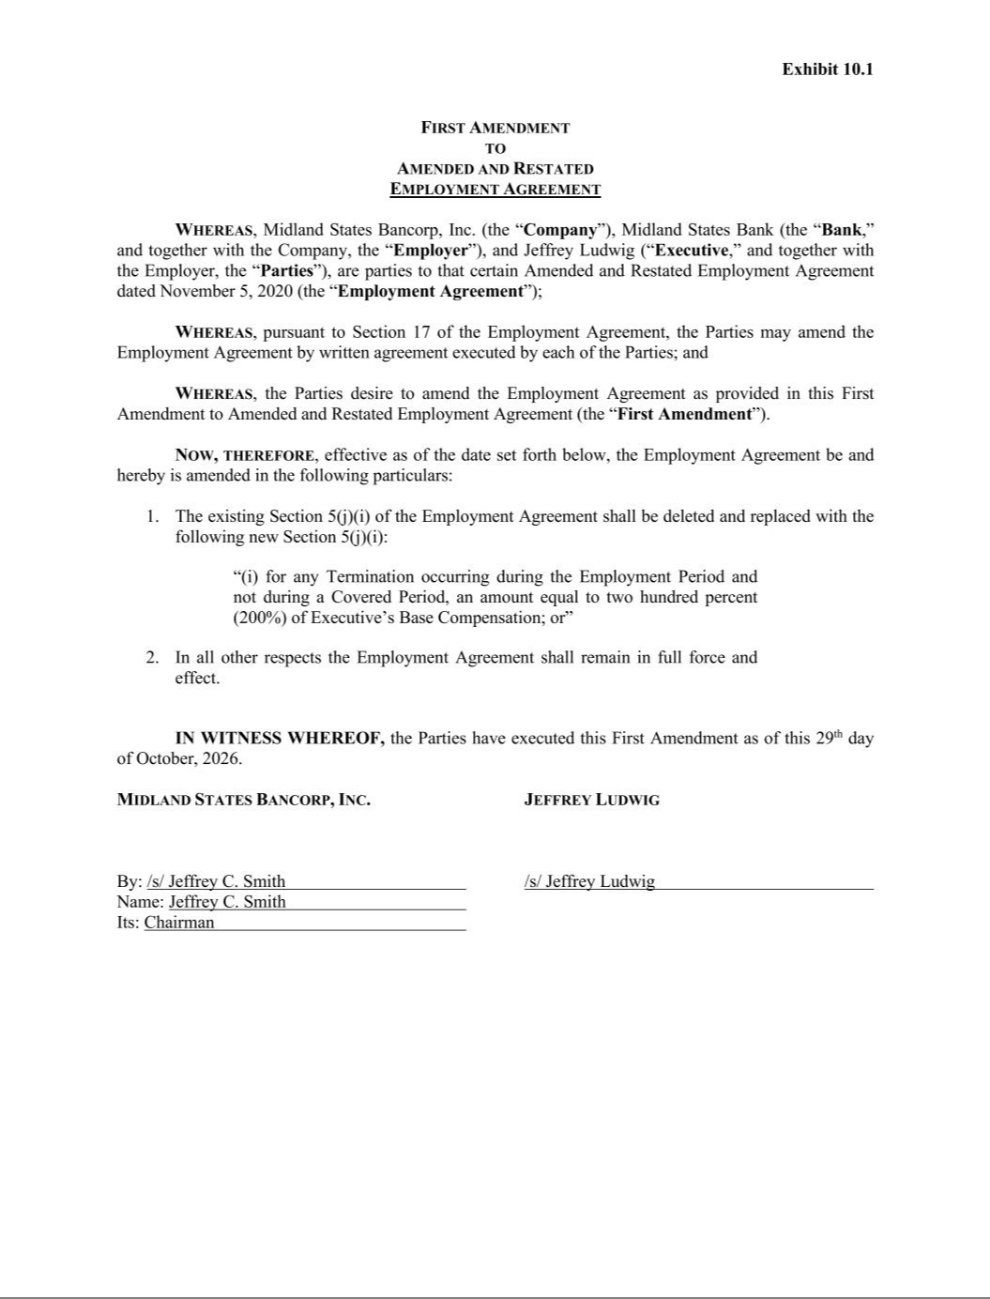

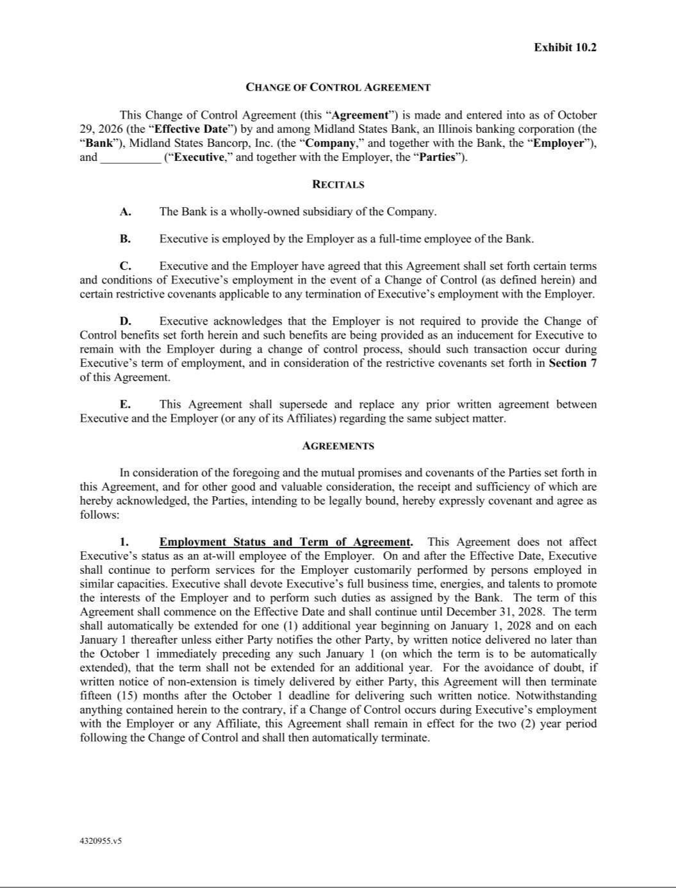

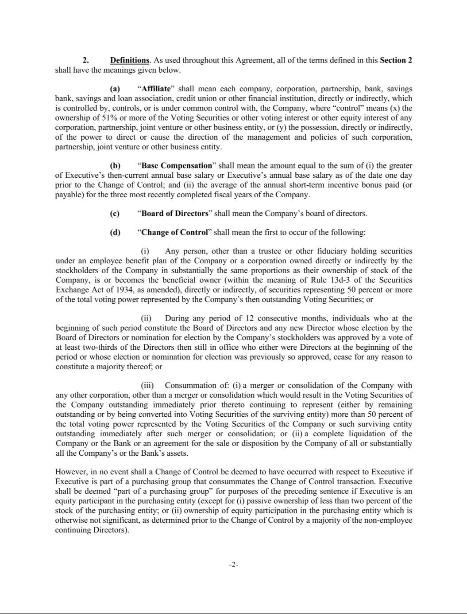

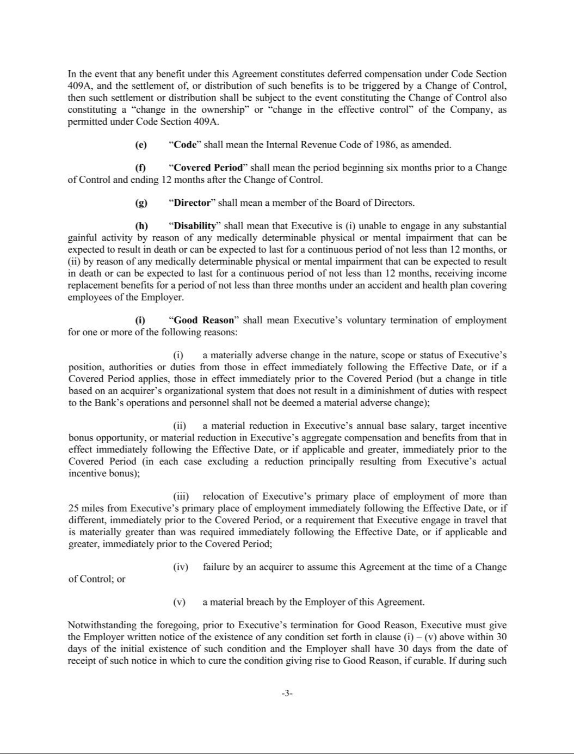

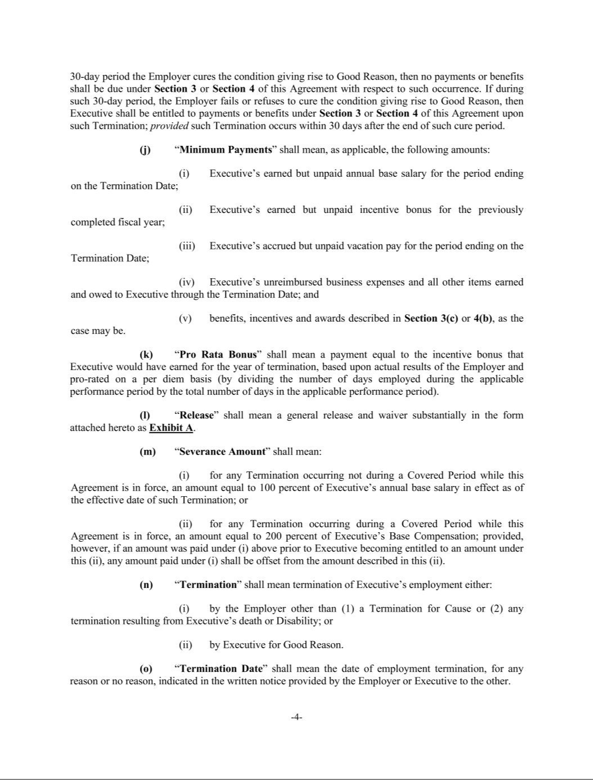

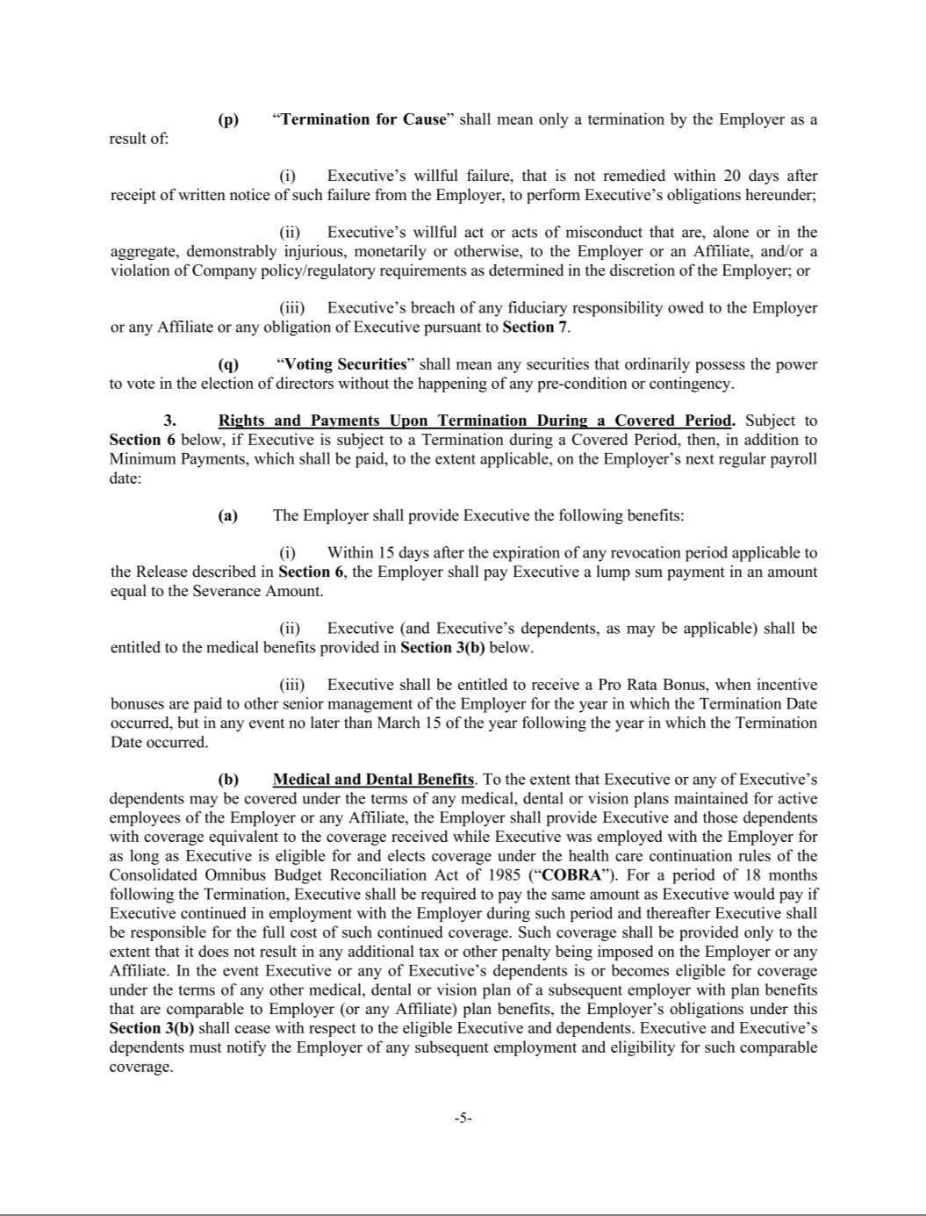

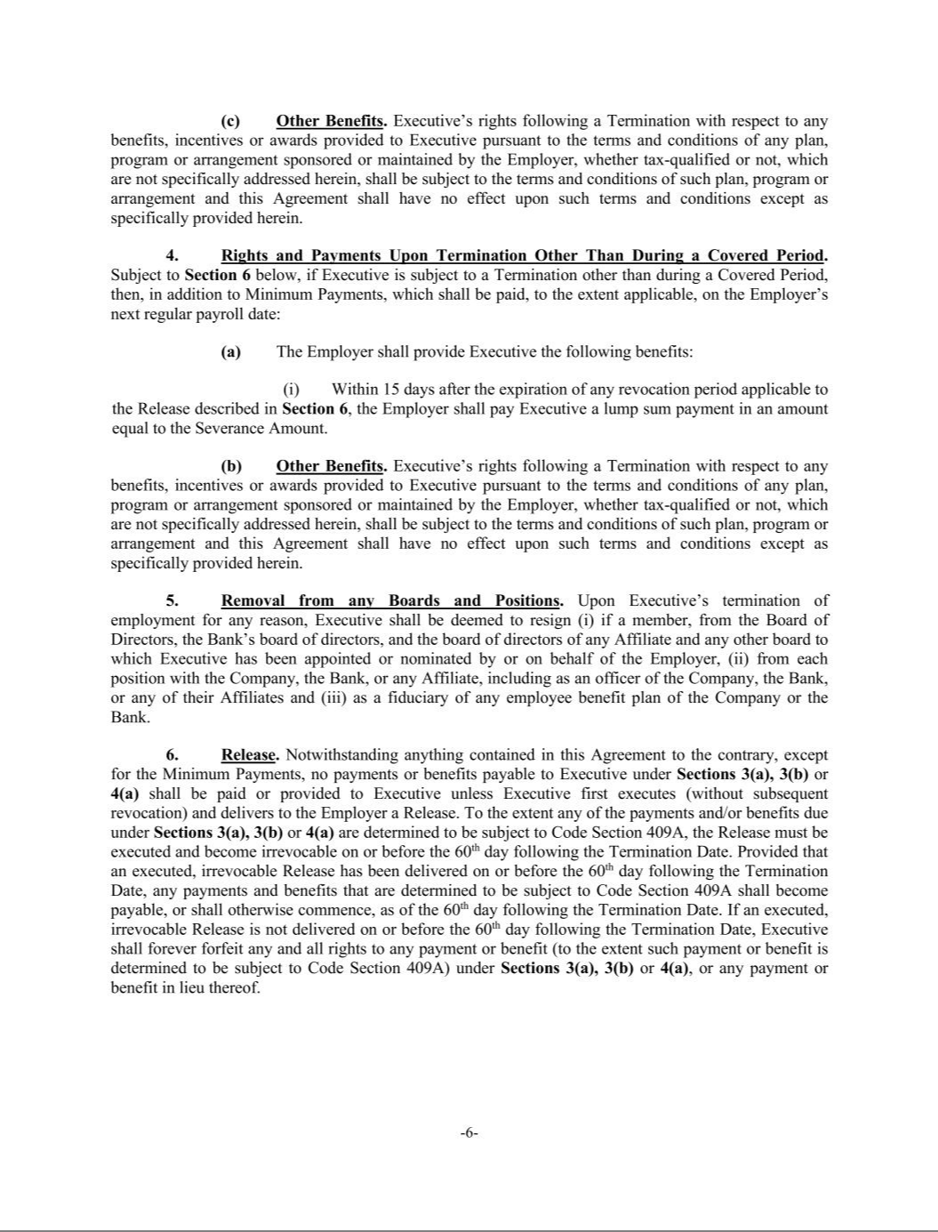

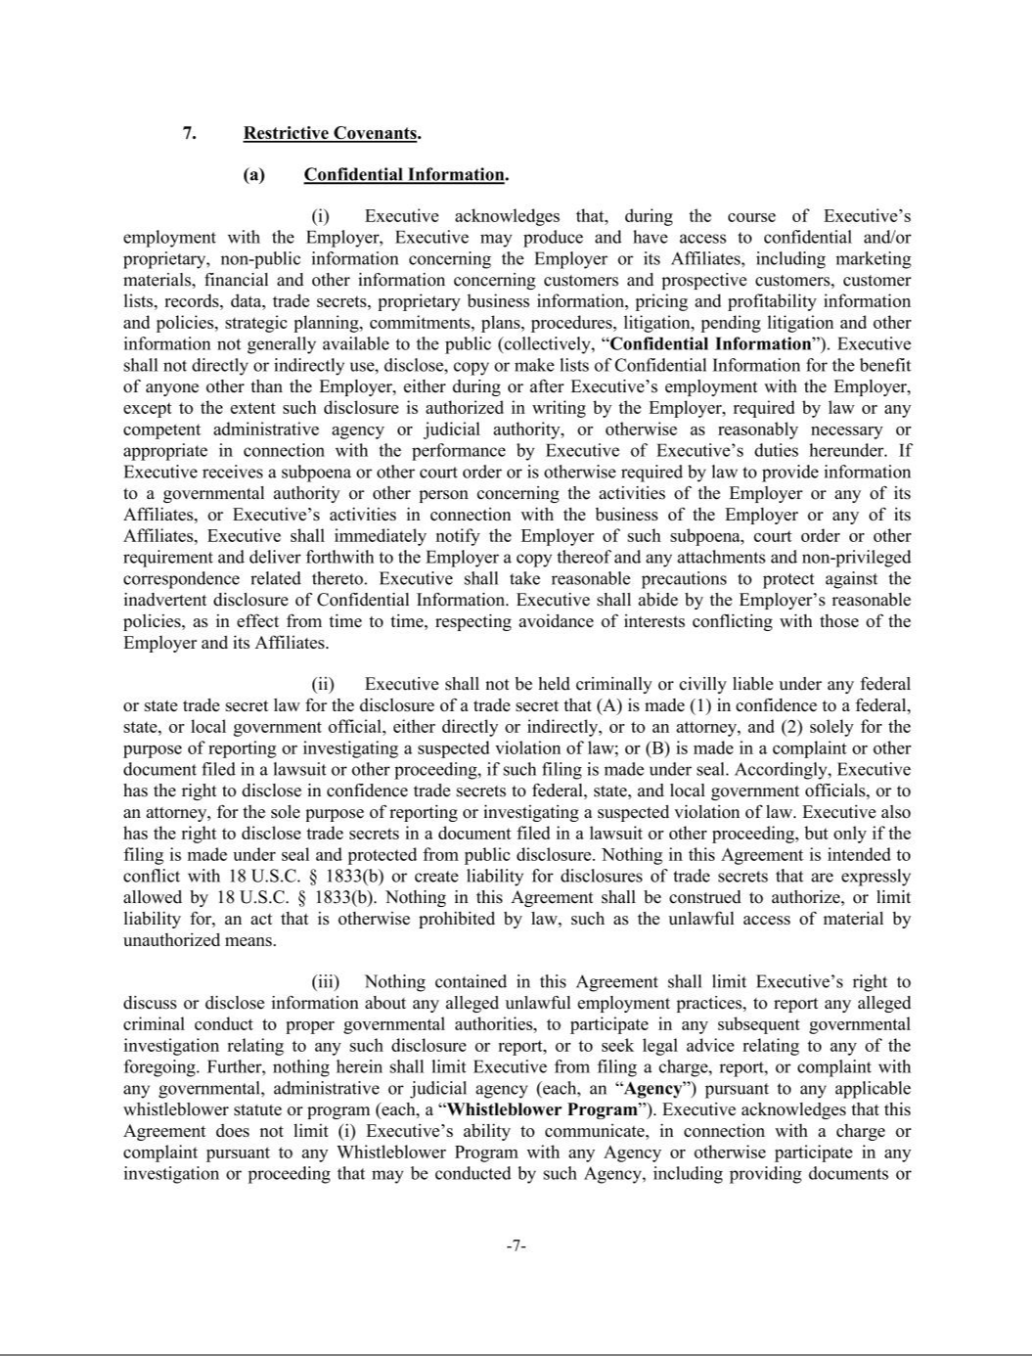

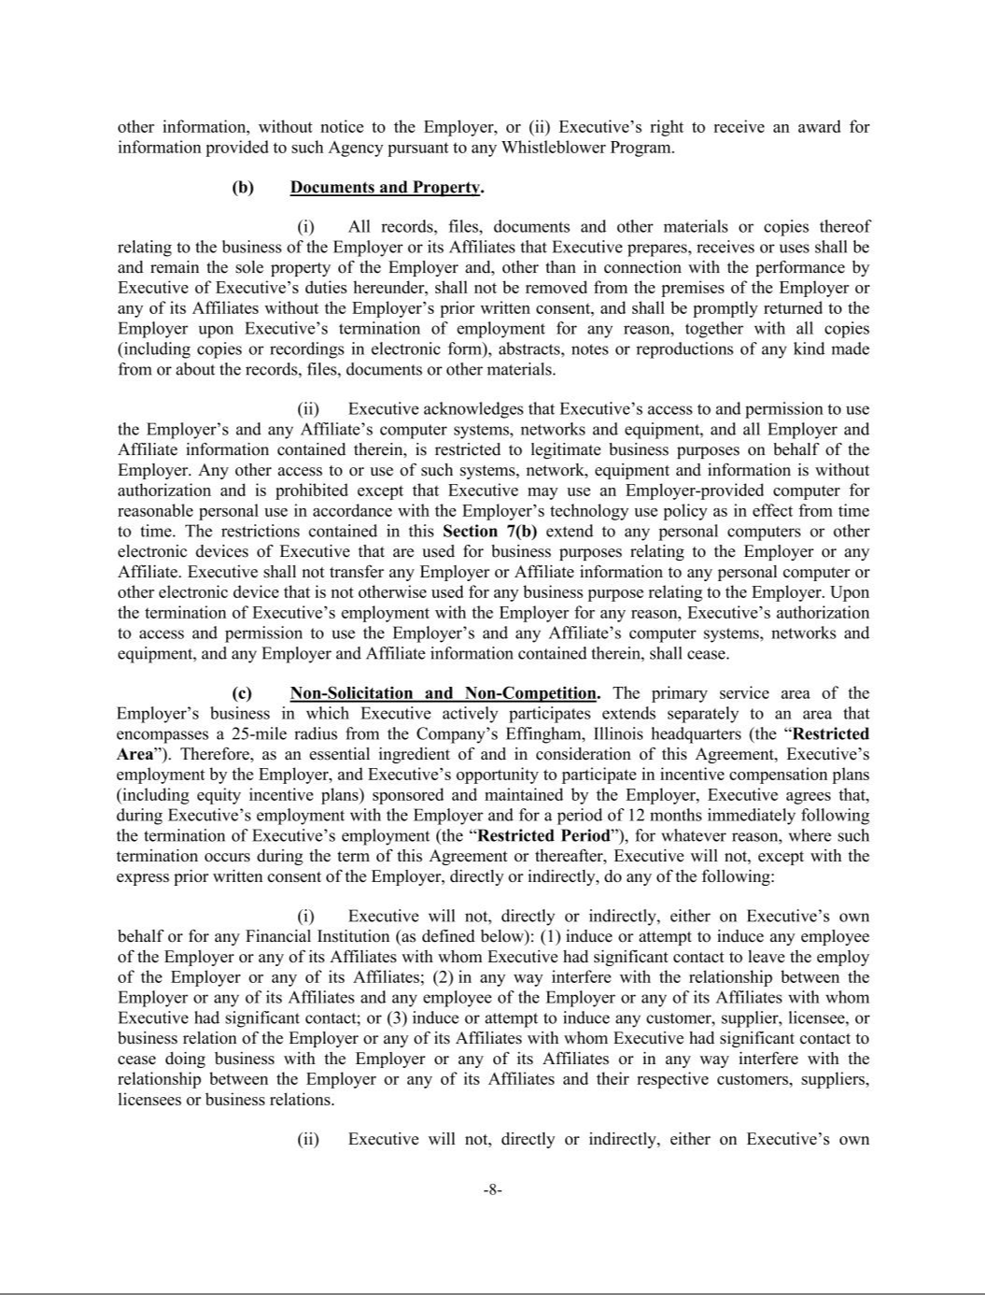

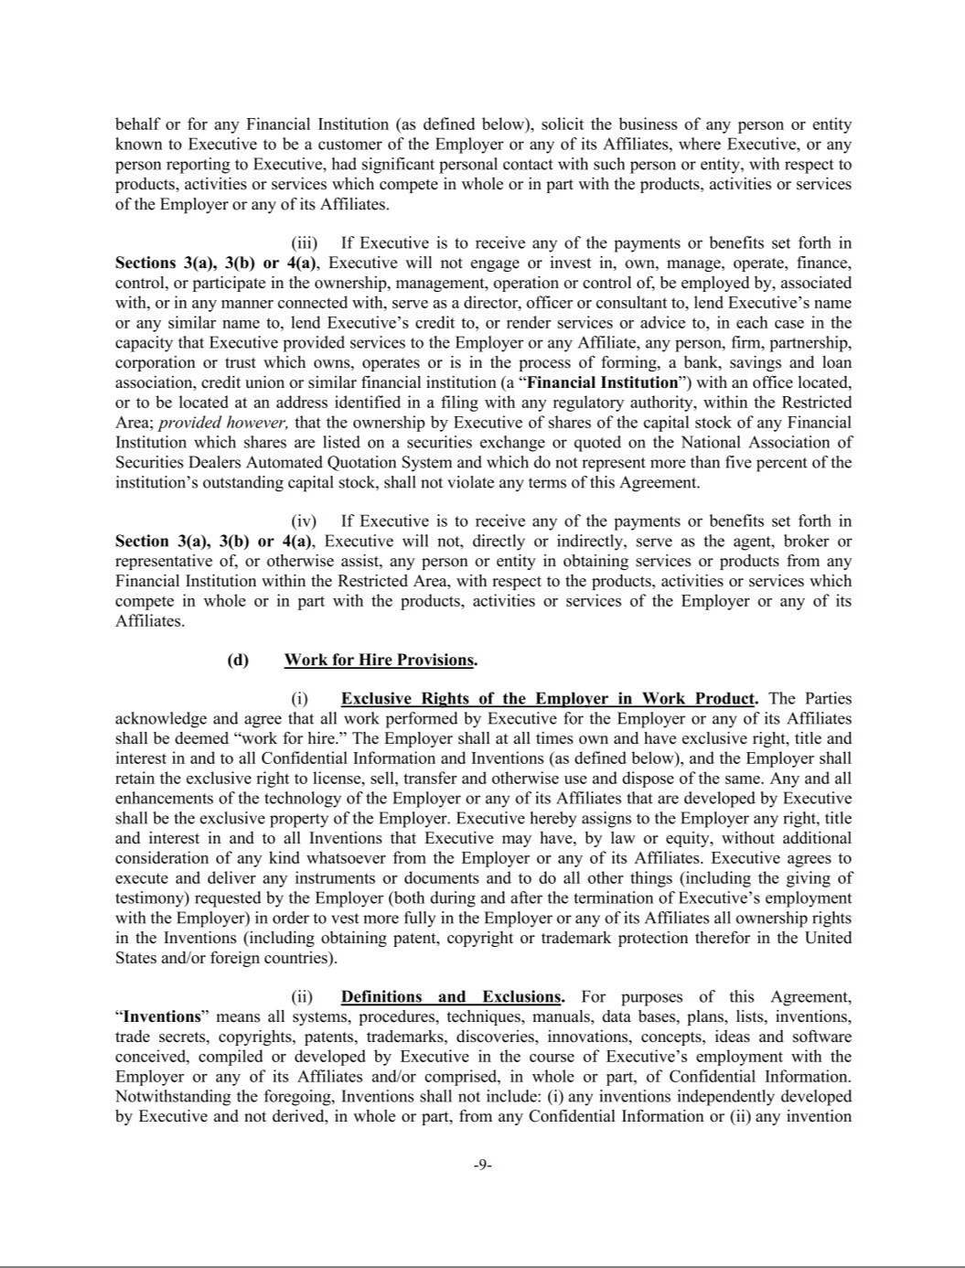

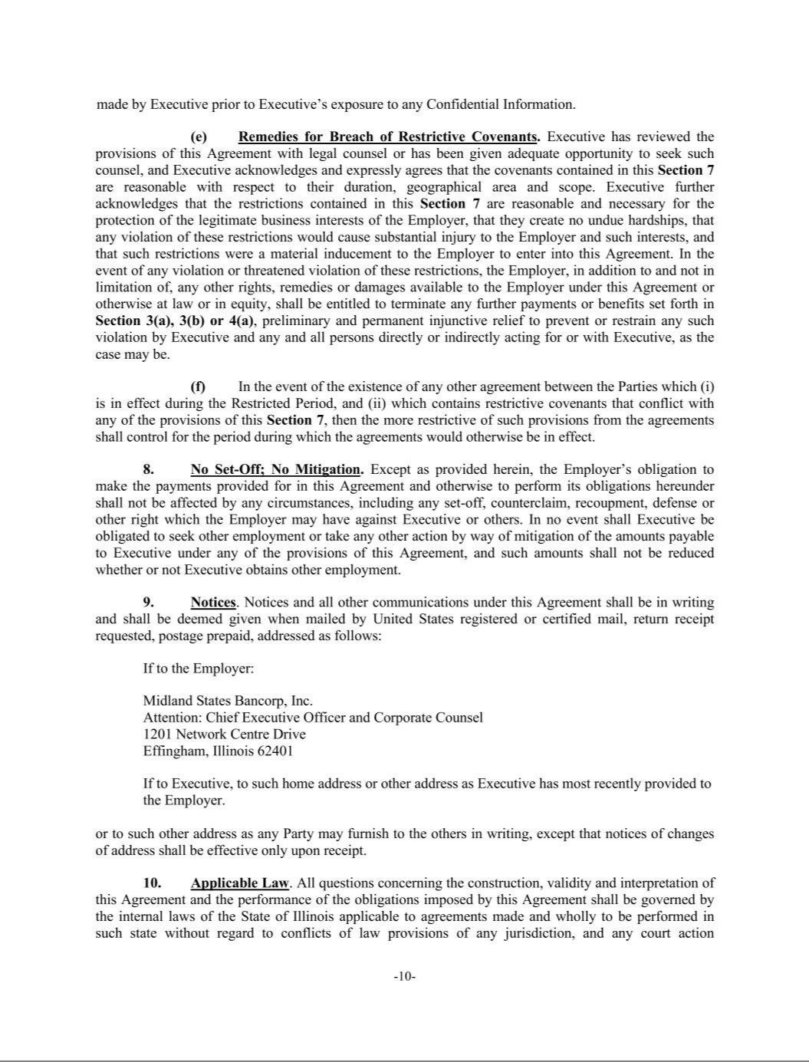

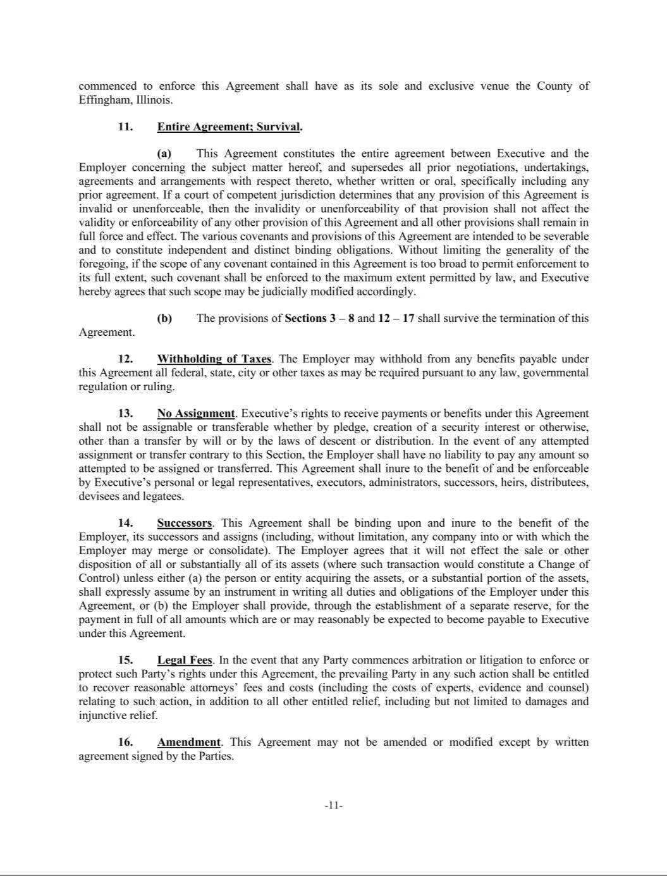

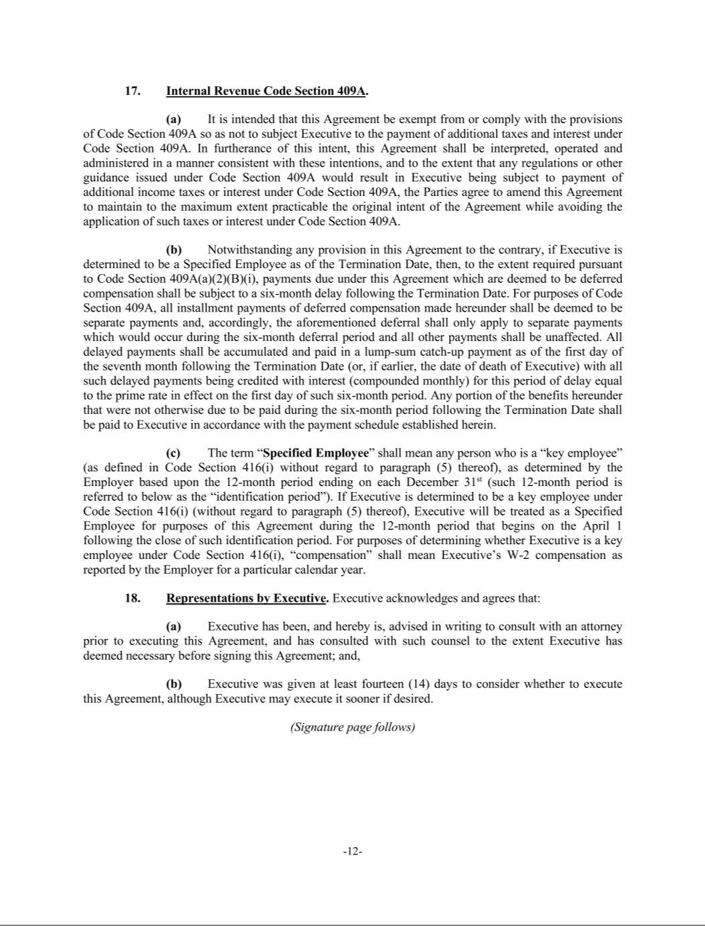



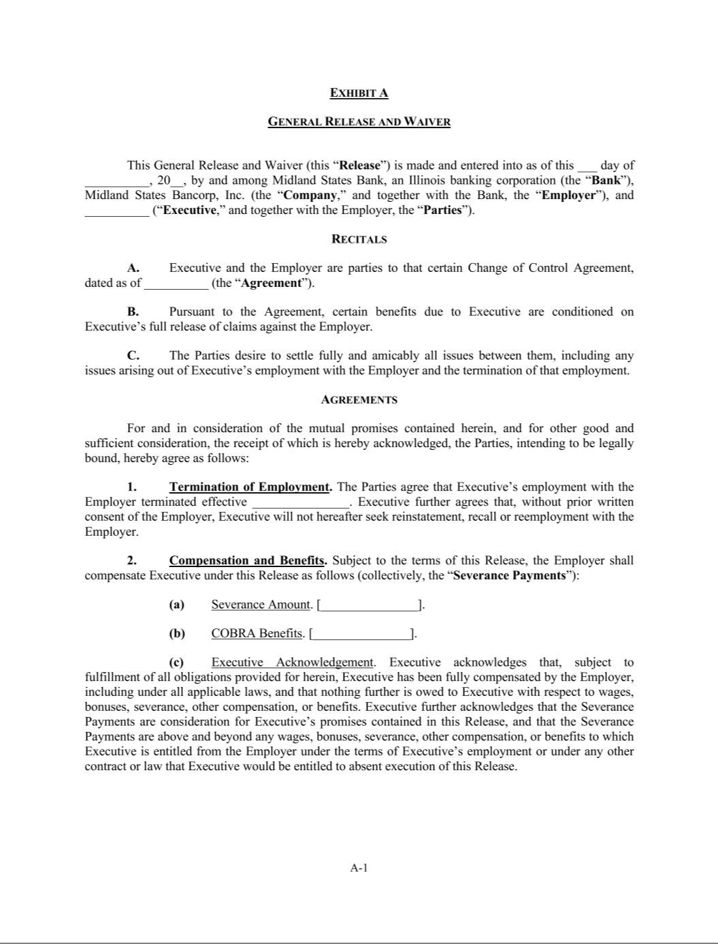

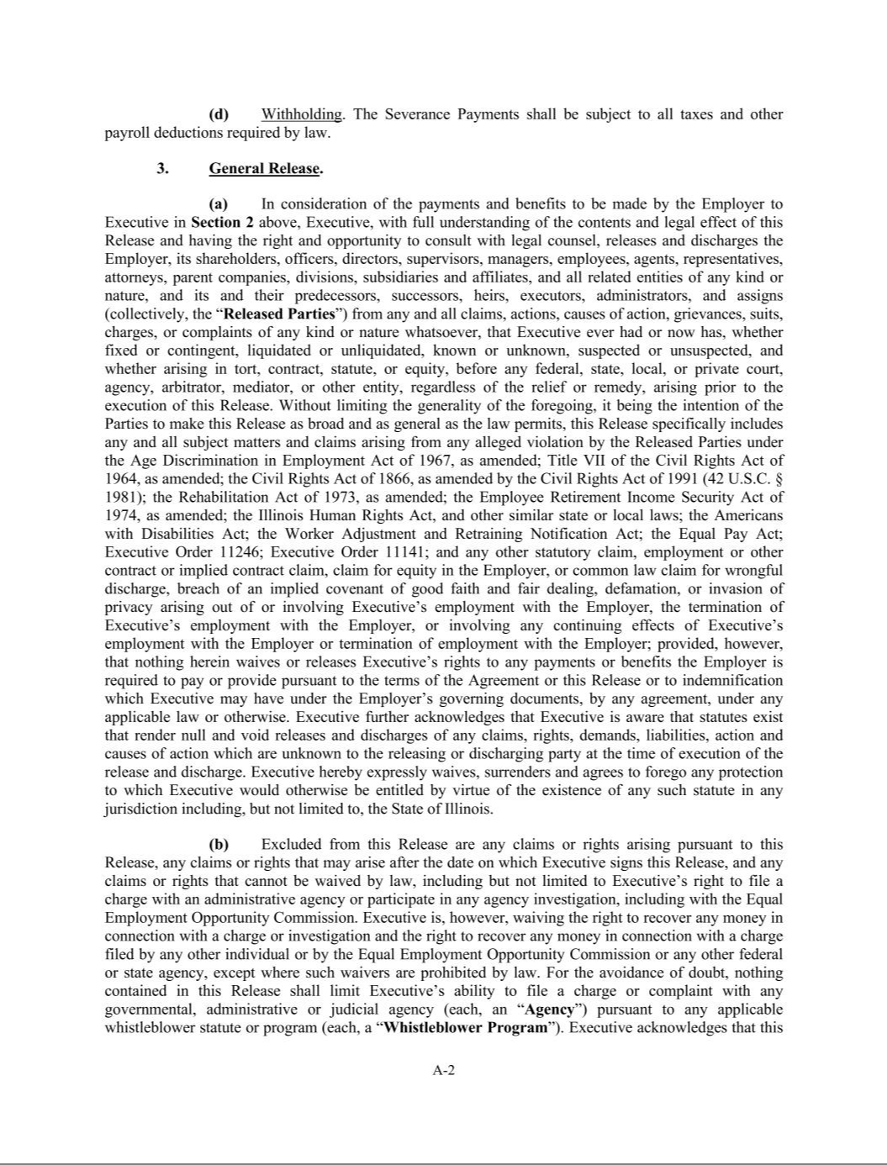

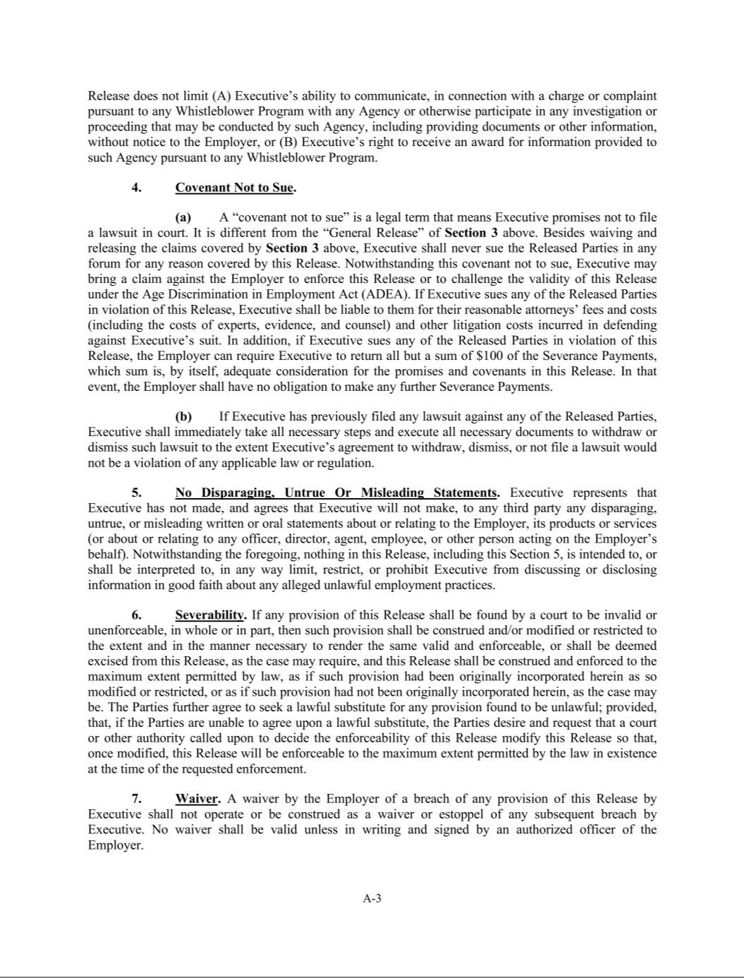

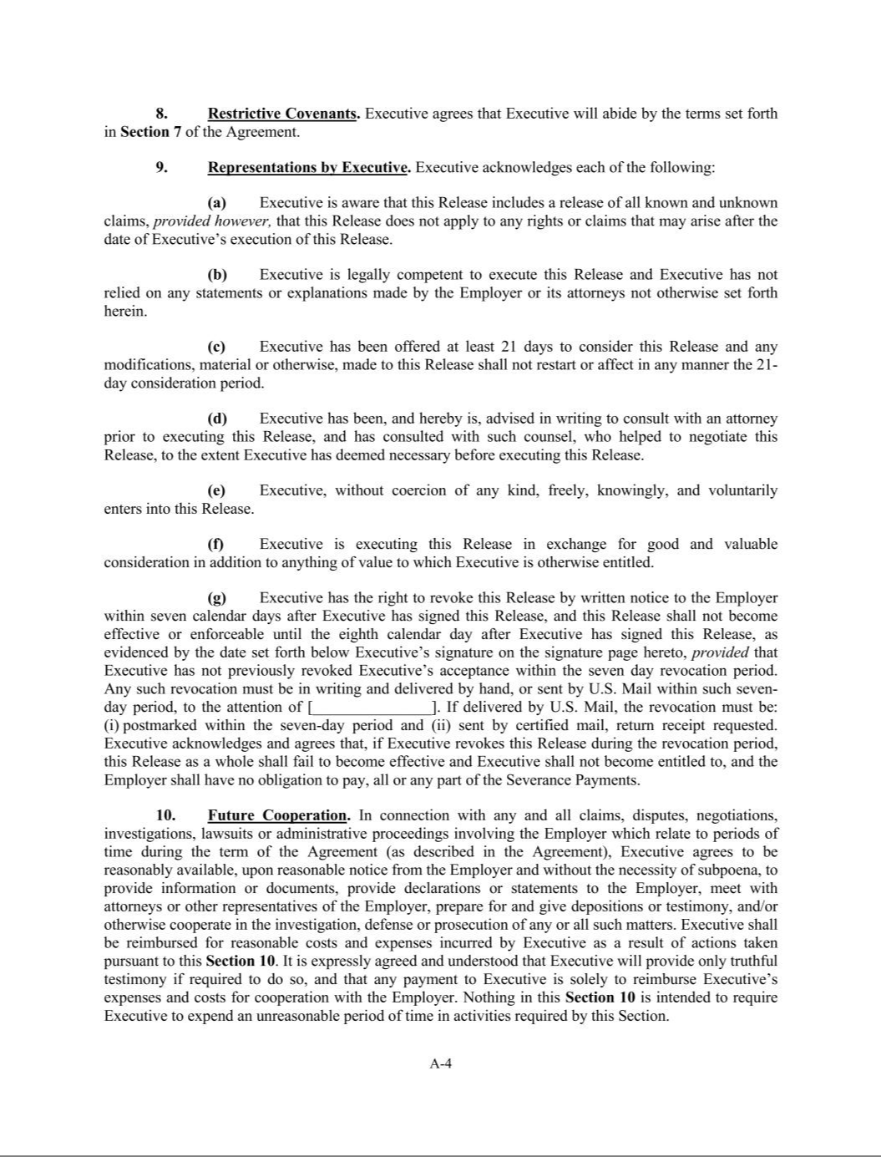

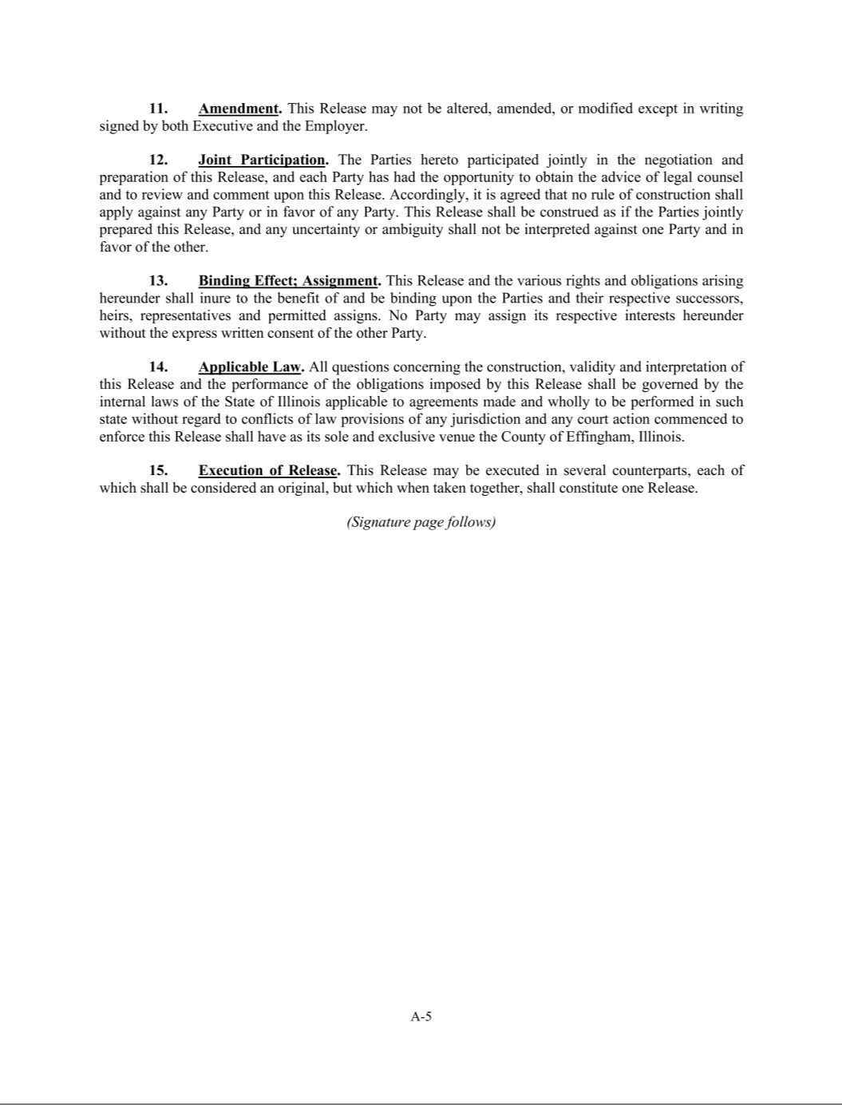



Exhibit 21.1

LIST OF SUBSIDIARIES OF MIDLAND STATES BANCORP, INC.

Subsidiary |  | Organized Under Laws of |  | Percent Owned by the Company
Midland States Bank |  | State of Illinois |  | 100%
Midland Wealth Advisors LLC |  | State of Illinois |  | 100%
Midland Wealth Insurance Services LLC |  | State of Illinois |  | 100%
Midland States Preferred Securities Trust |  | State of Delaware |  | 100% of common securities
Love Savings/Heartland Capital Trust III |  | State of Delaware |  | 100% of common securities
Love Savings/Heartland Capital Trust IV |  | State of Delaware |  | 100% of common securities
Grant Park Statutory Trust I |  | State of Delaware |  | 100% of common securities
Centrue Statutory Trust II |  | State of Connecticut |  | 100% of common securities
Midland Trust Company |  | State of Illinois |  | 100% owned by Midland States Bank
Midland States Investments Inc. |  | State of Nevada |  | 100% owned by Midland States Bank

Exhibit 31.1

CERTIFICATIONS REQUIRED BY

RULE 13a-14(a) OR RULE 15d-14(a)

UNDER THE SECURITIES EXCHANGE ACT OF 1934

I, Jeffrey G. Ludwig, certify that:

- I have reviewed this Quarterly Report on Form 10-Q (the “Report”) of Midland States Bancorp, Inc. (the “Registrant”);

- Based on my knowledge, this Report does not contain any untrue statement of a material fact or omit to state a material fact necessary to make the statements made, in light of the circumstances under which such statements were made, not misleading with respect to the period covered by this Report;

- Based on my knowledge, the financial statements, and other financial information included in this Report, fairly present in all material respects the financial condition, results of operations and cash flows of the Registrant as of, and for, the periods presented in this Report;

- The Registrant’s other certifying officer(s) and I are responsible for establishing and maintaining disclosure controls and procedures (as defined in Exchange Act Rules 13a-15(e) and 15d-15(e)) and internal control over financial reporting (as defined in Exchange Act Rules 13a-15(f) and 15d-15(f)) for the Registrant and have:

  - Designed such disclosure controls and procedures, or caused such disclosure controls and procedures to be designed under our supervision, to ensure that material information relating to the Registrant, including its consolidated subsidiaries, is made known to us by others within those entities, particularly during the period in which this Report is being prepared;

  - Designed such internal control over financial reporting, or caused such internal control over financial reporting to be designed under our supervision, to provide reasonable assurance regarding the reliability of financial reporting and the preparation of financial statements for external purposes in accordance with generally accepted accounting principles;

  - Evaluated the effectiveness of the Registrant’s disclosure controls and procedures and presented in this Report our conclusions about the effectiveness of the disclosure controls and procedures, as of the end of the period covered by this Report based on such evaluation; and

  - Disclosed in this Report any change in the Registrant’s internal control over financial reporting that occurred during the Registrant’s most recent fiscal quarter (the Registrant’s fourth fiscal quarter in the case of an annual report) that has materially affected, or is reasonably likely to materially affect, the Registrant’s internal control over financial reporting; and

- The Registrant’s other certifying officer(s) and I have disclosed, based on our most recent evaluation of internal control over financial reporting, to the Registrant’s auditors and the audit committee of the Registrant’s board of directors (or persons performing the equivalent functions):

  - All significant deficiencies and material weaknesses in the design or operation of internal control over financial reporting which are reasonably likely to adversely affect the Registrant’s ability to record, process, summarize and report financial information; and

  - Any fraud, whether or not material, that involves management or other employees who have a significant role in the Registrant’s internal control over financial reporting.

Midland States Bancorp, Inc.

Dated as of: October 29, 2026 By: /s/ Jeffrey G. Ludwig

Jeffrey G. Ludwig

President and Chief Executive Officer

(Principal Executive Officer)

Exhibit 31.2

CERTIFICATIONS REQUIRED BY

RULE 13a-14(a) OR RULE 15d-14(a)

UNDER THE SECURITIES EXCHANGE ACT OF 1934

I, Claire A. Stack, certify that:

- I have reviewed this Quarterly Report on Form 10-Q (the “Report”) of Midland States Bancorp, Inc. (the “Registrant”);

- Based on my knowledge, this Report does not contain any untrue statement of a material fact or omit to state a material fact necessary to make the statements made, in light of the circumstances under which such statements were made, not misleading with respect to the period covered by this Report;

- Based on my knowledge, the financial statements, and other financial information included in this Report, fairly present in all material respects the financial condition, results of operations and cash flows of the Registrant as of, and for, the periods presented in this Report;

- The Registrant’s other certifying officer(s) and I are responsible for establishing and maintaining disclosure controls and procedures (as defined in Exchange Act Rules 13a-15(e) and 15d-15(e)) and internal control over financial reporting (as defined in Exchange Act Rules 13a-15(f) and 15d-15(f)) for the Registrant and have:

  - Designed such disclosure controls and procedures, or caused such disclosure controls and procedures to be designed under our supervision, to ensure that material information relating to the Registrant, including its consolidated subsidiaries, is made known to us by others within those entities, particularly during the period in which this Report is being prepared;

  - Designed such internal control over financial reporting, or caused such internal control over financial reporting to be designed under our supervision, to provide reasonable assurance regarding the reliability of financial reporting and the preparation of financial statements for external purposes in accordance with generally accepted accounting principles;

  - Evaluated the effectiveness of the Registrant’s disclosure controls and procedures and presented in this Report our conclusions about the effectiveness of the disclosure controls and procedures, as of the end of the period covered by this Report based on such evaluation; and

  - Disclosed in this Report any change in the Registrant’s internal control over financial reporting that occurred during the Registrant’s most recent fiscal quarter (the Registrant’s fourth fiscal quarter in the case of an annual report) that has materially affected, or is reasonably likely to materially affect, the Registrant’s internal control over financial reporting; and

- The Registrant’s other certifying officer(s) and I have disclosed, based on our most recent evaluation of internal control over financial reporting, to the Registrant’s auditors and the audit committee of the Registrant’s board of directors (or persons performing the equivalent functions):

  - All significant deficiencies and material weaknesses in the design or operation of internal control over financial reporting which are reasonably likely to adversely affect the Registrant’s ability to record, process, summarize and report financial information; and

  - Any fraud, whether or not material, that involves management or other employees who have a significant role in the Registrant’s internal control over financial reporting.

Midland States Bancorp, Inc.

Dated as of: October 29, 2026 By: /s/ Claire A. Stack

Claire A. Stack

Chief Financial Officer

(Principal Financial Officer and Principal Accounting Officer)

Exhibit 32.1

CERTIFICATIONS PURSUANT TO

18 U.S.C. SECTION 1350,

AS ADOPTED PURSUANT TO

SECTION 906 OF THE SARBANES-OXLEY ACT OF 2002

I, Jeffrey G. Ludwig, President and Chief Executive Officer of Midland States Bancorp, Inc. (the “Company”) certify, pursuant to 18 U.S.C. Section 1350, as adopted pursuant to Section 906 of the Sarbanes-Oxley Act of 2002, that to the best of my knowledge:

- The Quarterly Report on Form 10-Q of the Company for the quarterly period ended September 30, 2026 (the “Report”) fully complies with the requirements of Sections 13(a) or 15(d) of the Securities Exchange Act of 1934; and

- The information contained in the Report fairly presents, in all material respects, the financial condition and results of operations of the Company.

 | Midland States Bancorp, Inc.
Dated as of: October 29, 2026 | By: | /s/ | Jeffrey G. Ludwig
 |  |  | Jeffrey G. Ludwig

President and Chief Executive Officer

(Principal Executive Officer)

Exhibit 32.2

CERTIFICATIONS PURSUANT TO

18 U.S.C. SECTION 1350,

AS ADOPTED PURSUANT TO

SECTION 906 OF THE SARBANES-OXLEY ACT OF 2002

I, Claire A. Stack, Chief Financial Officer of Midland States Bancorp, Inc. (the “Company”) certify, pursuant to 18 U.S.C. Section 1350, as adopted pursuant to Section 906 of the Sarbanes-Oxley Act of 2002, that to the best of my knowledge:

- The Quarterly Report on Form 10-Q of the Company for the quarterly period ended September 30, 2026 (the “Report”) fully complies with the requirements of Sections 13(a) or 15(d) of the Securities Exchange Act of 1934; and

- The information contained in the Report fairly presents, in all material respects, the financial condition and results of operations of the Company.

 | Midland States Bancorp, Inc.
Dated as of: October 29, 2026 | By: | /s/ | Claire A. Stack
 |  |  | Claire A. Stack
 |  |  | Chief Financial Officer
 |  |  | (Principal Financial Officer and Principal Accounting Officer)

