UNITED STATES
SECURITIES AND EXCHANGE COMMISSION
WASHINGTON, DC 20549
FORM 8-K
CURRENT REPORT
Pursuant to Section 13 OR 15(d) of the Securities Exchange Act of 1934
Date of Report (Date of earliest event reported): October 22, 2026
Midland States Bancorp, Inc.
(Exact Name of Registrant as Specified in Its Charter)
Illinois |  |  |  |  |  | 001-35272 |  |  |  |  |  | 37-1233196
(State or Other Jurisdiction of Incorporation) |  |  |  |  |  | (Commission File Number) |  |  |  |  |  | (IRS Employer Identification No.)

1201 Network Centre Drive
Effingham, Illinois 62401
(Address of Principal Executive Offices) (Zip Code)

(217) 342-7321
(Registrant’s Telephone Number, Including Area Code)
N/A
(Former Name or Former Address, if Changed Since Last Report)
Check the appropriate box below if the Form 8-K filing is intended to simultaneously satisfy the filing obligation of the registrant under any of the following provisions (see General Instruction A.2. below):
☐ |  |  | Written communications pursuant to Rule 425 under the Securities Act (17 CFR 230.425)
☐ |  |  | Soliciting material pursuant to Rule 14a-12 under the Exchange Act (17 CFR 240.14a-12)
☐ |  |  | Pre-commencement communications pursuant to Rule 14d-2(b) under the Exchange Act (17 CFR 240.14d-2(b))
☐ |  |  | Pre-commencement communications pursuant to Rule 13e-4(c) under the Exchange Act (17 CFR 240.13e-4(c))
Securities registered pursuant to Section 12(b) of the Act:
Title of each class |  |  | Trading symbol(s) |  |  | Name of each exchange on which registered
Common Stock, $0.01 par value |  |  | MSBI |  |  | The Nasdaq Market LLC
Depositary Shares, each representing a 1/40th interest in a share of 7.75% fixed rate reset non-cumulative perpetual preferred stock, Series A, $2.00 par value |  |  | MSBIP |  |  | The Nasdaq Market LLC
Indicate by check mark whether the registrant is an emerging growth company as defined in Rule 405 of the Securities Act of 1933 (§230.405 of this chapter) or Rule 12b-2 of the Securities Exchange Act of 1934 (§240.12b-2 of this chapter).
Emerging growth company ☐
If an emerging growth company, indicate by check mark if the registrant has elected not to use the extended transition period for complying with any new or revised financial accounting standards provided pursuant to Section 13(a) of the Exchange Act. ☐

Item 2.02. Results of Operations and Financial Condition.
On October 22, 2026, Midland States Bancorp, Inc. (the “Company”) issued a press release announcing its financial results for the third quarter of 2026. The press release is attached as Exhibit 99.1.

Item 7.01. Regulation FD Disclosure.
On October 22, 2026, the Company made available on its website an updated investor presentation regarding the Company’s recent financial results, which it intends to use in meetings with investors, analysts, and any other interest parties from time to time. The slide presentation is attached as Exhibit 99.2.

The information set forth under Items 2.02 and 7.01 in this Form 8-K and the attached exhibits shall not be deemed “filed” for purposes of Section 18 of the Securities Exchange Act of 1934, as amended, and shall not be deemed incorporated by reference in any filing under the Securities Act of 1933, as amended, except as shall be expressly set forth by specific reference in any such filing.

Item 9.01. Financial Statements and Exhibits.
(d) Exhibits.
Exhibit No. |  |  |  |  |  | Description
99.1 |  |  |  |  |  | Press Release of Midland States Bancorp, Inc., dated October 22, 2026
99.2 |  |  |  |  |  | Slide Presentation of Midland States Bancorp, Inc. regarding third quarter 2026 financial results
104 |  |  |  |  |  | Cover Page Interactive Data File (embedded within the Inline XBRL document)
SIGNATURE
Pursuant to the requirements of the Securities Exchange Act of 1934, the Registrant has duly caused this report to be signed on its behalf by the undersigned thereunto duly authorized.
Date: October 22, 2026 |  |  | By: |  |  | /s/ Claire A. Stack
 |  |  |  |  |  | Claire A. Stack
 |  |  |  |  |  | Chief Financial Officer

EXHIBIT 99.1

Midland States Bancorp, Inc. Announces 2026 Third Quarter Results
Effingham, IL, October 22, 2026 (GLOBE NEWSWIRE) -- Midland States Bancorp, Inc. (Nasdaq: MSBI) (the “Company”) today reported net income available to common shareholders of $20.6 million, or $0.95 per diluted share, for the third quarter of 2026, compared to net income available to common shareholders of $17.7 million, or $0.82 per diluted share, for the second quarter of 2026. This also compares to net income available to common shareholders of $5.3 million, or $0.24 per diluted share, for the third quarter of 2025.

2026 Third Quarter Results

•Net income available to common shareholders of $20.6 million, or $0.95 per diluted share
•Return on average assets of 1.35% and return on average tangible common equity of 18.50%
•Net interest margin of 4.03% compared to 3.98% in the prior quarter; current quarter included a $1.6 million interest recovery on the payoff of a nonaccrual loan
•Total loans increased $39.1 million, including $23.7 million of net growth in the Community Bank loan portfolio, or 2.8% annualized, during the quarter
•Total capital to risk-weighted assets of 15.60% and common equity tier 1 capital of 10.36%
•Ratio of nonperforming assets to total assets of 0.86%, a decrease of five basis points compared to prior quarter
Discussion of Outlook; President & Chief Executive Officer, Jeffrey G. Ludwig:
“Our third quarter results reflect another solid quarter of execution and continued progress toward building a higher-performing community bank. We delivered diluted earnings per share of $0.95 and a 1.35% return on average assets while maintaining strong net interest margin. The Community Bank generated loan growth, while we continued the planned runoff of non-core portfolios, further improving the composition of our balance sheet.

"We also made meaningful progress resolving legacy credit issues. Past-due, substandard and nonperforming loans declined, net charge-offs moderated from the prior quarter, and our nonperforming asset ratio improved to 0.86%. We remain disciplined in addressing the remaining legacy credits while supporting high-quality loan growth in our markets.

"Strong earnings continued to support our capital position. We enter the fourth quarter with solid momentum and remain focused on profitable relationship growth, continued credit normalization and disciplined capital deployment to support long-term shareholder value.”

1
Financial Highlights and Key Performance Indicators
 |  |  |  |  |  | As of and for the Three Months Ended
 |  |  |  |  |  | September 30, |  |  |  |  |  | June 30, |  |  |  |  |  | March 31, |  |  |  |  |  | December 31, |  |  |  |  |  | September 30,
(dollars in thousands, except per share data) |  |  |  |  |  | 2026 |  |  |  |  |  | 2026 |  |  |  |  |  | 2026 |  |  |  |  |  | 2025 |  |  |  |  |  | 2025
Diluted earnings (loss) per common share |  |  |  |  |  | $ | 0.95 |  |  |  |  | $ | 0.82 |  |  |  |  | $ | 0.74 |  |  |  |  | $ | (0.24) |  |  |  |  | $ | 0.24
Return on average assets (annualized) |  |  |  |  |  | 1.35 |  | % |  |  |  | 1.22 |  | % |  |  |  | 1.16 |  | % |  |  |  | (0.17) |  | % |  |  |  | 0.43 |  | %
Return on average tangible common equity (annualized) (1) |  |  |  |  |  | 18.50 |  | % |  |  |  | 16.27 |  | % |  |  |  | 14.88 |  | % |  |  |  | (4.46) |  | % |  |  |  | 4.72 |  | %
Adjusted pre-provision net revenue to average assets (annualized) (1) |  |  |  |  |  | 1.96 |  | % |  |  |  | 2.01 |  | % |  |  |  | 1.91 |  | % |  |  |  | 1.86 |  | % |  |  |  | 1.81 |  | %
Net interest margin (annualized) |  |  |  |  |  | 4.03 |  | % |  |  |  | 3.98 |  | % |  |  |  | 3.91 |  | % |  |  |  | 3.74 |  | % |  |  |  | 3.79 |  | %
Efficiency ratio (1) |  |  |  |  |  | 61.34 |  | % |  |  |  | 60.61 |  | % |  |  |  | 62.17 |  | % |  |  |  | 63.01 |  | % |  |  |  | 61.01 |  | %
Noninterest expense to average assets |  |  |  |  |  | 3.13 |  | % |  |  |  | 3.12 |  | % |  |  |  | 3.16 |  | % |  |  |  | 4.54 |  | % |  |  |  | 2.86 |  | %
Net charge-offs to average loans (annualized) |  |  |  |  |  | 0.50 |  | % |  |  |  | 1.17 |  | % |  |  |  | 0.64 |  | % |  |  |  | 3.69 |  | % |  |  |  | 0.99 |  | %
Tangible book value per share at period end (1) |  |  |  |  |  | $ | 19.52 |  |  |  |  | $ | 21.41 |  |  |  |  | $ | 20.77 |  |  |  |  | $ | 20.70 |  |  |  |  | $ | 21.16
Tangible book value per share, excluding AOCI at period end (1) |  |  |  |  |  | $ | 25.39 |  |  |  |  | $ | 24.69 |  |  |  |  | $ | 24.11 |  |  |  |  | $ | 23.55 |  |  |  |  | $ | 24.08
Common shares outstanding at period end |  |  |  |  |  | 20,801,859 |  |  |  |  |  | 20,725,814 |  |  |  |  |  | 20,813,975 |  |  |  |  |  | 21,169,854 |  |  |  |  |  | 21,543,557
Trust assets under administration |  |  |  |  |  | $ | 4,770,581 |  |  |  |  | $ | 4,782,625 |  |  |  |  | $ | 4,474,234 |  |  |  |  | $ | 4,478,999 |  |  |  |  | $ | 4,363,756
(1) Non-GAAP financial measures. Refer to pages 10-12 for a reconciliation to the comparable GAAP financial measures.
Key Points for Third Quarter and Outlook
Growth Trends in Community Bank & Wealth Management

•Total loans at September 30, 2026 were $4.28 billion, an increase of $39.1 million from June 30, 2026. Key changes in the loan portfolio were as follows:

◦Community Bank balances increased $23.7 million, or 2.8% annualized.

◦Specialty finance loans increased $28.0 million to $560.1 million from June 30, 2026.

◦Non-core loans, which include our third-party lending and servicing programs and remaining equipment finance portfolio, decreased $12.7 million to $295.7 million from June 30, 2026.

•Total deposits were $5.62 billion at September 30, 2026, a decrease of $89.8 million from June 30, 2026. Key changes in deposits were as follows:

◦Retail deposits decreased $112.7 million, primarily reflecting $115.7 million of balance reductions resulting from actions taken to manage liquidity and deposit pricing.

◦Commercial and public funds deposits increased $35.7 million and $33.7 million, respectively.

◦Servicing and higher-cost brokered deposits decreased $26.5 million and $7.9 million, respectively.

2
•Wealth Management revenue totaled $8.7 million in the third quarter of 2026. Assets under administration remained stable at $4.77 billion at September 30, 2026, compared to $4.78 billion at June 30, 2026.

Net Interest Margin

•Net interest margin increased five basis points to 4.03% in the third quarter of 2026, benefiting from a $1.6 million interest recovery on the payoff of a nonaccrual loan and continued balance sheet and interest rate risk management, partially offset by higher funding costs. The cost of deposits increased four basis points to 1.82%.

The following table presents the Company’s net interest margin for the third quarter of 2026 compared to the second quarter of 2026 and the third quarter of 2025.

 |  |  |  |  |  | For the Three Months Ended
(dollars in thousands) |  |  |  |  |  | September 30, 2026 |  |  |  |  |  |  |  |  |  |  |  |  |  |  |  |  |  | June 30, 2026 |  |  |  |  |  |  |  |  |  |  |  |  |  |  |  |  |  | September 30, 2025
Interest-earning assets |  |  |  |  |  | Average Balance |  |  |  |  |  | Interest & Fees |  |  |  |  |  | Yield/Rate |  |  |  |  |  | Average Balance |  |  |  |  |  | Interest & Fees |  |  |  |  |  | Yield/Rate |  |  |  |  |  | Average Balance |  |  |  |  |  | Interest & Fees |  |  |  |  |  | Yield/Rate
Cash and cash equivalents |  |  |  |  |  | $ | 149,088 |  |  |  |  | $ | 1,333 |  |  |  |  | 3.55 |  | % |  |  |  | $ | 108,157 |  |  |  |  | $ | 987 |  |  |  |  | 3.66 |  | % |  |  |  | $ | 78,567 |  |  |  |  | $ | 849 |  |  |  |  | 4.29 |  | %
Investment securities (1) |  |  |  |  |  | 1,780,505 |  |  |  |  |  | 22,090 |  |  |  |  |  | 4.92 |  |  |  |  |  | 1,617,474 |  |  |  |  |  | 19,540 |  |  |  |  |  | 4.85 |  |  |  |  |  | 1,338,997 |  |  |  |  |  | 15,979 |  |  |  |  |  | 4.73
Loans (1)(2) |  |  |  |  |  | 4,235,207 |  |  |  |  |  | 69,173 |  |  |  |  |  | 6.48 |  |  |  |  |  | 4,268,168 |  |  |  |  |  | 67,195 |  |  |  |  |  | 6.31 |  |  |  |  |  | 4,947,675 |  |  |  |  |  | 81,012 |  |  |  |  |  | 6.50
Loans held for sale |  |  |  |  |  | 6,054 |  |  |  |  |  | 97 |  |  |  |  |  | 6.36 |  |  |  |  |  | 8,431 |  |  |  |  |  | 128 |  |  |  |  |  | 6.10 |  |  |  |  |  | 9,268 |  |  |  |  |  | 147 |  |  |  |  |  | 6.29
Nonmarketable equity securities |  |  |  |  |  | 29,215 |  |  |  |  |  | 530 |  |  |  |  |  | 7.20 |  |  |  |  |  | 30,285 |  |  |  |  |  | 534 |  |  |  |  |  | 7.07 |  |  |  |  |  | 38,559 |  |  |  |  |  | 715 |  |  |  |  |  | 7.36
Total interest-earning assets |  |  |  |  |  | 6,200,069 |  |  |  |  |  | 93,223 |  |  |  |  |  | 5.97 |  |  |  |  |  | 6,032,515 |  |  |  |  |  | 88,384 |  |  |  |  |  | 5.88 |  |  |  |  |  | 6,413,066 |  |  |  |  |  | 98,702 |  |  |  |  |  | 6.11
Noninterest-earning assets |  |  |  |  |  | 495,446 |  |  |  |  |  |  |  |  |  |  |  |  |  |  |  |  |  | 495,663 |  |  |  |  |  |  |  |  |  |  |  |  |  |  |  |  |  | 498,875
Total assets |  |  |  |  |  | $ | 6,695,515 |  |  |  |  |  |  |  |  |  |  |  |  |  |  |  |  | $ | 6,528,178 |  |  |  |  |  |  |  |  |  |  |  |  |  |  |  |  | $ | 6,911,941
Interest-Bearing Liabilities
Interest-bearing deposits |  |  |  |  |  | $ | 4,720,701 |  |  |  |  | $ | 26,251 |  |  |  |  | 2.21 |  | % |  |  |  | $ | 4,512,697 |  |  |  |  | $ | 24,526 |  |  |  |  | 2.18 |  | % |  |  |  | $ | 4,644,455 |  |  |  |  | $ | 30,219 |  |  |  |  | 2.58 |  | %
Short-term borrowings |  |  |  |  |  | 42,059 |  |  |  |  |  | 349 |  |  |  |  |  | 3.29 |  |  |  |  |  | 28,521 |  |  |  |  |  | 202 |  |  |  |  |  | 2.84 |  |  |  |  |  | 54,839 |  |  |  |  |  | 499 |  |  |  |  |  | 3.61
FHLB advances & other borrowings |  |  |  |  |  | 221,217 |  |  |  |  |  | 2,165 |  |  |  |  |  | 3.88 |  |  |  |  |  | 249,044 |  |  |  |  |  | 2,349 |  |  |  |  |  | 3.78 |  |  |  |  |  | 386,772 |  |  |  |  |  | 4,044 |  |  |  |  |  | 4.15
Subordinated debt |  |  |  |  |  | 27,032 |  |  |  |  |  | 380 |  |  |  |  |  | 5.58 |  |  |  |  |  | 27,027 |  |  |  |  |  | 380 |  |  |  |  |  | 5.64 |  |  |  |  |  | 77,210 |  |  |  |  |  | 1,393 |  |  |  |  |  | 7.16
Trust preferred debentures |  |  |  |  |  | 52,316 |  |  |  |  |  | 1,154 |  |  |  |  |  | 8.75 |  |  |  |  |  | 52,128 |  |  |  |  |  | 1,131 |  |  |  |  |  | 8.70 |  |  |  |  |  | 51,602 |  |  |  |  |  | 1,221 |  |  |  |  |  | 9.39
Total interest-bearing liabilities |  |  |  |  |  | 5,063,325 |  |  |  |  |  | 30,299 |  |  |  |  |  | 2.37 |  |  |  |  |  | 4,869,417 |  |  |  |  |  | 28,588 |  |  |  |  |  | 2.35 |  |  |  |  |  | 5,214,878 |  |  |  |  |  | 37,376 |  |  |  |  |  | 2.84
Noninterest-bearing deposits |  |  |  |  |  | 989,768 |  |  |  |  |  |  |  |  |  |  |  |  |  |  |  |  |  | 1,012,592 |  |  |  |  |  |  |  |  |  |  |  |  |  |  |  |  |  | 1,020,196
Other noninterest-bearing liabilities |  |  |  |  |  | 75,440 |  |  |  |  |  |  |  |  |  |  |  |  |  |  |  |  |  | 84,416 |  |  |  |  |  |  |  |  |  |  |  |  |  |  |  |  |  | 100,436
Shareholders’ equity |  |  |  |  |  | 566,982 |  |  |  |  |  |  |  |  |  |  |  |  |  |  |  |  |  | 561,753 |  |  |  |  |  |  |  |  |  |  |  |  |  |  |  |  |  | 576,431
Total liabilities and shareholders’ equity |  |  |  |  |  | $ | 6,695,515 |  |  |  |  |  |  |  |  |  |  |  |  |  |  |  |  | $ | 6,528,178 |  |  |  |  |  |  |  |  |  |  |  |  |  |  |  |  | $ | 6,911,941
Net Interest Margin |  |  |  |  |  |  |  |  |  |  |  | $ | 62,924 |  |  |  |  | 4.03 |  | % |  |  |  |  |  |  |  |  |  | $ | 59,796 |  |  |  |  | 3.98 |  | % |  |  |  |  |  |  |  |  |  | $ | 61,326 |  |  |  |  | 3.79 |  | %
Cost of Deposits |  |  |  |  |  |  |  |  |  |  |  |  |  |  |  |  |  | 1.82 |  | % |  |  |  |  |  |  |  |  |  |  |  |  |  |  |  | 1.78 |  | % |  |  |  |  |  |  |  |  |  |  |  |  |  |  |  | 2.12 |  | %
(1)Interest income and average rates for tax-exempt loans and investment securities are presented on a tax-equivalent basis, assuming a federal income tax rate of 21%. Tax-equivalent adjustments totaled $0.2 million for each of the three months ended September 30, 2026, June 30, 2026, and September 30, 2025, respectively.
(2)Average loan balances include nonaccrual loans. Interest income on loans includes amortization of deferred loan fees, net of deferred loan costs.
3
Trends in Noninterest Income and Expense
•Noninterest income was $23.2 million for the third quarter of 2026 compared to $23.8 million for the second quarter of 2026.

•Noninterest expense was $52.8 million for the third quarter of 2026 compared to $50.8 million for the second quarter of 2026, driven by an increase in variable compensation expense.

•Income tax expense was $6.6 million, resulting in an effective tax rate of 22.4% for the third quarter of 2026 compared to 22.9% and 33.2% for the second quarter of 2026 and third quarter of 2025, respectively. We currently expect our effective tax rate to be approximately 23% for the full year, subject to changes in earnings mix, state tax legislation, and other factors.

Continued Progress on Credit Quality
•Loans 30-89 days past due decreased to $9.1 million, or 0.21% of total loans, at September 30, 2026, compared to $11.0 million, or 0.26% of total loans, at June 30, 2026. Substandard accruing loans decreased by $0.4 million to $71.2 million at September 30, 2026.

•Nonperforming loans decreased to $58.7 million, or 1.37% of total loans, at September 30, 2026, compared to $60.9 million, or 1.43% of total loans, at June 30, 2026.

•Net charge-offs were $5.4 million for the third quarter of 2026, including $3.2 million of charge-offs on two previously identified nonperforming commercial real estate relationships in the Community Bank portfolio, partially offset by a $0.8 million recovery on the payoff of another previously identified nonperforming commercial real estate relationship.

•Provision for credit losses on loans was $3.7 million for the third quarter of 2026, reflecting improved credit quality metrics, including favorable past due and delinquency trends.

•Allowance for credit losses on loans was $60.9 million, or 1.42% of total loans, at September 30, 2026, compared to an allowance of $62.5 million, or 1.47% of total loans, at June 30, 2026.

4
The table below summarizes certain information regarding the Company’s loan portfolio asset quality for the periods presented.
 |  |  |  |  |  | As of and for the Three Months Ended
(dollars in thousands) |  |  |  |  |  | September 30, |  |  |  |  |  | June 30, |  |  |  |  |  | March 31, |  |  |  |  |  | December 31, |  |  |  |  |  | September 30,
 |  |  |  |  |  | 2026 |  |  |  |  |  | 2026 |  |  |  |  |  | 2026 |  |  |  |  |  | 2025 |  |  |  |  |  | 2025
Asset Quality
Loans 30-89 days past due |  |  |  |  |  | $ | 9,103 |  |  |  |  | $ | 10,984 |  |  |  |  | $ | 20,266 |  |  |  |  | $ | 17,079 |  |  |  |  | $ | 26,019
Nonperforming loans |  |  |  |  |  | 58,690 |  |  |  |  |  | 60,879 |  |  |  |  |  | 58,791 |  |  |  |  |  | 65,483 |  |  |  |  |  | 68,703
Nonperforming assets |  |  |  |  |  | 58,870 |  |  |  |  |  | 61,235 |  |  |  |  |  | 59,305 |  |  |  |  |  | 66,089 |  |  |  |  |  | 70,369
Substandard accruing loans |  |  |  |  |  | 71,168 |  |  |  |  |  | 71,526 |  |  |  |  |  | 91,963 |  |  |  |  |  | 76,000 |  |  |  |  |  | 78,901
Net charge-offs |  |  |  |  |  | 5,352 |  |  |  |  |  | 12,465 |  |  |  |  |  | 6,747 |  |  |  |  |  | 43,492 |  |  |  |  |  | 12,309
Loans 30-89 days past due to total loans |  |  |  |  |  | 0.21 |  | % |  |  |  | 0.26 |  | % |  |  |  | 0.47 |  | % |  |  |  | 0.39 |  | % |  |  |  | 0.53 |  | %
Nonperforming loans to total loans |  |  |  |  |  | 1.37 |  | % |  |  |  | 1.43 |  | % |  |  |  | 1.36 |  | % |  |  |  | 1.50 |  | % |  |  |  | 1.41 |  | %
Nonperforming assets to total assets |  |  |  |  |  | 0.86 |  | % |  |  |  | 0.91 |  | % |  |  |  | 0.91 |  | % |  |  |  | 1.01 |  | % |  |  |  | 1.02 |  | %
Allowance for credit losses to total loans |  |  |  |  |  | 1.42 |  | % |  |  |  | 1.47 |  | % |  |  |  | 1.56 |  | % |  |  |  | 1.59 |  | % |  |  |  | 2.07 |  | %
Allowance for credit losses to nonperforming loans |  |  |  |  |  | 103.68 |  | % |  |  |  | 102.69 |  | % |  |  |  | 115.45 |  | % |  |  |  | 105.71 |  | % |  |  |  | 146.84 |  | %
Net charge-offs to average loans (annualized) |  |  |  |  |  | 0.50 |  | % |  |  |  | 1.17 |  | % |  |  |  | 0.64 |  | % |  |  |  | 3.69 |  | % |  |  |  | 0.99 |  | %
Capital
As previously announced, the Company’s board of directors authorized a share repurchase program, pursuant to which the Company is authorized to repurchase up to $45.0 million of its common stock through December 31, 2026. The Company repurchased $10.6 million of its common stock during year-to-date 2026, and approximately $24.8 million remained available under the program at September 30, 2026.

The Company and Midland States Bank exceeded all regulatory capital requirements under Basel III, and Midland States Bank met the qualifications to be a ‘‘well-capitalized’’ financial institution, as summarized in the following table:
 |  |  | As of September 30, 2026
 |  |  | Midland States Bank |  |  |  |  |  | Midland States Bancorp, Inc. |  |  |  |  |  | Minimum Regulatory Requirements (2)
Total capital to risk-weighted assets |  |  | 14.52% |  |  |  |  |  | 15.60% |  |  |  |  |  | 10.50%
Tier 1 capital to risk-weighted assets |  |  | 13.27% |  |  |  |  |  | 13.82% |  |  |  |  |  | 8.50%
Common equity Tier 1 capital to risk-weighted assets |  |  | 13.27% |  |  |  |  |  | 10.36% |  |  |  |  |  | 7.00%
Tier 1 leverage ratio |  |  | 9.93% |  |  |  |  |  | 10.34% |  |  |  |  |  | 4.00%
Tangible common equity to tangible assets (1) |  |  | N/A |  |  |  |  |  | 5.97% |  |  |  |  |  | N/A
 |  |  | As of June 30, 2026
 |  |  | Midland States Bank |  |  |  |  |  | Midland States Bancorp, Inc. |  |  |  |  |  | Minimum Regulatory Requirements (2)
Total capital to risk-weighted assets |  |  | 14.84% |  |  |  |  |  | 15.77% |  |  |  |  |  | 10.50%
Tier 1 capital to risk-weighted assets |  |  | 13.59% |  |  |  |  |  | 13.97% |  |  |  |  |  | 8.50%
Common equity Tier 1 capital to risk-weighted assets |  |  | 13.59% |  |  |  |  |  | 10.39% |  |  |  |  |  | 7.00%
Tier 1 leverage ratio |  |  | 10.08% |  |  |  |  |  | 10.37% |  |  |  |  |  | 4.00%
Tangible common equity to tangible assets (1) |  |  | N/A |  |  |  |  |  | 6.64% |  |  |  |  |  | N/A
(1) Non-GAAP financial measure. Refer to pages 10-12 for a reconciliation to the comparable GAAP financial measure.
(2) Includes the capital conservation buffer of 2.5%, as applicable.
5
About Midland States Bancorp, Inc.
Midland States Bancorp, Inc. is a community-based financial holding company headquartered in Effingham, Illinois, and is the sole shareholder of Midland States Bank. As of September 30, 2026, the Company had total assets of approximately $6.82 billion, and its Wealth Management Group had assets under administration of approximately $4.77 billion. The Company provides a full range of commercial and consumer banking products and services, merchant credit card services, trust and investment management, insurance and financial planning services. For additional information, visit https://www.midlandsb.com/ or https://www.linkedin.com/company/midland-states-bank.
Non-GAAP Financial Measures
Some of the financial measures included in this press release are not measures calculated in accordance with GAAP.
These non-GAAP financial measures include “Adjusted pre-provision net revenue,” “Adjusted pre-provision net revenue to average assets,” “Adjusted earnings,” “Adjusted earnings available to common shareholders,” “Adjusted diluted earnings per common share,” “Return on average tangible common equity,” “Efficiency ratio,” “Tangible common equity to tangible assets,” “Tangible book value per share,” and “Tangible book value per share, excluding AOCI.” The Company believes these non-GAAP financial measures provide both management and investors a more complete understanding of the Company’s profitability and asset profile, and that the tangible asset-based measures are commonly used by investors in evaluating value of financial institutions and their equity securities. These non-GAAP financial measures are supplemental and are not a substitute for any analysis based on GAAP financial measures. Not all companies use the same calculation of these measures; therefore, the measures in this press release may not be comparable to other similarly titled measures as presented by other companies.
Forward-Looking Statements
Readers should note that in addition to the historical information contained herein, this press release includes "forward-looking statements" within the meanings of the Private Securities Litigation Reform Act of 1995, Section 27A of the Securities Act of 1933, as amended, and Section 21E of the Securities Exchange Act of 1934, as amended, including but not limited to statements about the Company’s plans, objectives, future performance, goals and future earnings levels, including currently anticipated levels of noninterest income and operating expenses. These statements are subject to many risks and uncertainties, including changes in interest rates and other general economic, business and political conditions; the impact of federal trade policy, inflation, deposit volatility and potential regulatory developments; the performance of our loan portfolio and our ability to manage credit risk; changes in the financial markets; the effects of armed conflict, including the scope and duration of disruptions in global energy markets relating to war in the Middle East; changes in the business environment resulting from the adoption of artificial intelligence, including fraud and cybersecurity risk; operational risks, including with respect to fraud and information technology; changes in business plans as circumstances warrant; changes to U.S. and state tax laws, regulations and guidance; and other risks detailed from time to time in filings made by the Company with the Securities and Exchange Commission, including the risk factors set forth in our Annual Report on Form 10-K for the year ended December 31, 2025, which are incorporated herein by reference. Readers should note that the forward-looking statements included in this press release are not a guarantee of future events, and that actual events may differ materially from those made in or suggested by the forward-looking statements. Forward-looking statements generally can be identified by the use of forward-looking terminology such as "will," “should,” "propose," "may," "plan," "seek," "expect," "intend," "estimate," "anticipate," "believe," "continue," “outlook,” “trends,” or similar terminology. Any forward-looking statements presented herein are made only as of the date of this press release, and the
6
Company does not undertake any obligation to update or revise any forward-looking statements to reflect changes in assumptions, the occurrence of unanticipated events, or otherwise.
CONTACTS:
Jeffrey G. Ludwig, President and CEO, at jludwig@midlandsb.com or (217) 342-7321
Claire A. Stack, Chief Financial Officer, at cstack@midlandsb.com or (217) 342-7321

MIDLAND STATES BANCORP, INC.
CONSOLIDATED FINANCIAL SUMMARY (unaudited)
 |  |  |  |  |  | As of
 |  |  |  |  |  | September 30, |  |  |  |  |  | June 30, |  |  |  |  |  | March 31, |  |  |  |  |  | December 31, |  |  |  |  |  | September 30,
(dollars in thousands) |  |  |  |  |  | 2026 |  |  |  |  |  | 2026 |  |  |  |  |  | 2026 |  |  |  |  |  | 2025 |  |  |  |  |  | 2025
Assets
Cash and cash equivalents |  |  |  |  |  | $ | 99,612 |  |  |  |  | $ | 298,747 |  |  |  |  | $ | 113,658 |  |  |  |  | $ | 127,811 |  |  |  |  | $ | 166,147
Investment securities |  |  |  |  |  | 1,909,021 |  |  |  |  |  | 1,657,313 |  |  |  |  |  | 1,596,220 |  |  |  |  |  | 1,527,236 |  |  |  |  |  | 1,383,121
Loans |  |  |  |  |  | 4,282,828 |  |  |  |  |  | 4,243,704 |  |  |  |  |  | 4,338,573 |  |  |  |  |  | 4,352,004 |  |  |  |  |  | 4,867,587
Allowance for credit losses on loans |  |  |  |  |  | (60,852) |  |  |  |  |  | (62,519) |  |  |  |  |  | (67,875) |  |  |  |  |  | (69,219) |  |  |  |  |  | (100,886)
Total loans, net |  |  |  |  |  | 4,221,976 |  |  |  |  |  | 4,181,185 |  |  |  |  |  | 4,270,698 |  |  |  |  |  | 4,282,785 |  |  |  |  |  | 4,766,701
Loans held for sale |  |  |  |  |  | 4,580 |  |  |  |  |  | 8,944 |  |  |  |  |  | 6,709 |  |  |  |  |  | 7,781 |  |  |  |  |  | 7,535
Premises and equipment, net |  |  |  |  |  | 82,435 |  |  |  |  |  | 82,898 |  |  |  |  |  | 84,169 |  |  |  |  |  | 85,134 |  |  |  |  |  | 86,005
Other real estate owned |  |  |  |  |  | 180 |  |  |  |  |  | 356 |  |  |  |  |  | 514 |  |  |  |  |  | 606 |  |  |  |  |  | 393
Loan servicing rights, at lower of cost or fair value |  |  |  |  |  | 10,931 |  |  |  |  |  | 11,316 |  |  |  |  |  | 11,688 |  |  |  |  |  | 11,932 |  |  |  |  |  | 16,165
Goodwill |  |  |  |  |  | 7,927 |  |  |  |  |  | 7,927 |  |  |  |  |  | 7,927 |  |  |  |  |  | 7,927 |  |  |  |  |  | 7,927
Other intangible assets, net |  |  |  |  |  | 6,849 |  |  |  |  |  | 7,495 |  |  |  |  |  | 8,159 |  |  |  |  |  | 8,876 |  |  |  |  |  | 9,619
Company-owned life insurance |  |  |  |  |  | 224,884 |  |  |  |  |  | 222,757 |  |  |  |  |  | 220,630 |  |  |  |  |  | 218,554 |  |  |  |  |  | 216,494
Credit enhancement asset |  |  |  |  |  | 14,364 |  |  |  |  |  | 13,642 |  |  |  |  |  | 13,476 |  |  |  |  |  | 12,557 |  |  |  |  |  | 5,765
Other assets |  |  |  |  |  | 234,083 |  |  |  |  |  | 208,036 |  |  |  |  |  | 214,115 |  |  |  |  |  | 222,221 |  |  |  |  |  | 245,643
Total assets |  |  |  |  |  | $ | 6,816,842 |  |  |  |  | $ | 6,700,616 |  |  |  |  | $ | 6,547,963 |  |  |  |  | $ | 6,513,420 |  |  |  |  | $ | 6,911,515
Liabilities and Shareholders' Equity
Noninterest-bearing demand deposits |  |  |  |  |  | $ | 973,388 |  |  |  |  | $ | 1,010,128 |  |  |  |  | $ | 1,013,808 |  |  |  |  | $ | 1,040,411 |  |  |  |  | $ | 1,015,930
Interest-bearing deposits |  |  |  |  |  | 4,644,050 |  |  |  |  |  | 4,697,150 |  |  |  |  |  | 4,426,259 |  |  |  |  |  | 4,383,968 |  |  |  |  |  | 4,588,895
Total deposits |  |  |  |  |  | 5,617,438 |  |  |  |  |  | 5,707,278 |  |  |  |  |  | 5,440,067 |  |  |  |  |  | 5,424,379 |  |  |  |  |  | 5,604,825
Short-term borrowings |  |  |  |  |  | 151,499 |  |  |  |  |  | 7,645 |  |  |  |  |  | 153,425 |  |  |  |  |  | 60,181 |  |  |  |  |  | 146,766
FHLB advances |  |  |  |  |  | 353,000 |  |  |  |  |  | 258,000 |  |  |  |  |  | 238,000 |  |  |  |  |  | 293,000 |  |  |  |  |  | 373,000
Subordinated debt |  |  |  |  |  | 27,035 |  |  |  |  |  | 27,030 |  |  |  |  |  | 27,024 |  |  |  |  |  | 27,019 |  |  |  |  |  | 27,014
Trust preferred debentures |  |  |  |  |  | 52,409 |  |  |  |  |  | 52,219 |  |  |  |  |  | 52,035 |  |  |  |  |  | 51,857 |  |  |  |  |  | 51,684
Other liabilities |  |  |  |  |  | 84,094 |  |  |  |  |  | 78,756 |  |  |  |  |  | 78,458 |  |  |  |  |  | 91,485 |  |  |  |  |  | 124,225
Total liabilities |  |  |  |  |  | 6,285,475 |  |  |  |  |  | 6,130,928 |  |  |  |  |  | 5,989,009 |  |  |  |  |  | 5,947,921 |  |  |  |  |  | 6,327,514
Total shareholders’ equity |  |  |  |  |  | 531,367 |  |  |  |  |  | 569,688 |  |  |  |  |  | 558,954 |  |  |  |  |  | 565,499 |  |  |  |  |  | 584,001
Total liabilities and shareholders’ equity |  |  |  |  |  | $ | 6,816,842 |  |  |  |  | $ | 6,700,616 |  |  |  |  | $ | 6,547,963 |  |  |  |  | $ | 6,513,420 |  |  |  |  | $ | 6,911,515
7
MIDLAND STATES BANCORP, INC.
CONSOLIDATED FINANCIAL SUMMARY (unaudited) (continued)
 |  |  |  |  |  | For the Three Months Ended
 |  |  |  |  |  | September 30, |  |  |  |  |  | June 30, |  |  |  |  |  | March 31, |  |  |  |  |  | December 31, |  |  |  |  |  | September 30,
(dollars in thousands, except per share data) |  |  |  |  |  | 2026 |  |  |  |  |  | 2026 |  |  |  |  |  | 2026 |  |  |  |  |  | 2025 |  |  |  |  |  | 2025
Net interest income:
Interest income |  |  |  |  |  | $ | 93,021 |  |  |  |  | $ | 88,177 |  |  |  |  | $ | 86,022 |  |  |  |  | $ | 92,095 |  |  |  |  | $ | 98,493
Interest expense |  |  |  |  |  | 30,299 |  |  |  |  |  | 28,588 |  |  |  |  |  | 28,605 |  |  |  |  |  | 33,393 |  |  |  |  |  | 37,376
Net interest income |  |  |  |  |  | 62,722 |  |  |  |  |  | 59,589 |  |  |  |  |  | 57,417 |  |  |  |  |  | 58,702 |  |  |  |  |  | 61,117
Provision for credit losses:
Provision for credit losses on loans |  |  |  |  |  | 3,685 |  |  |  |  |  | 7,109 |  |  |  |  |  | 5,403 |  |  |  |  |  | 11,825 |  |  |  |  |  | 20,505
Provision (recapture) of credit losses on unfunded commitments |  |  |  |  |  | 50 |  |  |  |  |  | (290) |  |  |  |  |  | (400) |  |  |  |  |  | (200) |  |  |  |  |  | (500)
Total provision for credit losses |  |  |  |  |  | 3,735 |  |  |  |  |  | 6,819 |  |  |  |  |  | 5,003 |  |  |  |  |  | 11,625 |  |  |  |  |  | 20,005
Net interest income after provision for credit losses |  |  |  |  |  | 58,987 |  |  |  |  |  | 52,770 |  |  |  |  |  | 52,414 |  |  |  |  |  | 47,077 |  |  |  |  |  | 41,112
Noninterest income:
Wealth management revenue |  |  |  |  |  | 8,651 |  |  |  |  |  | 8,768 |  |  |  |  |  | 8,248 |  |  |  |  |  | 8,272 |  |  |  |  |  | 8,018
Service charges on deposit accounts |  |  |  |  |  | 3,775 |  |  |  |  |  | 3,449 |  |  |  |  |  | 3,355 |  |  |  |  |  | 3,573 |  |  |  |  |  | 3,598
Interchange revenue |  |  |  |  |  | 3,984 |  |  |  |  |  | 3,553 |  |  |  |  |  | 3,528 |  |  |  |  |  | 3,437 |  |  |  |  |  | 3,445
Residential mortgage banking revenue |  |  |  |  |  | 216 |  |  |  |  |  | 686 |  |  |  |  |  | 626 |  |  |  |  |  | 690 |  |  |  |  |  | 735
Income on company-owned life insurance |  |  |  |  |  | 1,828 |  |  |  |  |  | 2,127 |  |  |  |  |  | 2,076 |  |  |  |  |  | 2,060 |  |  |  |  |  | 2,102
Gain (loss) on sales of investment securities, net |  |  |  |  |  | — |  |  |  |  |  | — |  |  |  |  |  | (1,731) |  |  |  |  |  | — |  |  |  |  |  | 14
Credit enhancement income (loss) |  |  |  |  |  | 3,108 |  |  |  |  |  | 3,081 |  |  |  |  |  | 3,360 |  |  |  |  |  | 6,876 |  |  |  |  |  | (242)
Other income |  |  |  |  |  | 1,675 |  |  |  |  |  | 2,104 |  |  |  |  |  | 2,660 |  |  |  |  |  | 1,959 |  |  |  |  |  | 2,346
Total noninterest income |  |  |  |  |  | 23,237 |  |  |  |  |  | 23,768 |  |  |  |  |  | 22,122 |  |  |  |  |  | 26,867 |  |  |  |  |  | 20,016
Noninterest expense:
Salaries and employee benefits |  |  |  |  |  | 28,500 |  |  |  |  |  | 27,354 |  |  |  |  |  | 26,157 |  |  |  |  |  | 25,906 |  |  |  |  |  | 26,393
Occupancy and equipment |  |  |  |  |  | 4,330 |  |  |  |  |  | 4,229 |  |  |  |  |  | 4,535 |  |  |  |  |  | 4,353 |  |  |  |  |  | 4,206
Data processing |  |  |  |  |  | 6,871 |  |  |  |  |  | 6,994 |  |  |  |  |  | 7,065 |  |  |  |  |  | 6,834 |  |  |  |  |  | 7,186
Professional services |  |  |  |  |  | 1,669 |  |  |  |  |  | 1,665 |  |  |  |  |  | 2,242 |  |  |  |  |  | 2,321 |  |  |  |  |  | 2,017
Amortization of intangible assets |  |  |  |  |  | 646 |  |  |  |  |  | 664 |  |  |  |  |  | 717 |  |  |  |  |  | 743 |  |  |  |  |  | 743
Loss on sale of loan portfolios |  |  |  |  |  | — |  |  |  |  |  | — |  |  |  |  |  | — |  |  |  |  |  | 23,051 |  |  |  |  |  | —
Impairment on leased assets and surrendered assets |  |  |  |  |  | — |  |  |  |  |  | — |  |  |  |  |  | — |  |  |  |  |  | 684 |  |  |  |  |  | —
FDIC insurance |  |  |  |  |  | 791 |  |  |  |  |  | 781 |  |  |  |  |  | 529 |  |  |  |  |  | 3,739 |  |  |  |  |  | 1,512
Other expense |  |  |  |  |  | 10,036 |  |  |  |  |  | 9,068 |  |  |  |  |  | 9,179 |  |  |  |  |  | 9,561 |  |  |  |  |  | 7,757
Total noninterest expense |  |  |  |  |  | 52,843 |  |  |  |  |  | 50,755 |  |  |  |  |  | 50,424 |  |  |  |  |  | 77,192 |  |  |  |  |  | 49,814
Income (loss) before income taxes |  |  |  |  |  | 29,381 |  |  |  |  |  | 25,783 |  |  |  |  |  | 24,112 |  |  |  |  |  | (3,248) |  |  |  |  |  | 11,314
Income tax expense (benefit) |  |  |  |  |  | 6,573 |  |  |  |  |  | 5,895 |  |  |  |  |  | 5,649 |  |  |  |  |  | (360) |  |  |  |  |  | 3,757
Net income (loss) |  |  |  |  |  | 22,808 |  |  |  |  |  | 19,888 |  |  |  |  |  | 18,463 |  |  |  |  |  | (2,888) |  |  |  |  |  | 7,557
Preferred stock dividends |  |  |  |  |  | 2,229 |  |  |  |  |  | 2,228 |  |  |  |  |  | 2,228 |  |  |  |  |  | 2,228 |  |  |  |  |  | 2,229
Net income (loss) available to common shareholders |  |  |  |  |  | $ | 20,579 |  |  |  |  | $ | 17,660 |  |  |  |  | $ | 16,235 |  |  |  |  | $ | (5,116) |  |  |  |  | $ | 5,328
Basic earnings (loss) per common share |  |  |  |  |  | $ | 0.95 |  |  |  |  | $ | 0.82 |  |  |  |  | $ | 0.74 |  |  |  |  | $ | (0.24) |  |  |  |  | $ | 0.24
Diluted earnings (loss) per common share |  |  |  |  |  | $ | 0.95 |  |  |  |  | $ | 0.82 |  |  |  |  | $ | 0.74 |  |  |  |  | $ | (0.24) |  |  |  |  | $ | 0.24
Weighted average common shares outstanding |  |  |  |  |  | 21,128,351 |  |  |  |  |  | 21,074,683 |  |  |  |  |  | 21,301,246 |  |  |  |  |  | 21,854,033 |  |  |  |  |  | 21,863,911
Weighted average diluted common shares outstanding |  |  |  |  |  | 21,140,143 |  |  |  |  |  | 21,074,683 |  |  |  |  |  | 21,301,246 |  |  |  |  |  | 21,854,033 |  |  |  |  |  | 21,863,911

8
MIDLAND STATES BANCORP, INC.
CONSOLIDATED FINANCIAL SUMMARY (unaudited)(continued)
 |  |  |  |  |  | As of
 |  |  |  |  |  | September 30, |  |  |  |  |  | June 30, |  |  |  |  |  | March 31, |  |  |  |  |  | December 31, |  |  |  |  |  | September 30,
(dollars in thousands) |  |  |  |  |  | 2026 |  |  |  |  |  | 2026 |  |  |  |  |  | 2026 |  |  |  |  |  | 2025 |  |  |  |  |  | 2025
Loan Portfolio Mix
Commercial loans |  |  |  |  |  | $ | 1,183,813 |  |  |  |  | $ | 1,185,730 |  |  |  |  | $ | 1,216,511 |  |  |  |  | $ | 1,178,521 |  |  |  |  | $ | 1,476,533
Equipment finance leases |  |  |  |  |  | 30,339 |  |  |  |  |  | 37,086 |  |  |  |  |  | 43,803 |  |  |  |  |  | 50,981 |  |  |  |  |  | 310,983
Total commercial loans and leases |  |  |  |  |  | 1,214,152 |  |  |  |  |  | 1,222,816 |  |  |  |  |  | 1,260,314 |  |  |  |  |  | 1,229,502 |  |  |  |  |  | 1,787,516
Commercial real estate |  |  |  |  |  | 2,332,478 |  |  |  |  |  | 2,296,978 |  |  |  |  |  | 2,322,198 |  |  |  |  |  | 2,342,664 |  |  |  |  |  | 2,336,661
Construction and land development |  |  |  |  |  | 249,268 |  |  |  |  |  | 243,840 |  |  |  |  |  | 276,469 |  |  |  |  |  | 286,140 |  |  |  |  |  | 260,073
Residential real estate |  |  |  |  |  | 358,021 |  |  |  |  |  | 347,664 |  |  |  |  |  | 344,511 |  |  |  |  |  | 349,623 |  |  |  |  |  | 353,475
Consumer |  |  |  |  |  | 128,909 |  |  |  |  |  | 132,406 |  |  |  |  |  | 135,081 |  |  |  |  |  | 144,075 |  |  |  |  |  | 129,862
Total loans |  |  |  |  |  | $ | 4,282,828 |  |  |  |  | $ | 4,243,704 |  |  |  |  | $ | 4,338,573 |  |  |  |  | $ | 4,352,004 |  |  |  |  | $ | 4,867,587
Loan Portfolio Segment
Regions
Eastern |  |  |  |  |  | $ | 985,101 |  |  |  |  | $ | 978,944 |  |  |  |  | $ | 989,596 |  |  |  |  | $ | 972,031 |  |  |  |  | $ | 927,977
Northern |  |  |  |  |  | 782,911 |  |  |  |  |  | 771,844 |  |  |  |  |  | 758,815 |  |  |  |  |  | 711,702 |  |  |  |  |  | 724,695
Southern |  |  |  |  |  | 664,770 |  |  |  |  |  | 700,937 |  |  |  |  |  | 713,592 |  |  |  |  |  | 729,368 |  |  |  |  |  | 725,892
St. Louis |  |  |  |  |  | 994,197 |  |  |  |  |  | 951,505 |  |  |  |  |  | 934,974 |  |  |  |  |  | 915,126 |  |  |  |  |  | 896,005
Total Community Bank |  |  |  |  |  | 3,426,979 |  |  |  |  |  | 3,403,230 |  |  |  |  |  | 3,396,977 |  |  |  |  |  | 3,328,227 |  |  |  |  |  | 3,274,569
Specialty finance |  |  |  |  |  | 560,102 |  |  |  |  |  | 532,070 |  |  |  |  |  | 613,514 |  |  |  |  |  | 668,183 |  |  |  |  |  | 642,167
Non-core loan program and other (1) |  |  |  |  |  | 295,747 |  |  |  |  |  | 308,404 |  |  |  |  |  | 328,082 |  |  |  |  |  | 355,594 |  |  |  |  |  | 950,851
Total loans |  |  |  |  |  | $ | 4,282,828 |  |  |  |  | $ | 4,243,704 |  |  |  |  | $ | 4,338,573 |  |  |  |  | $ | 4,352,004 |  |  |  |  | $ | 4,867,587
Deposit Portfolio Mix
Noninterest-bearing demand |  |  |  |  |  | $ | 973,388 |  |  |  |  | $ | 1,010,128 |  |  |  |  | $ | 1,013,808 |  |  |  |  | $ | 1,040,411 |  |  |  |  | $ | 1,015,930
Interest-bearing:
Checking |  |  |  |  |  | 2,155,193 |  |  |  |  |  | 2,094,880 |  |  |  |  |  | 1,886,212 |  |  |  |  |  | 1,855,215 |  |  |  |  |  | 1,996,501
Money market |  |  |  |  |  | 1,306,610 |  |  |  |  |  | 1,242,303 |  |  |  |  |  | 1,295,781 |  |  |  |  |  | 1,248,942 |  |  |  |  |  | 1,240,885
Savings |  |  |  |  |  | 498,397 |  |  |  |  |  | 640,292 |  |  |  |  |  | 495,899 |  |  |  |  |  | 487,742 |  |  |  |  |  | 486,953
Time |  |  |  |  |  | 666,749 |  |  |  |  |  | 694,642 |  |  |  |  |  | 723,055 |  |  |  |  |  | 748,942 |  |  |  |  |  | 804,740
Brokered time |  |  |  |  |  | 17,101 |  |  |  |  |  | 25,033 |  |  |  |  |  | 25,312 |  |  |  |  |  | 43,127 |  |  |  |  |  | 59,816
Total deposits |  |  |  |  |  | $ | 5,617,438 |  |  |  |  | $ | 5,707,278 |  |  |  |  | $ | 5,440,067 |  |  |  |  | $ | 5,424,379 |  |  |  |  | $ | 5,604,825
Deposit Portfolio by Channel
Retail |  |  |  |  |  | $ | 2,890,419 |  |  |  |  | $ | 3,003,073 |  |  |  |  | $ | 2,904,695 |  |  |  |  | $ | 2,823,064 |  |  |  |  | $ | 2,791,085
Commercial |  |  |  |  |  | 1,361,246 |  |  |  |  |  | 1,325,592 |  |  |  |  |  | 1,209,210 |  |  |  |  |  | 1,193,637 |  |  |  |  |  | 1,248,445
Public Funds |  |  |  |  |  | 609,873 |  |  |  |  |  | 576,188 |  |  |  |  |  | 455,982 |  |  |  |  |  | 473,381 |  |  |  |  |  | 605,474
Wealth & Trust |  |  |  |  |  | 249,209 |  |  |  |  |  | 243,549 |  |  |  |  |  | 242,977 |  |  |  |  |  | 265,747 |  |  |  |  |  | 263,765
Servicing |  |  |  |  |  | 475,862 |  |  |  |  |  | 502,335 |  |  |  |  |  | 478,496 |  |  |  |  |  | 498,496 |  |  |  |  |  | 498,892
Brokered Deposits |  |  |  |  |  | 17,106 |  |  |  |  |  | 25,033 |  |  |  |  |  | 125,949 |  |  |  |  |  | 143,192 |  |  |  |  |  | 167,228
Other |  |  |  |  |  | 13,723 |  |  |  |  |  | 31,508 |  |  |  |  |  | 22,758 |  |  |  |  |  | 26,862 |  |  |  |  |  | 29,936
Total deposits |  |  |  |  |  | $ | 5,617,438 |  |  |  |  | $ | 5,707,278 |  |  |  |  | $ | 5,440,067 |  |  |  |  | $ | 5,424,379 |  |  |  |  | $ | 5,604,825
(1) Non-core loan programs refer to loan portfolios originated through third parties or capital markets, including loans to finance the sale of the GreenSky portfolio, and equipment financing loans and leases.

9
MIDLAND STATES BANCORP, INC.
RECONCILIATIONS OF NON-GAAP FINANCIAL MEASURES (unaudited)
Adjusted Earnings Reconciliation
 |  |  |  |  |  | For the Three Months Ended
 |  |  |  |  |  | September 30, |  |  |  |  |  | June 30, |  |  |  |  |  | March 31, |  |  |  |  |  | December 31, |  |  |  |  |  | September 30,
(dollars in thousands, except per share data) |  |  |  |  |  | 2026 |  |  |  |  |  | 2026 |  |  |  |  |  | 2026 |  |  |  |  |  | 2025 |  |  |  |  |  | 2025
Income (loss) before income tax expense (benefit) - GAAP |  |  |  |  |  | $ | 29,381 |  |  |  |  | $ | 25,783 |  |  |  |  | $ | 24,112 |  |  |  |  | $ | (3,248) |  |  |  |  | $ | 11,314
Adjustments to noninterest income:
(Gain) loss on sales of investment securities, net |  |  |  |  |  | — |  |  |  |  |  | — |  |  |  |  |  | 1,731 |  |  |  |  |  | — |  |  |  |  |  | (14)
Gain on sale of mortgage servicing rights |  |  |  |  |  | — |  |  |  |  |  | — |  |  |  |  |  | (2,077) |  |  |  |  |  | — |  |  |  |  |  | —
(Gain) loss on limited partnership investments |  |  |  |  |  | (18) |  |  |  |  |  | 176 |  |  |  |  |  | 1,689 |  |  |  |  |  | 134 |  |  |  |  |  | 315
Total adjustments to noninterest income |  |  |  |  |  | (18) |  |  |  |  |  | 176 |  |  |  |  |  | 1,343 |  |  |  |  |  | 134 |  |  |  |  |  | 301
Adjustments to noninterest expense:
Loss on sale of loan portfolios |  |  |  |  |  | — |  |  |  |  |  | — |  |  |  |  |  | — |  |  |  |  |  | (23,051) |  |  |  |  |  | —
Total adjustments to noninterest expense |  |  |  |  |  | — |  |  |  |  |  | — |  |  |  |  |  | — |  |  |  |  |  | (23,051) |  |  |  |  |  | —
Adjusted earnings pre-tax - non-GAAP |  |  |  |  |  | 29,363 |  |  |  |  |  | 25,959 |  |  |  |  |  | 25,455 |  |  |  |  |  | 19,937 |  |  |  |  |  | 11,615
Adjusted earnings tax expense |  |  |  |  |  | 6,579 |  |  |  |  |  | 5,941 |  |  |  |  |  | 6,002 |  |  |  |  |  | 5,726 |  |  |  |  |  | 3,836
Adjusted earnings - non-GAAP |  |  |  |  |  | 22,784 |  |  |  |  |  | 20,018 |  |  |  |  |  | 19,453 |  |  |  |  |  | 14,211 |  |  |  |  |  | 7,779
Preferred stock dividends |  |  |  |  |  | 2,229 |  |  |  |  |  | 2,228 |  |  |  |  |  | 2,228 |  |  |  |  |  | 2,228 |  |  |  |  |  | 2,229
Adjusted earnings available to common shareholders |  |  |  |  |  | $ | 20,555 |  |  |  |  | $ | 17,790 |  |  |  |  | $ | 17,225 |  |  |  |  | $ | 11,983 |  |  |  |  | $ | 5,550
Adjusted diluted earnings per common share |  |  |  |  |  | $ | 0.95 |  |  |  |  | $ | 0.82 |  |  |  |  | $ | 0.79 |  |  |  |  | $ | 0.54 |  |  |  |  | $ | 0.25
Adjusted Pre-Provision Net Revenue Reconciliation
 |  |  |  |  |  | For the Three Months Ended
 |  |  |  |  |  | September 30, |  |  |  |  |  | June 30, |  |  |  |  |  | March 31, |  |  |  |  |  | December 31, |  |  |  |  |  | September 30,
(dollars in thousands) |  |  |  |  |  | 2026 |  |  |  |  |  | 2026 |  |  |  |  |  | 2026 |  |  |  |  |  | 2025 |  |  |  |  |  | 2025
Adjusted earnings pre-tax - non-GAAP |  |  |  |  |  | $ | 29,363 |  |  |  |  | $ | 25,959 |  |  |  |  | $ | 25,455 |  |  |  |  | $ | 19,937 |  |  |  |  | $ | 11,615
Provision for credit losses |  |  |  |  |  | 3,735 |  |  |  |  |  | 6,819 |  |  |  |  |  | 5,003 |  |  |  |  |  | 11,625 |  |  |  |  |  | 20,005
Adjusted pre-provision net revenue |  |  |  |  |  | $ | 33,098 |  |  |  |  | $ | 32,778 |  |  |  |  | $ | 30,458 |  |  |  |  | $ | 31,562 |  |  |  |  | $ | 31,620
Adjusted pre-provision net revenue to average assets (annualized) |  |  |  |  |  | 1.96 |  | % |  |  |  | 2.01 |  | % |  |  |  | 1.91 |  | % |  |  |  | 1.86 |  | % |  |  |  | 1.81 |  | %
Return on Average Tangible Common Equity
 |  |  |  |  |  | For the Three Months Ended
 |  |  |  |  |  | September 30, |  |  |  |  |  | June 30, |  |  |  |  |  | March 31, |  |  |  |  |  | December 31, |  |  |  |  |  | September 30,
(dollars in thousands) |  |  |  |  |  | 2026 |  |  |  |  |  | 2026 |  |  |  |  |  | 2026 |  |  |  |  |  | 2025 |  |  |  |  |  | 2025
Net income available to common shareholders |  |  |  |  |  | $ | 20,579 |  |  |  |  | $ | 17,660 |  |  |  |  | $ | 16,235 |  |  |  |  | $ | (5,116) |  |  |  |  | $ | 5,328
Average total shareholders' equity—GAAP |  |  |  |  |  | $ | 566,982 |  |  |  |  | $ | 561,753 |  |  |  |  | $ | 569,482 |  |  |  |  | $ | 582,698 |  |  |  |  | $ | 576,431
Adjustments:
Preferred stock |  |  |  |  |  | (110,548) |  |  |  |  |  | (110,548) |  |  |  |  |  | (110,548) |  |  |  |  |  | (110,548) |  |  |  |  |  | (110,548)
Goodwill |  |  |  |  |  | (7,927) |  |  |  |  |  | (7,927) |  |  |  |  |  | (7,927) |  |  |  |  |  | (7,927) |  |  |  |  |  | (7,927)
Other intangible assets, net |  |  |  |  |  | (7,159) |  |  |  |  |  | (7,813) |  |  |  |  |  | (8,487) |  |  |  |  |  | (9,320) |  |  |  |  |  | (9,978)
Average tangible common equity |  |  |  |  |  | $ | 441,348 |  |  |  |  | $ | 435,465 |  |  |  |  | $ | 442,520 |  |  |  |  | $ | 454,903 |  |  |  |  | $ | 447,978
Return on average tangible common equity (annualized) |  |  |  |  |  | 18.50 |  | % |  |  |  | 16.27 |  | % |  |  |  | 14.88 |  | % |  |  |  | (4.46) |  | % |  |  |  | 4.72 |  | %

10
MIDLAND STATES BANCORP, INC.
RECONCILIATIONS OF NON-GAAP FINANCIAL MEASURES (unaudited)(continued)
Efficiency Ratio Reconciliation
 |  |  |  |  |  | For the Three Months Ended
 |  |  |  |  |  | September 30, |  |  |  |  |  | June 30, |  |  |  |  |  | March 31, |  |  |  |  |  | December 31, |  |  |  |  |  | September 30,
(dollars in thousands) |  |  |  |  |  | 2026 |  |  |  |  |  | 2026 |  |  |  |  |  | 2026 |  |  |  |  |  | 2025 |  |  |  |  |  | 2025
Noninterest expense - GAAP |  |  |  |  |  | $ | 52,843 |  |  |  |  | $ | 50,755 |  |  |  |  | $ | 50,424 |  |  |  |  | $ | 77,192 |  |  |  |  | $ | 49,814
Loss on sale of loan portfolios |  |  |  |  |  | — |  |  |  |  |  | — |  |  |  |  |  | — |  |  |  |  |  | (23,051) |  |  |  |  |  | —
Adjusted noninterest expense |  |  |  |  |  | $ | 52,843 |  |  |  |  | $ | 50,755 |  |  |  |  | $ | 50,424 |  |  |  |  | $ | 54,141 |  |  |  |  | $ | 49,814
Net interest income - GAAP |  |  |  |  |  | $ | 62,722 |  |  |  |  | $ | 59,589 |  |  |  |  | $ | 57,417 |  |  |  |  | $ | 58,702 |  |  |  |  | $ | 61,117
Effect of tax-exempt income |  |  |  |  |  | 202 |  |  |  |  |  | 207 |  |  |  |  |  | 218 |  |  |  |  |  | 221 |  |  |  |  |  | 209
Adjusted net interest income |  |  |  |  |  | 62,924 |  |  |  |  |  | 59,796 |  |  |  |  |  | 57,635 |  |  |  |  |  | 58,923 |  |  |  |  |  | 61,326
Noninterest income - GAAP |  |  |  |  |  | 23,237 |  |  |  |  |  | 23,768 |  |  |  |  |  | 22,122 |  |  |  |  |  | 26,867 |  |  |  |  |  | 20,016
(Gain) loss on sales of investment securities, net |  |  |  |  |  | — |  |  |  |  |  | — |  |  |  |  |  | 1,731 |  |  |  |  |  | — |  |  |  |  |  | (14)
Gain on sale of mortgage servicing rights |  |  |  |  |  | — |  |  |  |  |  | — |  |  |  |  |  | (2,077) |  |  |  |  |  | — |  |  |  |  |  | —
(Gain) loss on limited partnership investments |  |  |  |  |  | (18) |  |  |  |  |  | 176 |  |  |  |  |  | 1,689 |  |  |  |  |  | 134 |  |  |  |  |  | 315
Adjusted noninterest income |  |  |  |  |  | 23,219 |  |  |  |  |  | 23,944 |  |  |  |  |  | 23,465 |  |  |  |  |  | 27,001 |  |  |  |  |  | 20,317
Adjusted total revenue |  |  |  |  |  | $ | 86,143 |  |  |  |  | $ | 83,740 |  |  |  |  | $ | 81,100 |  |  |  |  | $ | 85,924 |  |  |  |  | $ | 81,643
Efficiency ratio |  |  |  |  |  | 61.34 |  | % |  |  |  | 60.61 |  | % |  |  |  | 62.17 |  | % |  |  |  | 63.01 |  | % |  |  |  | 61.01 |  | %

11
Tangible Common Equity to Tangible Assets Ratio and Tangible Book Value Per Share
 |  |  |  |  |  | As of
 |  |  |  |  |  | September 30, |  |  |  |  |  | June 30, |  |  |  |  |  | March 31, |  |  |  |  |  | December 31, |  |  |  |  |  | September 30,
(dollars in thousands, except per share data) |  |  |  |  |  | 2026 |  |  |  |  |  | 2026 |  |  |  |  |  | 2026 |  |  |  |  |  | 2025 |  |  |  |  |  | 2025
Shareholders' Equity to Tangible Common Equity
Total shareholders' equity—GAAP |  |  |  |  |  | $ | 531,367 |  |  |  |  | $ | 569,688 |  |  |  |  | $ | 558,954 |  |  |  |  | $ | 565,499 |  |  |  |  | $ | 584,001
Adjustments:
Preferred stock |  |  |  |  |  | (110,548) |  |  |  |  |  | (110,548) |  |  |  |  |  | (110,548) |  |  |  |  |  | (110,548) |  |  |  |  |  | (110,548)
Goodwill |  |  |  |  |  | (7,927) |  |  |  |  |  | (7,927) |  |  |  |  |  | (7,927) |  |  |  |  |  | (7,927) |  |  |  |  |  | (7,927)
Other intangible assets, net |  |  |  |  |  | (6,849) |  |  |  |  |  | (7,495) |  |  |  |  |  | (8,159) |  |  |  |  |  | (8,876) |  |  |  |  |  | (9,619)
Tangible common equity |  |  |  |  |  | $ | 406,043 |  |  |  |  | $ | 443,718 |  |  |  |  | $ | 432,320 |  |  |  |  | $ | 438,148 |  |  |  |  | $ | 455,907
Less: Accumulated other comprehensive loss (AOCI) |  |  |  |  |  | (122,197) |  |  |  |  |  | (67,931) |  |  |  |  |  | (69,582) |  |  |  |  |  | (60,333) |  |  |  |  |  | (62,966)
Tangible common equity, excluding AOCI |  |  |  |  |  | $ | 528,240 |  |  |  |  | $ | 511,649 |  |  |  |  | $ | 501,902 |  |  |  |  | $ | 498,481 |  |  |  |  | $ | 518,873
Total Assets to Tangible Assets:
Total assets—GAAP |  |  |  |  |  | $ | 6,816,842 |  |  |  |  | $ | 6,700,616 |  |  |  |  | $ | 6,547,963 |  |  |  |  | $ | 6,513,420 |  |  |  |  | $ | 6,911,515
Adjustments:
Goodwill |  |  |  |  |  | (7,927) |  |  |  |  |  | (7,927) |  |  |  |  |  | (7,927) |  |  |  |  |  | (7,927) |  |  |  |  |  | (7,927)
Other intangible assets, net |  |  |  |  |  | (6,849) |  |  |  |  |  | (7,495) |  |  |  |  |  | (8,159) |  |  |  |  |  | (8,876) |  |  |  |  |  | (9,619)
Tangible assets |  |  |  |  |  | $ | 6,802,066 |  |  |  |  | $ | 6,685,194 |  |  |  |  | $ | 6,531,877 |  |  |  |  | $ | 6,496,617 |  |  |  |  | $ | 6,893,969
Common Shares Outstanding |  |  |  |  |  | 20,801,859 |  |  |  |  |  | 20,725,814 |  |  |  |  |  | 20,813,975 |  |  |  |  |  | 21,169,854 |  |  |  |  |  | 21,543,557
Tangible Common Equity to Tangible Assets |  |  |  |  |  | 5.97 |  | % |  |  |  | 6.64 |  | % |  |  |  | 6.62 |  | % |  |  |  | 6.74 |  | % |  |  |  | 6.61 |  | %
Tangible Book Value Per Share |  |  |  |  |  | $ | 19.52 |  |  |  |  | $ | 21.41 |  |  |  |  | $ | 20.77 |  |  |  |  | $ | 20.70 |  |  |  |  | $ | 21.16
Tangible Book Value Per Share, excluding AOCI |  |  |  |  |  | $ | 25.39 |  |  |  |  | $ | 24.69 |  |  |  |  | $ | 24.11 |  |  |  |  | $ | 23.55 |  |  |  |  | $ | 24.08


12
Midland States Bancorp, Inc. NASDAQ: MSBI Third Quarter 2026 Earnings Presentation October 22, 2026

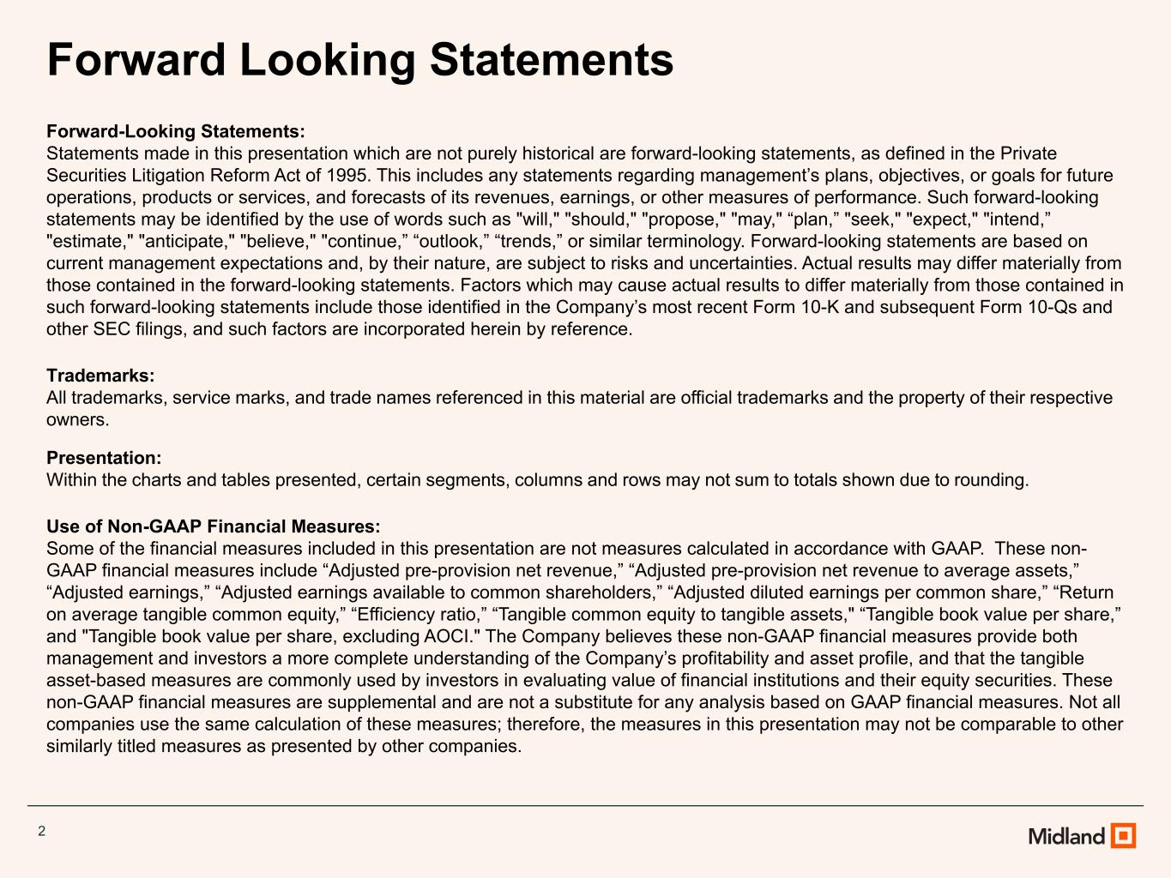
2 Forward Looking Statements Forward-Looking Statements: Statements made in this presentation which are not purely historical are forward-looking statements, as defined in the Private Securities Litigation Reform Act of 1995. This includes any statements regarding management’s plans, objectives, or goals for future operations, products or services, and forecasts of its revenues, earnings, or other measures of performance. Such forward-looking statements may be identified by the use of words such as "will," "should," "propose," "may," “plan,” "seek," "expect," "intend,” "estimate," "anticipate," "believe," "continue,” “outlook,” “trends,” or similar terminology. Forward-looking statements are based on current management expectations and, by their nature, are subject to risks and uncertainties. Actual results may differ materially from those contained in the forward-looking statements. Factors which may cause actual results to differ materially from those contained in such forward-looking statements include those identified in the Company’s most recent Form 10-K and subsequent Form 10-Qs and other SEC filings, and such factors are incorporated herein by reference. Trademarks: All trademarks, service marks, and trade names referenced in this material are official trademarks and the property of their respective owners. Presentation: Within the charts and tables presented, certain segments, columns and rows may not sum to totals shown due to rounding. Use of Non-GAAP Financial Measures: Some of the financial measures included in this presentation are not measures calculated in accordance with GAAP. These non- GAAP financial measures include “Adjusted pre-provision net revenue,” “Adjusted pre-provision net revenue to average assets,” “Adjusted earnings,” “Adjusted earnings available to common shareholders,” “Adjusted diluted earnings per common share,” “Return on average tangible common equity,” “Efficiency ratio,” “Tangible common equity to tangible assets," “Tangible book value per share,” and "Tangible book value per share, excluding AOCI." The Company believes these non-GAAP financial measures provide both management and investors a more complete understanding of the Company’s profitability and asset profile, and that the tangible asset-based measures are commonly used by investors in evaluating value of financial institutions and their equity securities. These non-GAAP financial measures are supplemental and are not a substitute for any analysis based on GAAP financial measures. Not all companies use the same calculation of these measures; therefore, the measures in this presentation may not be comparable to other similarly titled measures as presented by other companies.

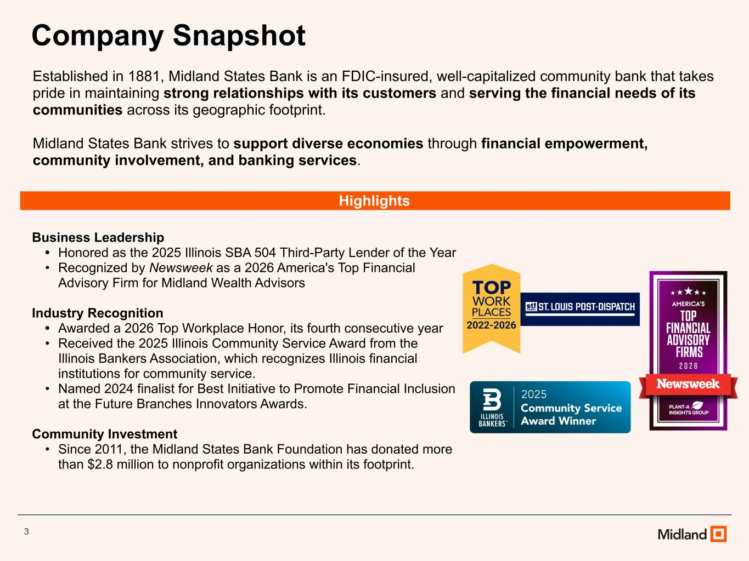
Business Leadership • Honored as the 2025 Illinois SBA 504 Third-Party Lender of the Year • Recognized by Newsweek as a 2026 America's Top Financial Advisory Firm for Midland Wealth Advisors Industry Recognition • Awarded a 2026 Top Workplace Honor, its fourth consecutive year • Received the 2025 Illinois Community Service Award from the Illinois Bankers Association, which recognizes Illinois financial institutions for community service. • Named 2024 finalist for Best Initiative to Promote Financial Inclusion at the Future Branches Innovators Awards. Community Investment • Since 2011, the Midland States Bank Foundation has donated more than $2.8 million to nonprofit organizations within its footprint. Company Snapshot Highlights Established in 1881, Midland States Bank is an FDIC-insured, well-capitalized community bank that takes pride in maintaining strong relationships with its customers and serving the financial needs of its communities across its geographic footprint. Midland States Bank strives to support diverse economies through financial empowerment, community involvement, and banking services. 3

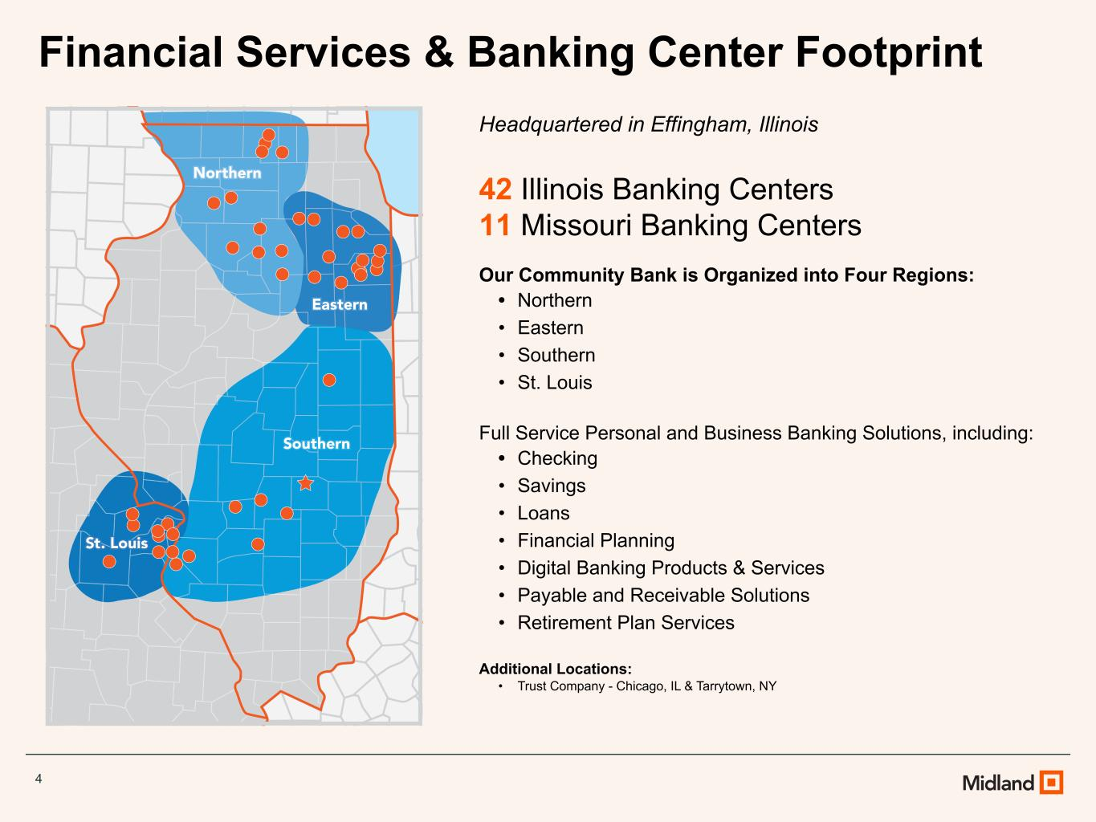
Headquartered in Effingham, Illinois 42 Illinois Banking Centers 11 Missouri Banking Centers Our Community Bank is Organized into Four Regions: • Northern • Eastern • Southern • St. Louis Full Service Personal and Business Banking Solutions, including: • Checking • Savings • Loans • Financial Planning • Digital Banking Products & Services • Payable and Receivable Solutions • Retirement Plan Services Additional Locations: • Trust Company - Chicago, IL & Tarrytown, NY Financial Services & Banking Center Footprint 4

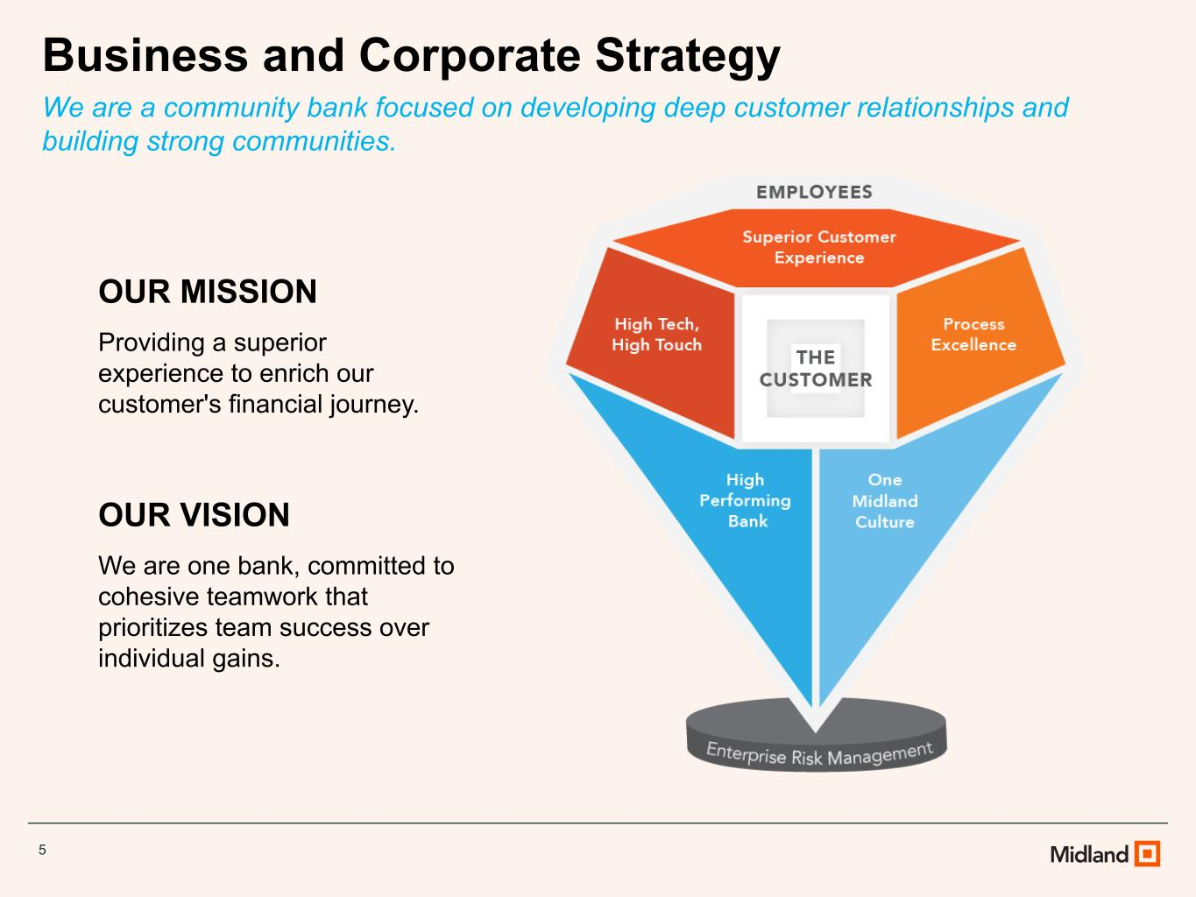
Business and Corporate Strategy We are a community bank focused on developing deep customer relationships and building strong communities. OUR MISSION Providing a superior experience to enrich our customer's financial journey. OUR VISION We are one bank, committed to cohesive teamwork that prioritizes team success over individual gains. 5


Executive Management Team Jeffrey G. Ludwig President – CEO of Midland States Bancorp CEO of Midland States Bank • Assumed Company CEO role in January 2019 after serving as Bank CEO • More than 10 years serving as CFO • Joined Midland in 2006 Claire A. Stack EVP, Chief Financial Officer of Midland States Bancorp and Midland States Bank • Promoted to EVP, Chief Financial Officer in May 2026 after serving as Corporate Controller • 15+ years of accounting and financial leadership experience within the financial services sector • Joined Midland in 2025 Daniel E. Casey EVP, Chief Risk Officer of Midland States Bank • 30+ years in risk and investment management • Administers enterprise risk management functions including compliance management, loan review, internal audit and other fiduciary safeguards • Joined Midland in 2023 Jeremy A. Jameson EVP, Chief Banking Officer of Midland States Bank • 20+ years in banking and credit with a track record of managing clients up to $100MM and designing comprehensive credit and lending strategies • Administers credit policy, credit risk management, and loan origination systems • Joined Midland in 2024 6

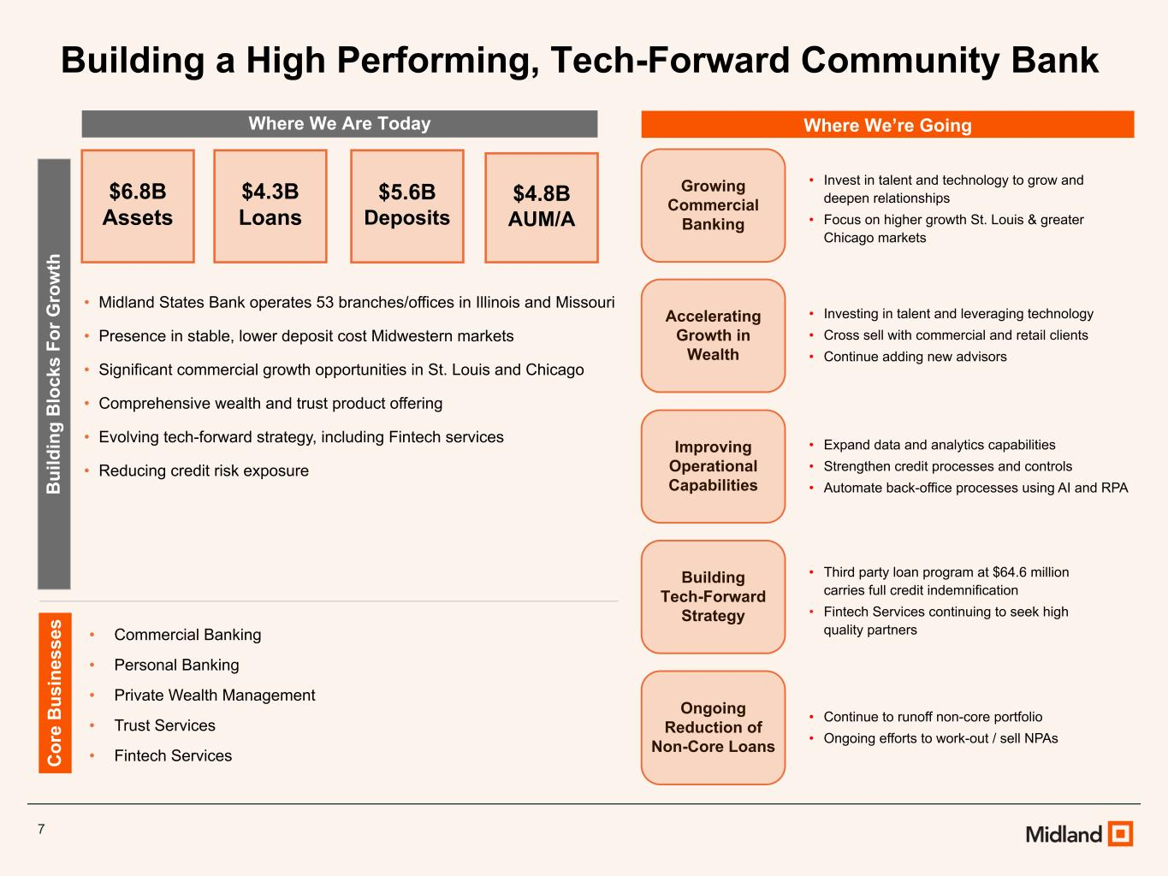
7 Where We Are Today Where We’re Going B ui ld in g B lo ck s Fo r G ro w th C or e B us in es se s • Midland States Bank operates 53 branches/offices in Illinois and Missouri • Presence in stable, lower deposit cost Midwestern markets • Significant commercial growth opportunities in St. Louis and Chicago • Comprehensive wealth and trust product offering • Evolving tech-forward strategy, including Fintech services • Reducing credit risk exposure • Commercial Banking • Personal Banking • Private Wealth Management • Trust Services • Fintech Services Ongoing Reduction of Non-Core Loans Growing Commercial Banking Accelerating Growth in Wealth Improving Operational Capabilities • Continue to runoff non-core portfolio • Ongoing efforts to work-out / sell NPAs • Invest in talent and technology to grow and deepen relationships • Focus on higher growth St. Louis & greater Chicago markets • Investing in talent and leveraging technology • Cross sell with commercial and retail clients • Continue adding new advisors • Expand data and analytics capabilities • Strengthen credit processes and controls • Automate back-office processes using AI and RPA Building Tech-Forward Strategy • Third party loan program at $64.6 million carries full credit indemnification • Fintech Services continuing to seek high quality partners $6.8B Assets $4.3B Loans $5.6B Deposits $4.8B AUM/A Building a High Performing, Tech-Forward Community Bank

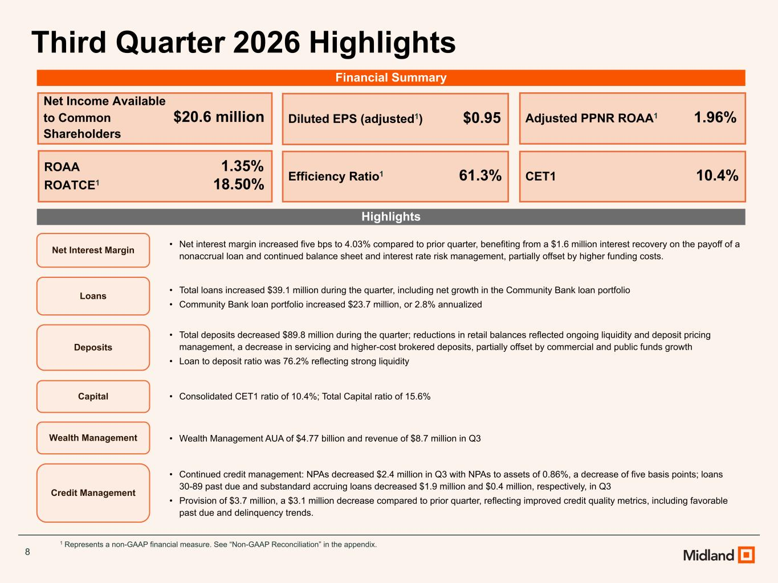
8 Third Quarter 2026 Highlights Highlights 1 Represents a non-GAAP financial measure. See “Non-GAAP Reconciliation” in the appendix. Net Income Available to Common $20.6 million Shareholders Diluted EPS (adjusted1) $0.95 ROAA 1.35% ROATCE1 18.50% Adjusted PPNR ROAA1 1.96% Efficiency Ratio1 61.3% CET1 10.4% Net Interest Margin • Net interest margin increased five bps to 4.03% compared to prior quarter, benefiting from a $1.6 million interest recovery on the payoff of a nonaccrual loan and continued balance sheet and interest rate risk management, partially offset by higher funding costs. Loans • Total loans increased $39.1 million during the quarter, including net growth in the Community Bank loan portfolio • Community Bank loan portfolio increased $23.7 million, or 2.8% annualized Wealth Management • Wealth Management AUA of $4.77 billion and revenue of $8.7 million in Q3 Credit Management • Continued credit management: NPAs decreased $2.4 million in Q3 with NPAs to assets of 0.86%, a decrease of five basis points; loans 30-89 past due and substandard accruing loans decreased $1.9 million and $0.4 million, respectively, in Q3 • Provision of $3.7 million, a $3.1 million decrease compared to prior quarter, reflecting improved credit quality metrics, including favorable past due and delinquency trends. Deposits • Total deposits decreased $89.8 million during the quarter; reductions in retail balances reflected ongoing liquidity and deposit pricing management, a decrease in servicing and higher-cost brokered deposits, partially offset by commercial and public funds growth • Loan to deposit ratio was 76.2% reflecting strong liquidity Capital • Consolidated CET1 ratio of 10.4%; Total Capital ratio of 15.6% Financial Summary

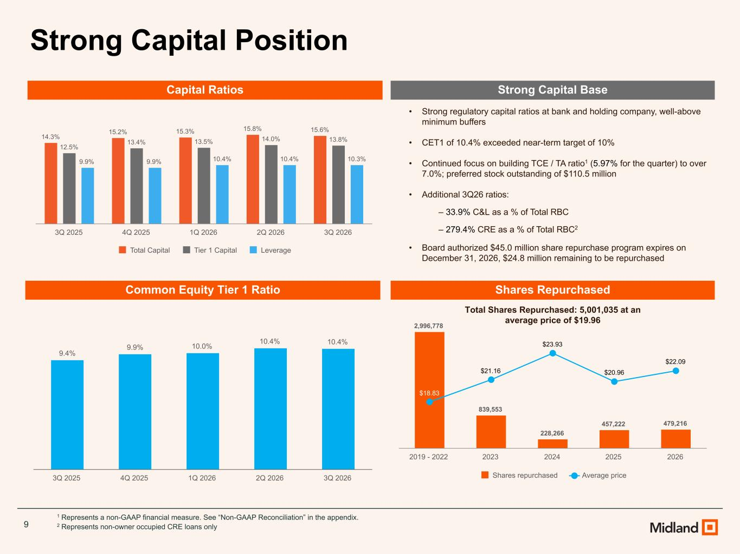
9 Strong Capital Position 14.3% 15.2% 15.3% 15.8% 15.6% 12.5% 13.4% 13.5% 14.0% 13.8% 9.9% 9.9% 10.4% 10.4% 10.3% Total Capital Tier 1 Capital Leverage 3Q 2025 4Q 2025 1Q 2026 2Q 2026 3Q 2026 9.4% 9.9% 10.0% 10.4% 10.4% 3Q 2025 4Q 2025 1Q 2026 2Q 2026 3Q 2026 • Strong regulatory capital ratios at bank and holding company, well-above minimum buffers • CET1 of 10.4% exceeded near-term target of 10% • Continued focus on building TCE / TA ratio1 (5.97% for the quarter) to over 7.0%; preferred stock outstanding of $110.5 million • Additional 3Q26 ratios: ‒ 33.9% C&L as a % of Total RBC ‒ 279.4% CRE as a % of Total RBC2 • Board authorized $45.0 million share repurchase program expires on December 31, 2026, $24.8 million remaining to be repurchased Capital Ratios Common Equity Tier 1 Ratio Strong Capital Base 1 Represents a non-GAAP financial measure. See “Non-GAAP Reconciliation” in the appendix. 2 Represents non-owner occupied CRE loans only Shares Repurchased 2,996,778 839,553 228,266 457,222 479,216 $18.83 $21.16 $23.93 $20.96 $22.09 Shares repurchased Average price 2019 - 2022 2023 2024 2025 2026 Total Shares Repurchased: 5,001,035 at an average price of $19.96

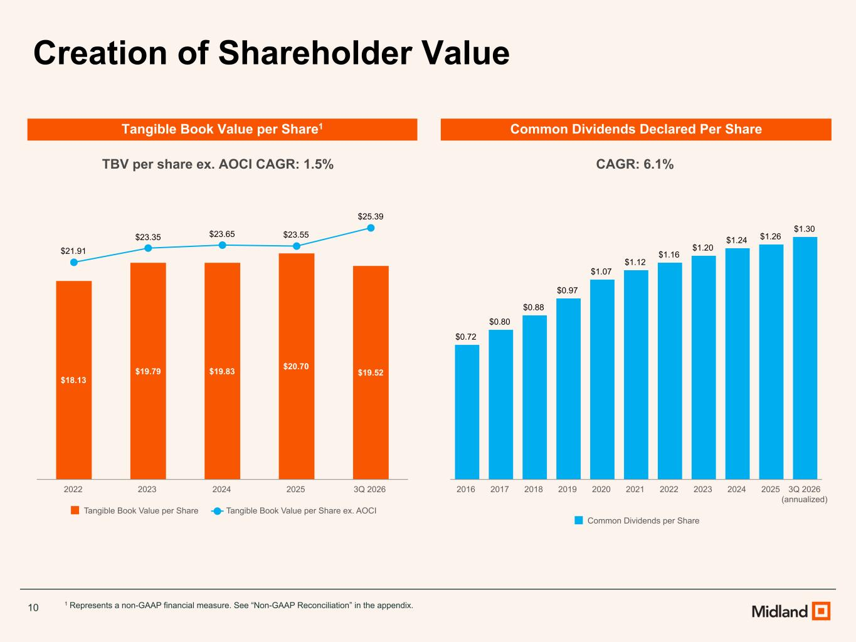
10 Tangible Book Value per Share1 Common Dividends Declared Per Share 1 Represents a non-GAAP financial measure. See “Non-GAAP Reconciliation” in the appendix. $18.13 $19.79 $19.83 $20.70 $19.52 $21.91 $23.35 $23.65 $23.55 $25.39 Tangible Book Value per Share Tangible Book Value per Share ex. AOCI 2022 2023 2024 2025 3Q 2026 Creation of Shareholder Value $0.72 $0.80 $0.88 $0.97 $1.07 $1.12 $1.16 $1.20 $1.24 $1.26 $1.30 Common Dividends per Share 2016 2017 2018 2019 2020 2021 2022 2023 2024 2025 3Q 2026 (annualized) CAGR: 6.1%TBV per share ex. AOCI CAGR: 1.5%

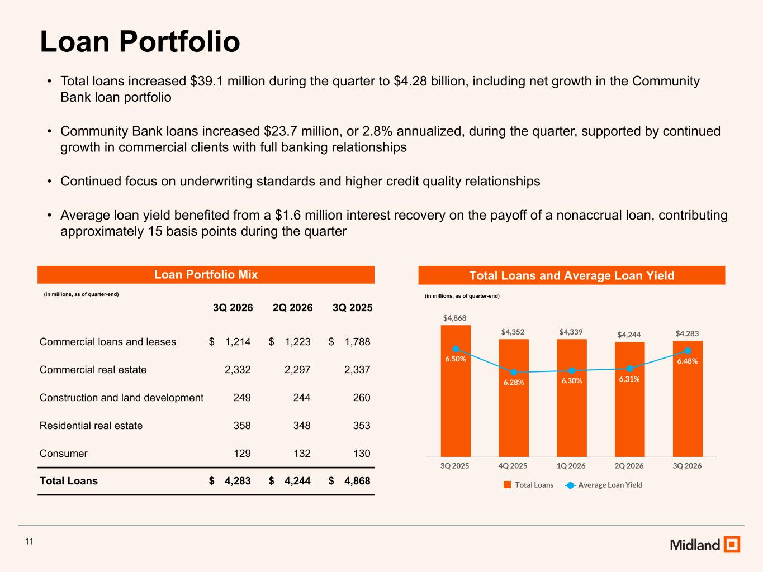
11 Loan Portfolio Total Loans and Average Loan Yield (in millions, as of quarter-end) • Total loans increased $39.1 million during the quarter to $4.28 billion, including net growth in the Community Bank loan portfolio • Community Bank loans increased $23.7 million, or 2.8% annualized, during the quarter, supported by continued growth in commercial clients with full banking relationships • Continued focus on underwriting standards and higher credit quality relationships • Average loan yield benefited from a $1.6 million interest recovery on the payoff of a nonaccrual loan, contributing approximately 15 basis points during the quarter Loan Portfolio Mix (in millions, as of quarter-end) 3Q 2026 2Q 2026 3Q 2025 Commercial loans and leases $ 1,214 $ 1,223 $ 1,788 Commercial real estate 2,332 2,297 2,337 Construction and land development 249 244 260 Residential real estate 358 348 353 Consumer 129 132 130 Total Loans $ 4,283 $ 4,244 $ 4,868 $4,868 $4,352 $4,339 $4,244 $4,283 6.50% 6.28% 6.30% 6.31% 6.48% Total Loans Average Loan Yield 3Q 2025 4Q 2025 1Q 2026 2Q 2026 3Q 2026

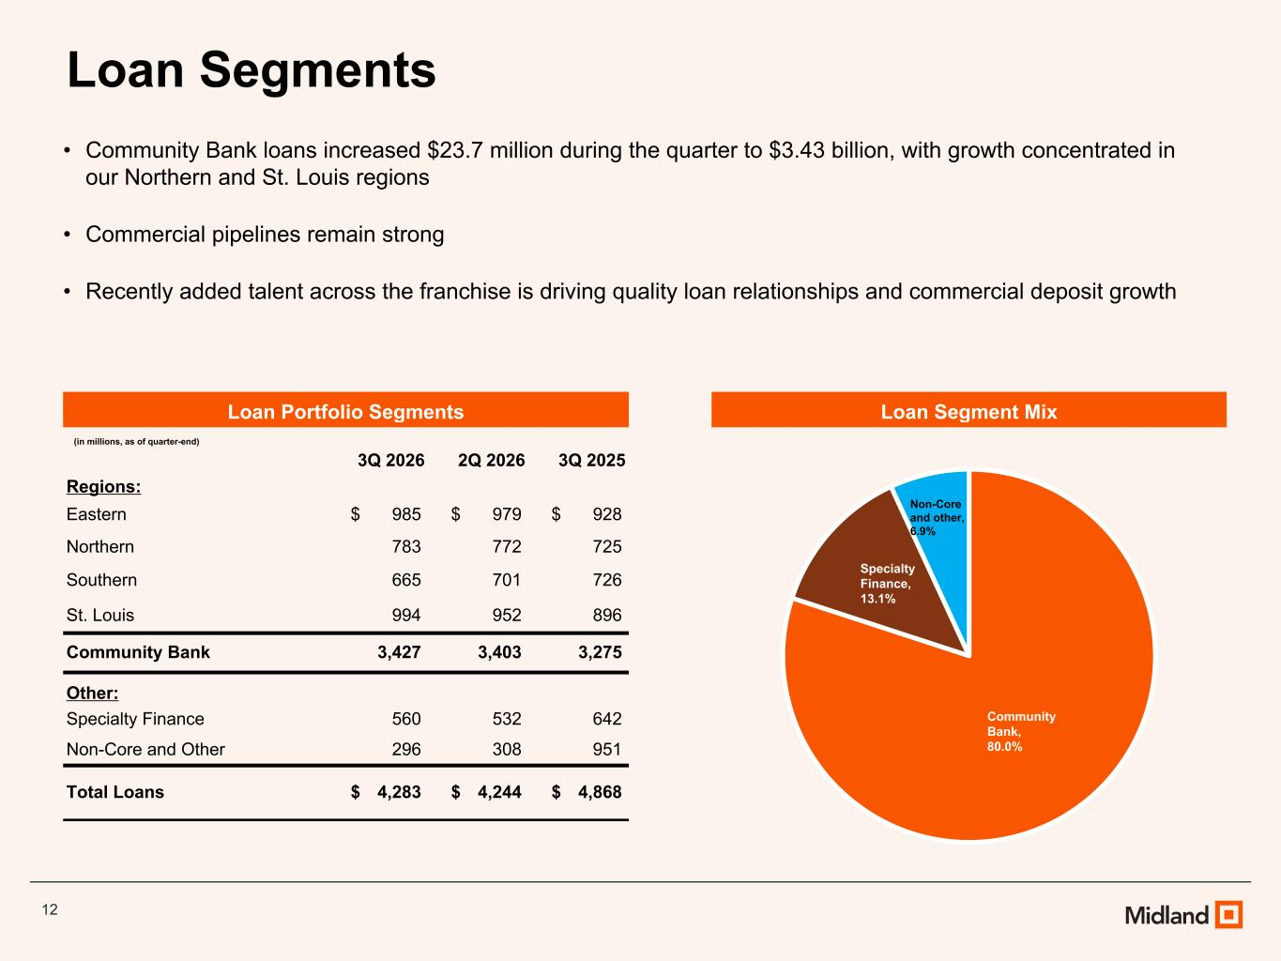
12 Loan Segments Loan Segment Mix • Community Bank loans increased $23.7 million during the quarter to $3.43 billion, with growth concentrated in our Northern and St. Louis regions • Commercial pipelines remain strong • Recently added talent across the franchise is driving quality loan relationships and commercial deposit growth Loan Portfolio Segments (in millions, as of quarter-end) 3Q 2026 2Q 2026 3Q 2025 Regions: Eastern $ 985 $ 979 $ 928 Northern 783 772 725 Southern 665 701 726 St. Louis 994 952 896 Community Bank 3,427 3,403 3,275 Other: Specialty Finance 560 532 642 Non-Core and Other 296 308 951 Total Loans $ 4,283 $ 4,244 $ 4,868 Community Bank, 80.0% Specialty Finance, 13.1% Non-Core and other, 6.9%

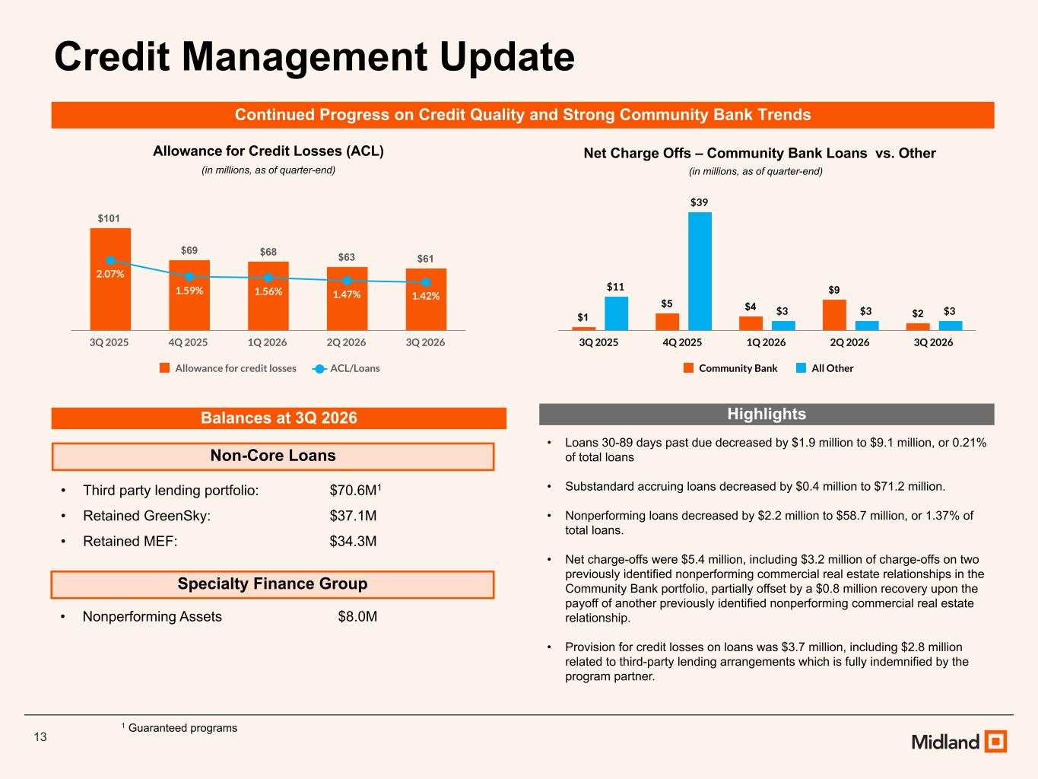
13 Credit Management Update Non-Core Loans Specialty Finance Group • Third party lending portfolio: $70.6M1 • Retained GreenSky: $37.1M • Retained MEF: $34.3M • Nonperforming Assets $8.0M 1 Guaranteed programs Balances at 3Q 2026 Allowance for Credit Losses (ACL) Net Charge Offs – Community Bank Loans vs. Other (in millions, as of quarter-end)(in millions, as of quarter-end) $101 $69 $68 $63 $61 2.07% 1.59% 1.56% 1.47% 1.42% Allowance for credit losses ACL/Loans 3Q 2025 4Q 2025 1Q 2026 2Q 2026 3Q 2026 $1 $5 $4 $9 $2 $11 $39 $3 $3 $3 Community Bank All Other 3Q 2025 4Q 2025 1Q 2026 2Q 2026 3Q 2026 Continued Progress on Credit Quality and Strong Community Bank Trends Highlights • Loans 30-89 days past due decreased by $1.9 million to $9.1 million, or 0.21% of total loans • Substandard accruing loans decreased by $0.4 million to $71.2 million. • Nonperforming loans decreased by $2.2 million to $58.7 million, or 1.37% of total loans. • Net charge-offs were $5.4 million, including $3.2 million of charge-offs on two previously identified nonperforming commercial real estate relationships in the Community Bank portfolio, partially offset by a $0.8 million recovery upon the payoff of another previously identified nonperforming commercial real estate relationship. • Provision for credit losses on loans was $3.7 million, including $2.8 million related to third-party lending arrangements which is fully indemnified by the program partner.

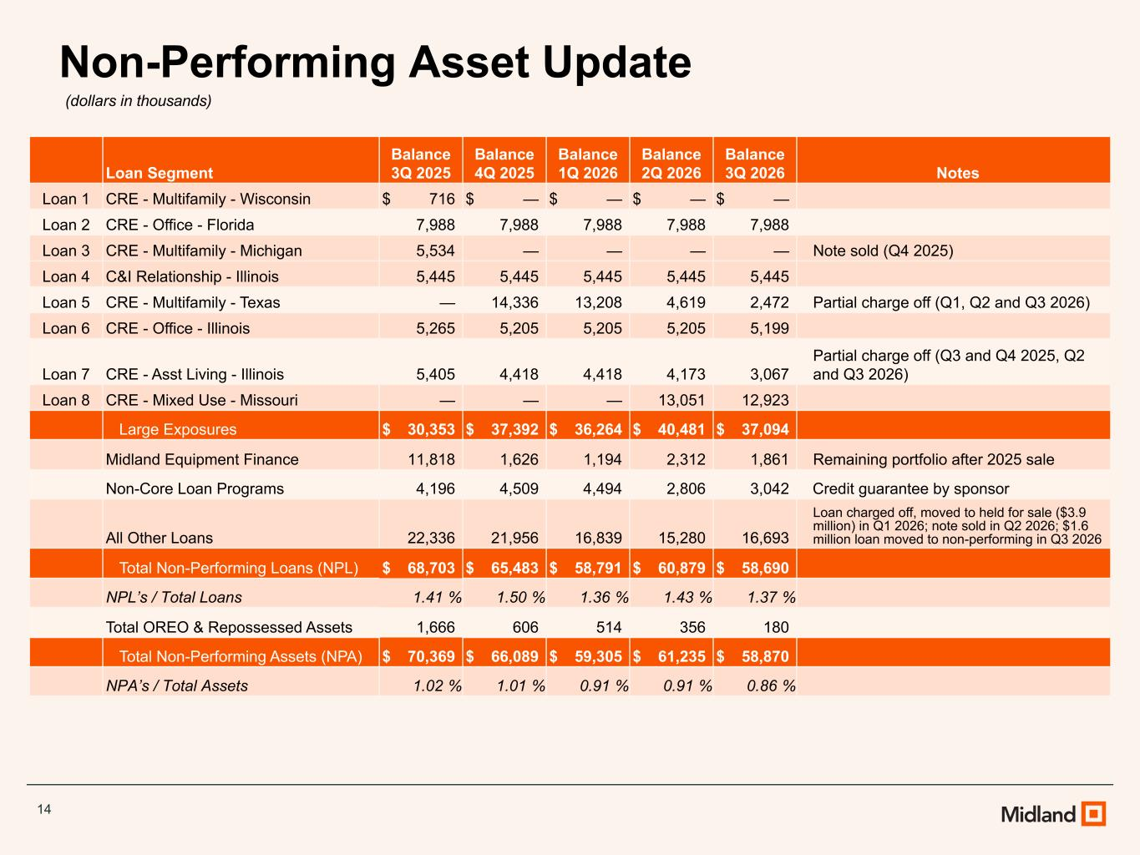
14 Non-Performing Asset Update (dollars in thousands) Loan Segment Balance 3Q 2025 Balance 4Q 2025 Balance 1Q 2026 Balance 2Q 2026 Balance 3Q 2026 Notes Loan 1 CRE - Multifamily - Wisconsin $ 716 $ — $ — $ — $ — Loan 2 CRE - Office - Florida 7,988 7,988 7,988 7,988 7,988 Loan 3 CRE - Multifamily - Michigan 5,534 — — — — Note sold (Q4 2025) Loan 4 C&I Relationship - Illinois 5,445 5,445 5,445 5,445 5,445 Loan 5 CRE - Multifamily - Texas — 14,336 13,208 4,619 2,472 Partial charge off (Q1, Q2 and Q3 2026) Loan 6 CRE - Office - Illinois 5,265 5,205 5,205 5,205 5,199 Loan 7 CRE - Asst Living - Illinois 5,405 4,418 4,418 4,173 3,067 Partial charge off (Q3 and Q4 2025, Q2 and Q3 2026) Loan 8 CRE - Mixed Use - Missouri — — — 13,051 12,923 Large Exposures $ 30,353 $ 37,392 $ 36,264 $ 40,481 $ 37,094 Midland Equipment Finance 11,818 1,626 1,194 2,312 1,861 Remaining portfolio after 2025 sale Non-Core Loan Programs 4,196 4,509 4,494 2,806 3,042 Credit guarantee by sponsor All Other Loans 22,336 21,956 16,839 15,280 16,693 Loan charged off, moved to held for sale ($3.9 million) in Q1 2026; note sold in Q2 2026; $1.6 million loan moved to non-performing in Q3 2026 Total Non-Performing Loans (NPL) $ 68,703 $ 65,483 $ 58,791 $ 60,879 $ 58,690 NPL’s / Total Loans 1.41 % 1.50 % 1.36 % 1.43 % 1.37 % Total OREO & Repossessed Assets 1,666 606 514 356 180 Total Non-Performing Assets (NPA) $ 70,369 $ 66,089 $ 59,305 $ 61,235 $ 58,870 NPA’s / Total Assets 1.02 % 1.01 % 0.91 % 0.91 % 0.86 %

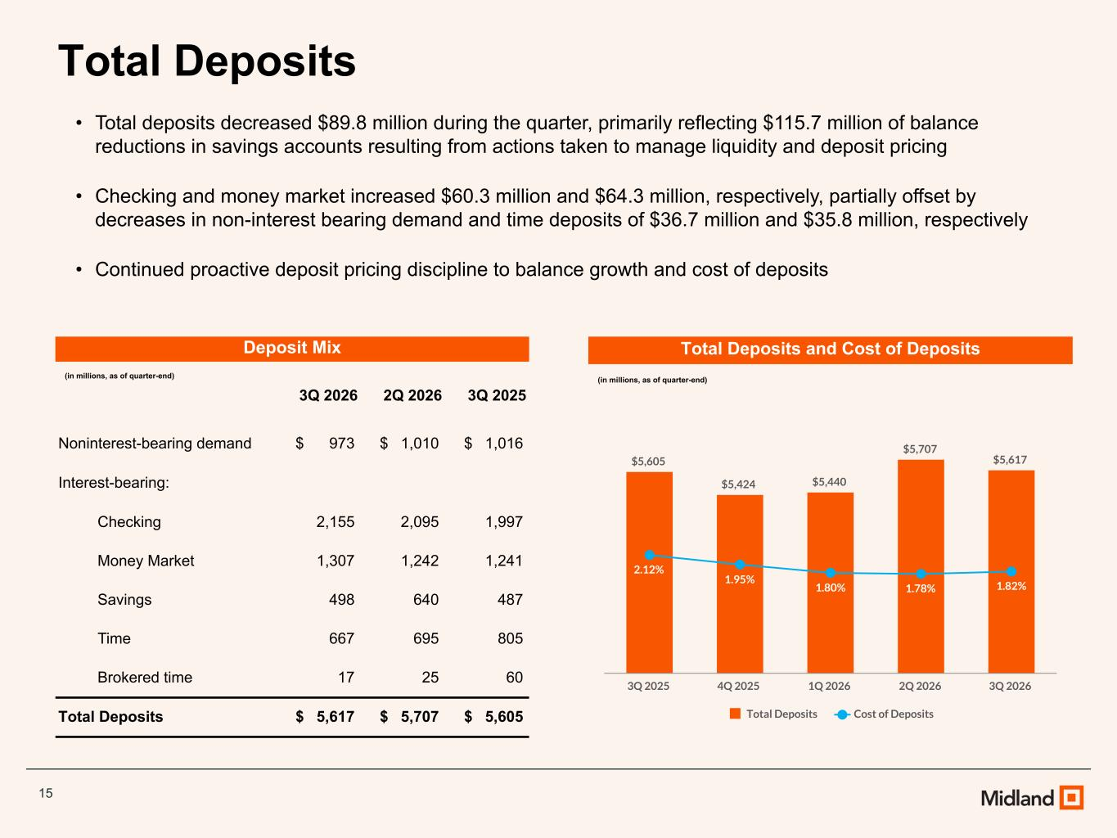
15 Total Deposits • Total deposits decreased $89.8 million during the quarter, primarily reflecting $115.7 million of balance reductions in savings accounts resulting from actions taken to manage liquidity and deposit pricing • Checking and money market increased $60.3 million and $64.3 million, respectively, partially offset by decreases in non-interest bearing demand and time deposits of $36.7 million and $35.8 million, respectively • Continued proactive deposit pricing discipline to balance growth and cost of deposits Deposit Mix (in millions, as of quarter-end) 3Q 2026 2Q 2026 3Q 2025 Noninterest-bearing demand $ 973 $ 1,010 $ 1,016 Interest-bearing: Checking 2,155 2,095 1,997 Money Market 1,307 1,242 1,241 Savings 498 640 487 Time 667 695 805 Brokered time 17 25 60 Total Deposits $ 5,617 $ 5,707 $ 5,605 Total Deposits and Cost of Deposits (in millions, as of quarter-end) $5,605 $5,424 $5,440 $5,707 $5,617 2.12% 1.95% 1.80% 1.78% 1.82% Total Deposits Cost of Deposits 3Q 2025 4Q 2025 1Q 2026 2Q 2026 3Q 2026

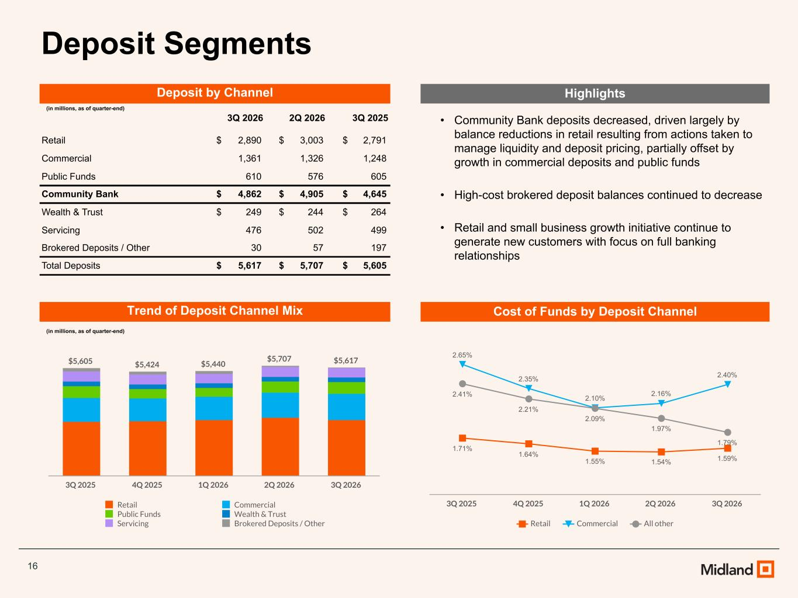
16 Deposit Segments • Community Bank deposits decreased, driven largely by balance reductions in retail resulting from actions taken to manage liquidity and deposit pricing, partially offset by growth in commercial deposits and public funds • High-cost brokered deposit balances continued to decrease • Retail and small business growth initiative continue to generate new customers with focus on full banking relationships Deposit by Channel (in millions, as of quarter-end) 3Q 2026 2Q 2026 3Q 2025 Retail $ 2,890 $ 3,003 $ 2,791 Commercial 1,361 1,326 1,248 Public Funds 610 576 605 Community Bank $ 4,862 $ 4,905 $ 4,645 Wealth & Trust $ 249 $ 244 $ 264 Servicing 476 502 499 Brokered Deposits / Other 30 57 197 Total Deposits $ 5,617 $ 5,707 $ 5,605 Trend of Deposit Channel Mix (in millions, as of quarter-end) $5,605 $5,424 $5,440 $5,707 $5,617 Retail Commercial Public Funds Wealth & Trust Servicing Brokered Deposits / Other 3Q 2025 4Q 2025 1Q 2026 2Q 2026 3Q 2026 Highlights Cost of Funds by Deposit Channel 1.71% 1.64% 1.55% 1.54% 1.59% 2.65% 2.35% 2.10% 2.16% 2.40% 2.41% 2.21% 2.09% 1.97% 1.79% Retail Commercial All other 3Q 2025 4Q 2025 1Q 2026 2Q 2026 3Q 2026

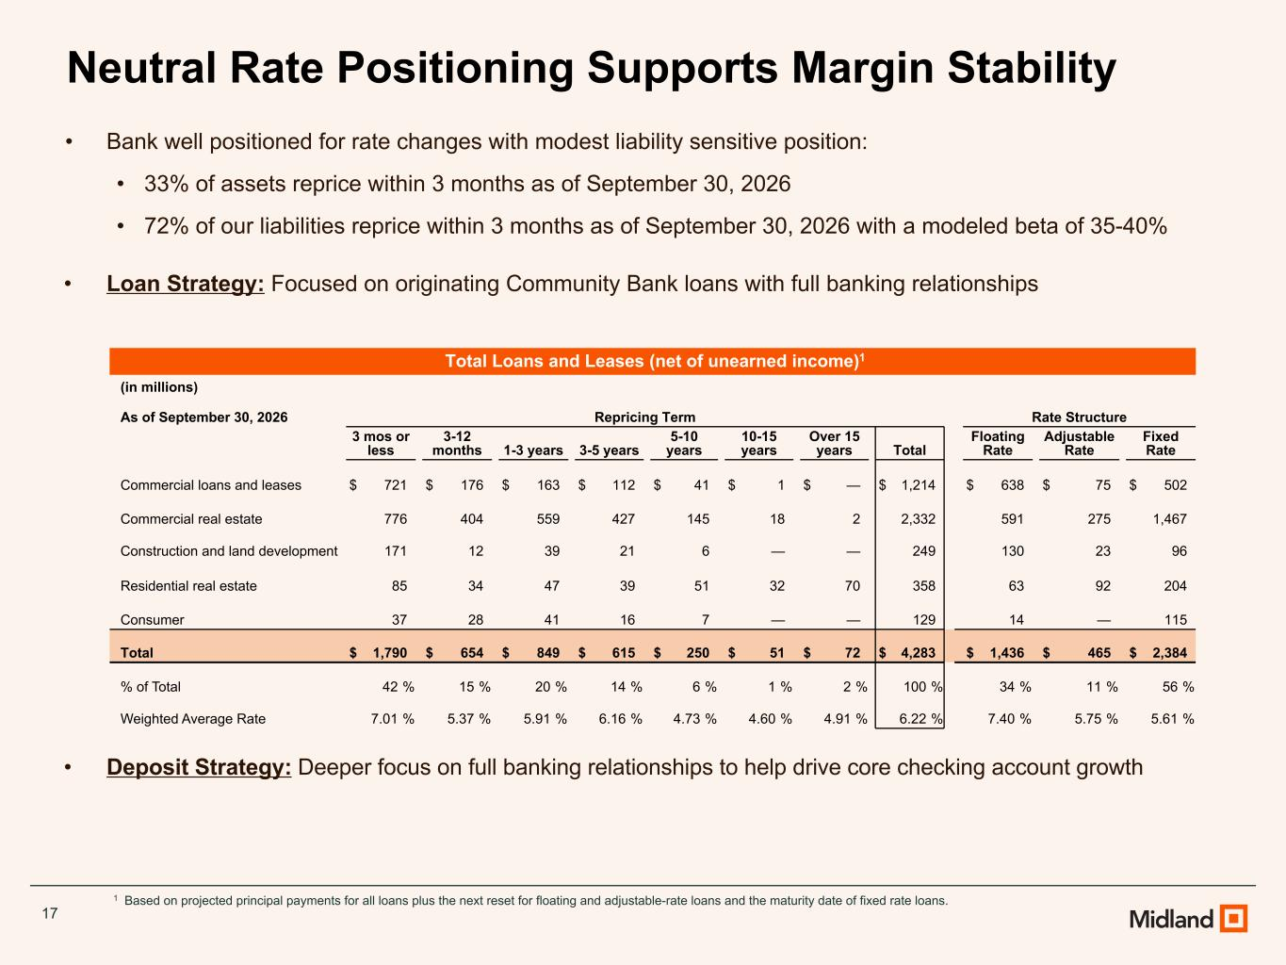
17 Neutral Rate Positioning Supports Margin Stability • Bank well positioned for rate changes with modest liability sensitive position: • 33% of assets reprice within 3 months as of September 30, 2026 • 72% of our liabilities reprice within 3 months as of September 30, 2026 with a modeled beta of 35-40% • Loan Strategy: Focused on originating Community Bank loans with full banking relationships • Deposit Strategy: Deeper focus on full banking relationships to help drive core checking account growth 1 Based on projected principal payments for all loans plus the next reset for floating and adjustable-rate loans and the maturity date of fixed rate loans. Total Loans and Leases (net of unearned income)1 (in millions) As of September 30, 2026 Repricing Term Rate Structure 3 mos or less 3-12 months 1-3 years 3-5 years 5-10 years 10-15 years Over 15 years Total Floating Rate Adjustable Rate Fixed Rate Commercial loans and leases $ 721 $ 176 $ 163 $ 112 $ 41 $ 1 $ — $ 1,214 $ 638 $ 75 $ 502 Commercial real estate 776 404 559 427 145 18 2 2,332 591 275 1,467 Construction and land development 171 12 39 21 6 — — 249 130 23 96 Residential real estate 85 34 47 39 51 32 70 358 63 92 204 Consumer 37 28 41 16 7 — — 129 14 — 115 Total $ 1,790 $ 654 $ 849 $ 615 $ 250 $ 51 $ 72 $ 4,283 $ 1,436 $ 465 $ 2,384 % of Total 42 % 15 % 20 % 14 % 6 % 1 % 2 % 100 % 34 % 11 % 56 % Weighted Average Rate 7.01 % 5.37 % 5.91 % 6.16 % 4.73 % 4.60 % 4.91 % 6.22 % 7.40 % 5.75 % 5.61 %

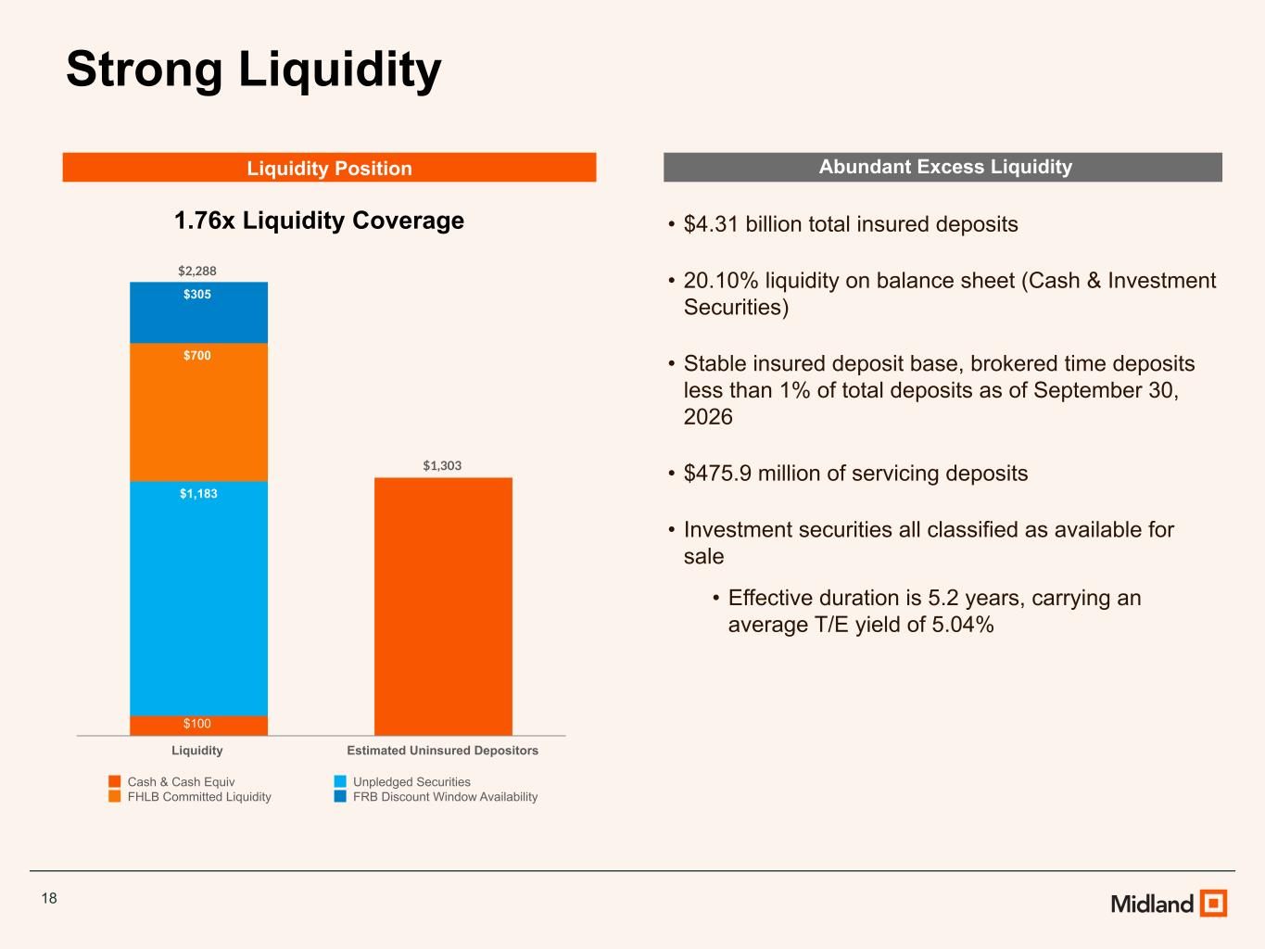
18 Strong Liquidity Abundant Excess Liquidity • $4.31 billion total insured deposits • 20.10% liquidity on balance sheet (Cash & Investment Securities) • Stable insured deposit base, brokered time deposits less than 1% of total deposits as of September 30, 2026 • $475.9 million of servicing deposits • Investment securities all classified as available for sale • Effective duration is 5.2 years, carrying an average T/E yield of 5.04% $2,288 $1,303 $100 $1,183 $700 $305 Cash & Cash Equiv Unpledged Securities FHLB Committed Liquidity FRB Discount Window Availability Liquidity Estimated Uninsured Depositors Liquidity Position 1.76x Liquidity Coverage

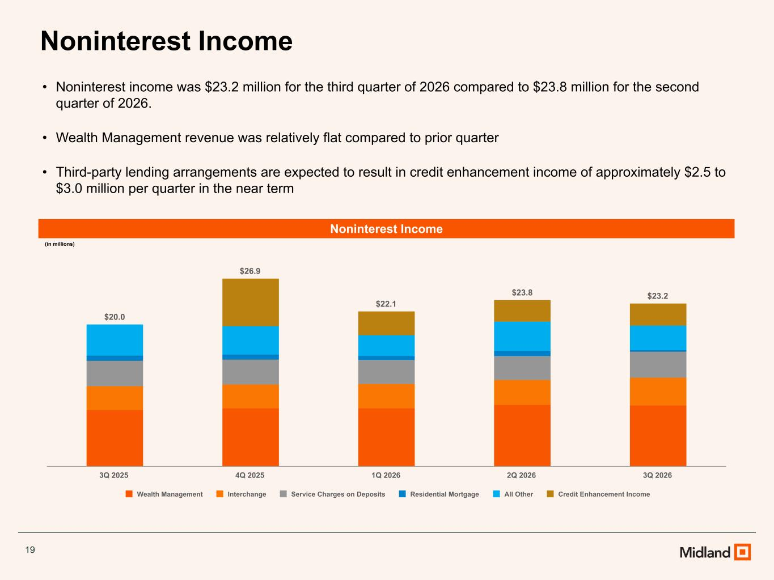
19 Noninterest Income • Noninterest income was $23.2 million for the third quarter of 2026 compared to $23.8 million for the second quarter of 2026. • Wealth Management revenue was relatively flat compared to prior quarter • Third-party lending arrangements are expected to result in credit enhancement income of approximately $2.5 to $3.0 million per quarter in the near term Noninterest Income (in millions) $20.0 $26.9 $22.1 $23.8 $23.2 Wealth Management Interchange Service Charges on Deposits Residential Mortgage All Other Credit Enhancement Income 3Q 2025 4Q 2025 1Q 2026 2Q 2026 3Q 2026

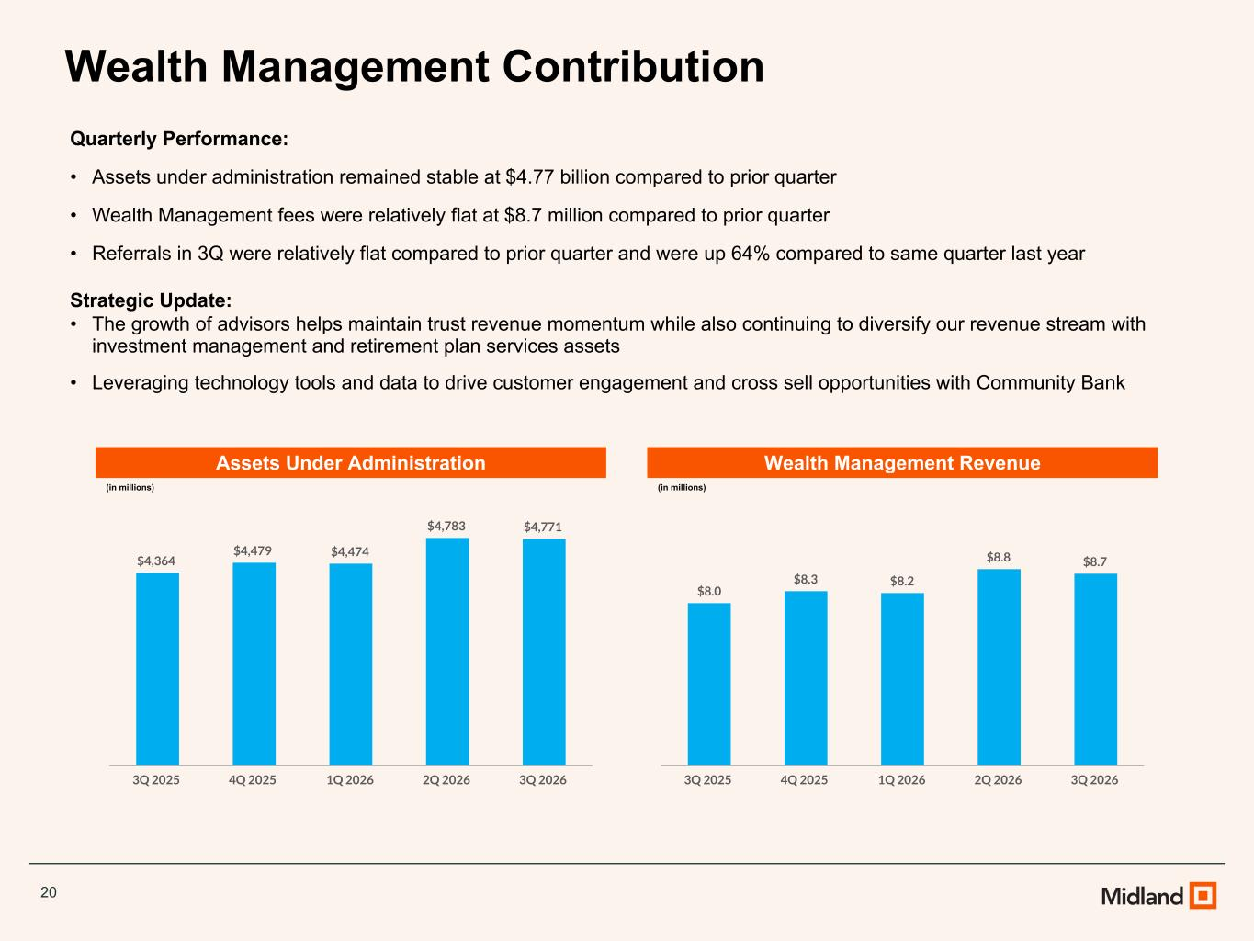
20 Wealth Management Contribution Quarterly Performance: • Assets under administration remained stable at $4.77 billion compared to prior quarter • Wealth Management fees were relatively flat at $8.7 million compared to prior quarter • Referrals in 3Q were relatively flat compared to prior quarter and were up 64% compared to same quarter last year Strategic Update: • The growth of advisors helps maintain trust revenue momentum while also continuing to diversify our revenue stream with investment management and retirement plan services assets • Leveraging technology tools and data to drive customer engagement and cross sell opportunities with Community Bank Assets Under Administration (in millions) Wealth Management Revenue (in millions) $4,364 $4,479 $4,474 $4,783 $4,771 3Q 2025 4Q 2025 1Q 2026 2Q 2026 3Q 2026 $8.0 $8.3 $8.2 $8.8 $8.7 3Q 2025 4Q 2025 1Q 2026 2Q 2026 3Q 2026

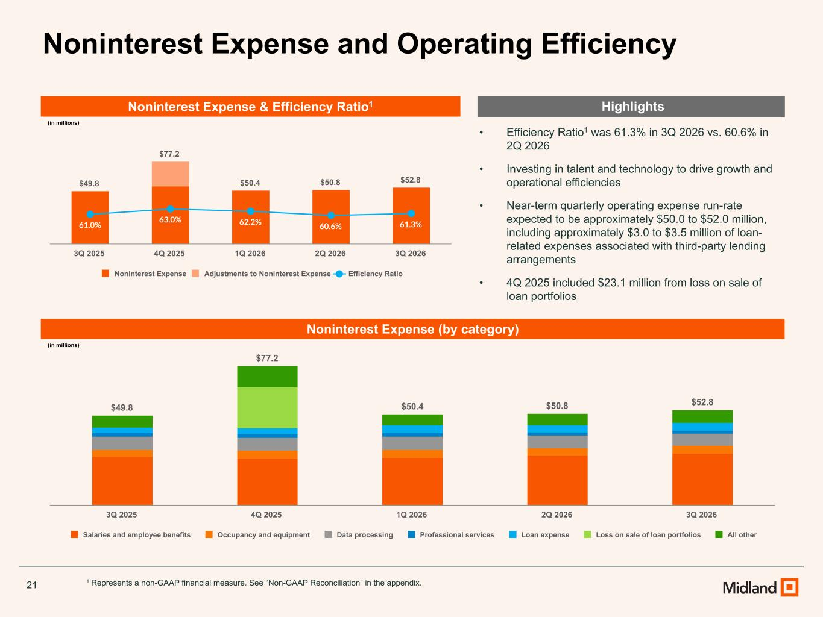
21 Noninterest Expense and Operating Efficiency Noninterest Expense & Efficiency Ratio1 (in millions) • Efficiency Ratio1 was 61.3% in 3Q 2026 vs. 60.6% in 2Q 2026 • Investing in talent and technology to drive growth and operational efficiencies • Near-term quarterly operating expense run-rate expected to be approximately $50.0 to $52.0 million, including approximately $3.0 to $3.5 million of loan- related expenses associated with third-party lending arrangements • 4Q 2025 included $23.1 million from loss on sale of loan portfolios 1 Represents a non-GAAP financial measure. See “Non-GAAP Reconciliation” in the appendix. $49.8 $77.2 $50.4 $50.8 $52.8 61.0% 63.0% 62.2% 60.6% 61.3% Noninterest Expense Adjustments to Noninterest Expense Efficiency Ratio 3Q 2025 4Q 2025 1Q 2026 2Q 2026 3Q 2026 Noninterest Expense (by category) (in millions) Highlights $49.8 $77.2 $50.4 $50.8 $52.8 Salaries and employee benefits Occupancy and equipment Data processing Professional services Loan expense Loss on sale of loan portfolios All other 3Q 2025 4Q 2025 1Q 2026 2Q 2026 3Q 2026

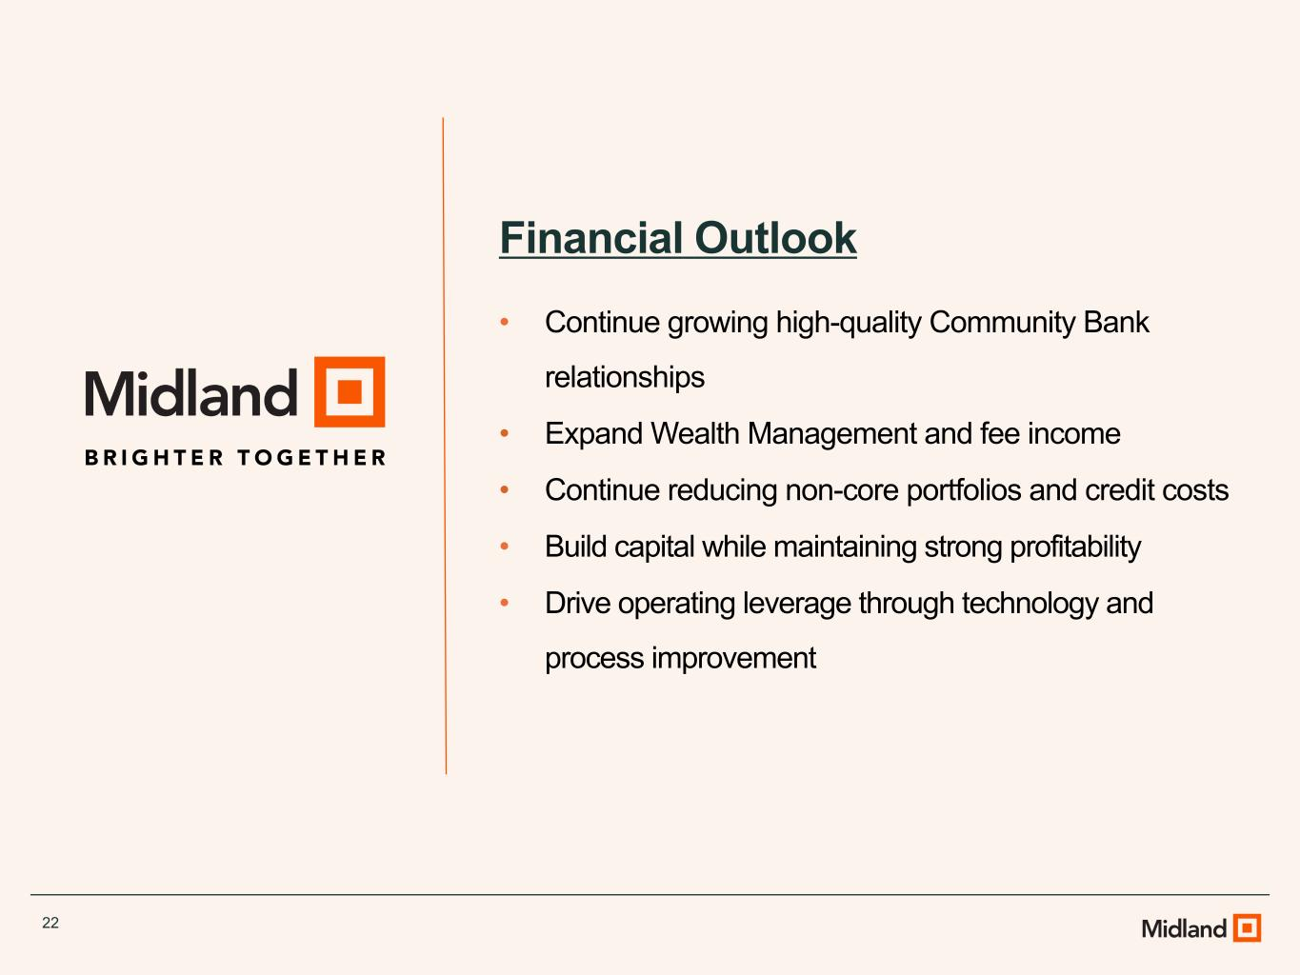
22 Financial Outlook • Continue growing high-quality Community Bank relationships • Expand Wealth Management and fee income • Continue reducing non-core portfolios and credit costs • Build capital while maintaining strong profitability • Drive operating leverage through technology and process improvement

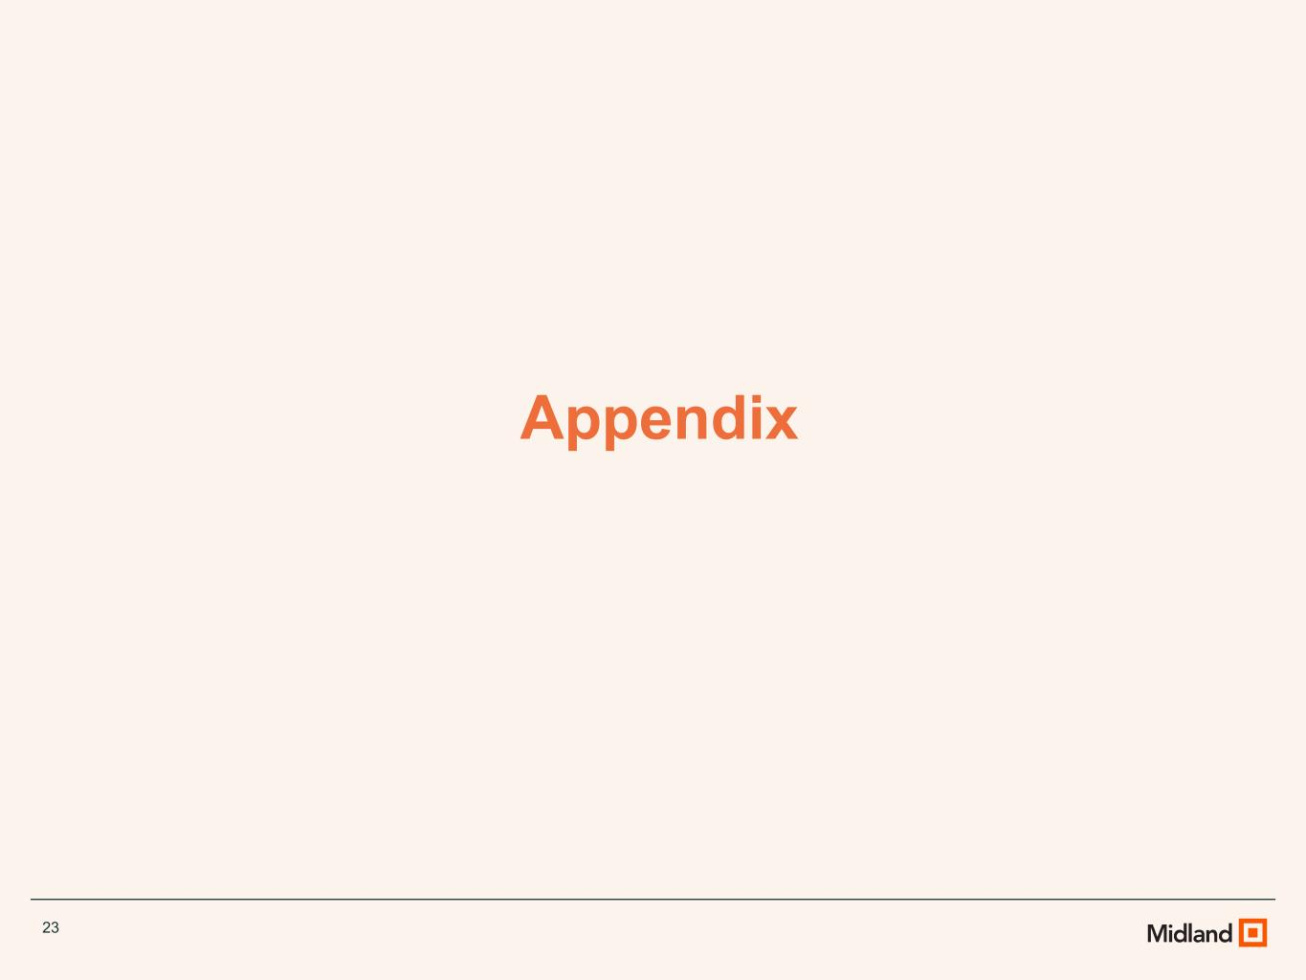
23 Appendix

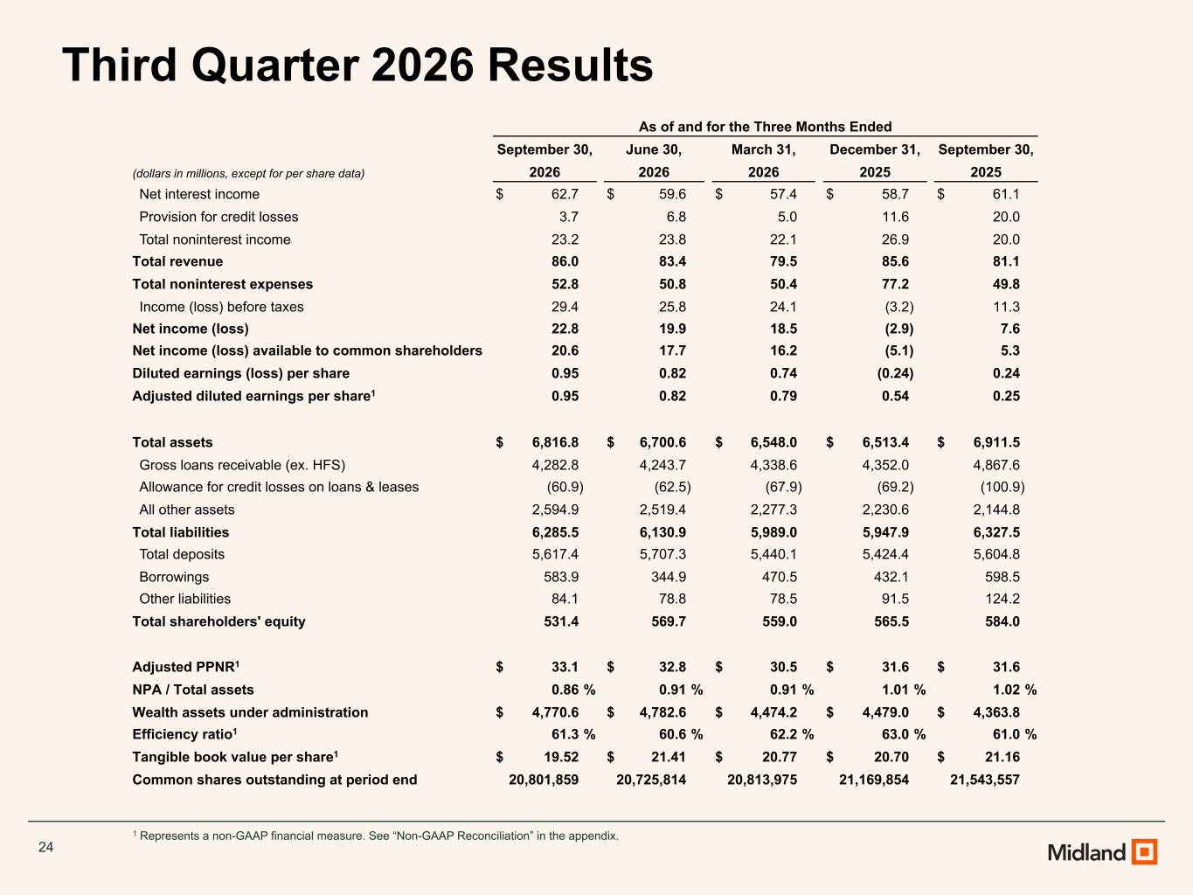
24 1 Represents a non-GAAP financial measure. See “Non-GAAP Reconciliation” in the appendix. Third Quarter 2026 Results As of and for the Three Months Ended September 30, June 30, March 31, December 31, September 30, (dollars in millions, except for per share data) 2026 2026 2026 2025 2025 Net interest income $ 62.7 $ 59.6 $ 57.4 $ 58.7 $ 61.1 Provision for credit losses 3.7 6.8 5.0 11.6 20.0 Total noninterest income 23.2 23.8 22.1 26.9 20.0 Total revenue 86.0 83.4 79.5 85.6 81.1 Total noninterest expenses 52.8 50.8 50.4 77.2 49.8 Income (loss) before taxes 29.4 25.8 24.1 (3.2) 11.3 Net income (loss) 22.8 19.9 18.5 (2.9) 7.6 Net income (loss) available to common shareholders 20.6 17.7 16.2 (5.1) 5.3 Diluted earnings (loss) per share 0.95 0.82 0.74 (0.24) 0.24 Adjusted diluted earnings per share1 0.95 0.82 0.79 0.54 0.25 Total assets $ 6,816.8 $ 6,700.6 $ 6,548.0 $ 6,513.4 $ 6,911.5 Gross loans receivable (ex. HFS) 4,282.8 4,243.7 4,338.6 4,352.0 4,867.6 Allowance for credit losses on loans & leases (60.9) (62.5) (67.9) (69.2) (100.9) All other assets 2,594.9 2,519.4 2,277.3 2,230.6 2,144.8 Total liabilities 6,285.5 6,130.9 5,989.0 5,947.9 6,327.5 Total deposits 5,617.4 5,707.3 5,440.1 5,424.4 5,604.8 Borrowings 583.9 344.9 470.5 432.1 598.5 Other liabilities 84.1 78.8 78.5 91.5 124.2 Total shareholders' equity 531.4 569.7 559.0 565.5 584.0 Adjusted PPNR1 $ 33.1 $ 32.8 $ 30.5 $ 31.6 $ 31.6 NPA / Total assets 0.86 % 0.91 % 0.91 % 1.01 % 1.02 % Wealth assets under administration $ 4,770.6 $ 4,782.6 $ 4,474.2 $ 4,479.0 $ 4,363.8 Efficiency ratio1 61.3 % 60.6 % 62.2 % 63.0 % 61.0 % Tangible book value per share1 $ 19.52 $ 21.41 $ 20.77 $ 20.70 $ 21.16 Common shares outstanding at period end 20,801,859 20,725,814 20,813,975 21,169,854 21,543,557

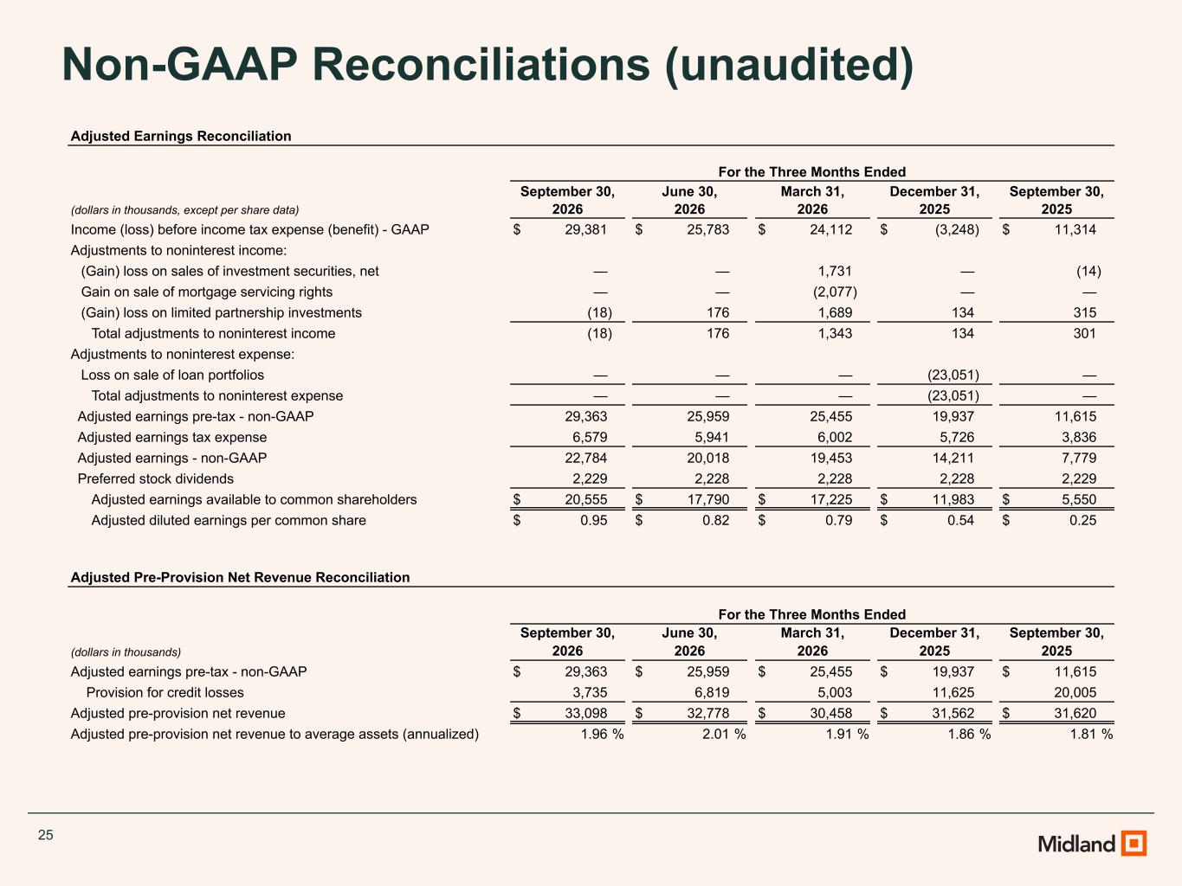
25 Non-GAAP Reconciliations (unaudited) Adjusted Earnings Reconciliation For the Three Months Ended September 30, June 30, March 31, December 31, September 30, (dollars in thousands, except per share data) 2026 2026 2026 2025 2025 Income (loss) before income tax expense (benefit) - GAAP $ 29,381 $ 25,783 $ 24,112 $ (3,248) $ 11,314 Adjustments to noninterest income: (Gain) loss on sales of investment securities, net — — 1,731 — (14) Gain on sale of mortgage servicing rights — — (2,077) — — (Gain) loss on limited partnership investments (18) 176 1,689 134 315 Total adjustments to noninterest income (18) 176 1,343 134 301 Adjustments to noninterest expense: Loss on sale of loan portfolios — — — (23,051) — Total adjustments to noninterest expense — — — (23,051) — Adjusted earnings pre-tax - non-GAAP 29,363 25,959 25,455 19,937 11,615 Adjusted earnings tax expense 6,579 5,941 6,002 5,726 3,836 Adjusted earnings - non-GAAP 22,784 20,018 19,453 14,211 7,779 Preferred stock dividends 2,229 2,228 2,228 2,228 2,229 Adjusted earnings available to common shareholders $ 20,555 $ 17,790 $ 17,225 $ 11,983 $ 5,550 Adjusted diluted earnings per common share $ 0.95 $ 0.82 $ 0.79 $ 0.54 $ 0.25 Adjusted Pre-Provision Net Revenue Reconciliation For the Three Months Ended September 30, June 30, March 31, December 31, September 30, (dollars in thousands) 2026 2026 2026 2025 2025 Adjusted earnings pre-tax - non-GAAP $ 29,363 $ 25,959 $ 25,455 $ 19,937 $ 11,615 Provision for credit losses 3,735 6,819 5,003 11,625 20,005 Adjusted pre-provision net revenue $ 33,098 $ 32,778 $ 30,458 $ 31,562 $ 31,620 Adjusted pre-provision net revenue to average assets (annualized) 1.96 % 2.01 % 1.91 % 1.86 % 1.81 %

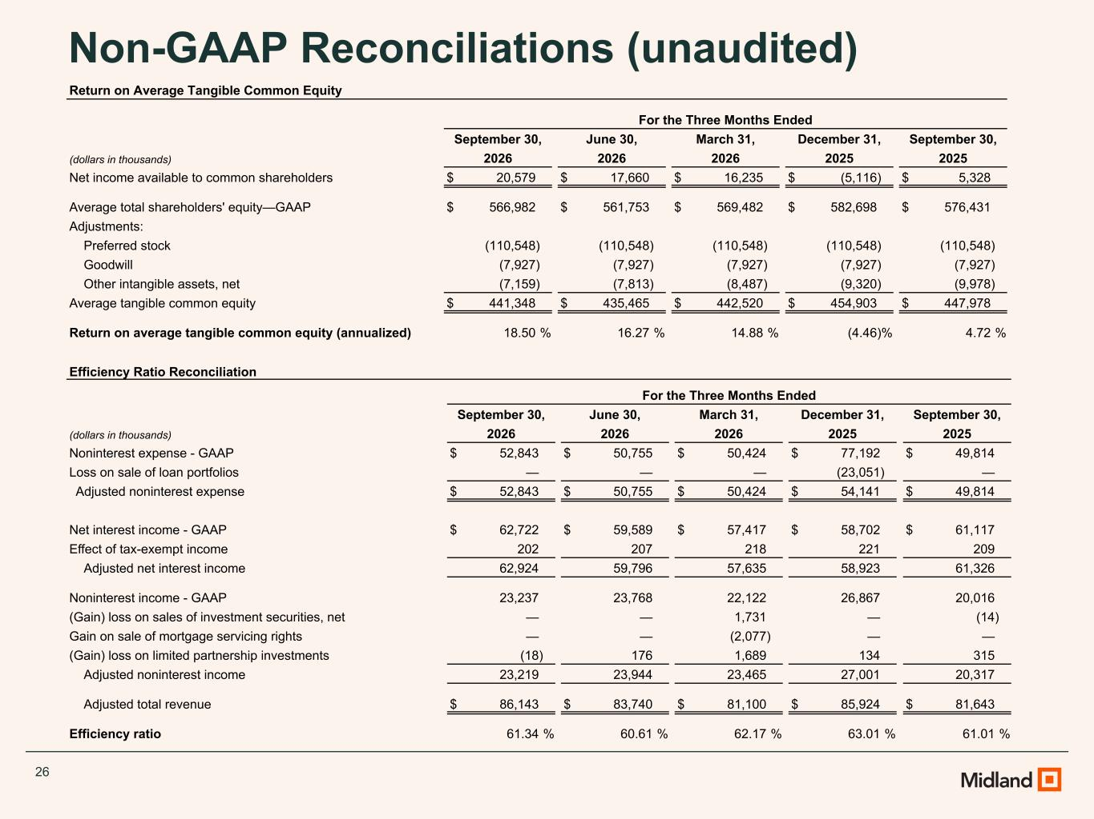
26 Non-GAAP Reconciliations (unaudited) Efficiency Ratio Reconciliation For the Three Months Ended September 30, June 30, March 31, December 31, September 30, (dollars in thousands) 2026 2026 2026 2025 2025 Noninterest expense - GAAP $ 52,843 $ 50,755 $ 50,424 $ 77,192 $ 49,814 Loss on sale of loan portfolios — — — (23,051) — Adjusted noninterest expense $ 52,843 $ 50,755 $ 50,424 $ 54,141 $ 49,814 Net interest income - GAAP $ 62,722 $ 59,589 $ 57,417 $ 58,702 $ 61,117 Effect of tax-exempt income 202 207 218 221 209 Adjusted net interest income 62,924 59,796 57,635 58,923 61,326 Noninterest income - GAAP 23,237 23,768 22,122 26,867 20,016 (Gain) loss on sales of investment securities, net — — 1,731 — (14) Gain on sale of mortgage servicing rights — — (2,077) — — (Gain) loss on limited partnership investments (18) 176 1,689 134 315 Adjusted noninterest income 23,219 23,944 23,465 27,001 20,317 Adjusted total revenue $ 86,143 $ 83,740 $ 81,100 $ 85,924 $ 81,643 Efficiency ratio 61.34 % 60.61 % 62.17 % 63.01 % 61.01 % Return on Average Tangible Common Equity For the Three Months Ended September 30, June 30, March 31, December 31, September 30, (dollars in thousands) 2026 2026 2026 2025 2025 Net income available to common shareholders $ 20,579 $ 17,660 $ 16,235 $ (5,116) $ 5,328 Average total shareholders' equity—GAAP $ 566,982 $ 561,753 $ 569,482 $ 582,698 $ 576,431 Adjustments: Preferred stock (110,548) (110,548) (110,548) (110,548) (110,548) Goodwill (7,927) (7,927) (7,927) (7,927) (7,927) Other intangible assets, net (7,159) (7,813) (8,487) (9,320) (9,978) Average tangible common equity $ 441,348 $ 435,465 $ 442,520 $ 454,903 $ 447,978 Return on average tangible common equity (annualized) 18.50 % 16.27 % 14.88 % (4.46) % 4.72 %

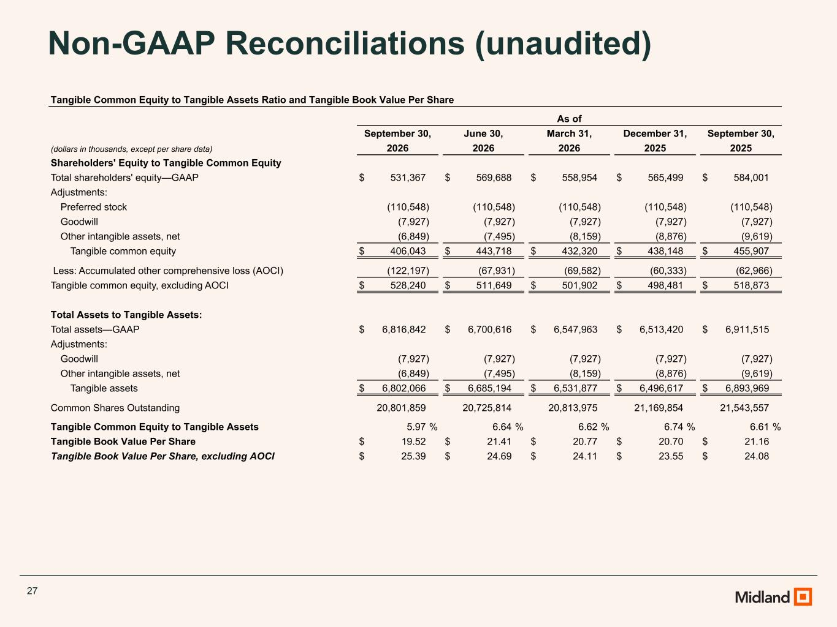
27 Non-GAAP Reconciliations (unaudited) Tangible Common Equity to Tangible Assets Ratio and Tangible Book Value Per Share As of September 30, June 30, March 31, December 31, September 30, (dollars in thousands, except per share data) 2026 2026 2026 2025 2025 Shareholders' Equity to Tangible Common Equity Total shareholders' equity—GAAP $ 531,367 $ 569,688 $ 558,954 $ 565,499 $ 584,001 Adjustments: Preferred stock (110,548) (110,548) (110,548) (110,548) (110,548) Goodwill (7,927) (7,927) (7,927) (7,927) (7,927) Other intangible assets, net (6,849) (7,495) (8,159) (8,876) (9,619) Tangible common equity $ 406,043 $ 443,718 $ 432,320 $ 438,148 $ 455,907 Less: Accumulated other comprehensive loss (AOCI) (122,197) (67,931) (69,582) (60,333) (62,966) Tangible common equity, excluding AOCI $ 528,240 $ 511,649 $ 501,902 $ 498,481 $ 518,873 Total Assets to Tangible Assets: Total assets—GAAP $ 6,816,842 $ 6,700,616 $ 6,547,963 $ 6,513,420 $ 6,911,515 Adjustments: Goodwill (7,927) (7,927) (7,927) (7,927) (7,927) Other intangible assets, net (6,849) (7,495) (8,159) (8,876) (9,619) Tangible assets $ 6,802,066 $ 6,685,194 $ 6,531,877 $ 6,496,617 $ 6,893,969 Common Shares Outstanding 20,801,859 20,725,814 20,813,975 21,169,854 21,543,557 Tangible Common Equity to Tangible Assets 5.97 % 6.64 % 6.62 % 6.74 % 6.61 % Tangible Book Value Per Share $ 19.52 $ 21.41 $ 20.77 $ 20.70 $ 21.16 Tangible Book Value Per Share, excluding AOCI $ 25.39 $ 24.69 $ 24.11 $ 23.55 $ 24.08

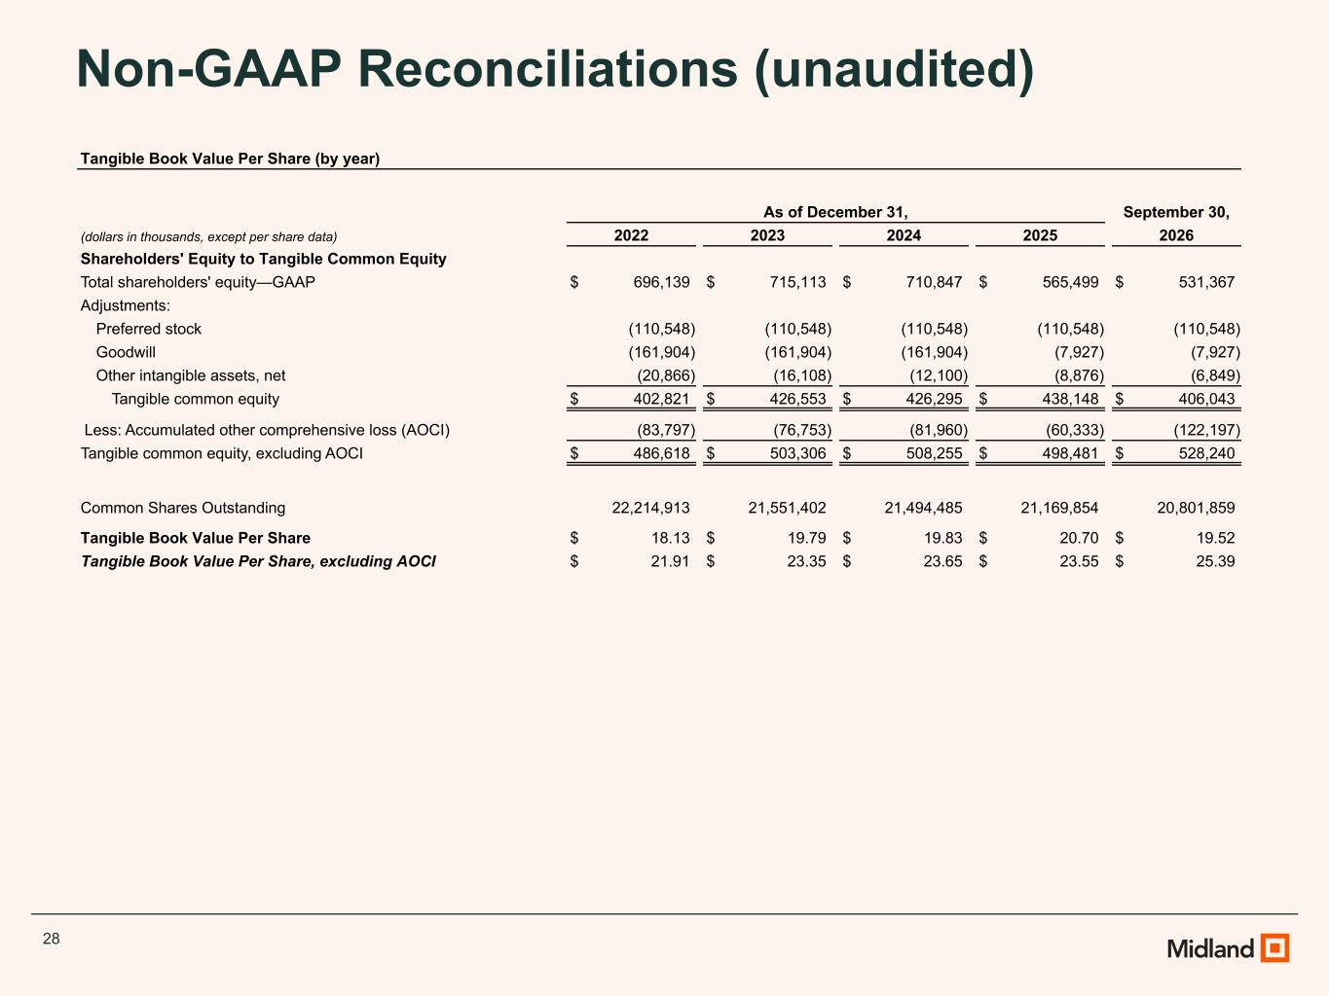
28 Non-GAAP Reconciliations (unaudited) Tangible Book Value Per Share (by year) As of December 31, September 30, (dollars in thousands, except per share data) 2022 2023 2024 2025 2026 Shareholders' Equity to Tangible Common Equity Total shareholders' equity—GAAP $ 696,139 $ 715,113 $ 710,847 $ 565,499 $ 531,367 Adjustments: Preferred stock (110,548) (110,548) (110,548) (110,548) (110,548) Goodwill (161,904) (161,904) (161,904) (7,927) (7,927) Other intangible assets, net (20,866) (16,108) (12,100) (8,876) (6,849) Tangible common equity $ 402,821 $ 426,553 $ 426,295 $ 438,148 $ 406,043 Less: Accumulated other comprehensive loss (AOCI) (83,797) (76,753) (81,960) (60,333) (122,197) Tangible common equity, excluding AOCI $ 486,618 $ 503,306 $ 508,255 $ 498,481 $ 528,240 Common Shares Outstanding 22,214,913 21,551,402 21,494,485 21,169,854 20,801,859 Tangible Book Value Per Share $ 18.13 $ 19.79 $ 19.83 $ 20.70 $ 19.52 Tangible Book Value Per Share, excluding AOCI $ 21.91 $ 23.35 $ 23.65 $ 23.55 $ 25.39

